Household Appliances Store Database Model
1. Business Description
The database represents a household appliances store that sells products such as refrigerators, washing machines, and microwaves. The system manages product catalog, suppliers, customers, and sales transactions. The main goal is to track sales, maintain product availability, and support analytical reporting.
2. Modeling Approach
Step 1: Requirement Analysis
Key entities identified: products, categories, suppliers, customers, orders, and order items. Business processes include product sales and supplier relationships.
Step 2: Conceptual Model
Entities: Category, Supplier, Product, Customer, Sales_Order, Order_Item.
Relationships:
- Category 1..* Product
- Supplier 1..* Product
- Customer 1..* Sales_Order
- Sales_Order 1..* Order_Item
- Product 1..* Order_Item
Many-to-many: Sales_Order ↔ Product via Order_Item.
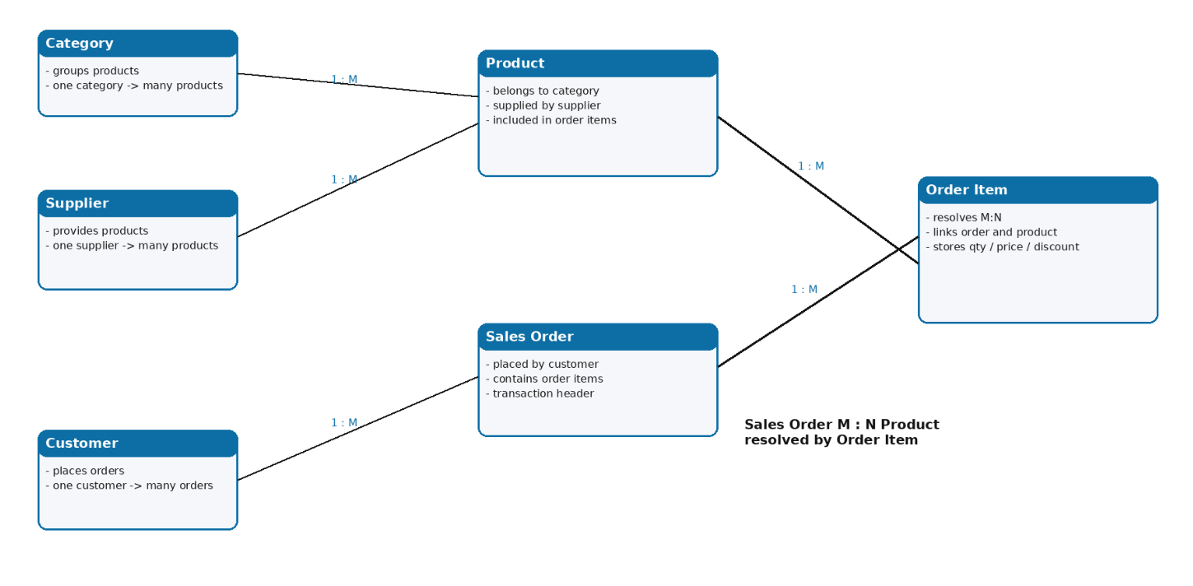
Step 3: Logical Model (3NF)
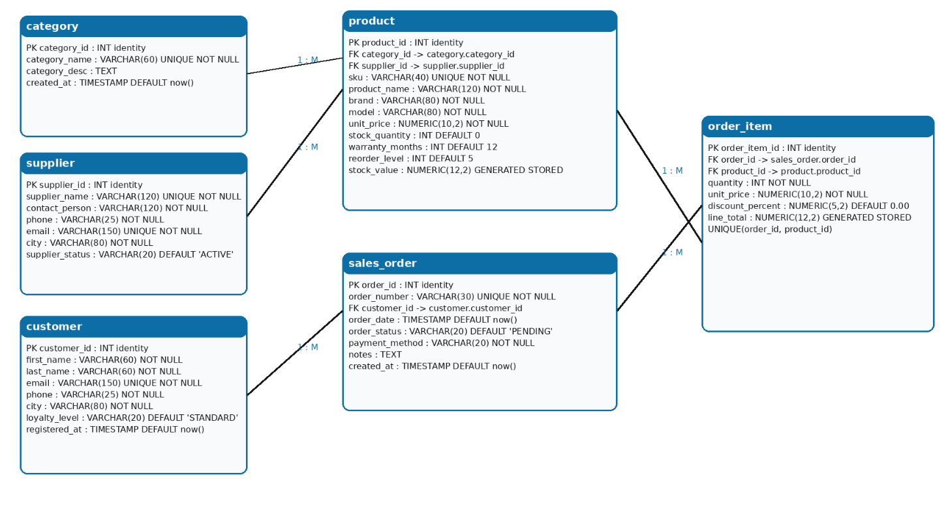
All tables are normalized to 3NF:
- No repeating groups
- All attributes depend on the primary key
- No transitive dependencies
Order_Item resolves many-to-many relationship.
Step 4: Physical Model
Implemented in PostgreSQL using:
- Identity columns for surrogate keys
- Foreign key constraints
- CHECK constraints for validation
- Generated column for line_total
Table Name | Field name | Field Description | Data Type
category | category_id | Unique category identifier, PK | integer
category | category_name | Name of product category | varchar
category | description | Description of category | text

Table Name | Field name | Field Description | Data Type
Supplier | supplier_id | Unique supplier identifier, PK | integer
supplier | supplier_name | Supplier company name | varchar
supplier | contact_email | Supplier email address (unique) | varchar
supplier | phone | Supplier phone number | varchar
supplier | created_at | Supplier registration date | timestamp

Table Name | Field name | Field Description | Data Type
Customer | customer_id | Unique customer identifier, PK | integer
customer | first_name | Customer first name | varchar
customer | last_name | Customer last name | varchar
customer | email | Customer email address (unique) | varchar
customer | phone | Customer phone number | varchar
customer | created_at | Customer registration date | timestamp

Table Name | Field name | Field Description | Data Type
Product | product_id | Unique product identifier, PK | integer
product | product_name | Name of the product | varchar
product | brand | Product brand name | varchar
product | model | Product model identifier | varchar
product | category_id | Reference to category, FK | integer
product | supplier_id | Reference to supplier, FK | integer
product | unit_price | Price of the product | numeric
product | stock_quantity | Available stock quantity | integer
product | warranty_months | Warranty period in months | integer
product | reorder_level | Minimum stock threshold | integer
product | active_flag | Indicates if product is active | boolean

Table Name | Field name | Field Description | Data Type
sales_order | order_id | Unique order identifier, PK | integer
sales_order | order_number | Unique business order number | varchar
sales_order | customer_id | Reference to customer, FK | integer
sales_order | order_date | Date of the order | date
sales_order | status | Order status (e.g., NEW, PAID) | varchar

Table Name | Field name | Field Description | Data Type
order_item | order_item_id | Unique order item identifier, PK | integer
order_item | order_id | Reference to sales order, FK | integer
order_item | product_id | Reference to product, FK | integer
order_item | quantity | Number of units ordered | integer
order_item | unit_price | Price per unit at time of order | numeric
order_item | line_total | Total amount (quantity × price), generated | numeric

Step 5: Constraints
- Price > 0
- Stock >= 0
- Order status limited to predefined values
- Order date restricted to recent period

1. PRIMARY KEY constraints (PK)
category.category_id
supplier.supplier_id
customer.customer_id
product.product_id
sales_order.order_id
order_item.order_item_id
2. FOREIGN KEY constraints (FK)
product.category_id → category.category_id
product.supplier_id → supplier.supplier_id
sales_order.customer_id → customer.customer_id
order_item.order_id → sales_order.order_id
order_item.product_id → product.product_id
3. NOT NULL constraints
category.category_name
supplier.supplier_name
customer.first_name, customer.last_name, customer.email
product.product_name, unit_price
sales_order.order_number, order_date
order_item.quantity, unit_price
4. UNIQUE constraints
supplier.contact_email
customer.email
sales_order.order_number

5. CHECK constraints (IMPORTANT for assignment)

(You added these with ALTER TABLE)

Product table:
chk_product_price_positive
unit_price > 0
chk_product_stock_non_negative
stock_quantity >= 0
chk_product_warranty_non_negative
warranty_months >= 0
chk_product_reorder_non_negative
reorder_level >= 0
Sales Order table:
chk_order_date_valid
order_date >= '2026-01-01'
chk_order_status_valid
status IN ('NEW', 'PAID', 'SHIPPED', 'CANCELLED')
Order Item table:
chk_order_item_quantity_positive
quantity > 0
chk_order_item_price_positive
unit_price > 0
chk_order_item_discount_range
discount_percent >= 0 AND discount_percent <= 100

6. DEFAULT constraints
product.active_flag DEFAULT TRUE
supplier.created_at DEFAULT CURRENT_TIMESTAMP
customer.created_at DEFAULT CURRENT_TIMESTAMP
sales_order.order_date DEFAULT CURRENT_DATE
Step 6: Functions
Two functions implemented:
1. Dynamic update function for product attributes
2. Transaction function to insert orders and order items
Step 7: Analytics View
A view was created to summarize sales for the latest quarter, including total revenue and quantity sold.
The view identifies the latest quarter based on the maximum order date and selects only orders from that period. The query joins orders, customers, products, categories, and order items to gather all required data.

For each product category, the view computes:

the total number of orders,
the number of unique customers,
the total quantity of products sold,
the total revenue,
and the average value of order lines.
Step 8: Security
A read-only role was created for managers with SELECT privileges only.

