- Figure out what security precautions are already used in your 'dvd_rental' database. Prepare description.
Existing users/roles and their permissions.
SELECT rolname,
rolsuper,
rolinherit,
rolcreaterole,
rolcreatedb,
rolcanlogin,
rolreplication,
rolconnlimit
FROM pg_roles
ORDER BY rolname;
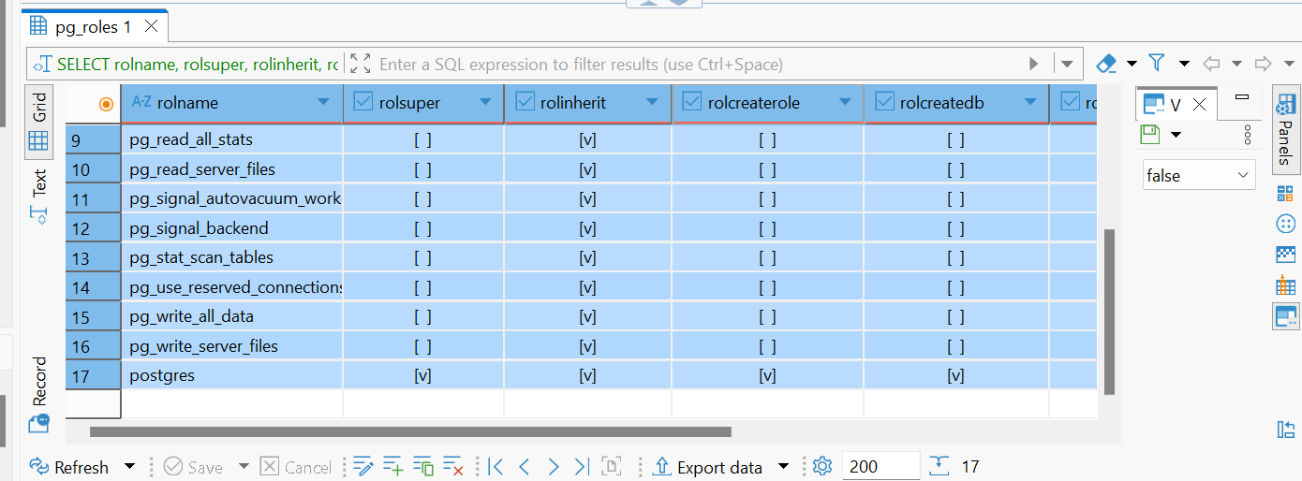
SELECT pg_get_userbyid(roleid) AS granted_role,
pg_get_userbyid(member) AS member_role,
admin_option
FROM pg_auth_members
ORDER BY granted_role, member_role;

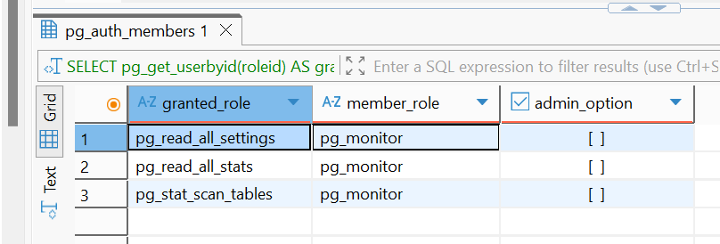
Query shows that the dvd_rental database contains the standard predefined PostgreSQL roles and one login-capable administrative account, postgres. The predefined roles (for example, pg_read_all_data, pg_write_all_data, pg_monitor, pg_read_server_files, pg_execute_server_program) are built-in non-login roles intended to be granted to other users when specific administrative capabilities are needed. In the result, all these roles have rolcanlogin = false, which means they cannot authenticate directly and therefore do not represent standalone user accounts.
Database-level settings like connection limits or authentication methods:
SELECT nspname,
nspacl
FROM pg_namespace
WHERE nspname NOT LIKE 'pg_%'
AND nspname <> 'information_schema'
ORDER BY nspname;
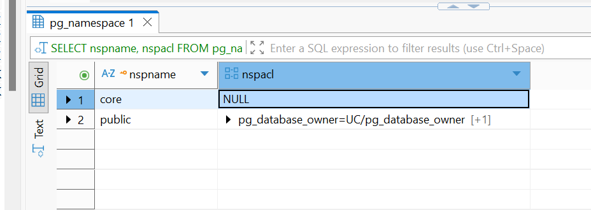
The database-level configuration shows that no connection limit is enforced (datconnlimit = NULL), which means that an unlimited number of concurrent connections is allowed.

The access control list (datacl) indicates that the database owner (pg_database_owner) has both CONNECT (U) and CREATE (C) privileges, which is expected.

Table privileges in the public schema :
SELECT table_schema,
table_name,
grantee,
privilege_type,
is_grantable
FROM information_schema.role_table_grants
WHERE table_schema = 'public'
ORDER BY table_name, grantee, privilege_type;

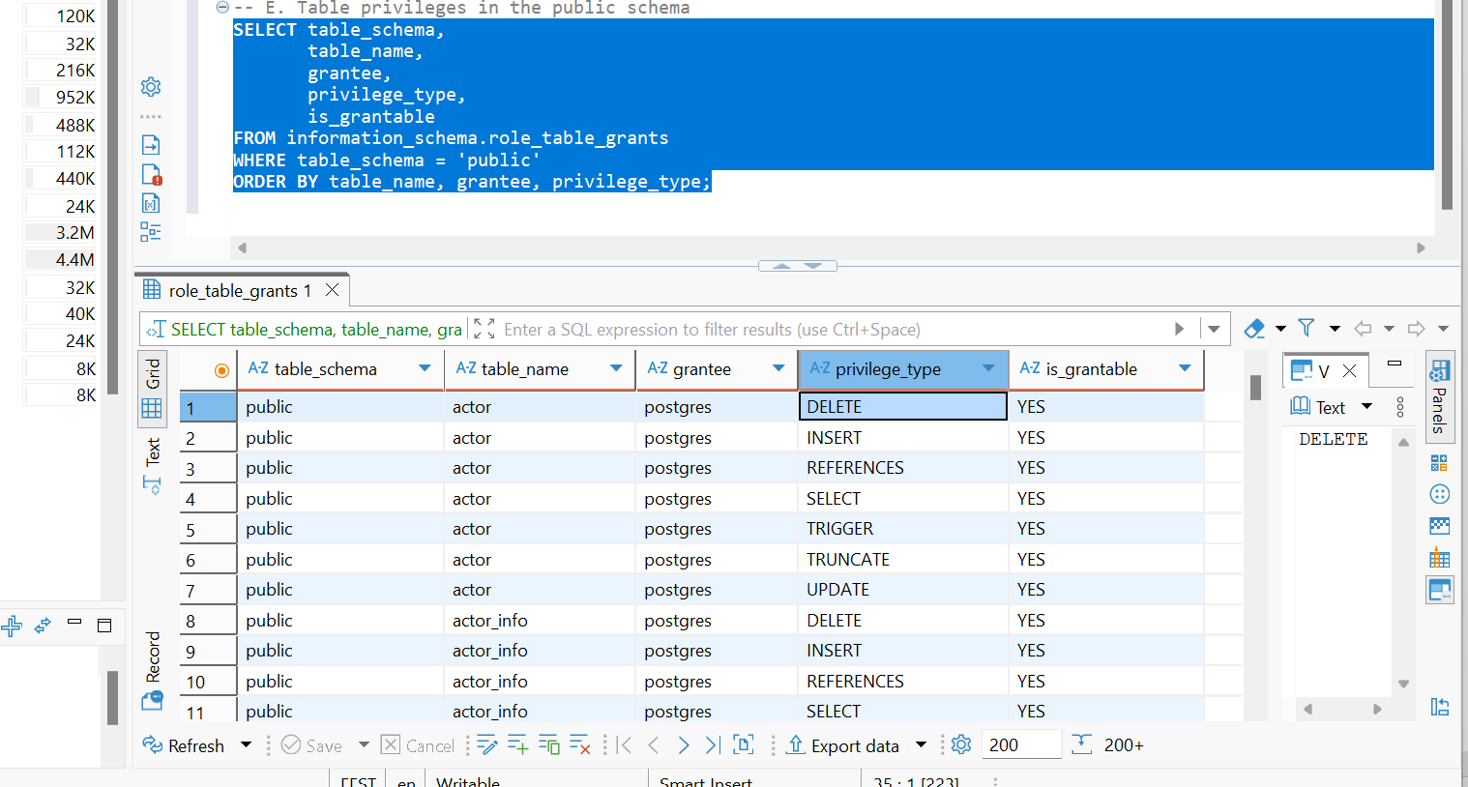
privilige types:
DELETE
INSERT
REFERENCES
SELECT
TRIGGER
TRUNCATE
UPDATE are granted to all tables in public schema
Row-level security policies:
SELECT schemaname,
tablename,
rowsecurity
FROM pg_tables
WHERE schemaname = 'public'
ORDER BY tablename;
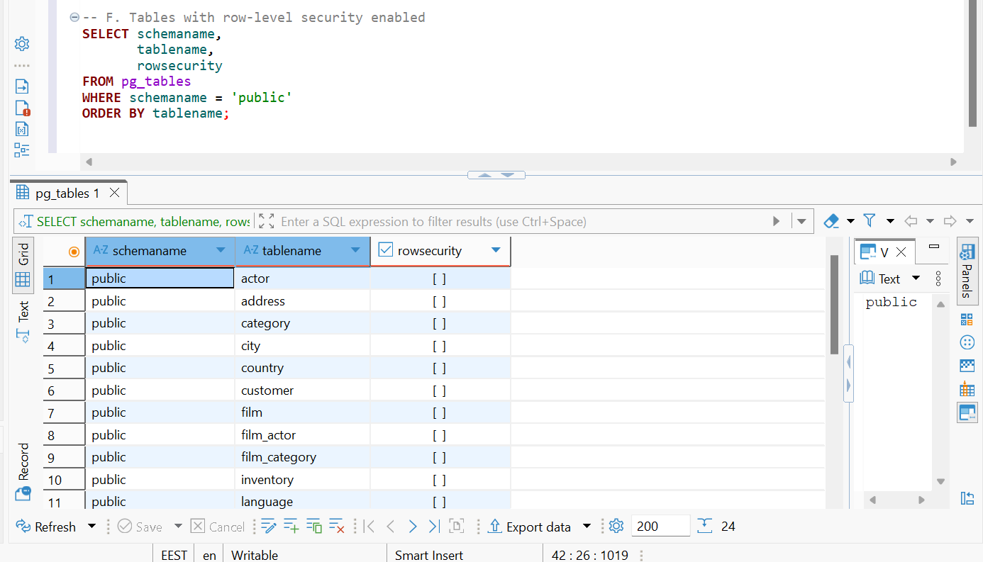
Row-level security for tables-rows are not set.

Database-level settings like connection limits or authentication methods:
SHOW max_connections;
SHOW ssl;
max_connections limit is not set.
