Business Model Description — SkyVista Airlines
SkyVista Airlines is a fictional commercial airline providing passenger air transportation services. The company offers several travel classes, including Business, Economy (ECO), and Economy Plus (ECO PLUS). Customers can book flights through different channels and payment methods and participate in the company's loyalty program. The SkyVista Aviation logo is used throughout the report as part of the corporate visual style.
Business Process and Report Purpose
The report analyzes the airline booking and financial performance process. Booking information from the DWH is analyzed by travel class, booking channel, payment method, loyalty level, customer type, and date.
The purpose of the report is to provide an interactive overview of the company's performance using key indicators such as total bookings, revenue, operating costs, discounts, profit, and profit margin. Users can apply filters to investigate specific periods and customer or travel segments.
End Users
The primary users are airline managers and business analysts. Management can use the Executive Overview for high-level performance monitoring, while analysts can use the detailed pages to investigate individual business areas and travel classes.
Business Questions and Problems
The report helps answer the following business questions:
What are the company's total bookings, revenue, costs, profit, and profit margin?
Which travel classes generate the most bookings, revenue, and profit?
Which booking channels and payment methods are most frequently used?
How are bookings distributed among loyalty levels?
How does performance change by date, travel class, booking channel, and customer type?
What detailed financial results are associated with a selected travel class?

The report addresses the problem of complex DWH data being difficult to interpret directly by transforming it into interactive KPIs and visualizations that support faster business analysis and decision-making.

Data model description
The Power BI report uses a star-schema-style dimensional model built from the bl_dm data mart. Two fact tables form the core of the model:
fct_bookings_dd — stores booking and financial data, including ticket price, operating cost, airport fee, promotion discount, and profit.
fct_customer_satisfactions_dd — stores customer satisfaction ratings, service-quality indicators, and departure/arrival delays.
These fact tables are connected to shared dimension tables using surrogate keys. The main shared dimensions are dim_customers_scd, dim_travels, and dim_time_day. Additional booking-related dimensions include dim_booking_channels, dim_payment_methods, dim_loyalties, and dim_travel_insurances, while dim_satisfaction_statuses is used for customer-satisfaction analysis.
The relationships are mainly configured as one-to-many (1:*), where the dimension table is on the 1 side and the fact table is on the * side. Single-direction filtering is used so that dimensions filter the related fact tables. For example, dim_travels[travel_surr_id] filters both fact tables, allowing the same Travel Class filter to affect booking and satisfaction analysis.
Calculated DAX columns such as Year Month, Year Quarter, Age Group, and Delay Category extend the model. DAX measures are used for aggregated business indicators including Total Bookings, Total Revenue, Total Operating Cost, Total Profit, Profit Margin %, and Average Departure Delay.
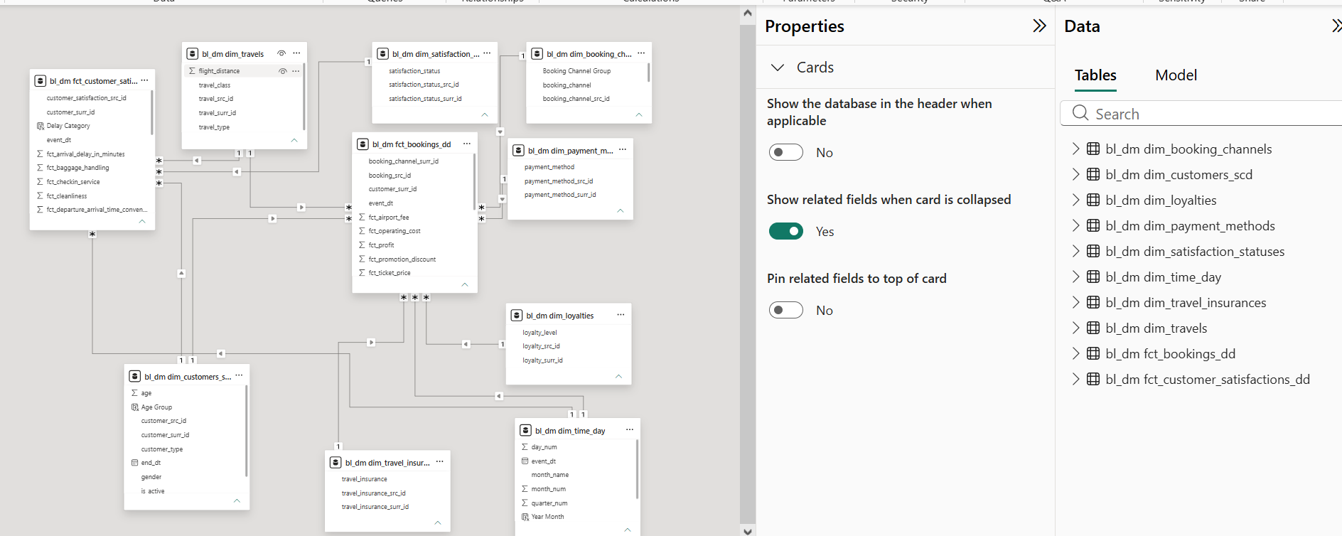
Figure 1. Power BI dimensional data model for the SkyVista Airlines report.

The structure of the report
The report includes two main pages. Each page has the following layout
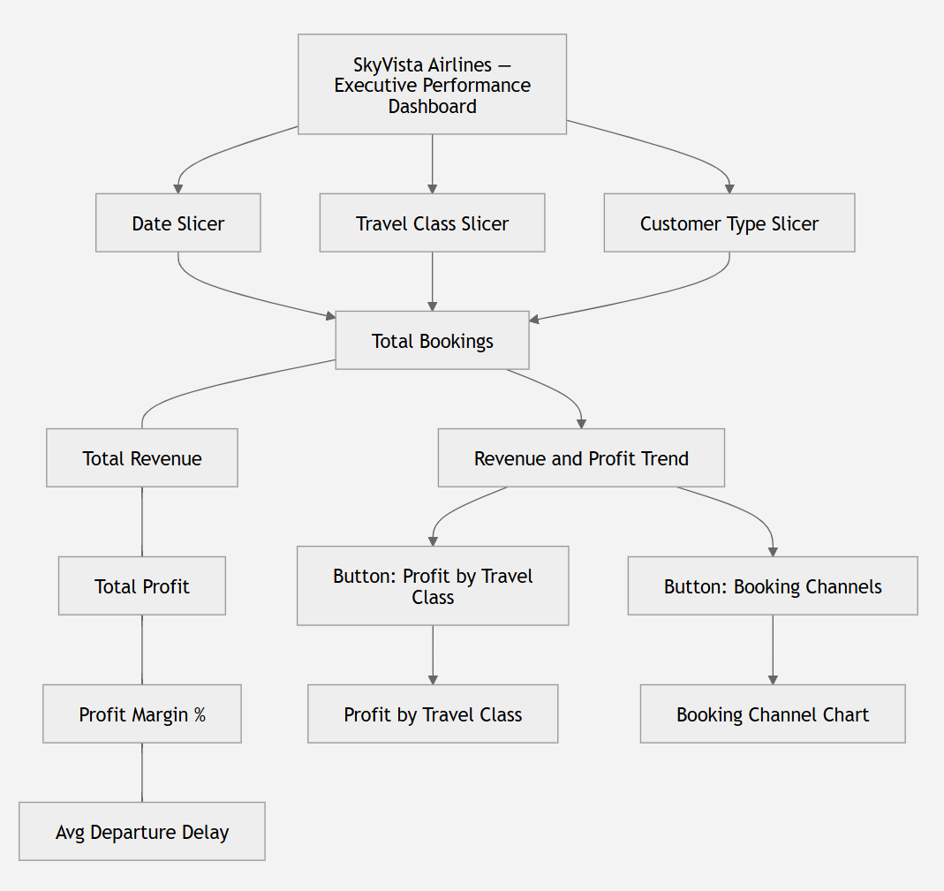
Page 1 — Executive Overview
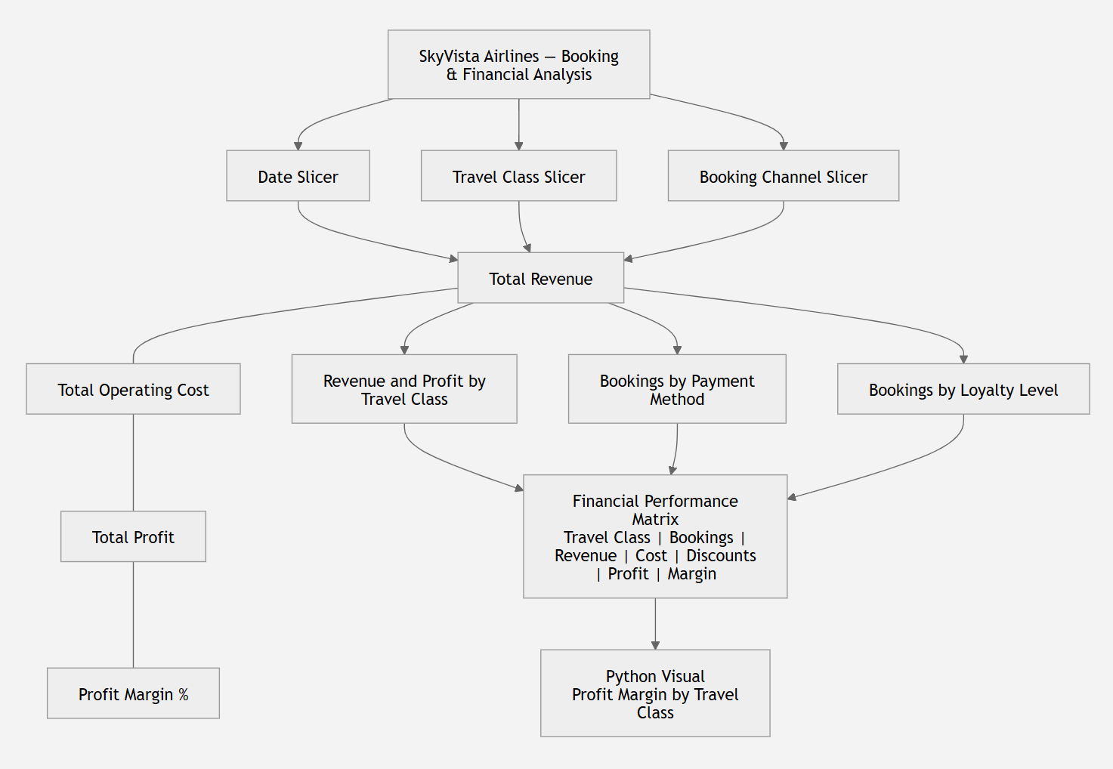
Page 2 — Booking & Financial Analysis

Report pages

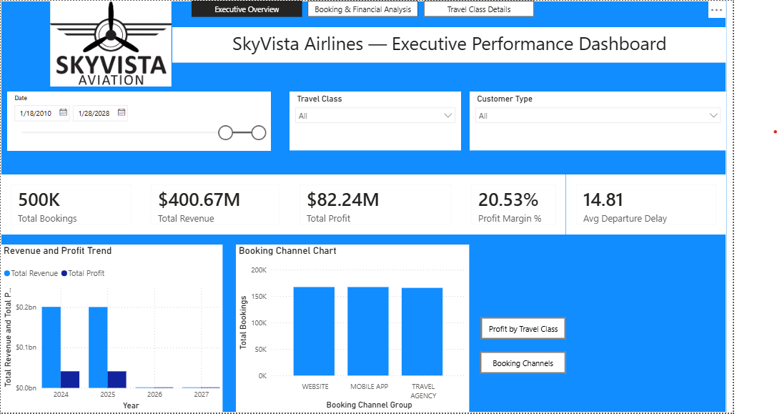
Figure 2. Executive Overview Page
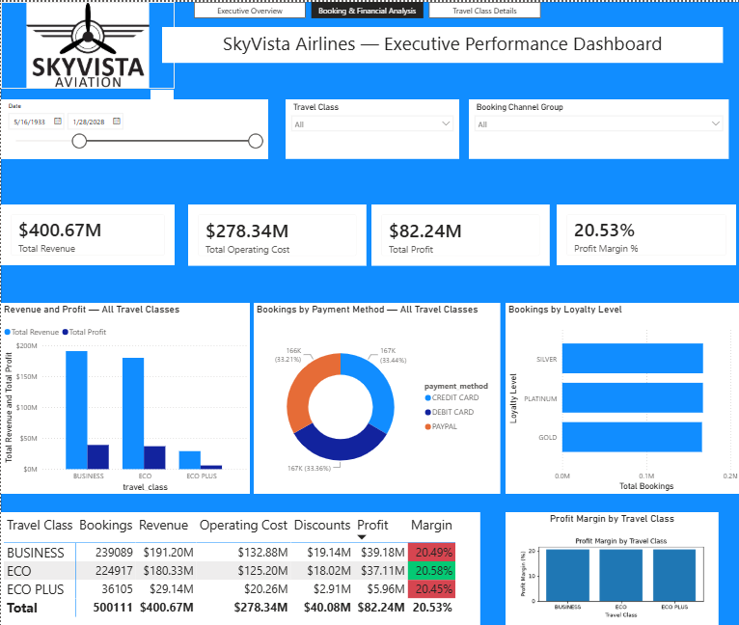
Figure 3. Booking and Financial Analysis

Conclusion
The developed Power BI report provides an interactive solution for analyzing the booking and financial performance of SkyVista Airlines. Data from the DWH was transformed into business-oriented indicators, including total bookings, revenue, operating costs, discounts, profit, and profit margin. The report enables users to analyze these indicators across travel classes, booking channels, payment methods, loyalty levels, customer types, and time periods.
The final solution combines DAX calculations, interactive filters, dynamic titles, bookmarks, buttons, tooltips, drillthrough, conditional formatting, and a custom Python visual. These features allow users to move from a high-level overview to detailed analysis while keeping the report intuitive and consistent. Overall, the report demonstrates how Power BI can transform DWH data into meaningful information that supports business monitoring and decision-making.

