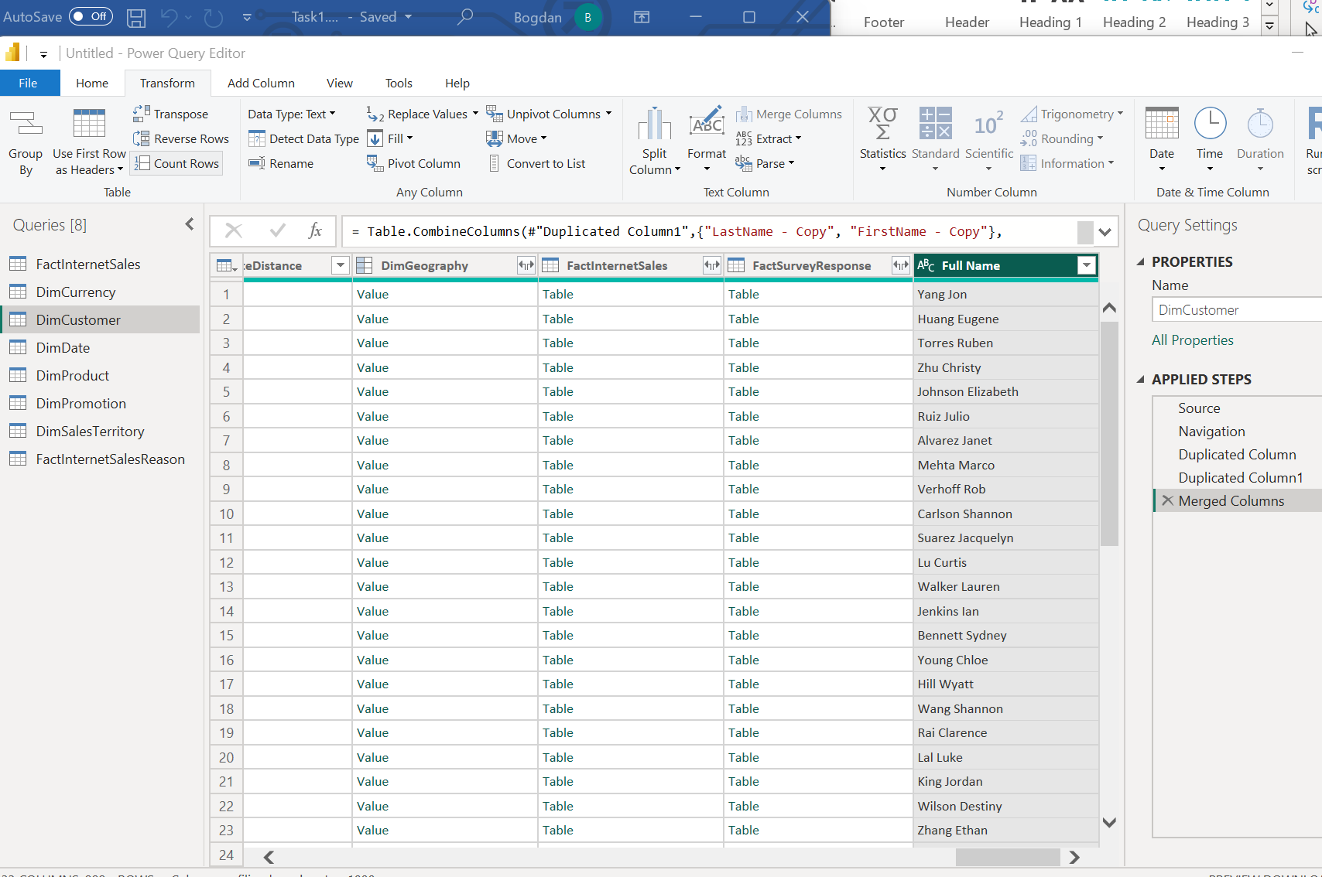

Basic Data Transformation
Create a column with full Customer name

Change column type : Select ‘DiscountPct’ column in ‘DimPromotion’ table
In Power Query, the data type of DiscountPct was changed to Decimal Number. in Power BI Desktop, the Format was changed from a decimal representation to Percentage. The data type remained Decimal Number.

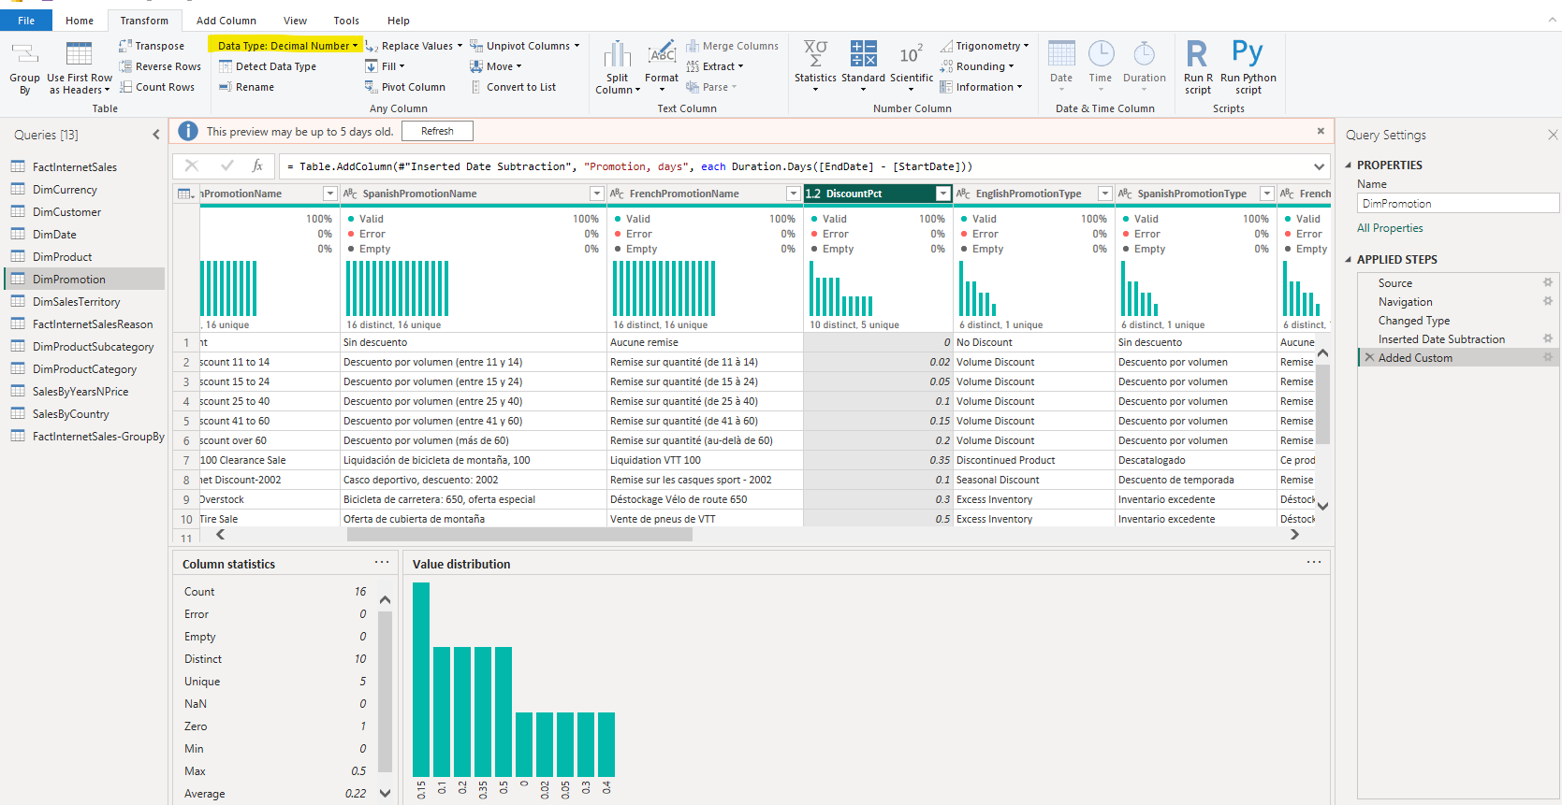
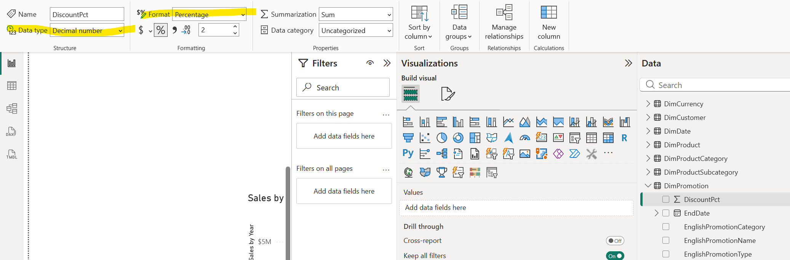

#Option 1 - Select ‘StartDate’ and ‘EndDate’ columns in ‘DimPromotion’ table and apply option for Date Subtraction.
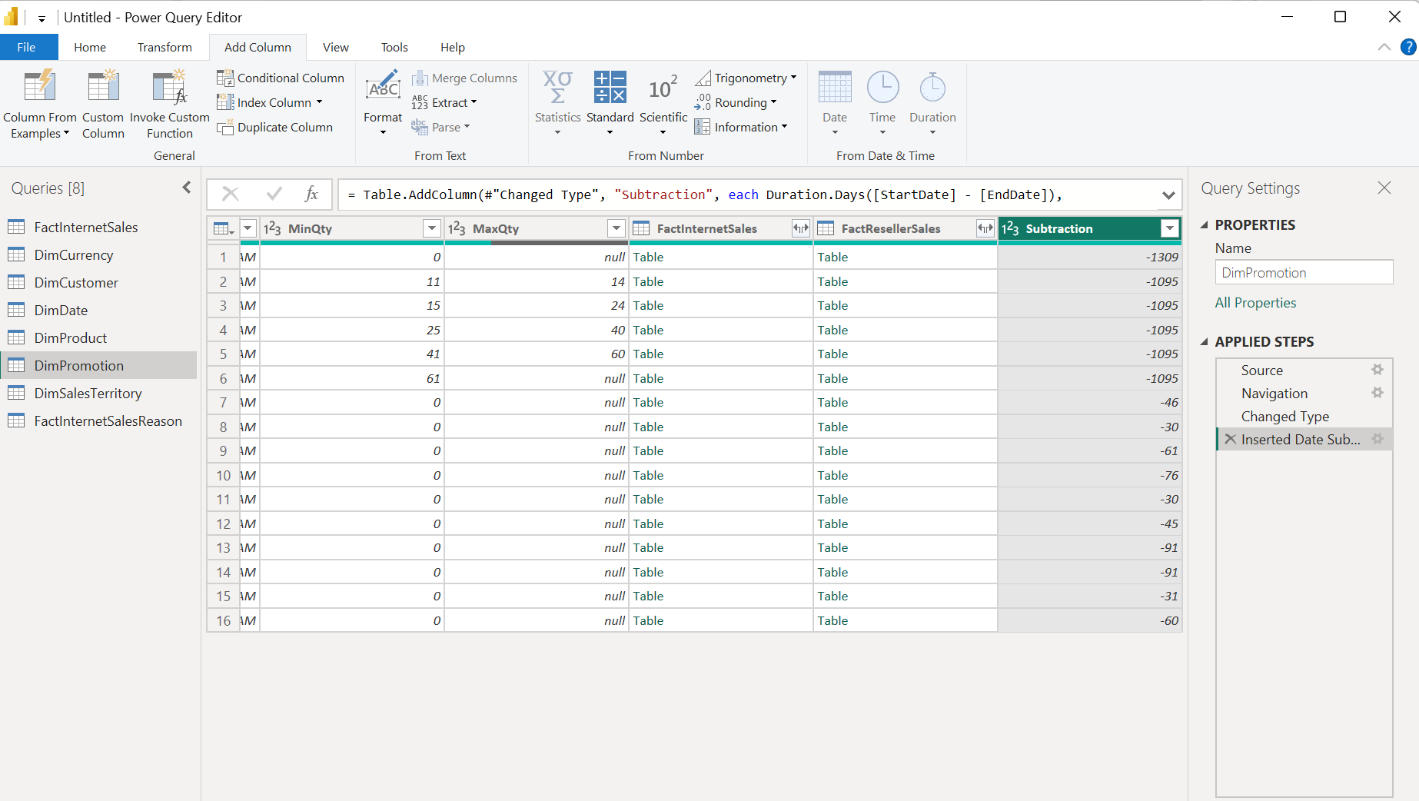
#Option2 - Create a Custom Column and type the necessary Custom column formula.
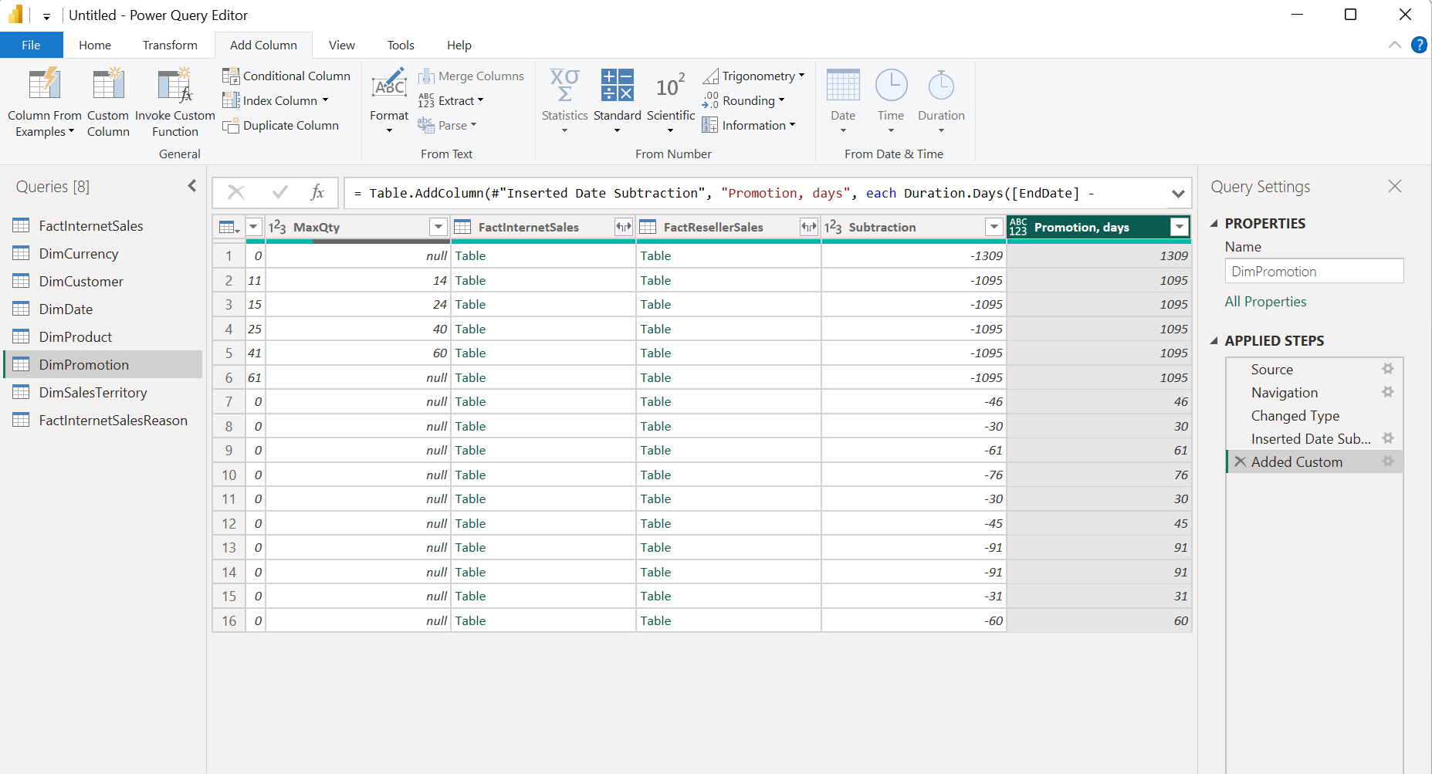

DATA PROFILING
Enabled Column Quality, Column distribution and Column profile
Data profiling was performed in Power Query before further transformations in order to evaluate the quality and structure of the imported AdventureWorks data. The Column Quality, Column Distribution, and Column Profile options were enabled. These profiling tools were used to inspect valid, error, and empty values, as well as the distribution and uniqueness of values in the selected columns. This step helps identify potential data-quality issues before grouping, joining, and aggregating the data.
The profiling results for the displayed columns showed that the data was valid, with no visible errors or empty values in the inspected fields. Column Distribution demonstrated the number and frequency of distinct values, which made it possible to verify whether categorical and key fields contained reasonable value sets. No critical data-quality problems requiring additional cleansing were identified in the inspected columns.
During profiling, an additional column Order Year was created in FactInternetSales from the OrderDate column using Date.Year([OrderDate]). This transformed the full transaction date into a year-level attribute that could subsequently be used for pivoting, grouping, and year-based sales analysis.
Conclusion. The profiling stage confirmed that the inspected source data was suitable for the subsequent transformations and analytical operations. No significant missing-value or error-related issues were detected in the profiled fields. Creating the Order Year attribute also prepared the dataset for later aggregation and comparison of sales results by year.
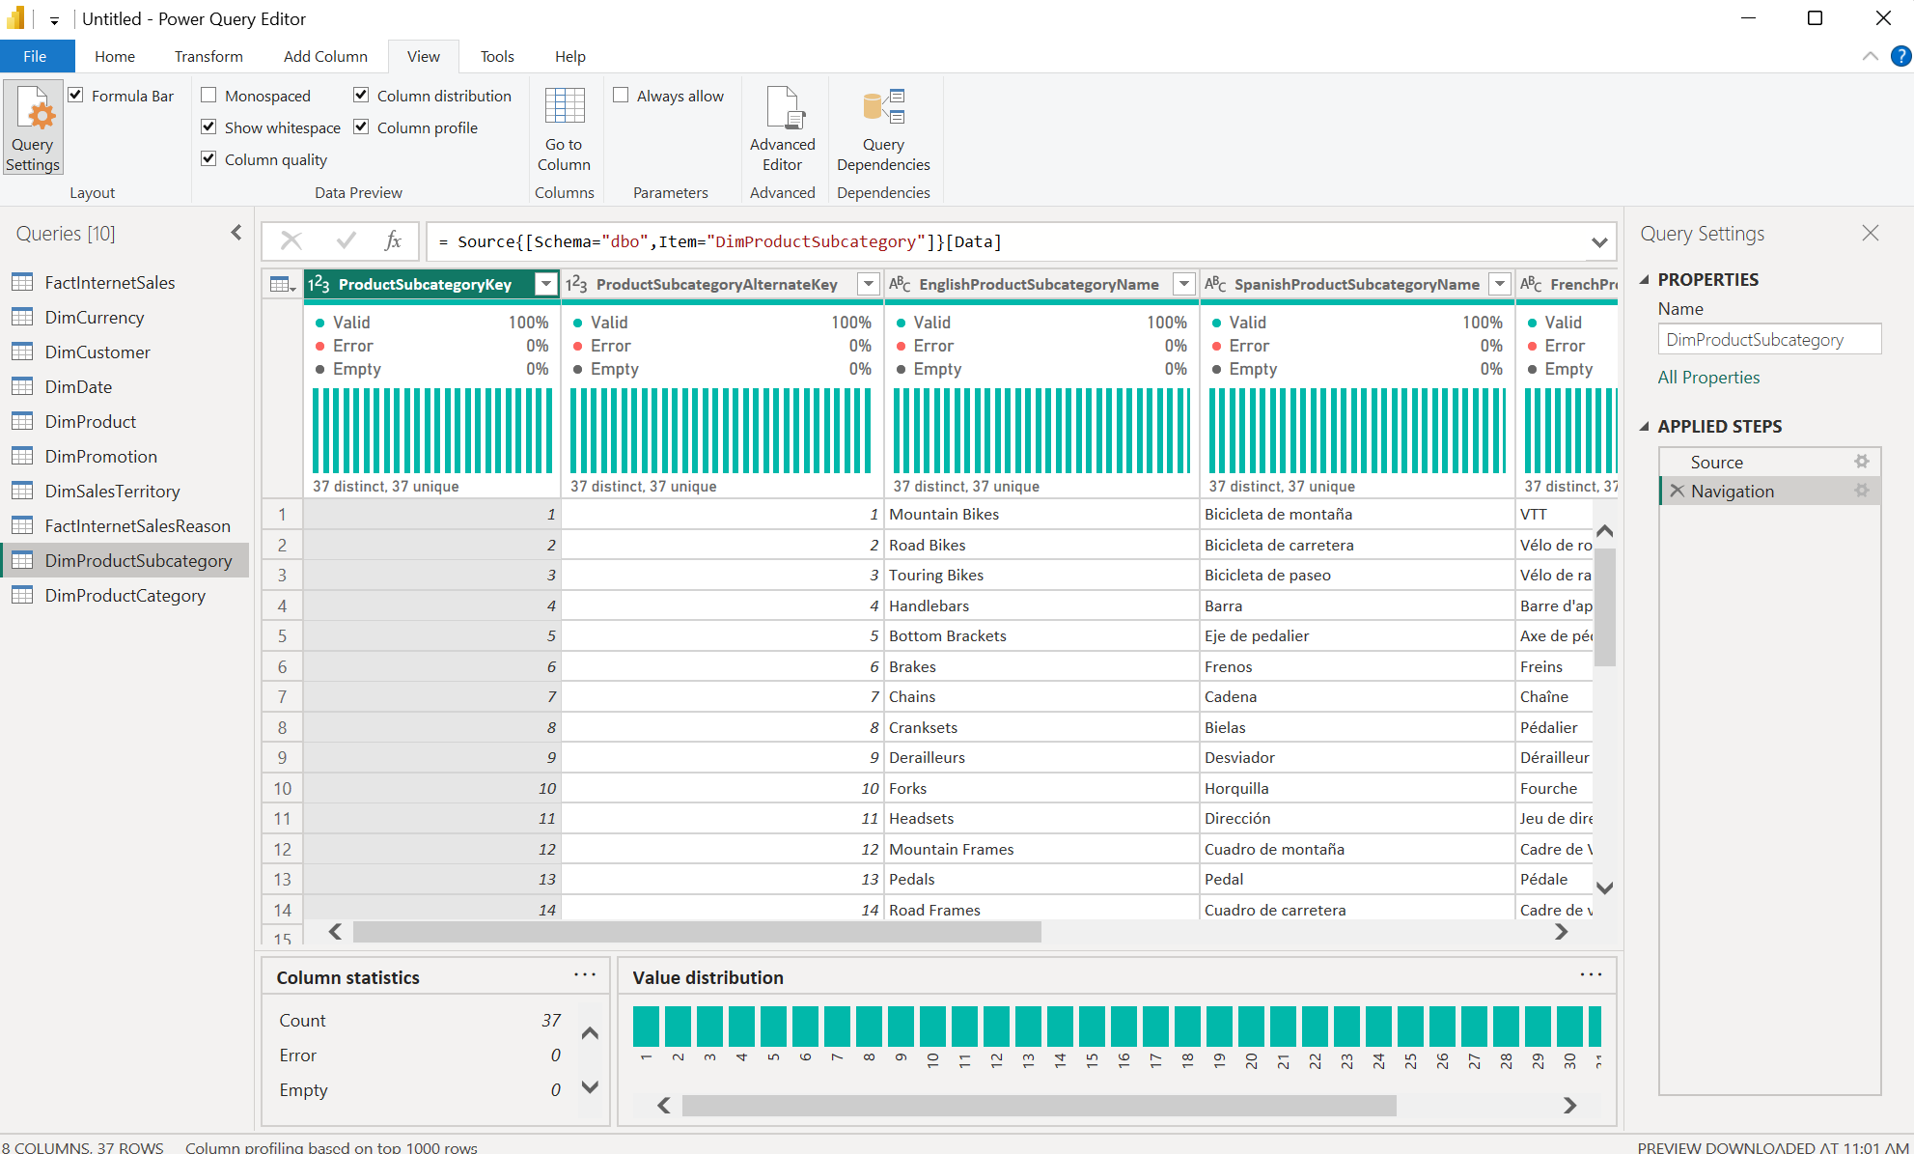
Create column ‘Order Year’ based on the ‘OrderDate’ column in the table ‘FactInternetSales’
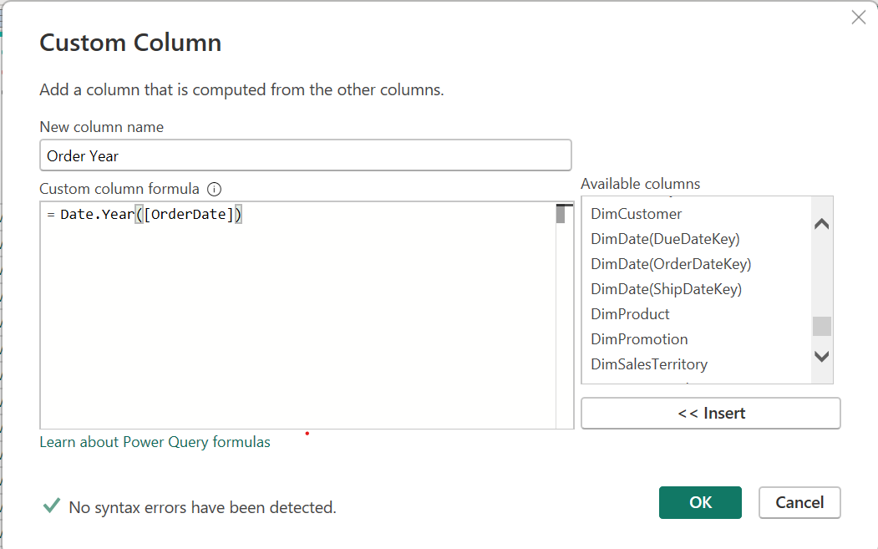
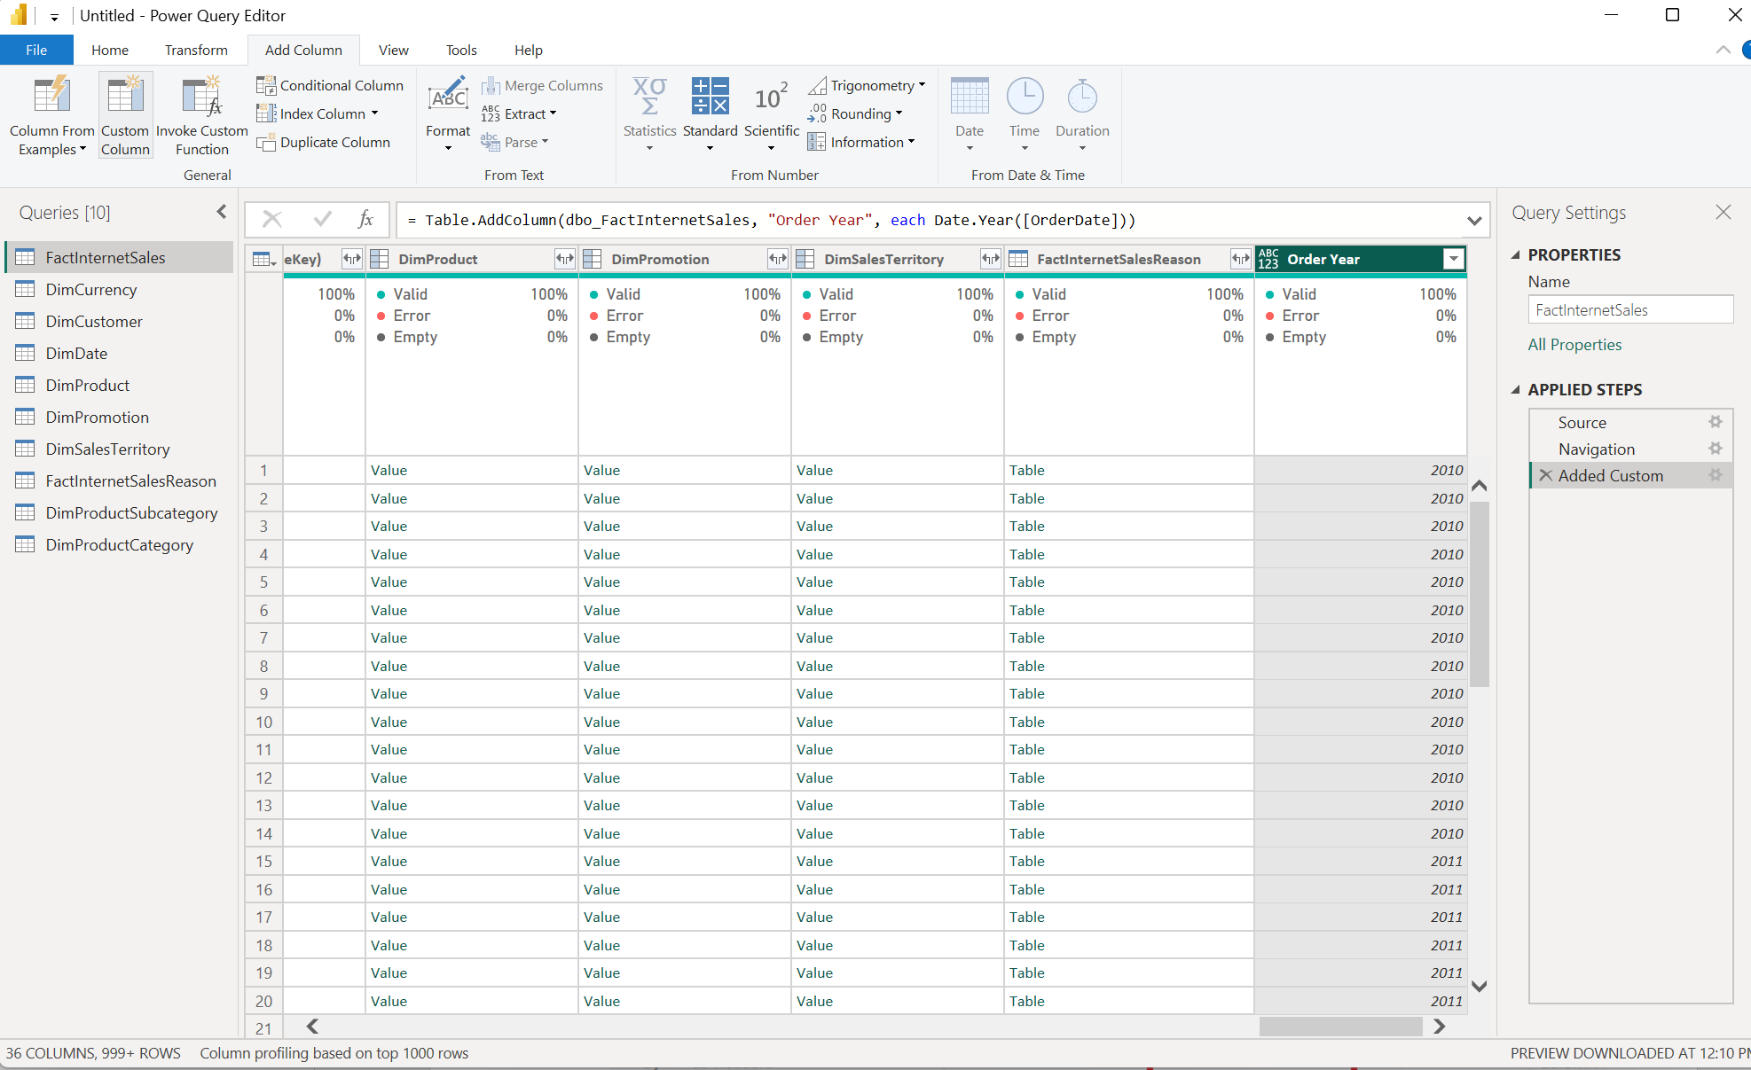
new table based on ‘FactInternetSales’
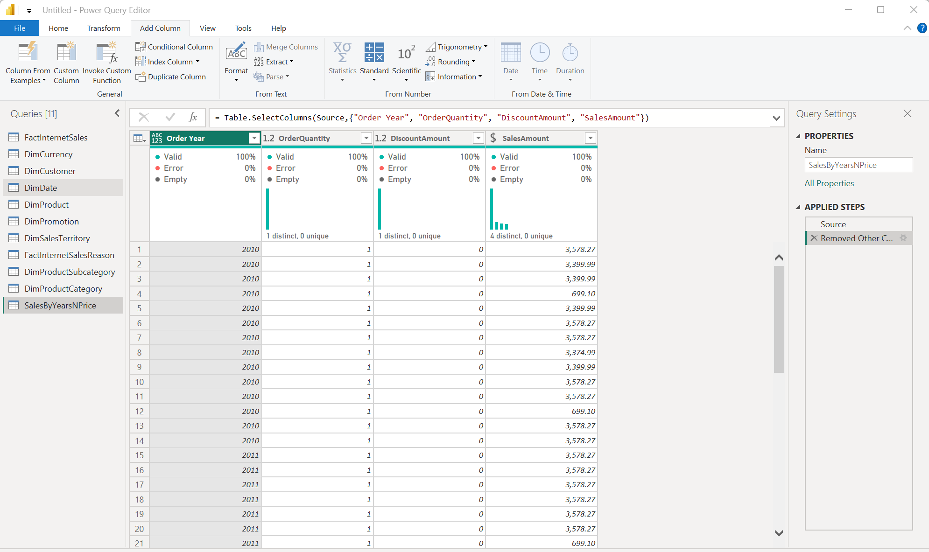
- Choose column ‘Order Year’ (‘SalesByYearsNPrice’ table), navigate on the Transform tab and click on Pivot Column

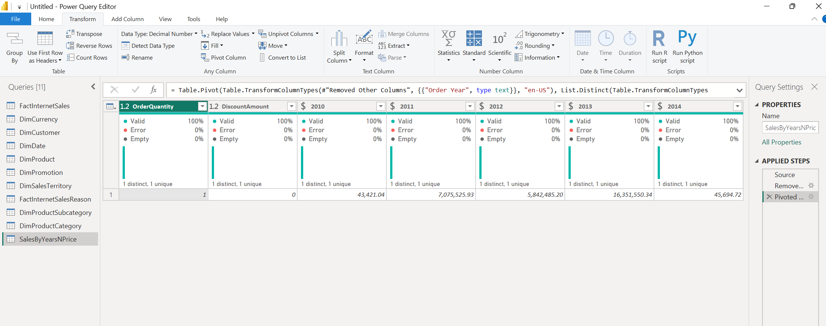
Join ‘SalesByCountry’ and ‘DimSalesTerritory’ tables by SalesTerritoryKey
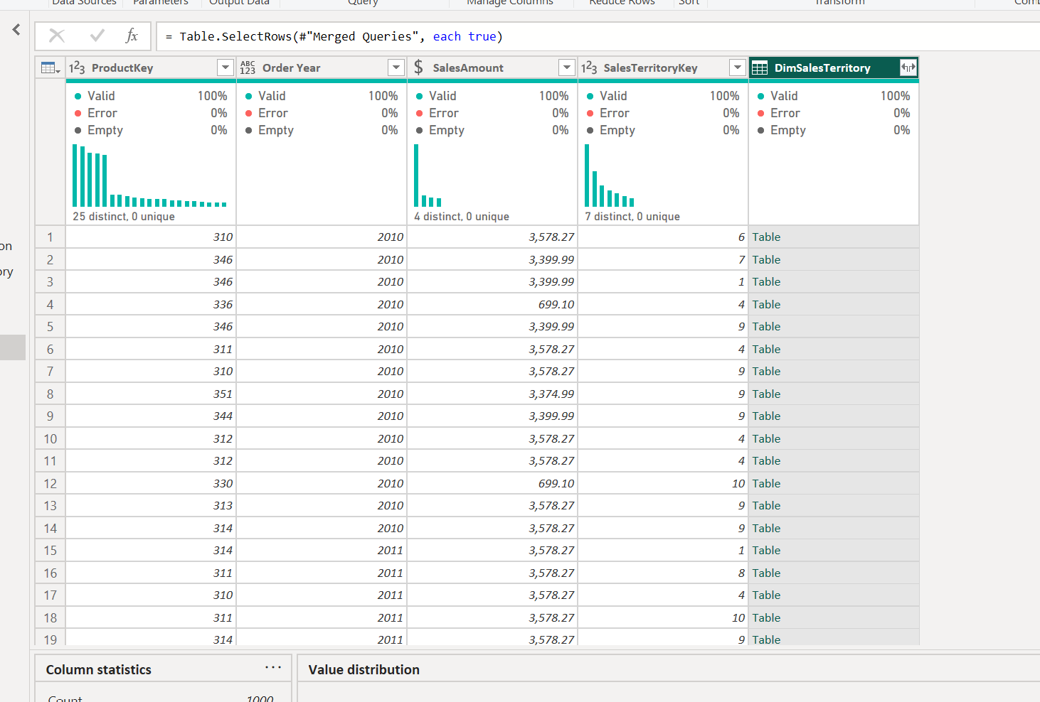
- show the ‘Sales territoryCountry’ column in the new table.

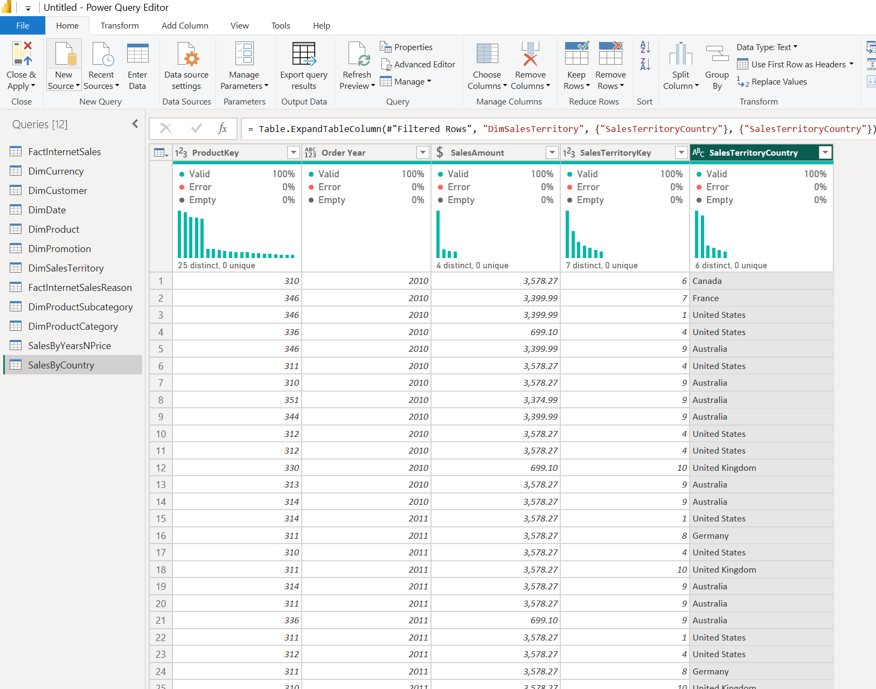
- Join DimProductCategory[EnglishProductCategory] column in the same way. (Hint: To complete this task you need to join 3 tables).

GROUPING DATA
Merging FactInternetSales[SalesTerritoryKey] = DimSalesTerritory[SalesTerritoryKey] to expand SalesTerritoryCountry
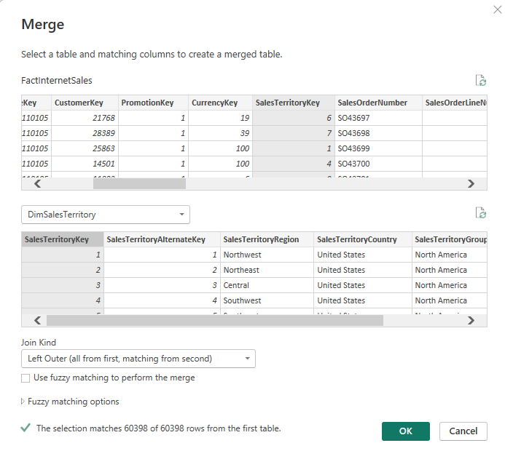
Merge FactInternetSales[ProductKey] = DimProduct[ProductKey] on DimProduct with left outer join
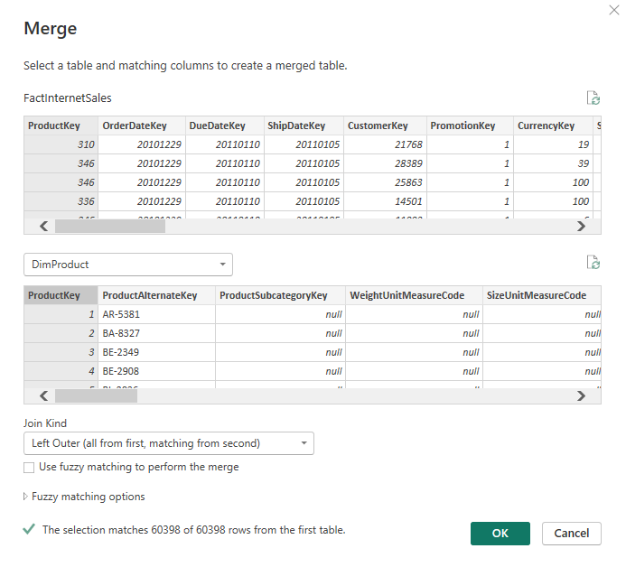
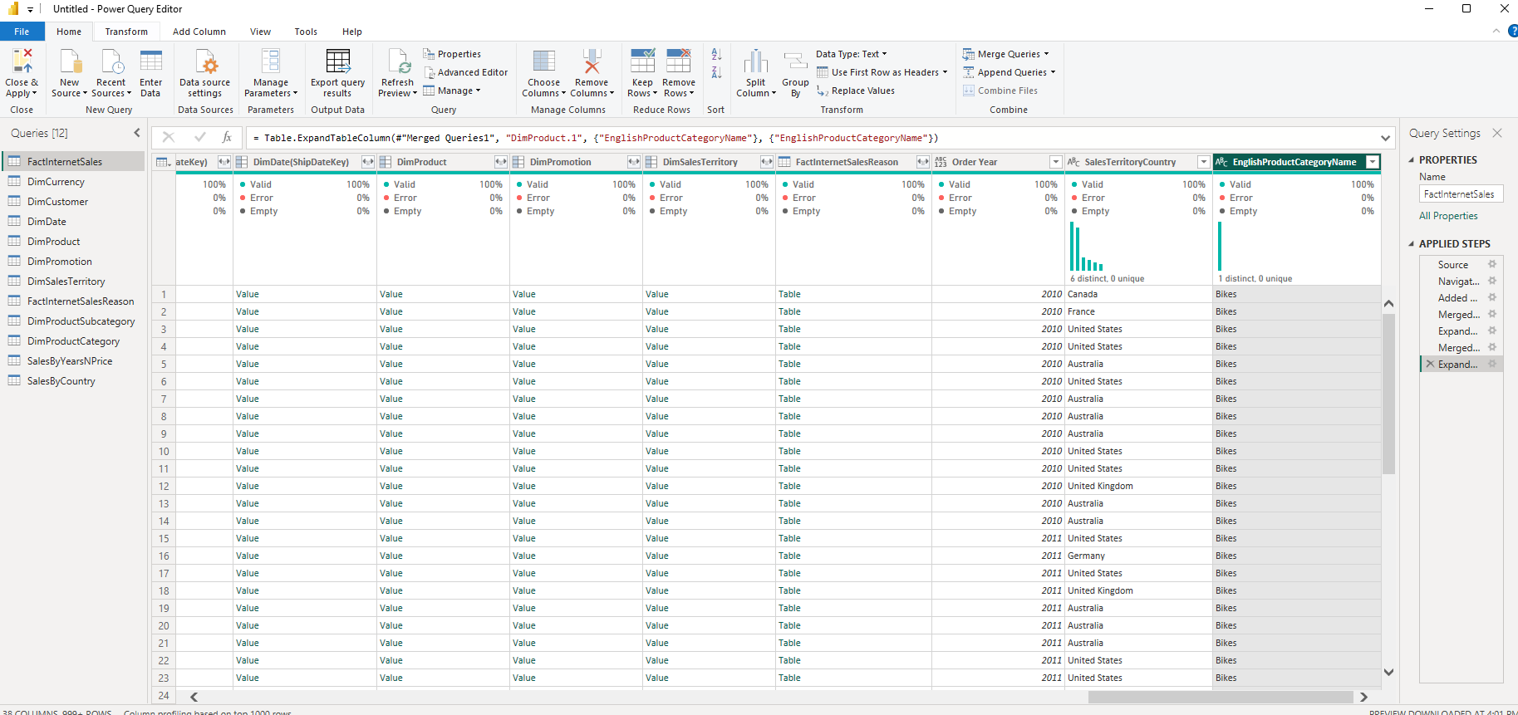
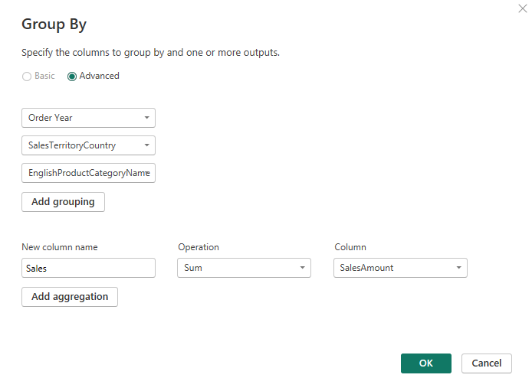
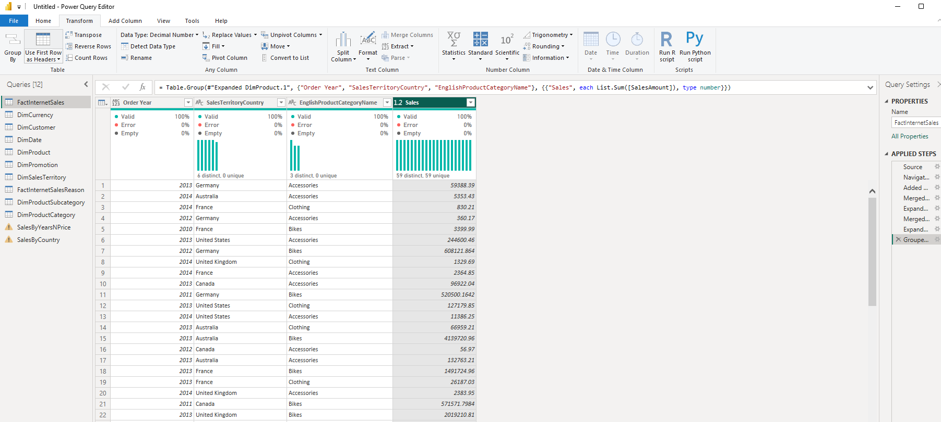
Sort Ascending
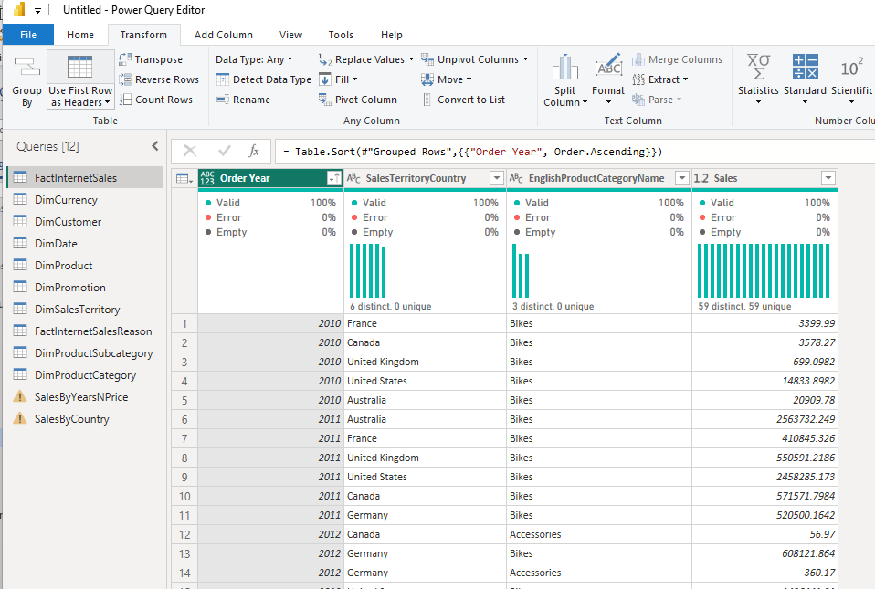

TABLE JOINING
DimProduct + DimProductSubcategory connect by ProductSubcategoryKey outer left join
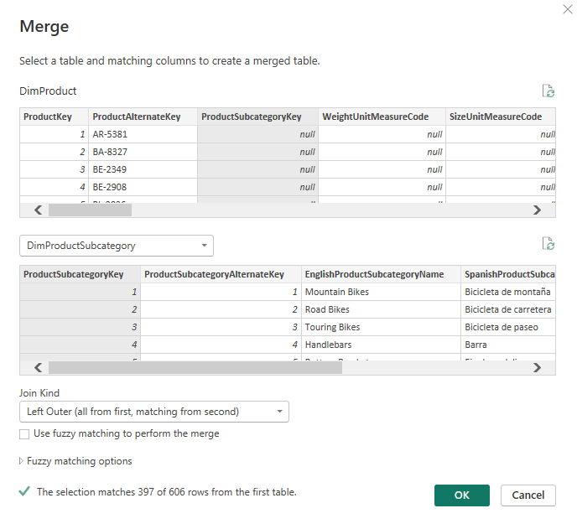
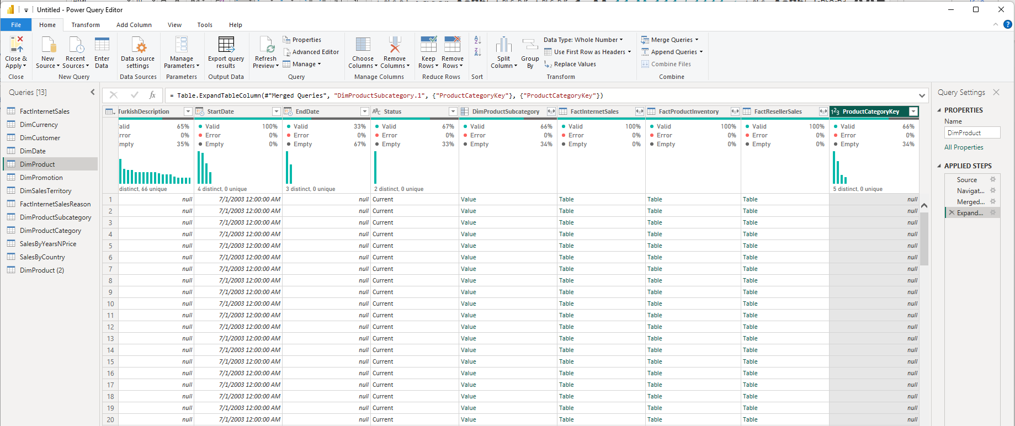
New column ProductCategoryKey after the join.
Result of the join of table DimProduct – left outer join with DimProductCategory by ProductCategoryKey
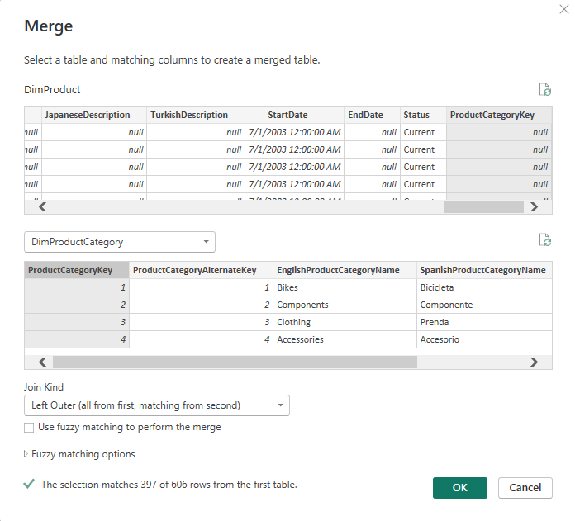
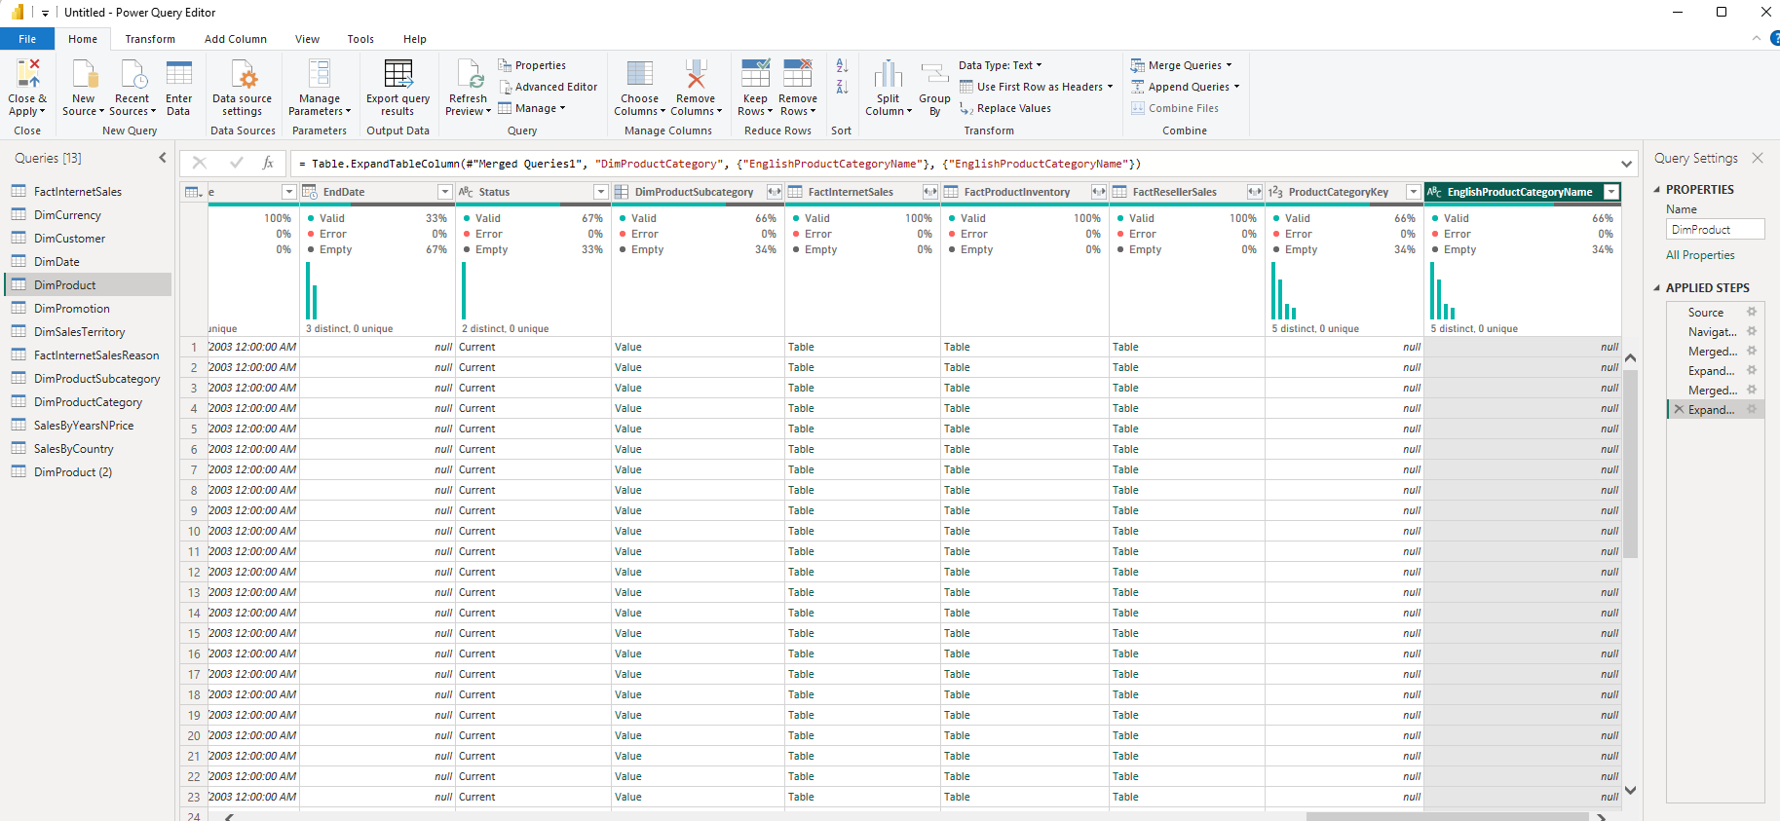
Result of the second join the field EnglishProductCategoryName

Load Data
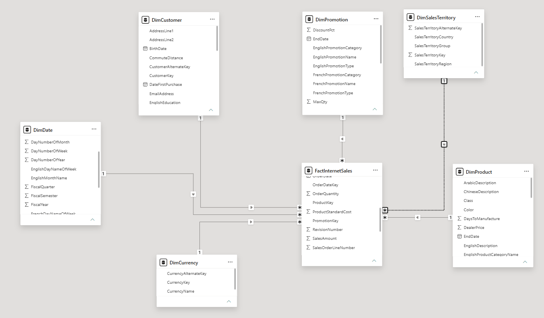

IMPORT VS DIRECT QUERY
The size of the Power BI file created using Import mode was 3,113 KB, whereas the size of the file created using DirectQuery was 60 KB. 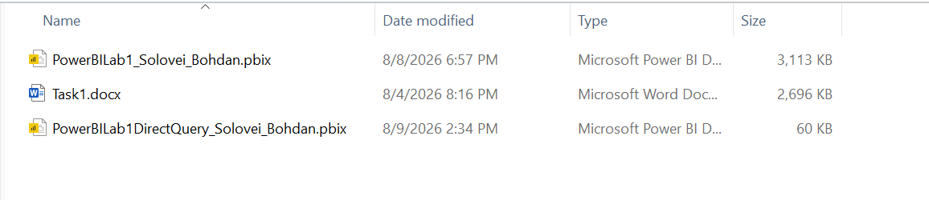
This difference was expected from the practical implementation because, in Import mode, the data used by the report was loaded into the Power BI data model and stored as part of the PBIX file. In DirectQuery mode, the report remained connected to SQL Server and the source data was not imported into the Power BI model in the same way.
In the Import report, changes made in the SQL Server database were not automatically available in the imported model until the data was refreshed.
Conclusion

Based on my practical comparison, Import mode was more convenient for this particular report because the dataset was small enough to be imported and report interactions were responsive without continuously querying SQL Server. The main disadvantage observed was the larger PBIX file size and the need to refresh the model when the source data changed.

WORKING WITH POWER BI MODEL

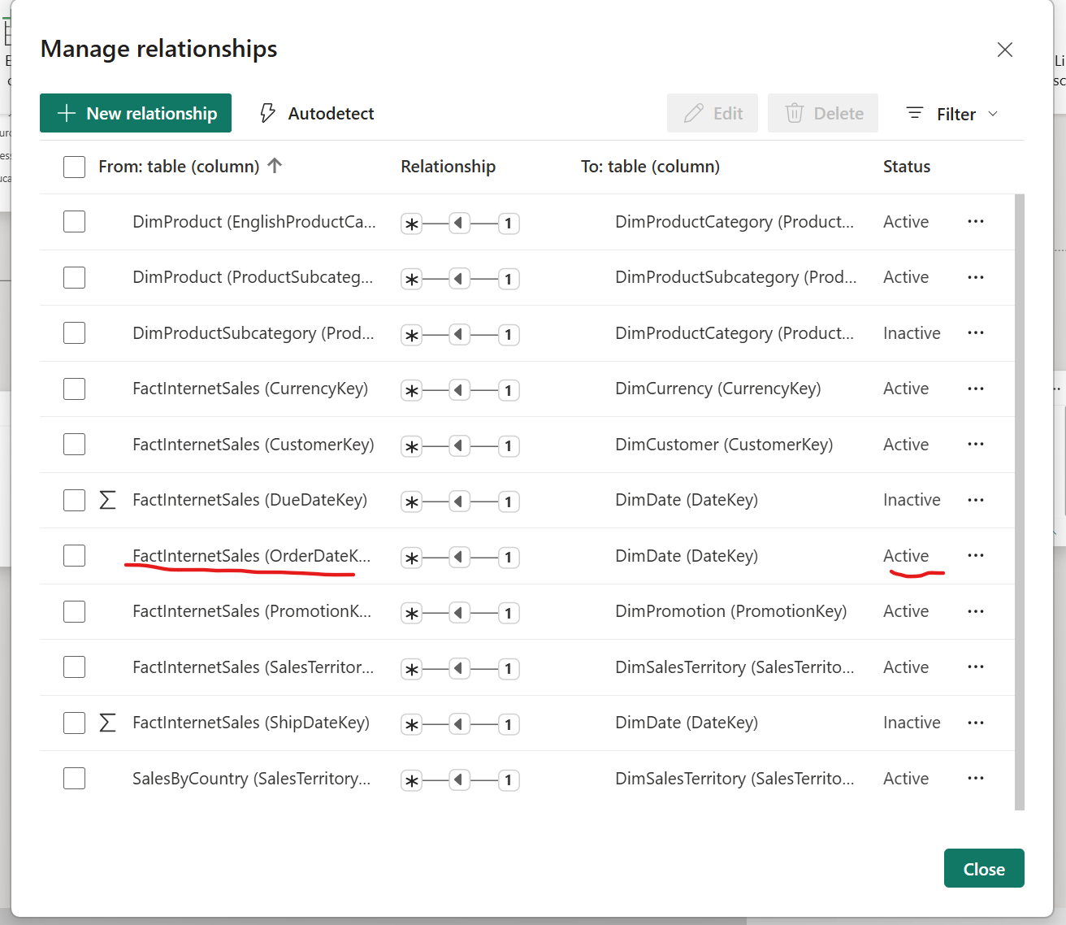

Create lab report

