Working with Power BI Report
- Add a Slicer. It should contain Full Name from DimCustomer table. Try to have in two types – List and Dropdown. Add Search to the slicers, since there are a lot of customers, so let’s simplify user experience.

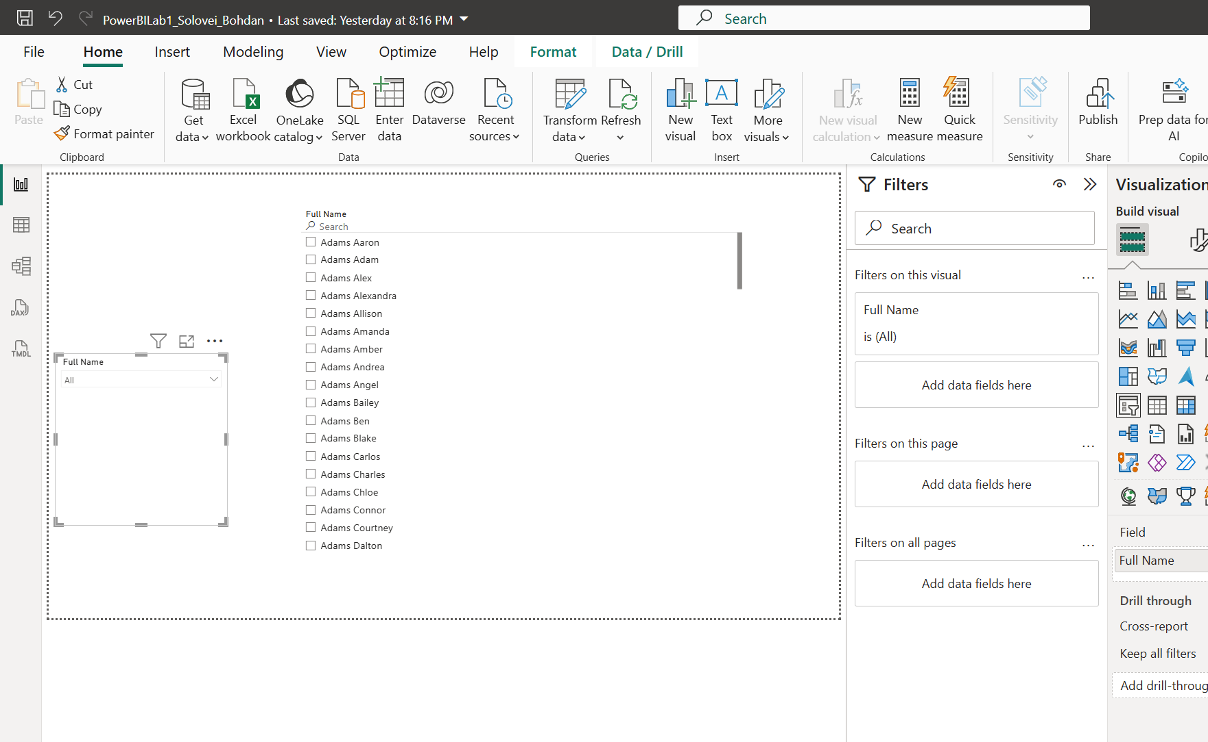

The report should have a header with report name and company logo.

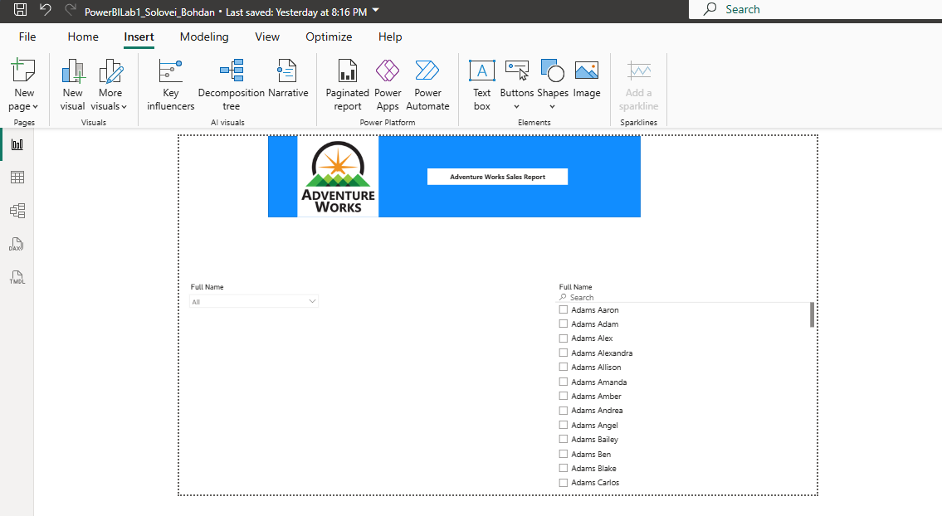

The report should contain 3 different types of Slicers (Filters) – drop-down, list box and date filter.
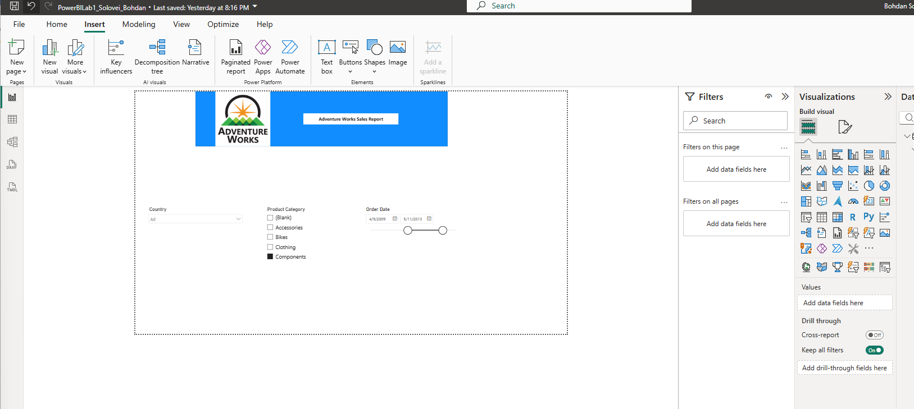

The report should contain at least 5 different visual types from standard list and at least 2 custom visuals. Explain the choice of custom visuals in the lab report.
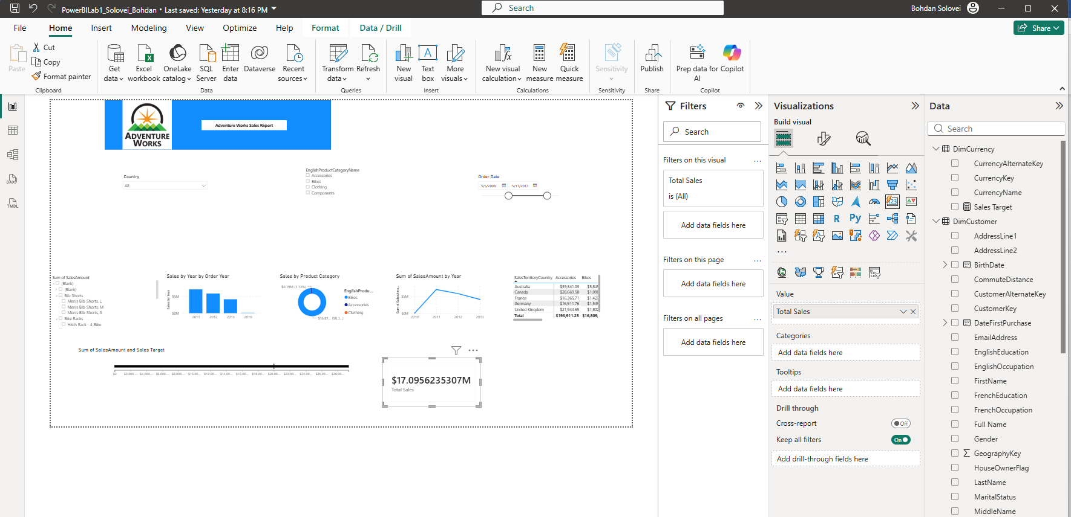

Creation of variable Sales Target = 20000000 using DAX measure
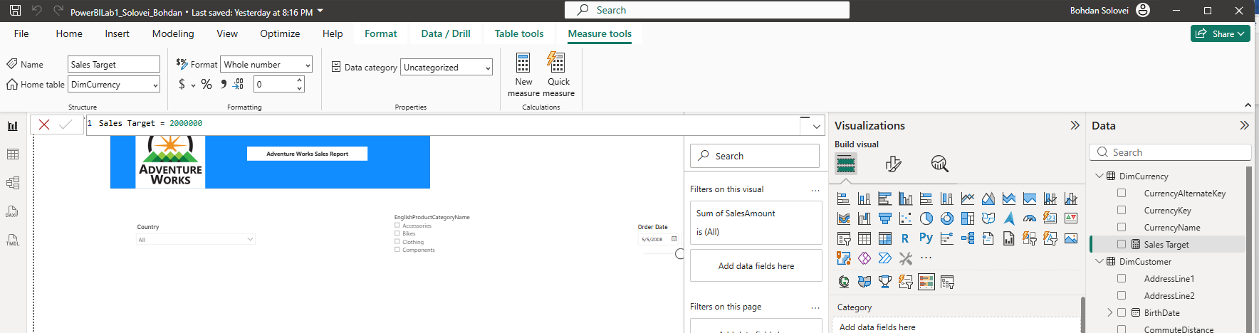
- Disable interactions between one of the slicers and one of the visuals in your report. Don’t forget to include description of this step into you word document.
Disabled interactions between Product Category slicer – EnglishProductCategoryName and Bullet Chart – Sum of SalesAmount and Sales Target
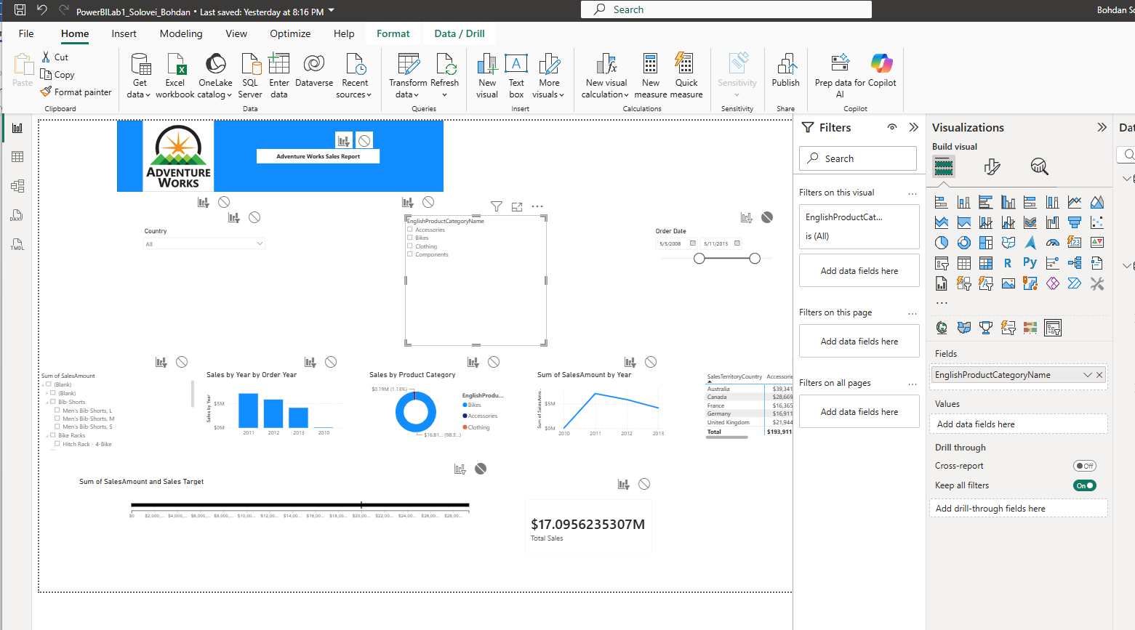

The report should be developed using a chosen color palette to be visually appealing – e.g., the colors of the bars and lines in the chart should correspond to the logo colors.
I’ve chosen the color blue for my visualization.
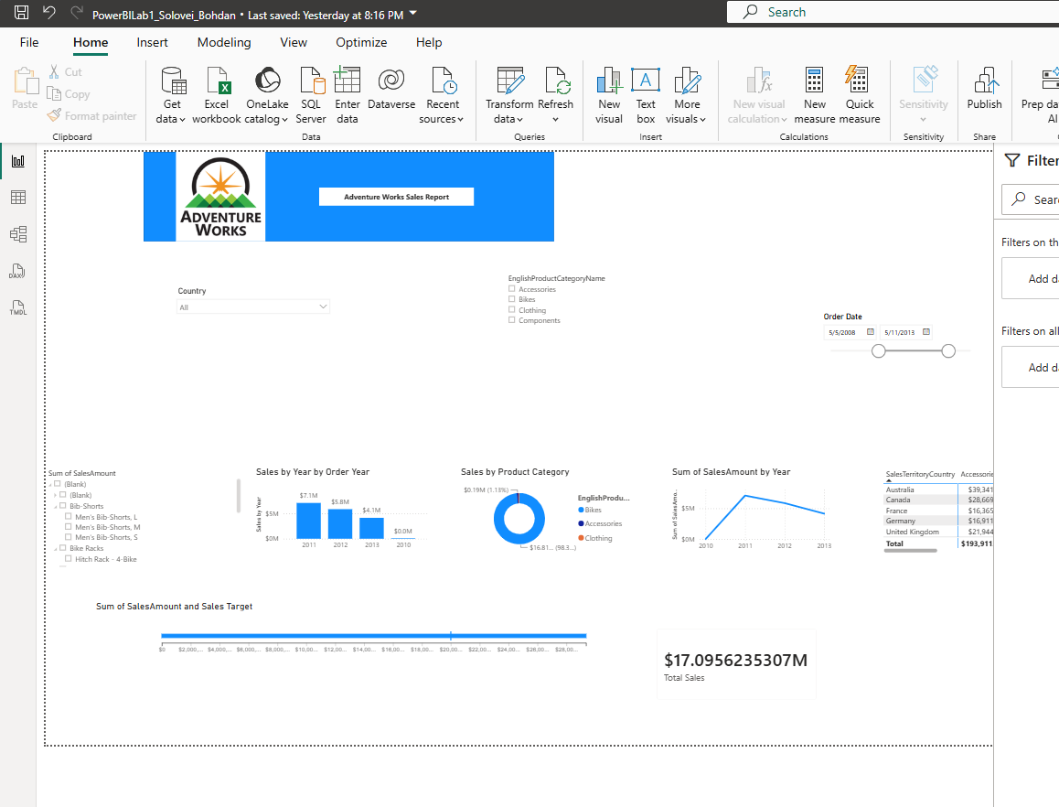

Add and configure a Map visual to the report. Add necessary tables from the AdventureWorks DWH if needed.
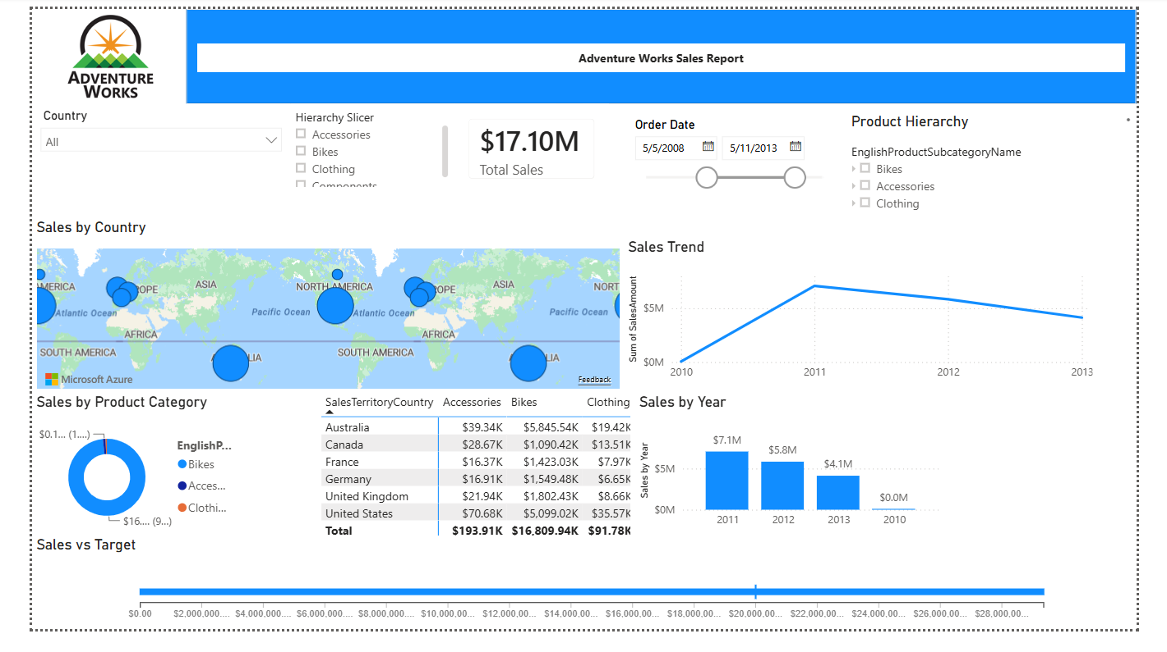

Configure mobile layout for your report.
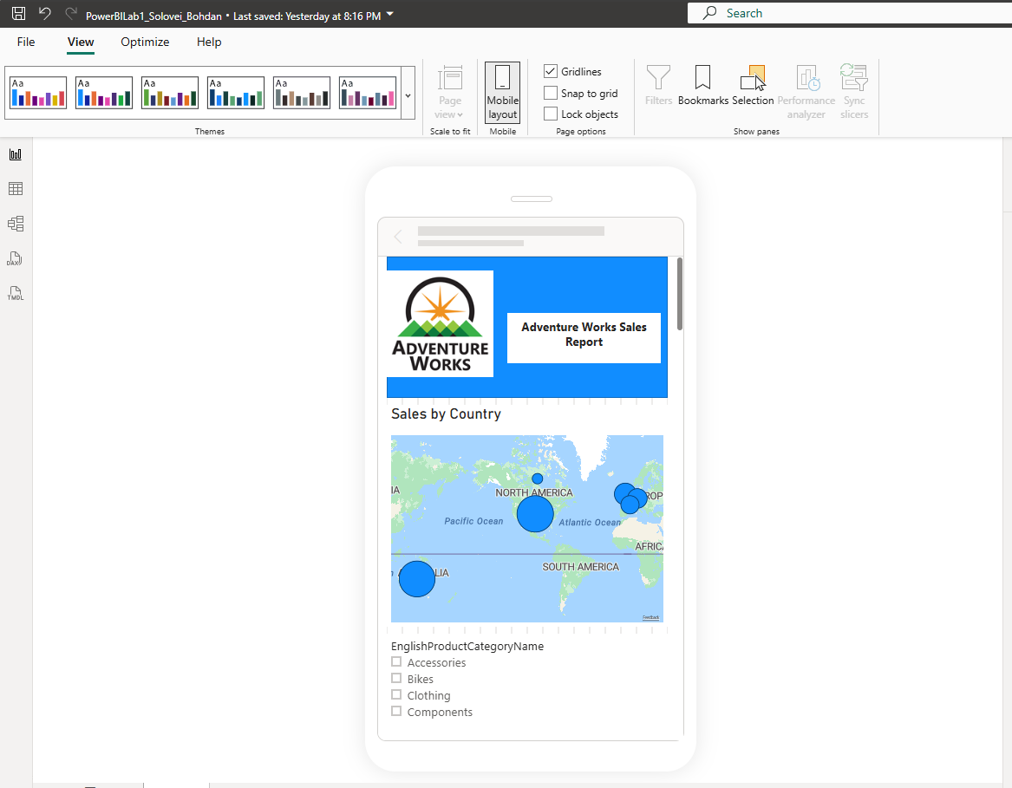

Publish the report to Power BI Service Portal and include the screenshot of published report into lab work results email.

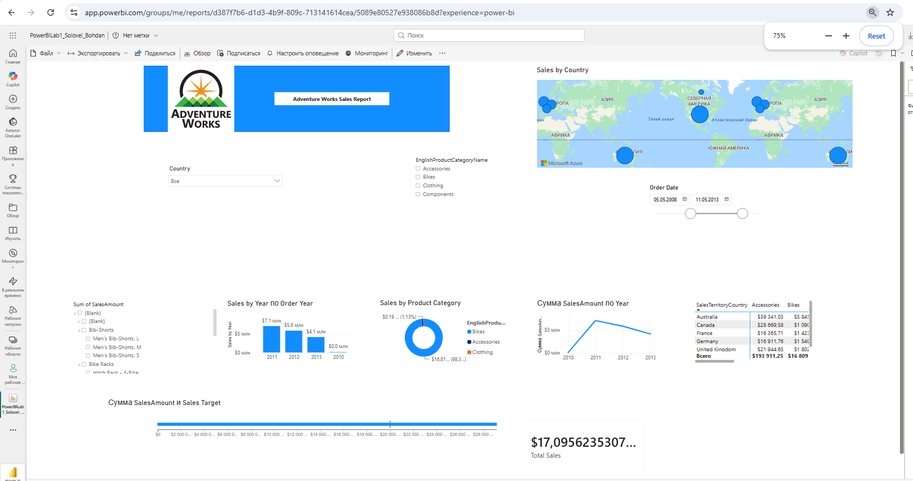

Install Personal Gateway and configure data refresh once a day and include the screenshot into lab work results email.
The Personal Gateway installed and configured.
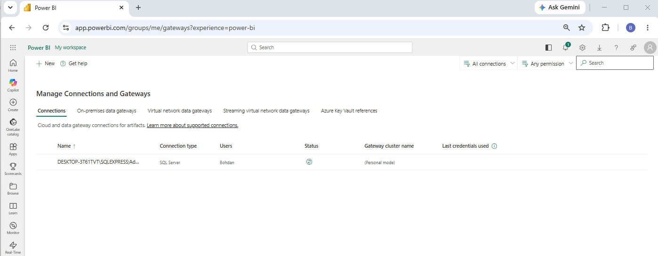
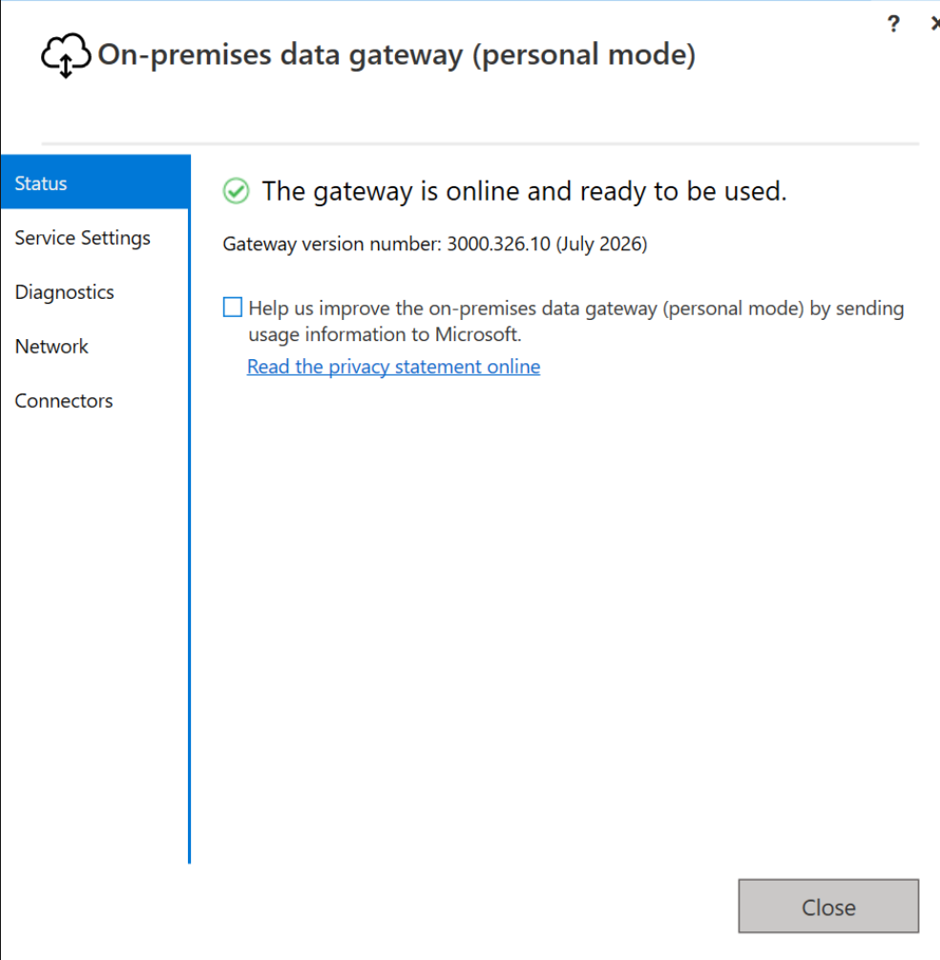
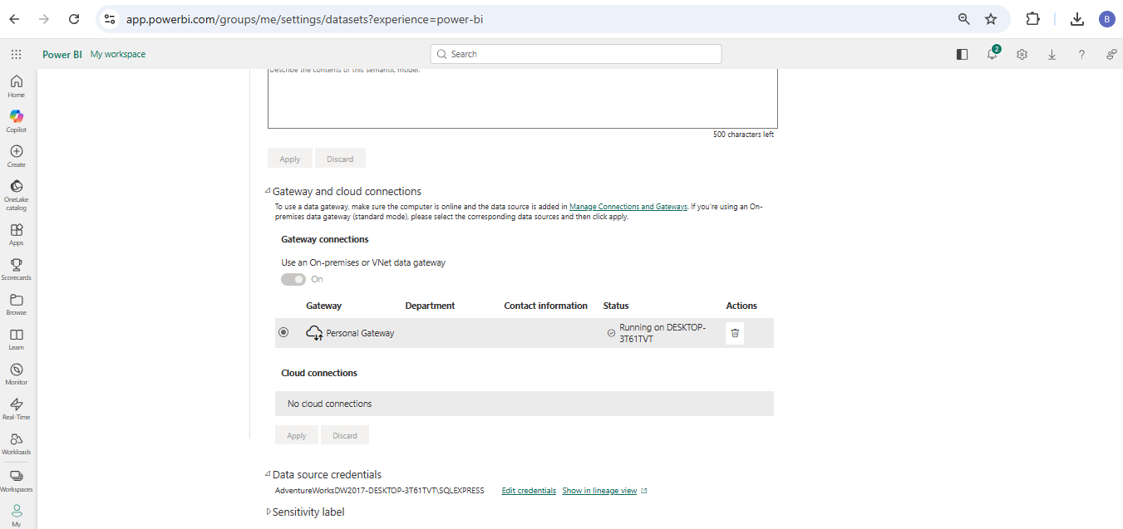
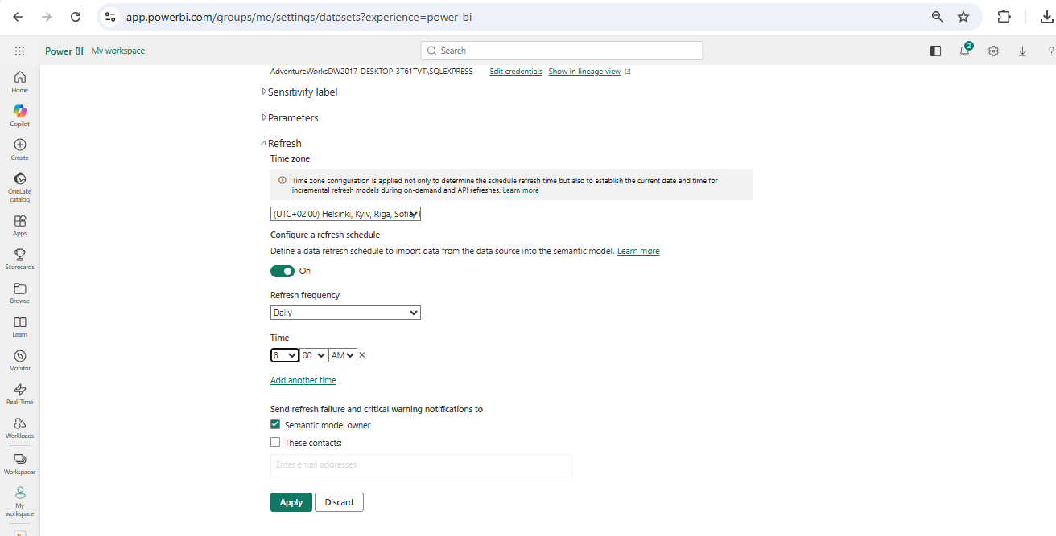
https://app.powerbi.com/groups/me/reports/d387f7b6-d1d3-4b9f-809c-713141614cea/5089e80527e938086b8d?experience=power-bi

Share the report with your mentor and send email notification to him/her.

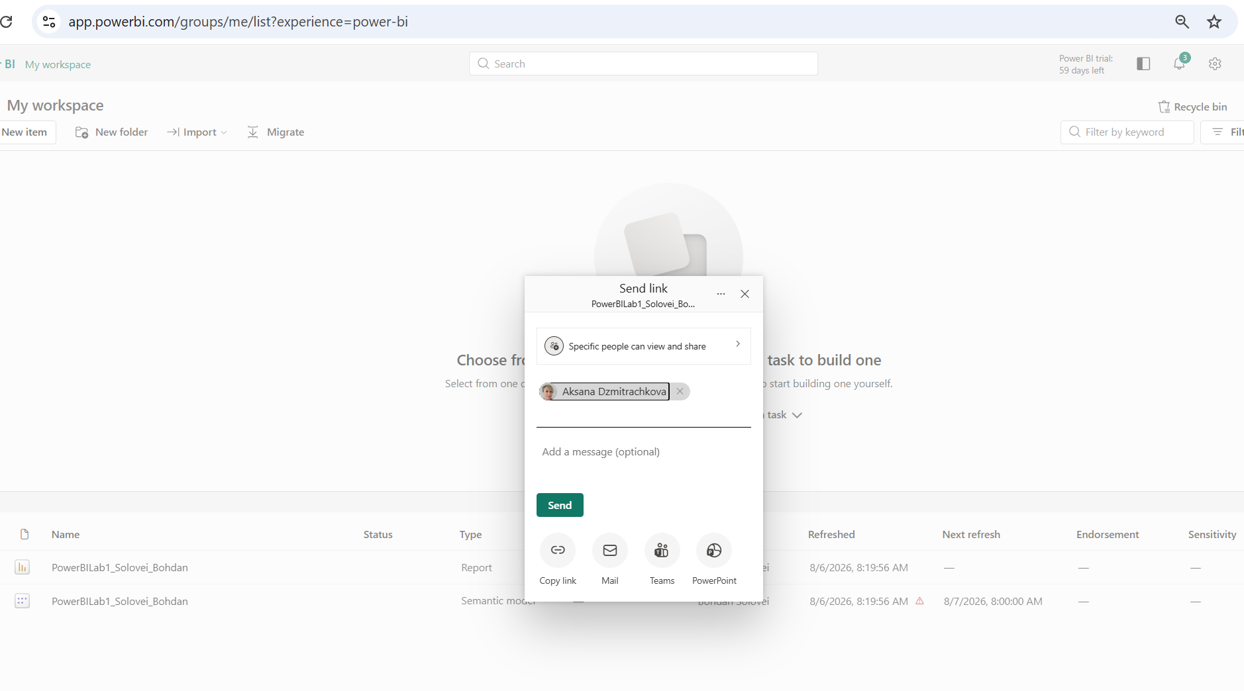

**Create and include into lab report the URL link that will have a built-in filter in it (e.g., the link will open the report filtered by one Country)
I have filtered by country Australia
