Creating simple DAX Expressions

Create a new report page and line chart
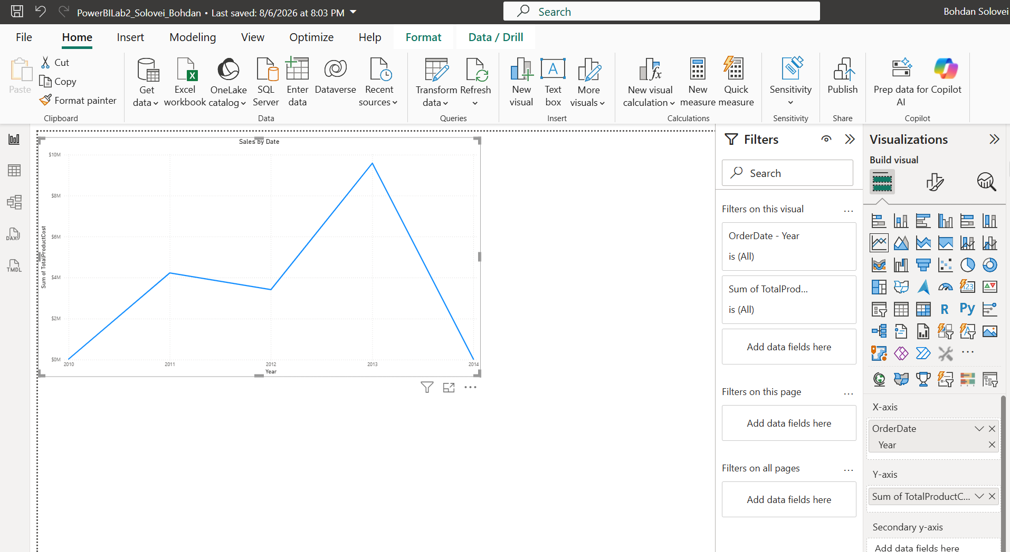
Replace the hierarchy with YearMonthLabel
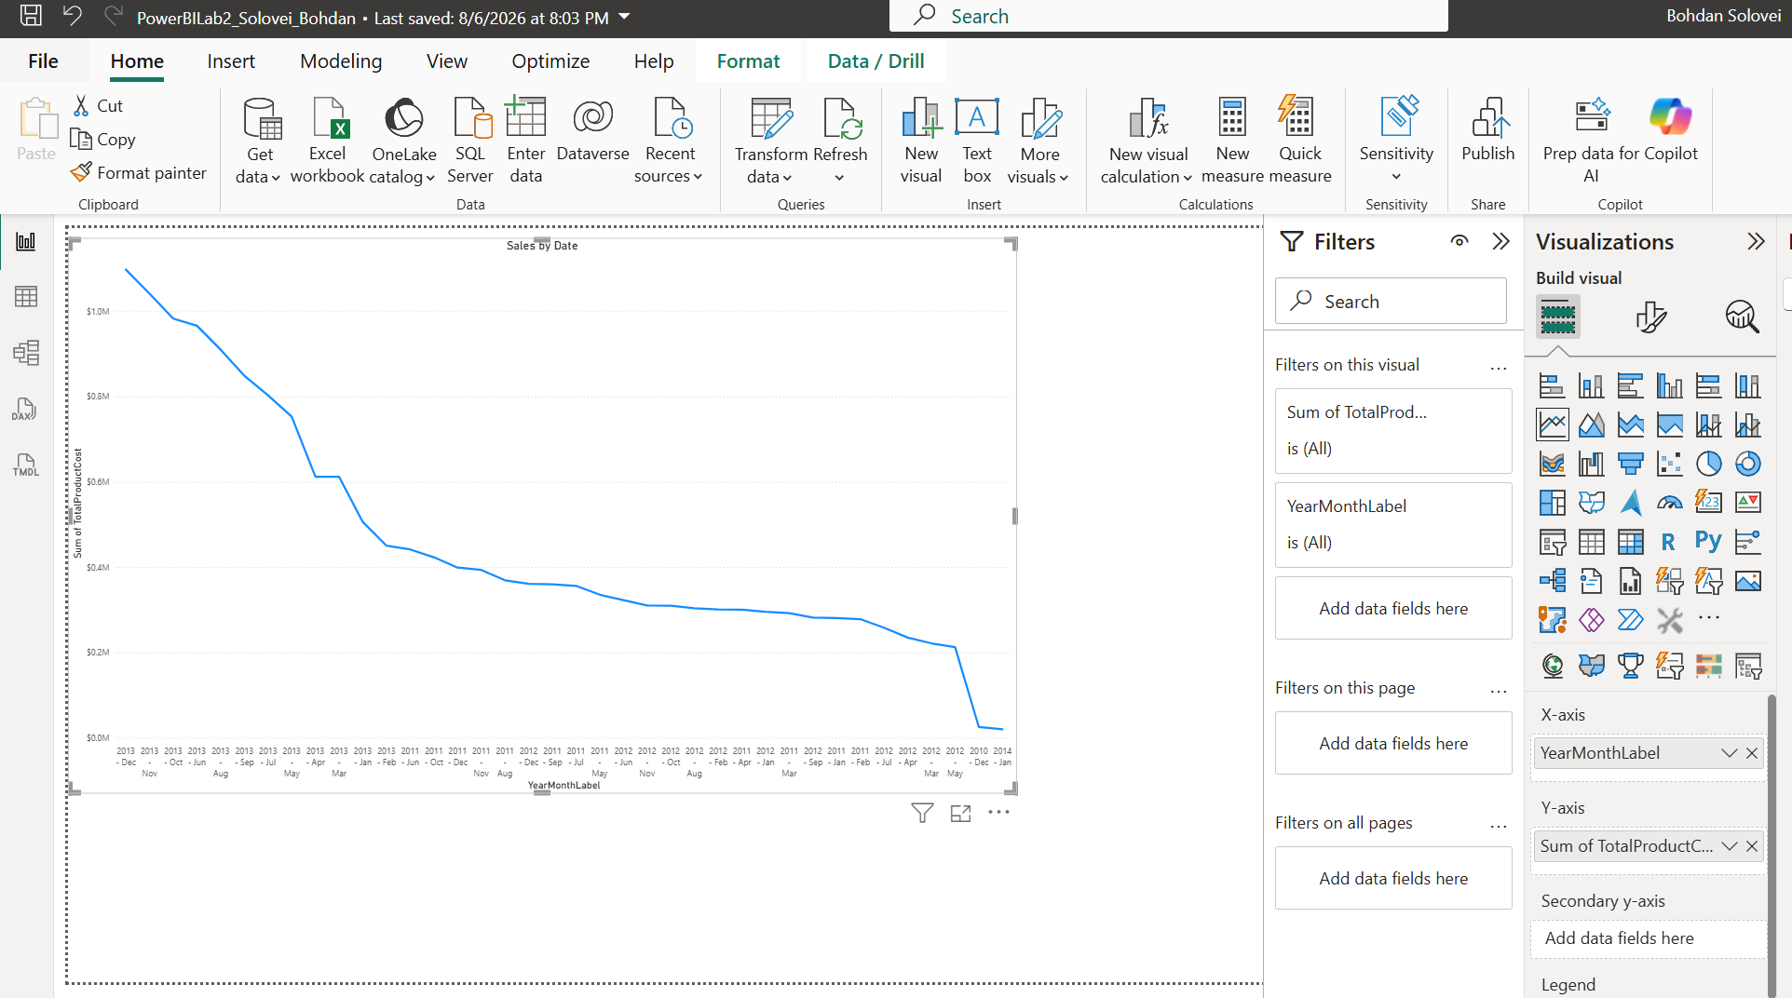
Filter the visual to 2013 onward
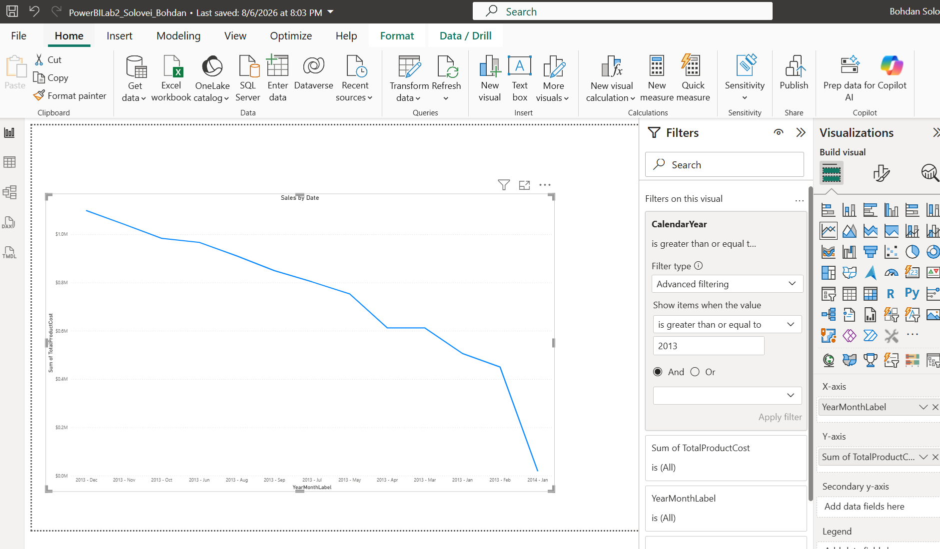
Sort the X-axis in the correct order
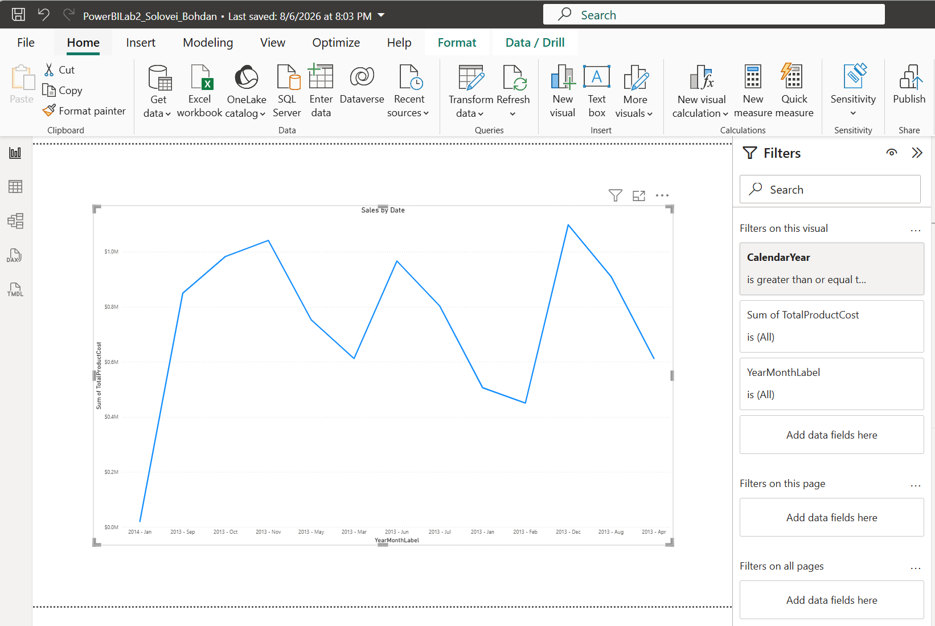

Measure

Display the date in the report. Add a Card visualization and add the Today Date measure to the fields list
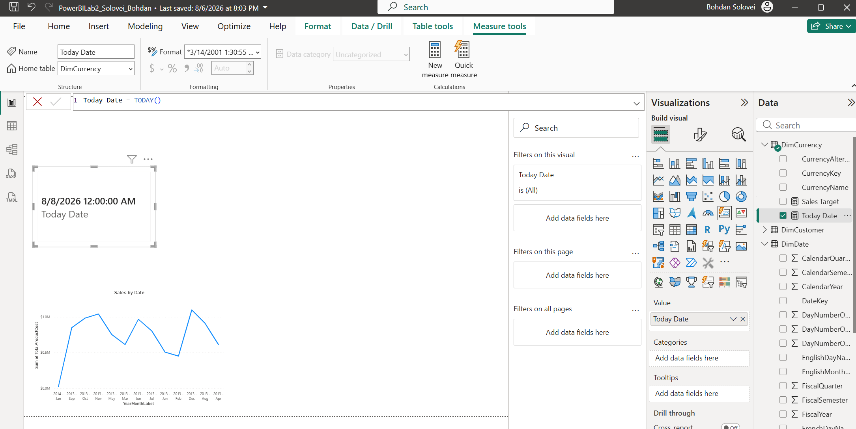
Put the today’s date as a footer in the report - just resize the card and move to the bottom right corner of your report:
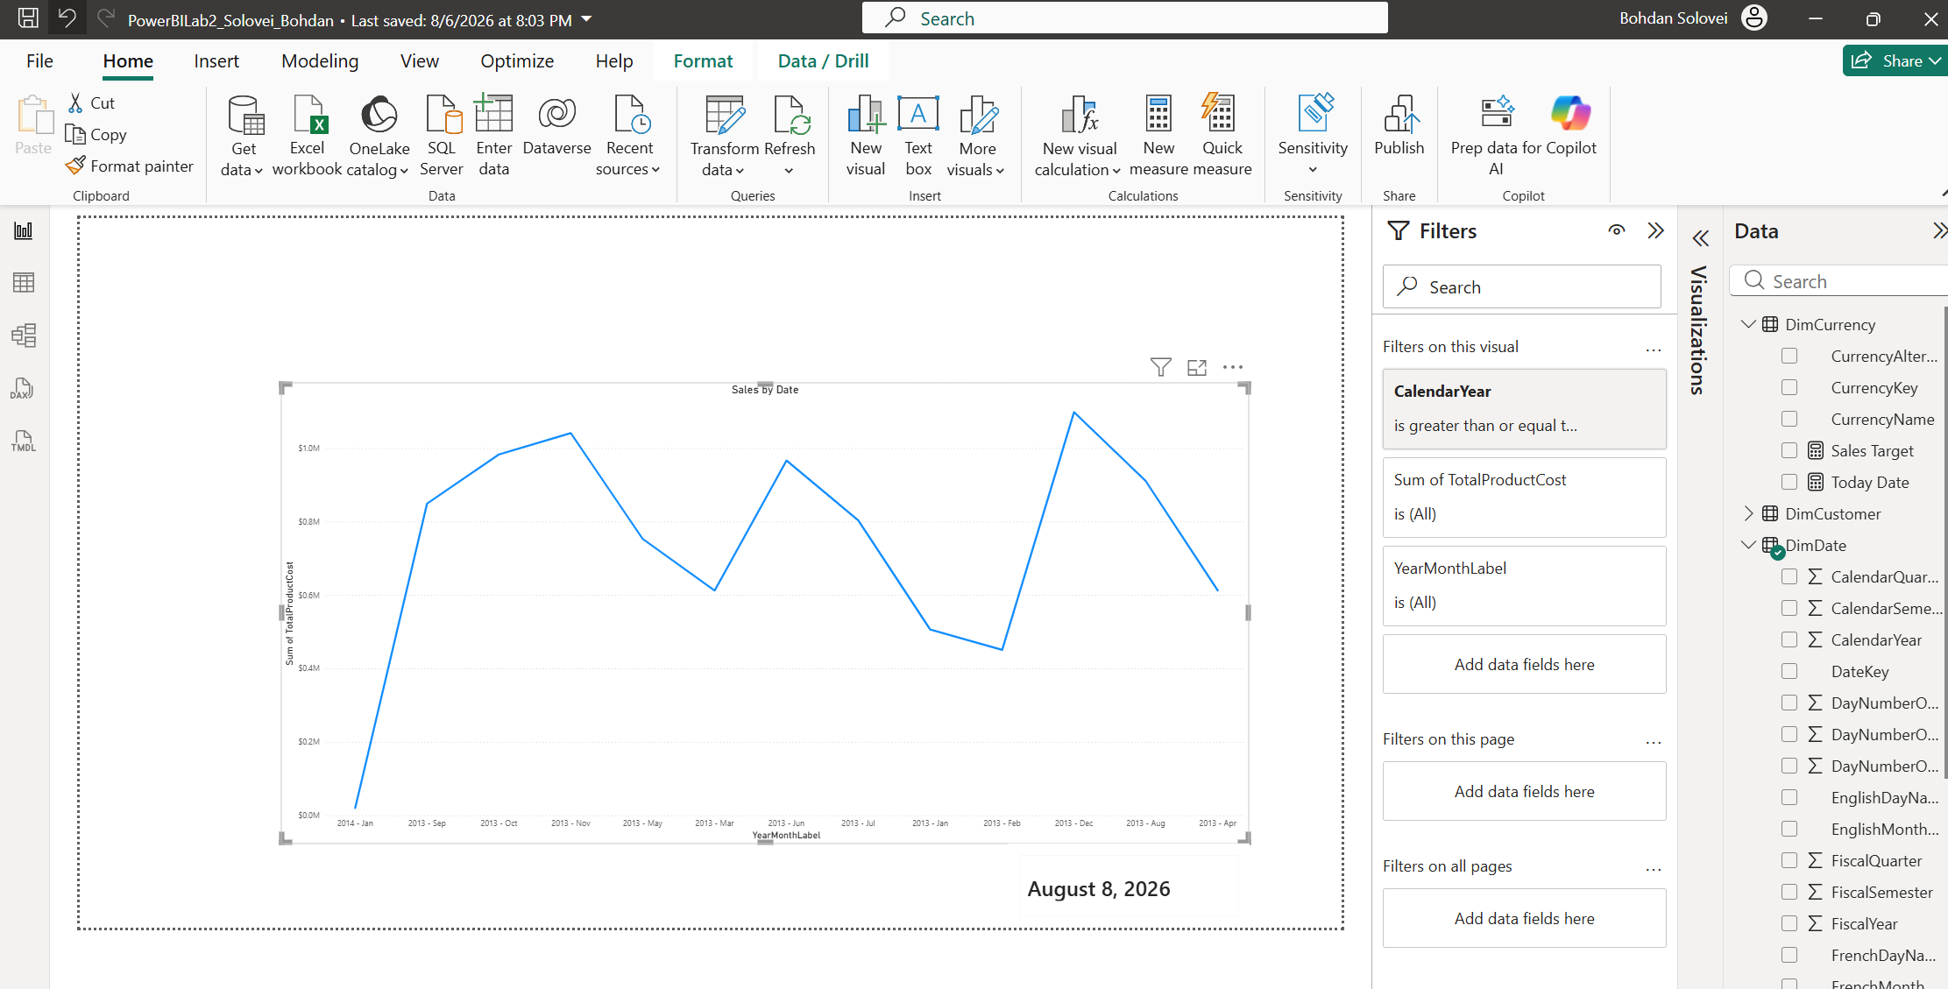
Add measure to the table. Order Quantity from the beginning of the year till the row date. When the new year starts, the calculation starts all over again
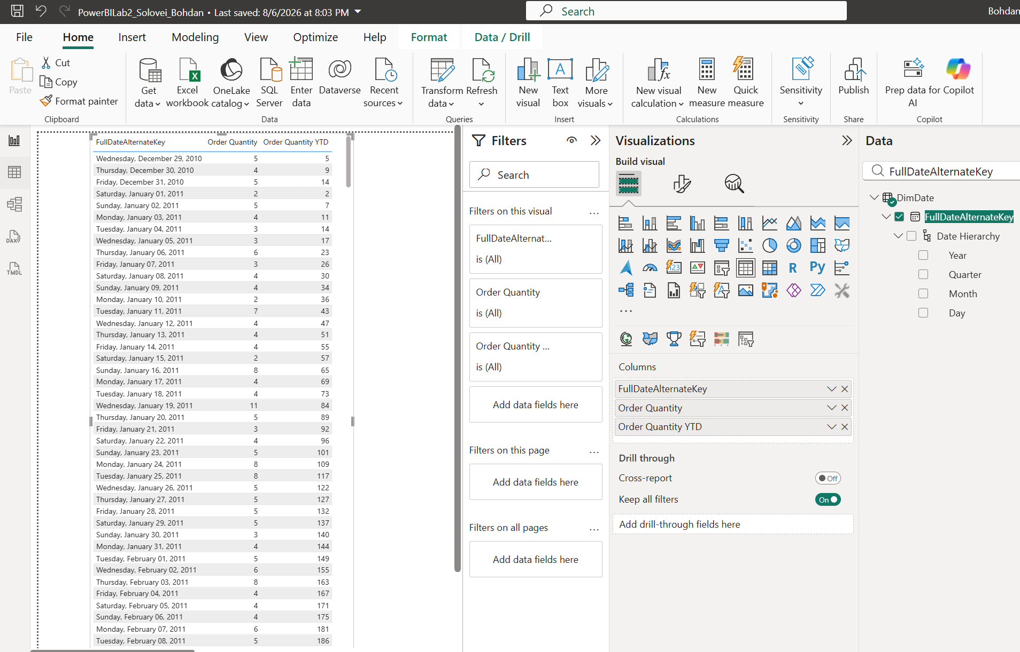

Create lab report
- Add ONE line chart the displays both Order Quantity YTD line and Order Quantity YTD for Previous Year. Create measures for these calculations using DAX.
- Add the same chart for Sales Amount.
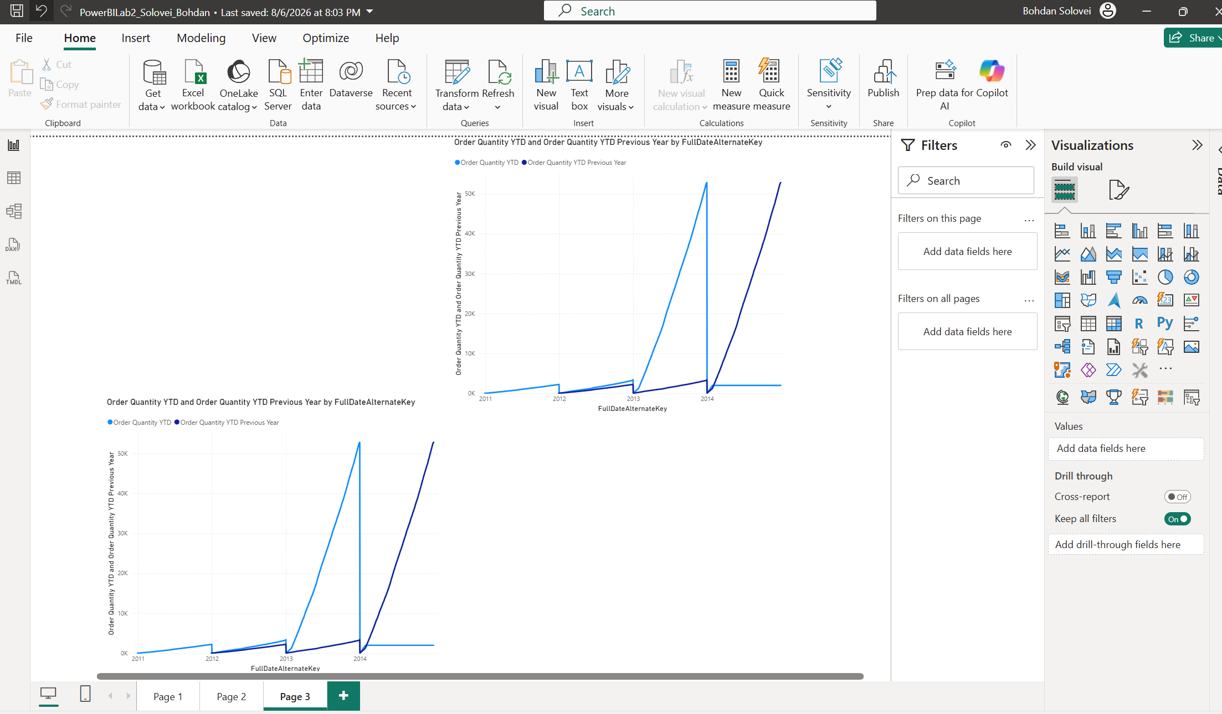
On top of the report display current username and current date in the format:
Welcome, [Current User]
Current Date is: [Current Date]

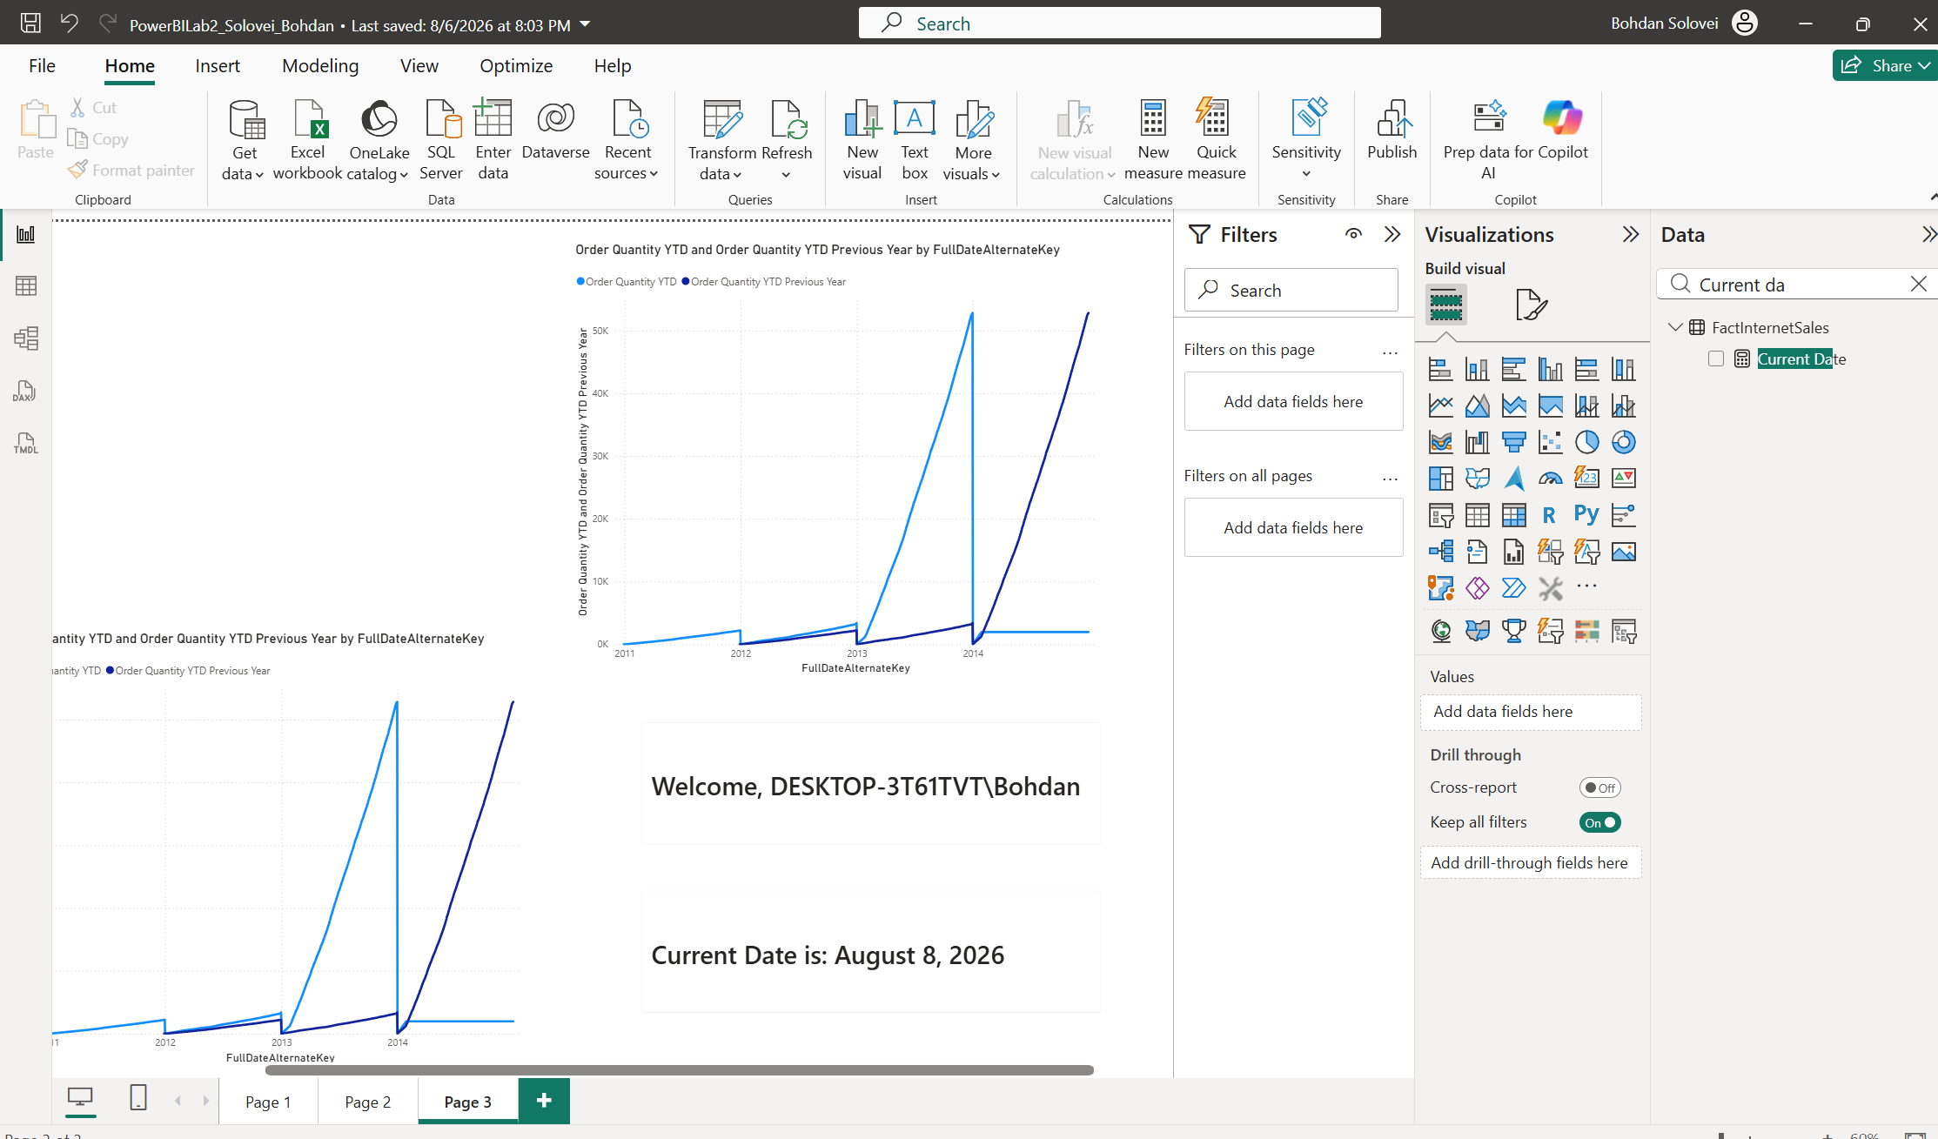
Add a table that shows Year-Month label that was created during lab work, Product Name, Color, Order Quantity and % of total Order quantity by Year Month Label and Color (see the screenshot below).

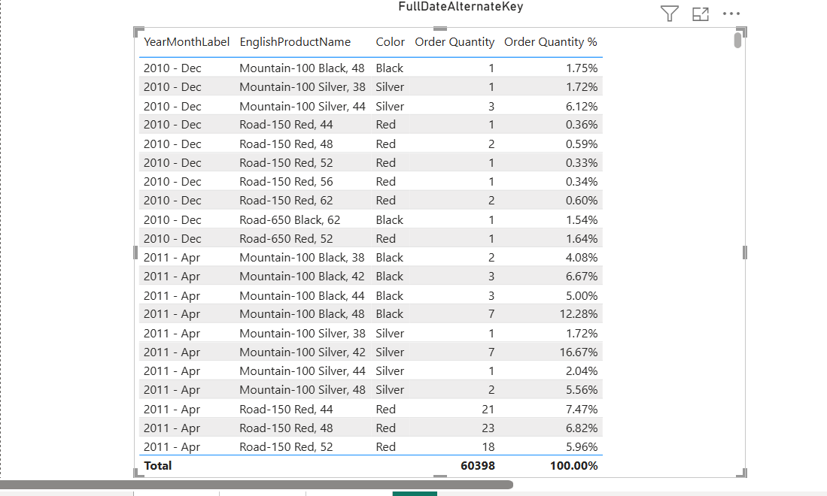
Create a DAX measure and use it in a chart that always shows Sales Amount for maximum OrderDate available. In Word file, explain why you chose this method of displaying information
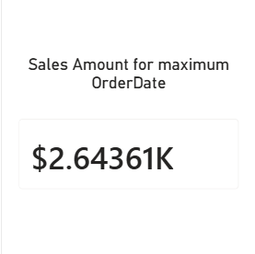
I used the Card because it shows “Sales Amount for the maximum OrderDate available.”
Create a DAX measure that shows the country with the highest sales in all years and display the result with a visual. In Word file, explain why you chose this method of displaying information.
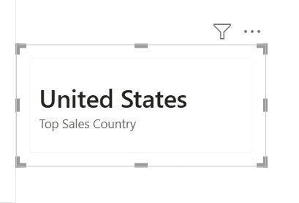
Top Sales Country =
VAR CountryTable =
TOPN (
1,
SUMMARIZE (
DimSalesTerritory,
DimSalesTerritory[SalesTerritoryCountry],
"TotalSales", SUM ( FactInternetSales[SalesAmount] )
),
[TotalSales],
DESC
)
RETURN
MAXX (
CountryTable,
DimSalesTerritory[SalesTerritoryCountry]
)

The TOPN function was used because the task requires identifying the country with the maximum Sales Amount across all available years. SUMMARIZE creates a temporary table containing countries and their total sales, while TOPN(1) selects the row with the highest sales value. MAXX is then used to return the country name as a scalar value that can be displayed in a Card visual.

Use DAX to calculate the ranks of ProductCategory by Sales Amount. In Word file, explain why you chose this particular way to get the result.

Product Category Rank =
IF (
ISINSCOPE ( FactInternetSales[EnglishProductCategoryName] ),
RANKX (
ALL ( FactInternetSales[EnglishProductCategoryName] ),
[Sales Amount],
,
DESC,
DENSE
)
)

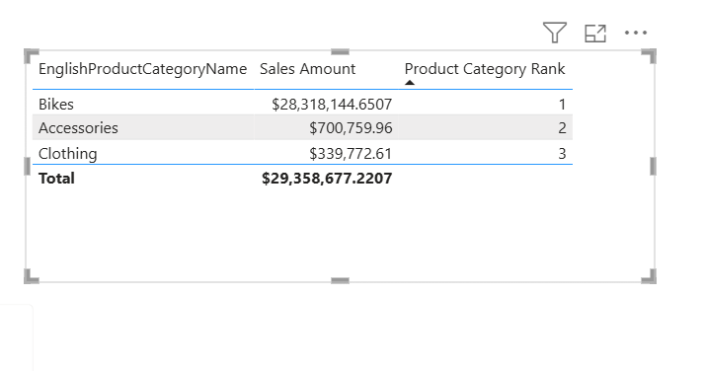
To rank product categories by Sales Amount, the RANKX function was used.
RANKX evaluates the Sales Amount for each product category and assigns a rank according to the result. The ALL function removes the current category filter so that the current category can be compared with all other categories in the dataset.
The DESC parameter specifies descending order, therefore the category with the highest Sales Amount receives rank 1.
The DENSE option is used so that equal Sales Amount values receive the same rank without creating gaps in the following rank numbers.
ISINSCOPE is added to display the rank only for individual product categories and to avoid showing an unnecessary rank in the Total row.

