Configure RLS based on a chosen security pattern. Give short description of your security groups and make screenshots of how it was configured in Power BI Desktop and Power BI Online Service.

Row-Level Security (RLS) was configured to restrict access to sales data according to the user's assigned security role.
A security role named USA_Sales was created in Power BI Desktop. The role applies a filter to the SalesTerritoryCountry attribute of the DimSalesTerritory table:
SalesTerritoryCountry = "United States"

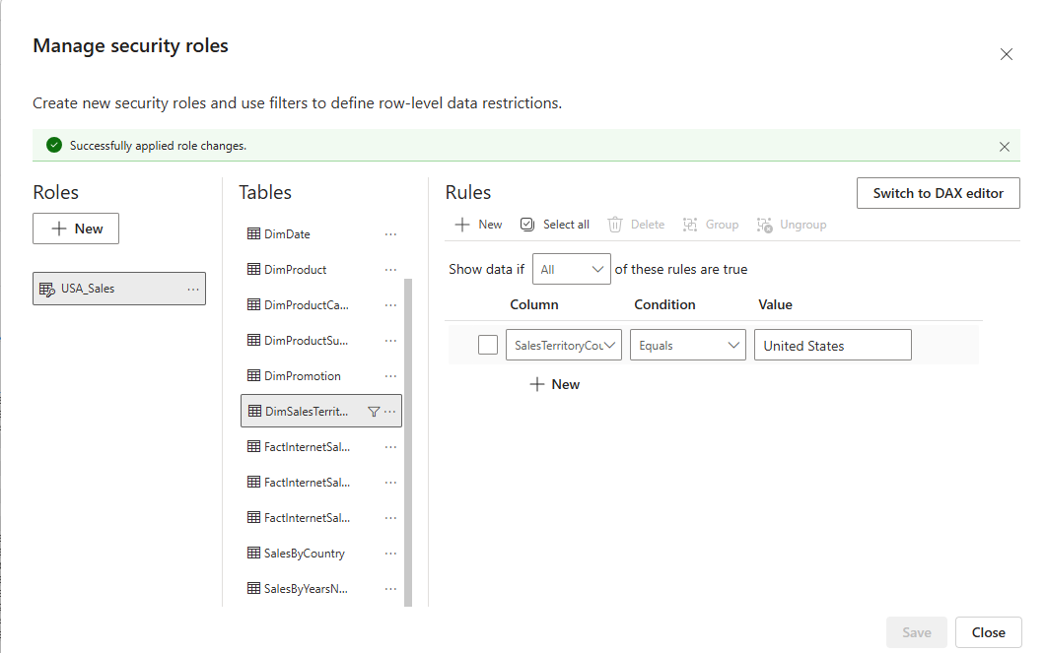

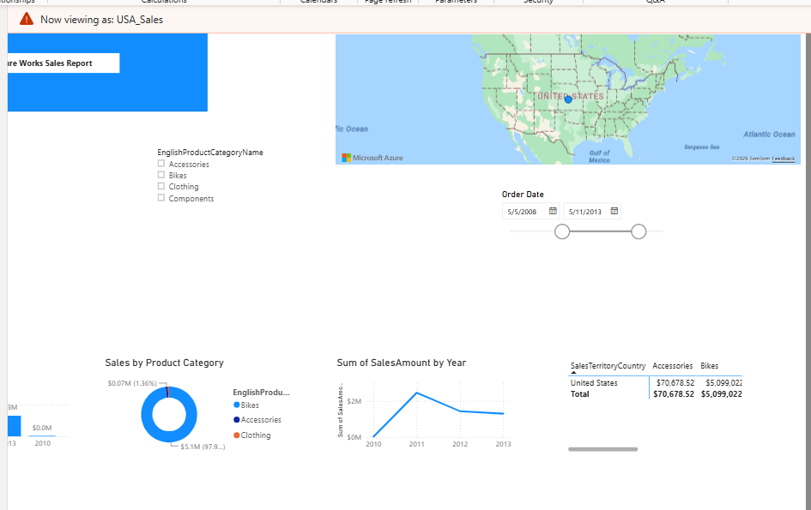
The configuration was tested in Power BI Desktop using the View as functionality. When the USA_Sales role was selected, the report was automatically filtered and only data available to this role was displayed.

Using bookmarks and buttons create a functionality to switch between bar chart and a map visual that are positioned in the same area. Give short description of you work.
Two visuals were created: a bar chart displaying Sales Amount by country and a map displaying the geographical distribution of Sales Amount. Both visuals were positioned in the same area of the report.
The Selection pane was used to control the visibility of the visuals. Two bookmarks, Bar Chart and Map, were created. The Bar Chart bookmark stores the state in which the bar chart is visible and the map is hidden, while the Map bookmark stores the opposite state.

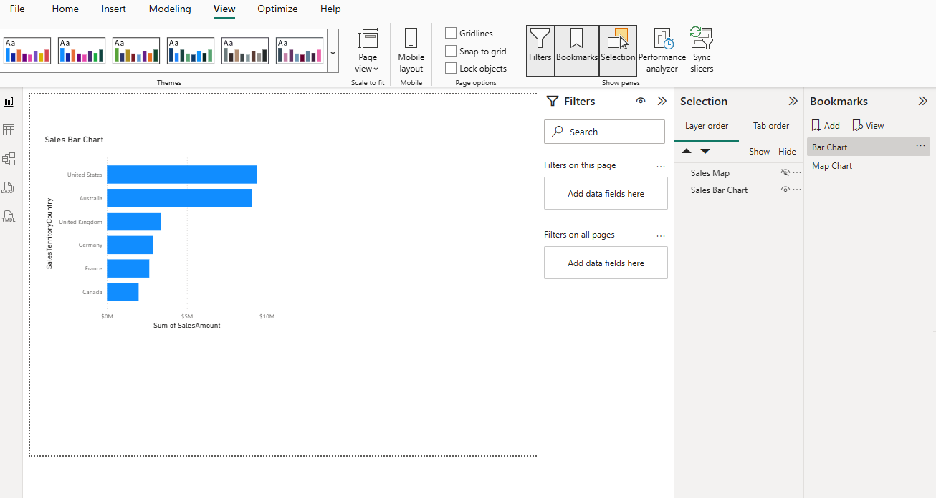
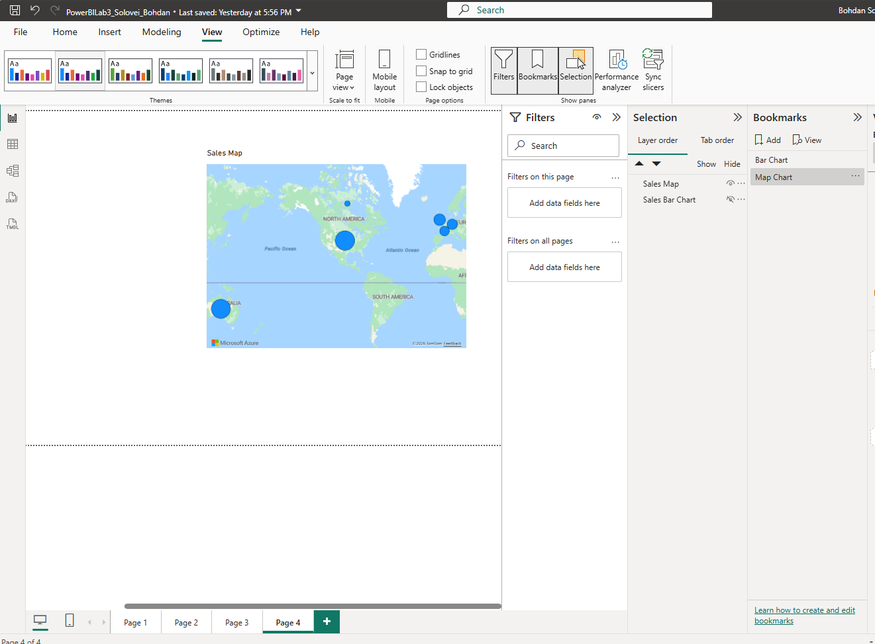
Two buttons were added and connected to the corresponding bookmarks using the Bookmark action. As a result, the user can switch between the bar chart and map.

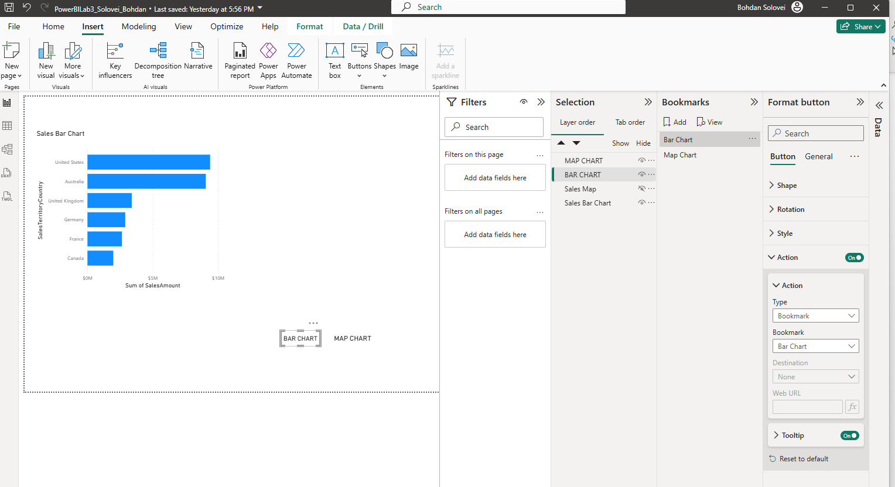
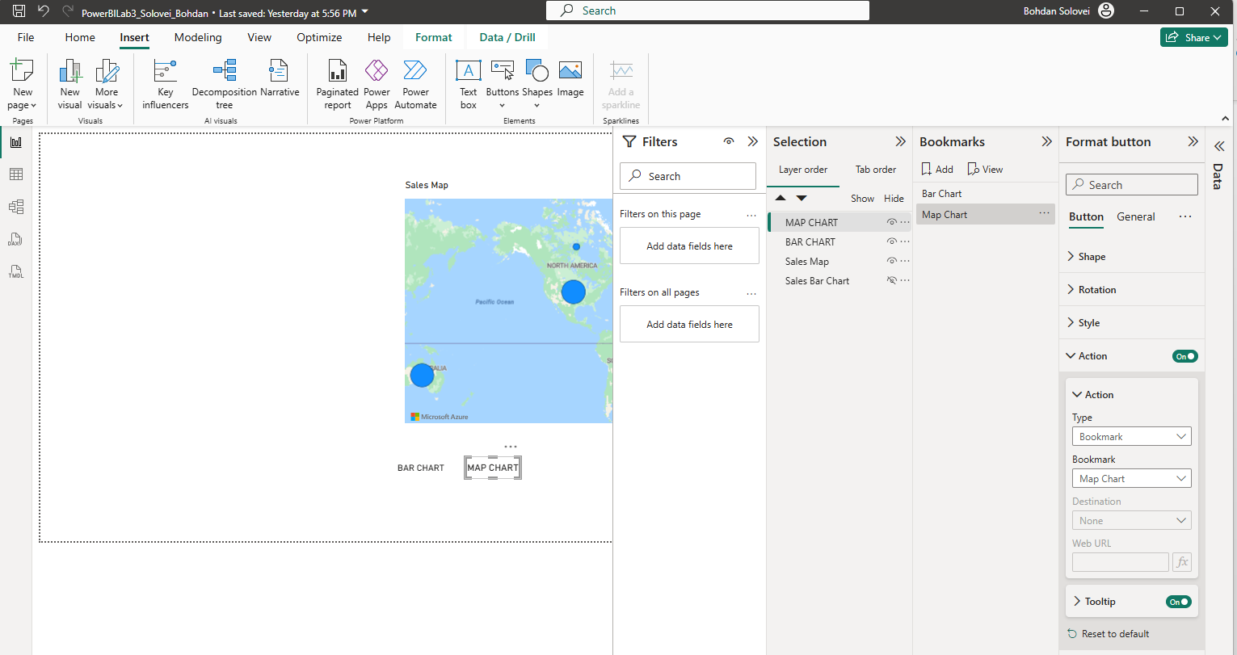

On the page with YTD calculation created in previous lab work, add the possibility to switch between MTD, QTD and YTD views for the user. You can use different ways of implementation, so add a description of the method you used and specify why you choose this logic.
To provide users with the ability to dynamically switch between Month-to-Date (MTD), Quarter-to-Date (QTD), and Year-to-Date (YTD) calculations, three DAX measures were created using the TOTALMTD, TOTALQTD, and TOTALYTD functions.
A Field Parameter named Time Period was then created containing the MTD, QTD, and YTD measures. The parameter was added to the existing time-based visual and was also presented to the user as a slicer.
As a result, the user can select MTD, QTD, or YTD and dynamically change the calculation displayed by the same visual without navigating to another report page or using multiple duplicate charts.
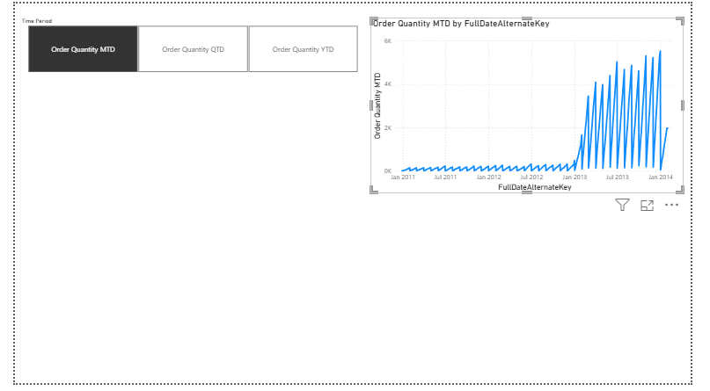
Order Quantity MTD =
CALCULATE (
[Order Quantity],
DATESMTD ( DimDate[FullDateAlternateKey] )
)

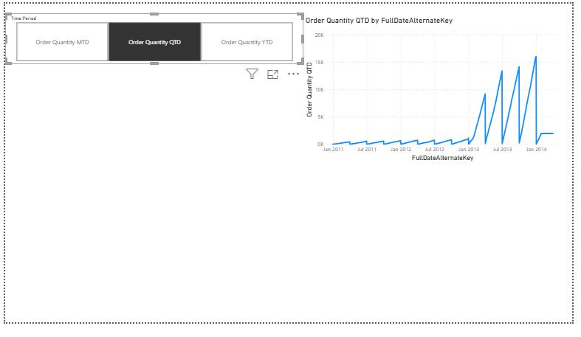
Order Quantity QTD =
CALCULATE (
[Order Quantity],
DATESQTD ( DimDate[FullDateAlternateKey] )
)

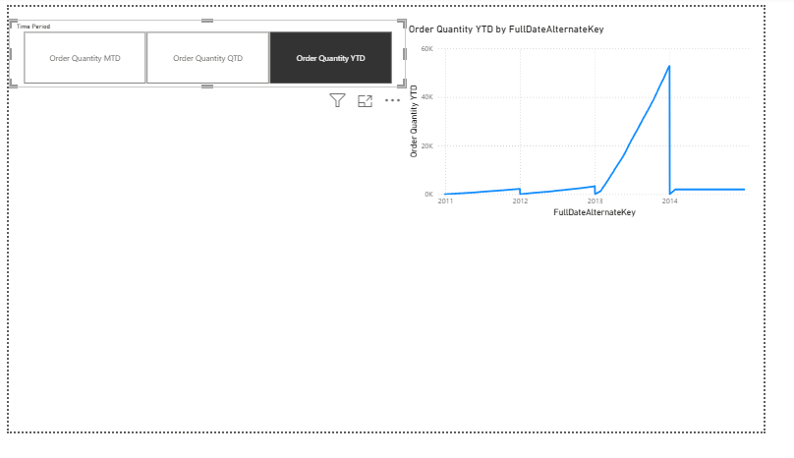
Order Quantity YTD =
CALCULATE (
[Order Quantity],
DATESYTD ( DimDate[FullDateAlternateKey] )
)

Create a decomposition tree visual with at least 3 independent variables. Give short description of you work.
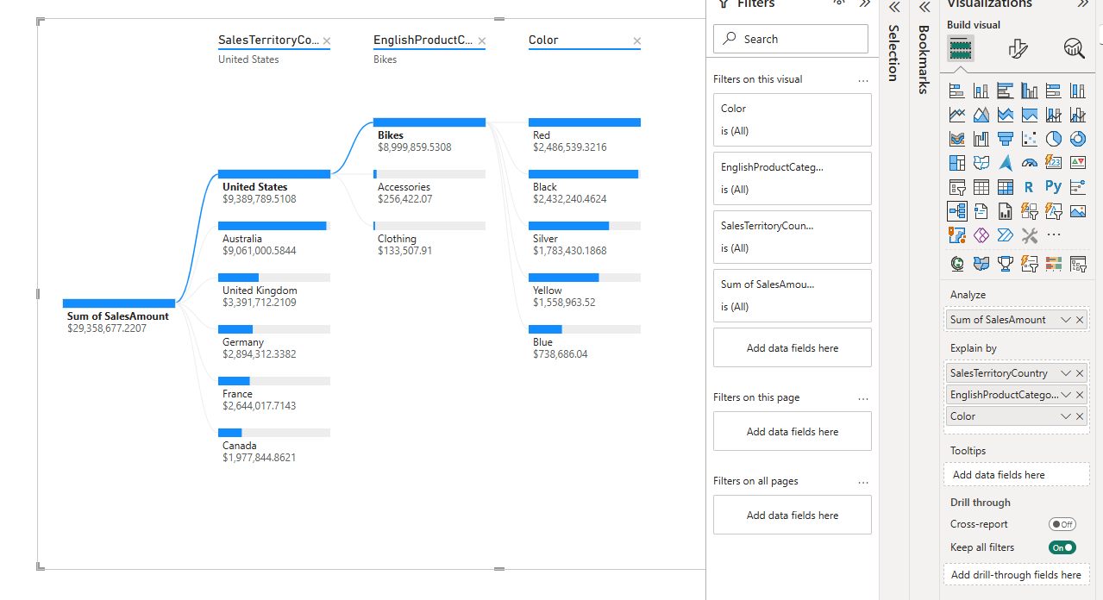

Three variables were added to the Explain by section: SalesTerritoryCountry, EnglishProductCategoryName, and Color. These variables allow sales results to be decomposed according to geographical and product-related characteristics.
The tree can be used to navigate from the total Sales Amount to a particular country, then to a product category, and finally to individual product colors.

Add a tooltip for the selected visual. Give short description of you work.

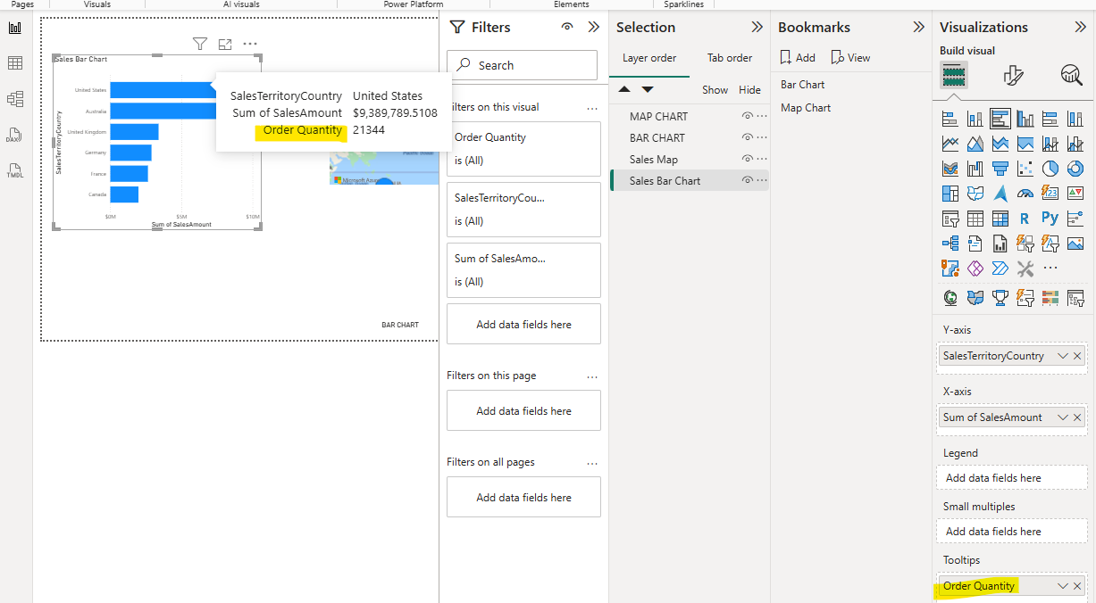
A tooltip was added to the Sales by Country bar chart to provide additional information without adding more elements to the report page. The Order Quantity measure was added to the Tooltips field of the visual.
When the user hovers over a country in the bar chart, Power BI displays the Sales Amount together with the corresponding Order Quantity for that country.

*Try to create Custom visual in Power BI Desktop. Add description of the method you choosed and explain what the usage of your visual is and what opportunities the visual you created gives you in comparison with the default visuals.
A Word Cloud custom visual was added to the report using Microsoft AppSource. The EnglishProductName field was used as the Category and SalesAmount was used as the Value.
The visual represents product-related terms using different font sizes according to their associated Sales Amount.
Words such as Road, Mountain, Black, Silver, 200 appeared separately because they contribute separately.
Terms associated with higher sales values are displayed bigger, which allows the user to quickly identify frequently occurring and commercially significant product characteristics.
