AWS Cloud for Data Engineering
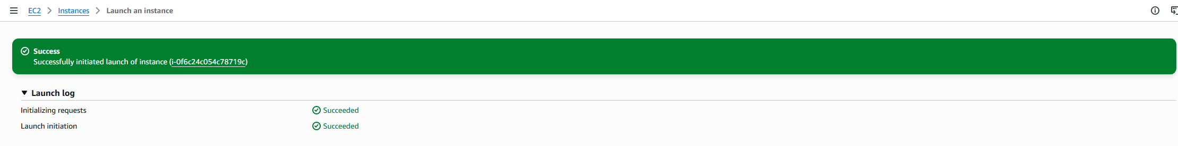
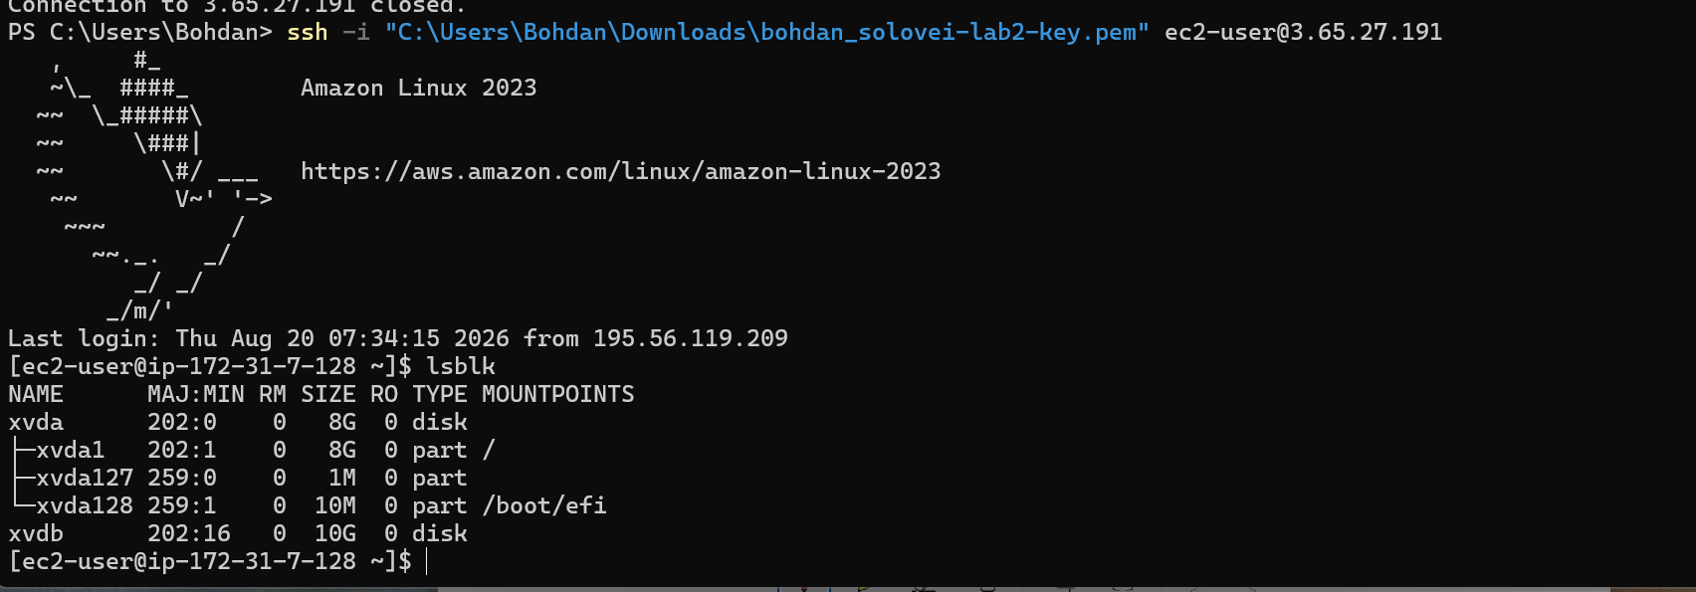
Fig.1. Launch of the Amazon EC2 instance and SSH connection to the Amazon Linux 2023 server; attached storage devices are verified using the lsblk command.

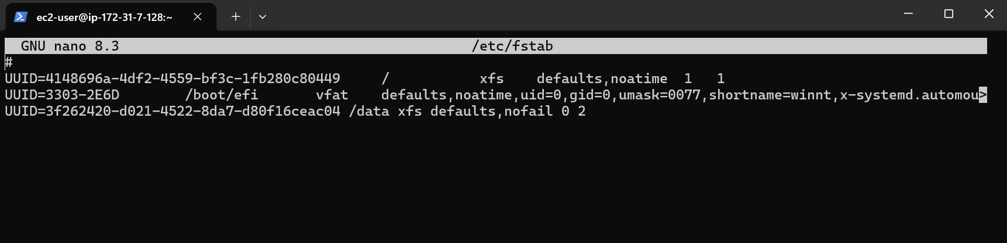
Fig.2. Configuration of the additional EBS volume for automatic mounting at the /data directory using the /etc/fstab file.

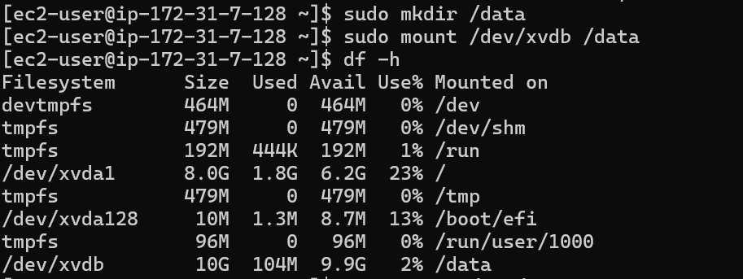
Fig.3. Creation of the /data directory and successful mounting of the additional EBS volume on the EC2 instance.

- 1.b Install Oracle/ or PostgreSQL/ or MySQL on the EC2.

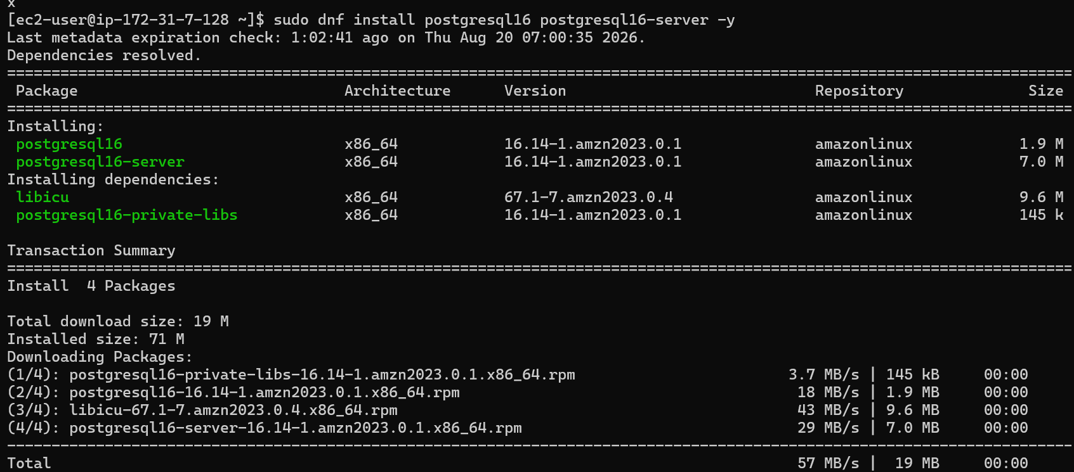
Fig.4. Installation of PostgreSQL 16 and PostgreSQL server packages on the Amazon EC2 instance.
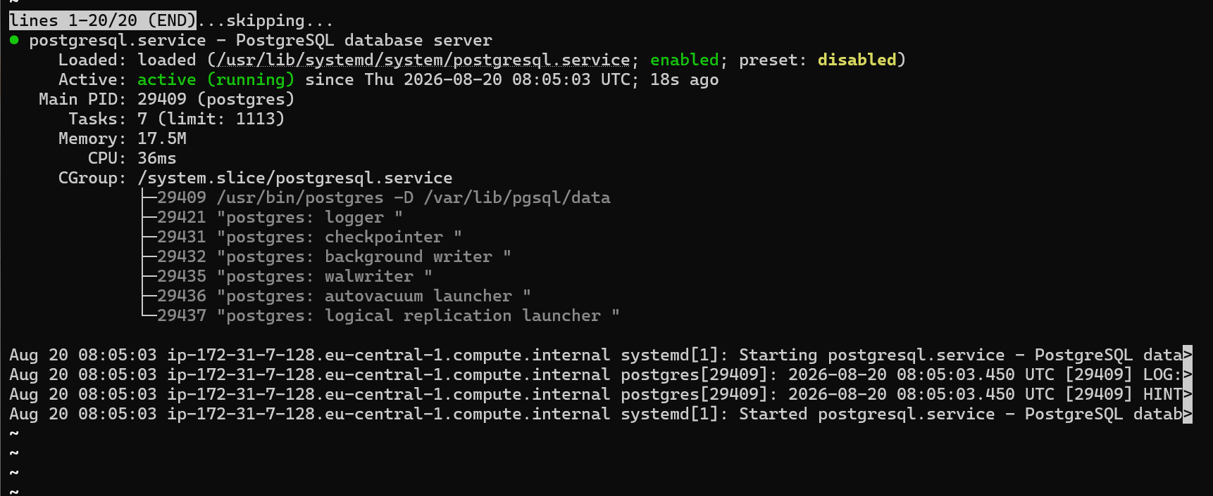
Fig. 5. PostgreSQL service status showing that the database server is active and running.
- 1.c Connect to this database from any SQL client (e.g. DBeaver - very useful IDE because of community edition and possibility to work with almost all most famous databases).

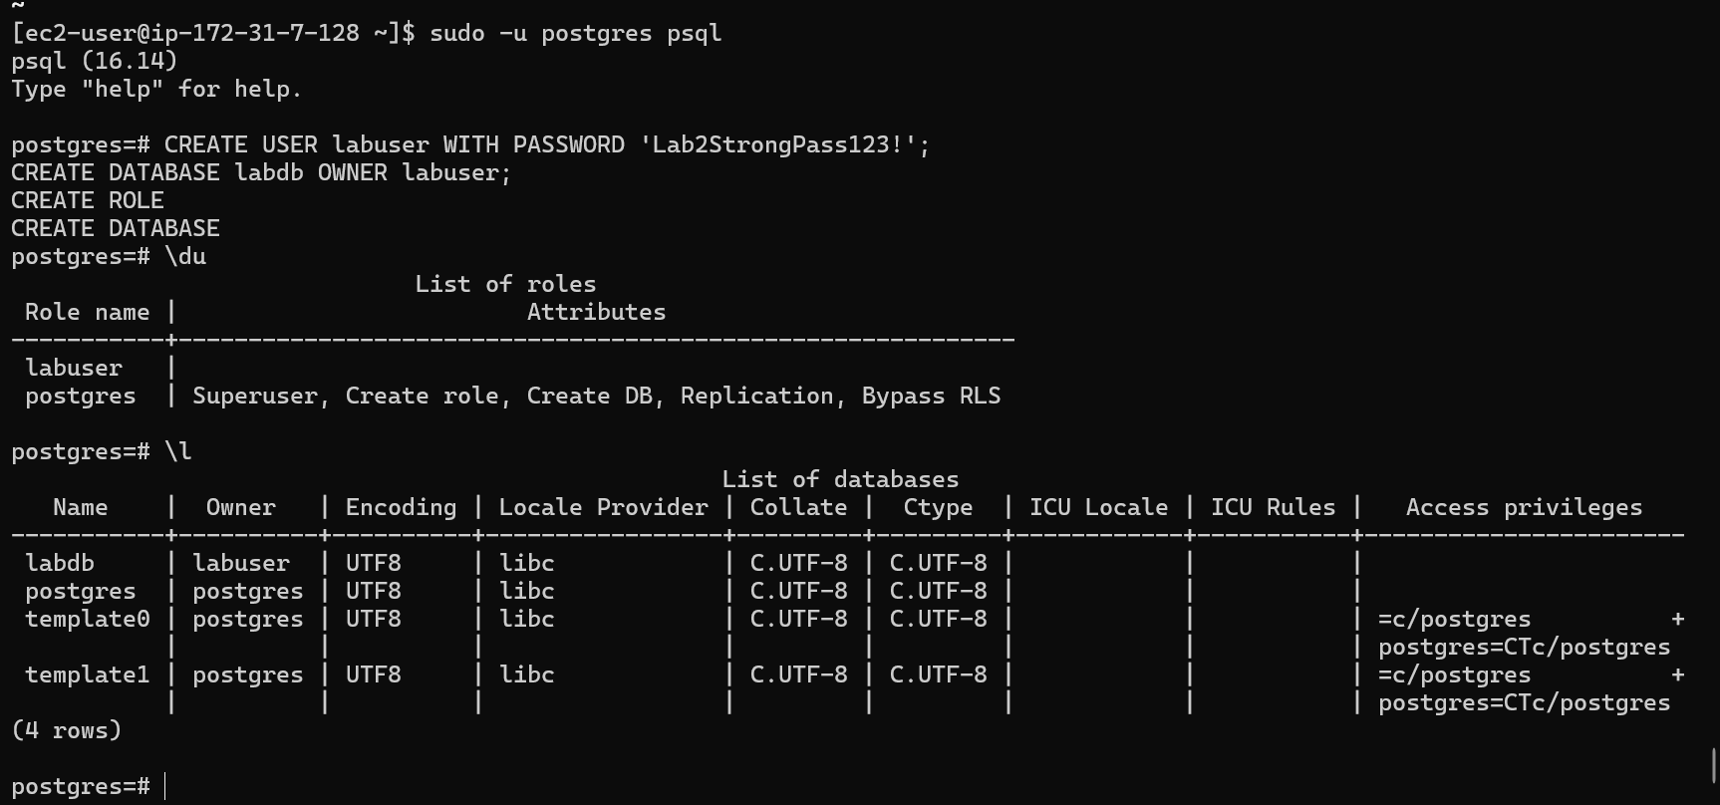
Fig.6. Creation of the labuser PostgreSQL user and the labdb database.

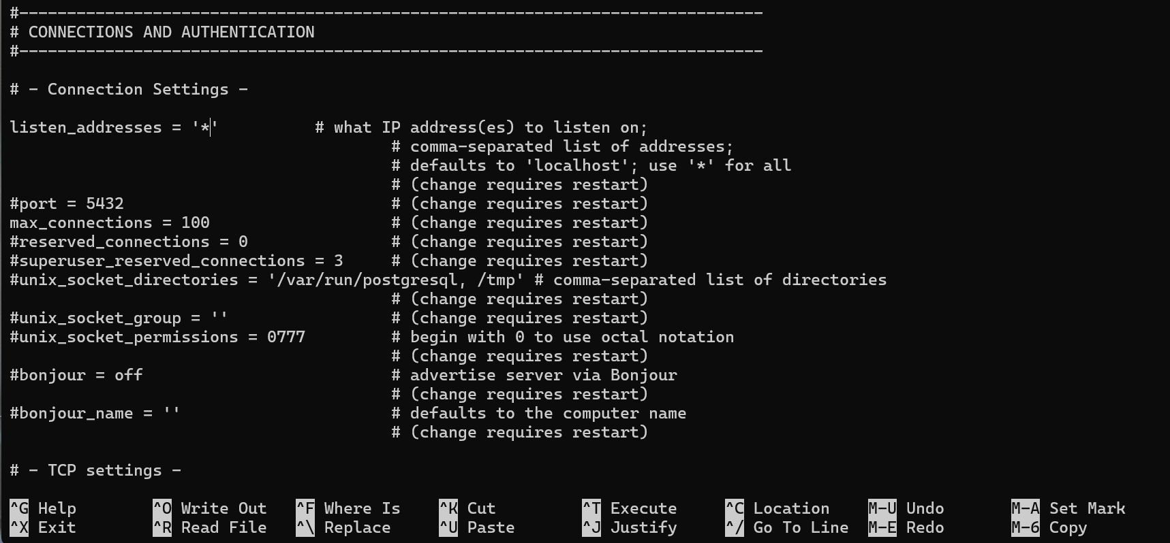
Fig.7. PostgreSQL configuration updated to listen for remote connections on all network interfaces.

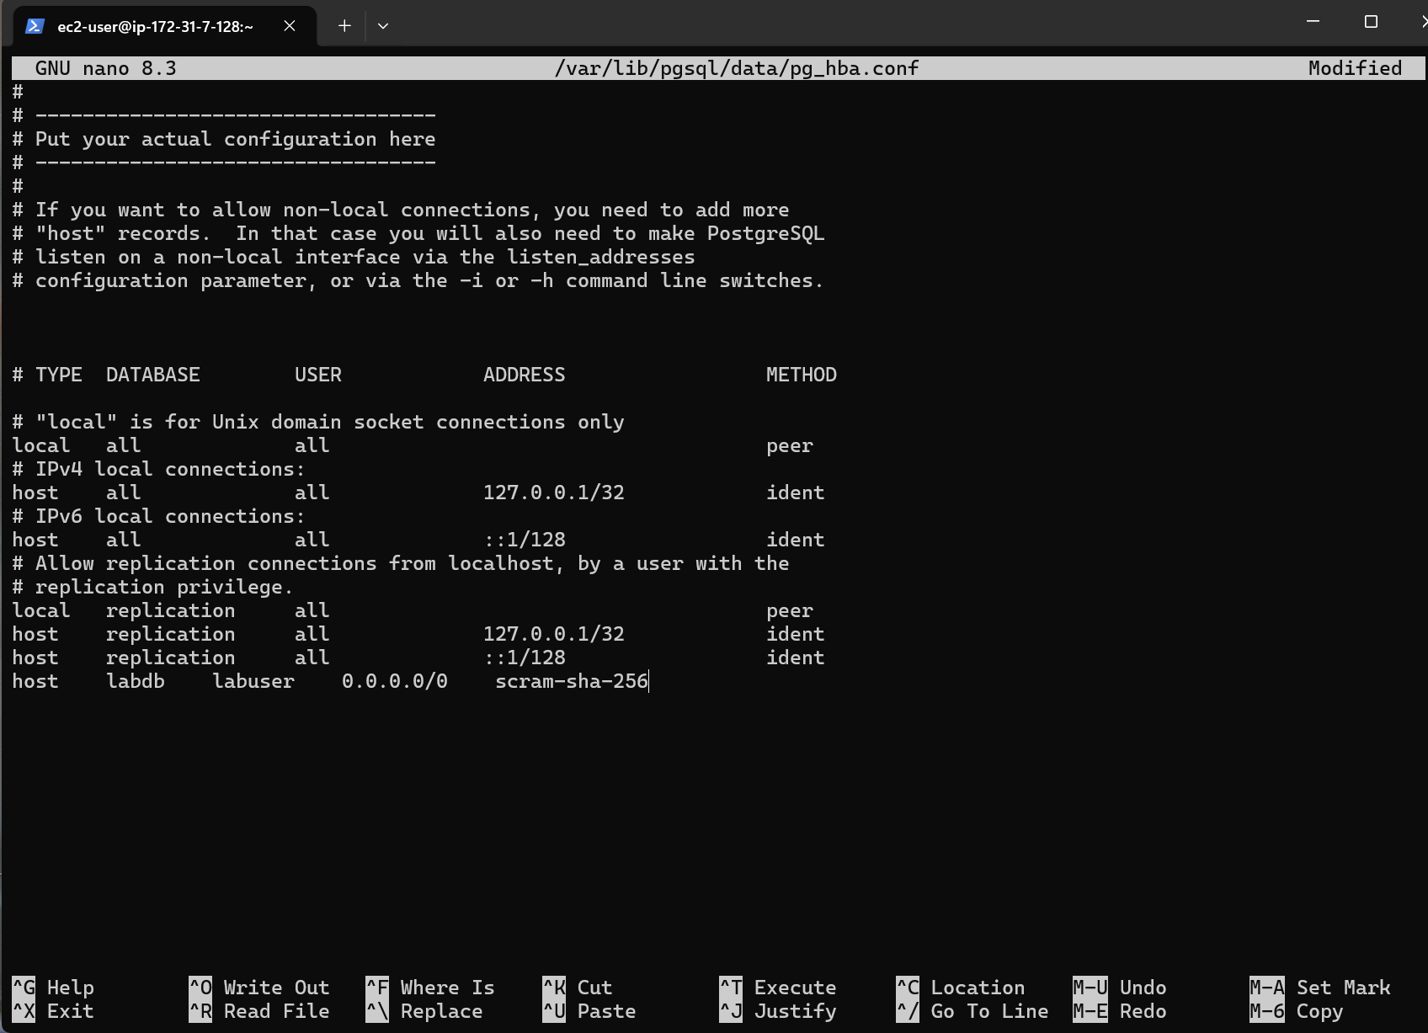
Fig.8. PostgreSQL client authentication configuration updated to allow remote access to the labdb database for labuser.

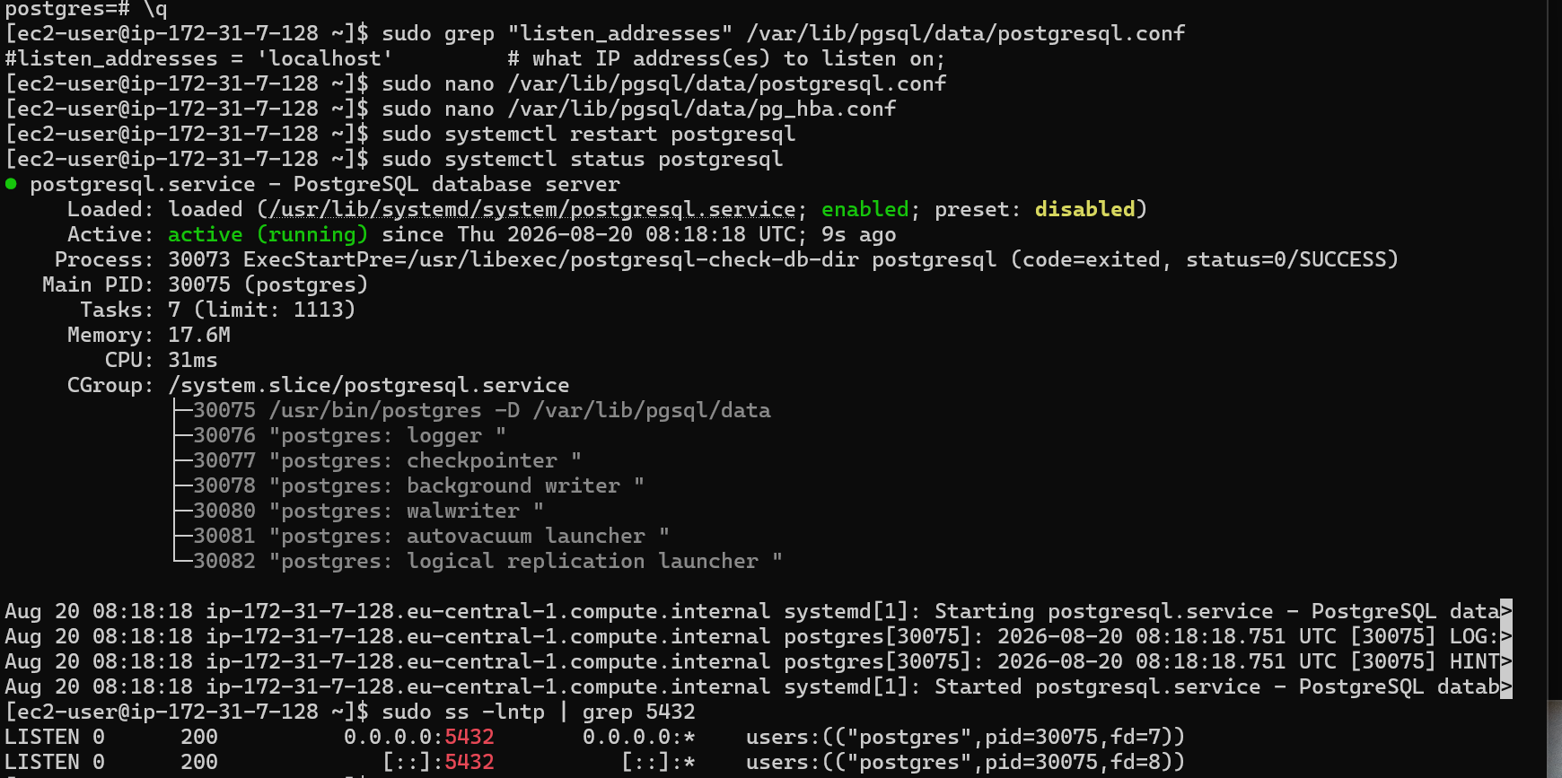
Fig.9. PostgreSQL service restarted successfully and verified as listening on port 5432.

- 1.c Connect to this database from any SQL client (e.g. DBeaver - very useful IDE because of community edition and possibility to work with almost all most famous databases).
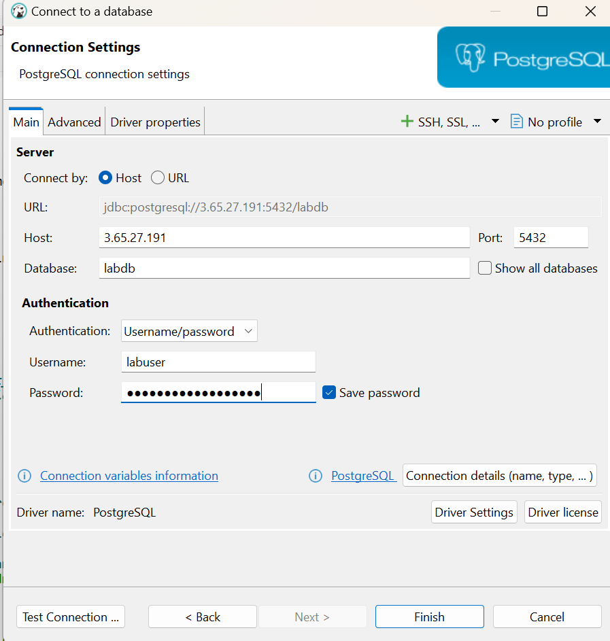
Fig.10. DBeaver connection settings configured for remote access to the PostgreSQL database running on the EC2 instance.
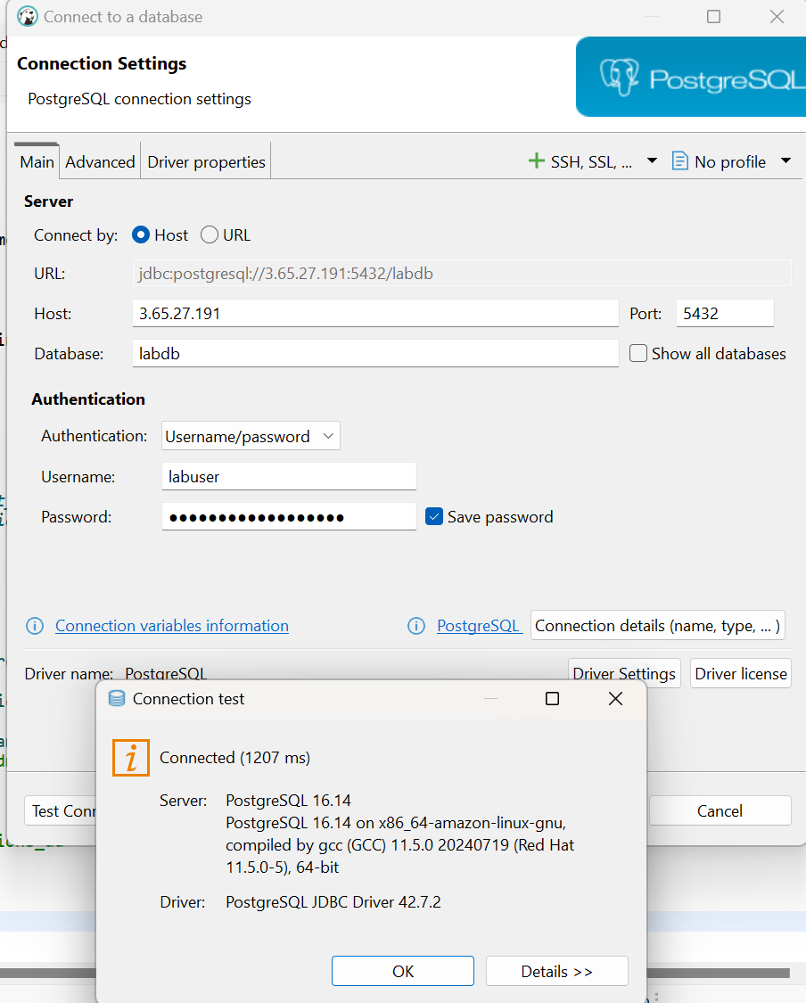
Fig. 11. Successful DBeaver connection test to the PostgreSQL 16 database on the EC2 instance.
1.e Create several objects in the created database ( at least one table, view, procedure ).
CREATE TABLE employees (
employee_id SERIAL PRIMARY KEY,
employee_name VARCHAR(100) NOT NULL,
department VARCHAR(50),
salary NUMERIC(10,2)
);

INSERT INTO employees (employee_name, department, salary)
VALUES
('Anna Smith', 'IT', 3500.00),
('John Brown', 'Finance', 3200.00),
('Maria Green', 'IT', 3800.00);

CREATE VIEW vw_it_employees AS
SELECT
employee_id,
employee_name,
salary
FROM employees
WHERE department = 'IT';

CREATE OR REPLACE PROCEDURE add_employee(
p_name VARCHAR,
p_department VARCHAR,
p_salary NUMERIC
)
LANGUAGE plpgsql
AS $$
BEGIN
INSERT INTO employees (employee_name, department, salary)
VALUES (p_name, p_department, p_salary);
END;
$$;
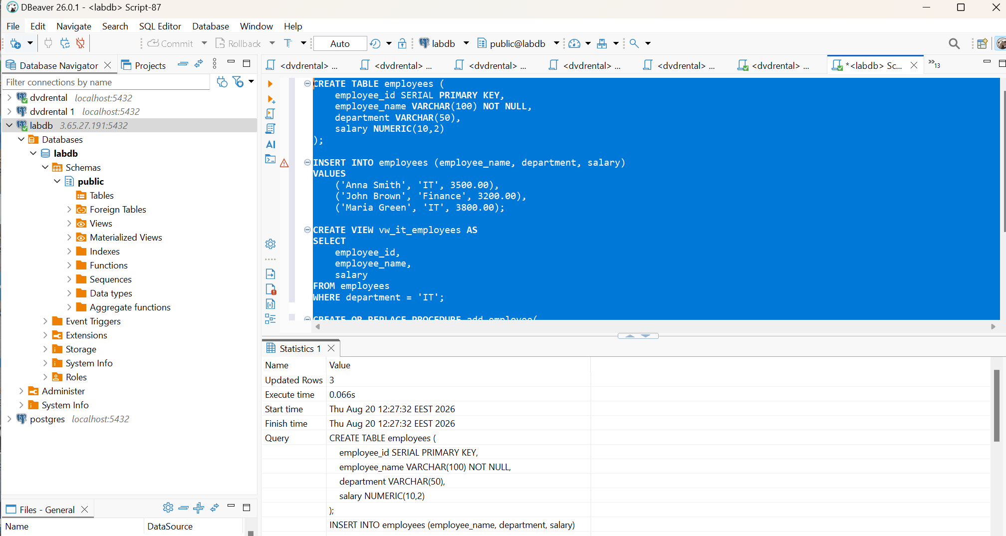
Fig. 12. SQL script executed in DBeaver to create the employees table, insert sample data, create the vw_it_employees view, and define the add_employee procedure.
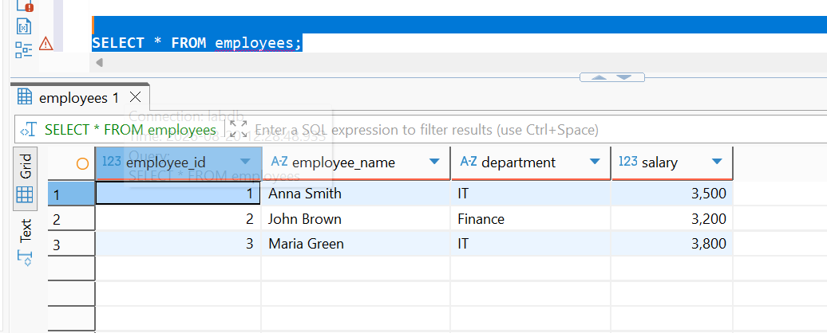
Fig. 13. Query result showing the records stored in the employees table.
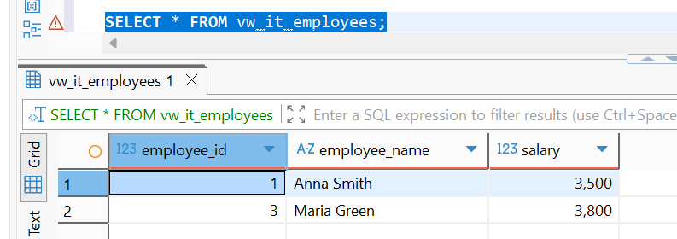
Fig. 14. Query result from the vw_it_employees view, displaying employees assigned to the IT department.
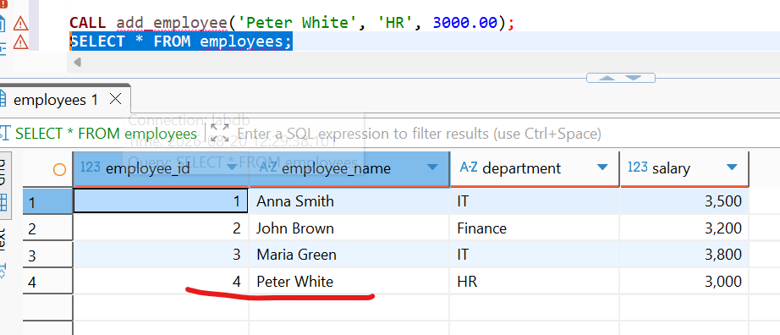
Fig. 15. Execution of the add_employee stored procedure and verification that the new employee record was added successfully.

2.1 Take any file from your S3 bucket and copy it into the EC2 using AWS_EC2_full_access_S3 role that has been attached to the virtual machine on the first step. Screen of the files inside the EC2 into the Report.
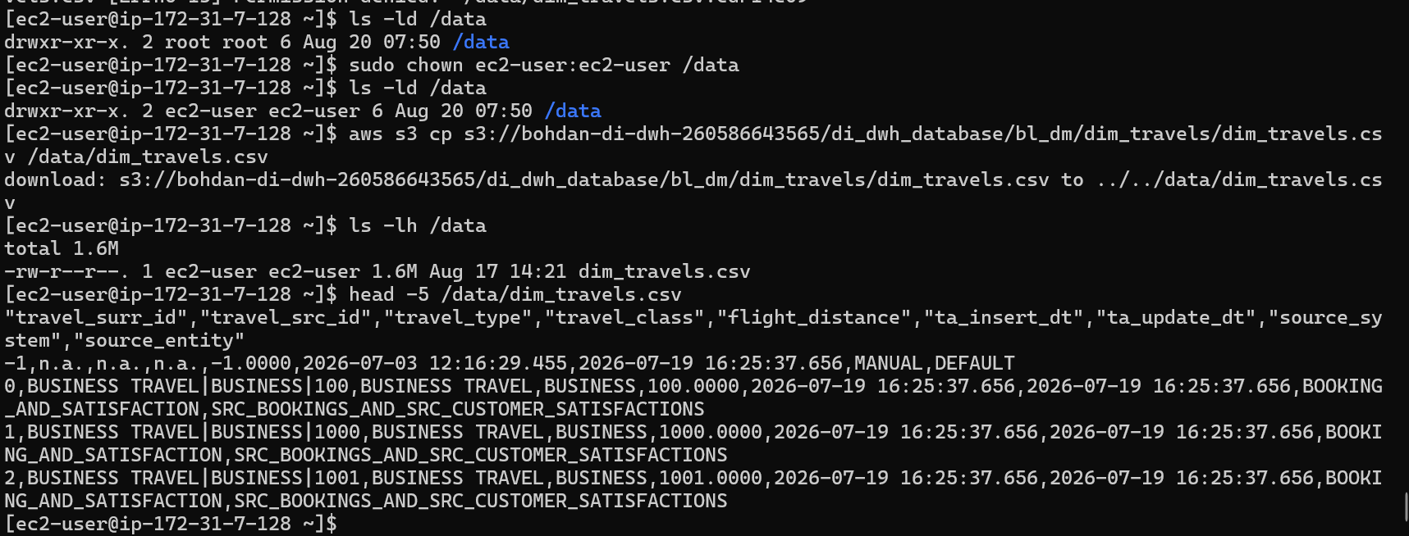
Fig. 16. Copying the dim_travels.csv file from the Amazon S3 bucket to the /data directory on the EC2 instance.
2.3 For you EC2 a separate EBS volume was allocated. Let’s create snapshot of this EBS volume. Afterwards, let’s create AMI (identifiable name) from the created previously snapshot. It will be a copy (image) of your EC2 machine.
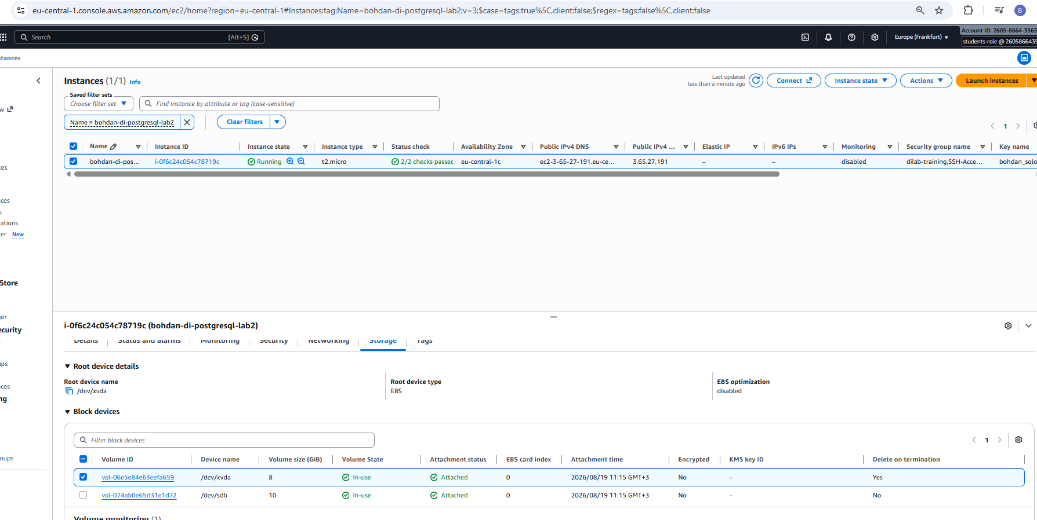
Fig.17. EC2 instance storage configuration showing the root volume and the separately attached EBS data volume.
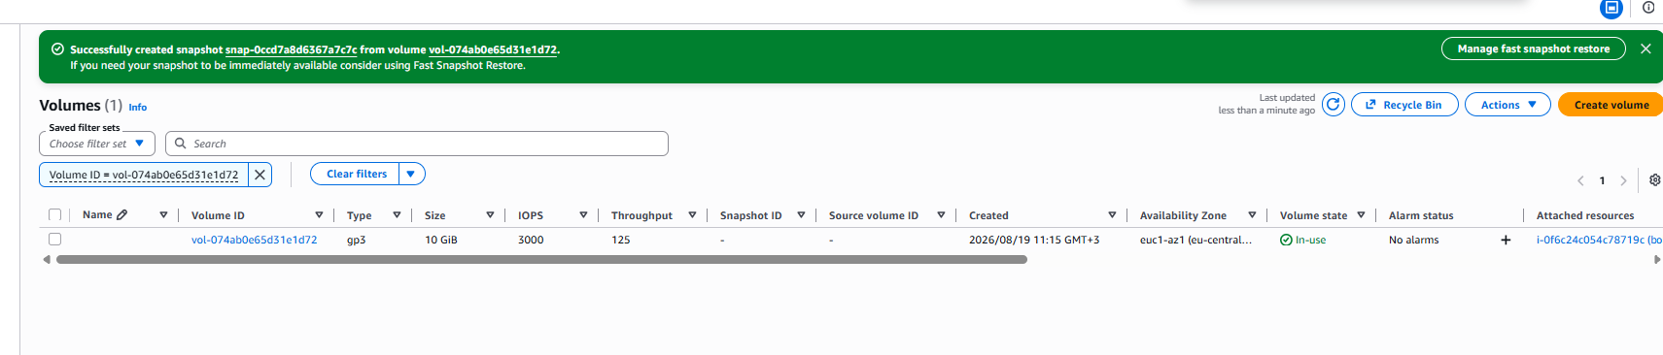
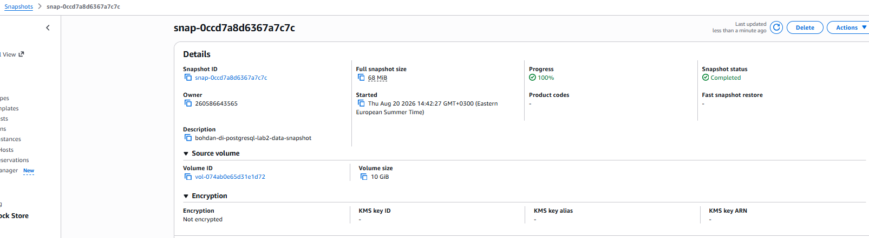
Fig.18. Successfully created snapshot of the attached EBS data volume.

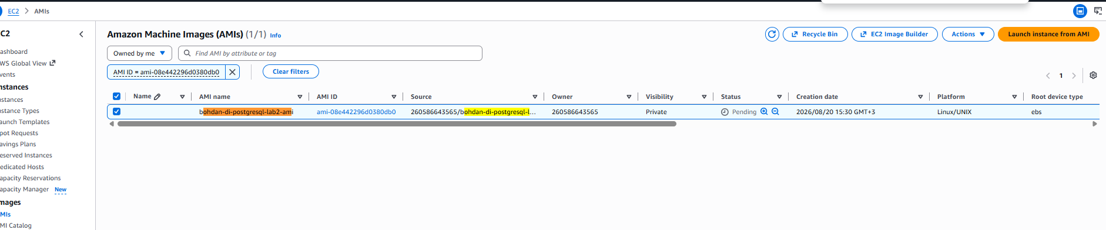
Fig.19. Amazon Machine Image (AMI) created from the configured EC2 instance.

  - From the image (AMI) you've made on the step 3, raise a copy of the EC2. As an Important security requirement ensure that Metadata Service Version 2 is enabled: on Launch an instance page click Advanced details and ensure that Metadata accessible is set to Enabled and Metadata version set to V2 only.
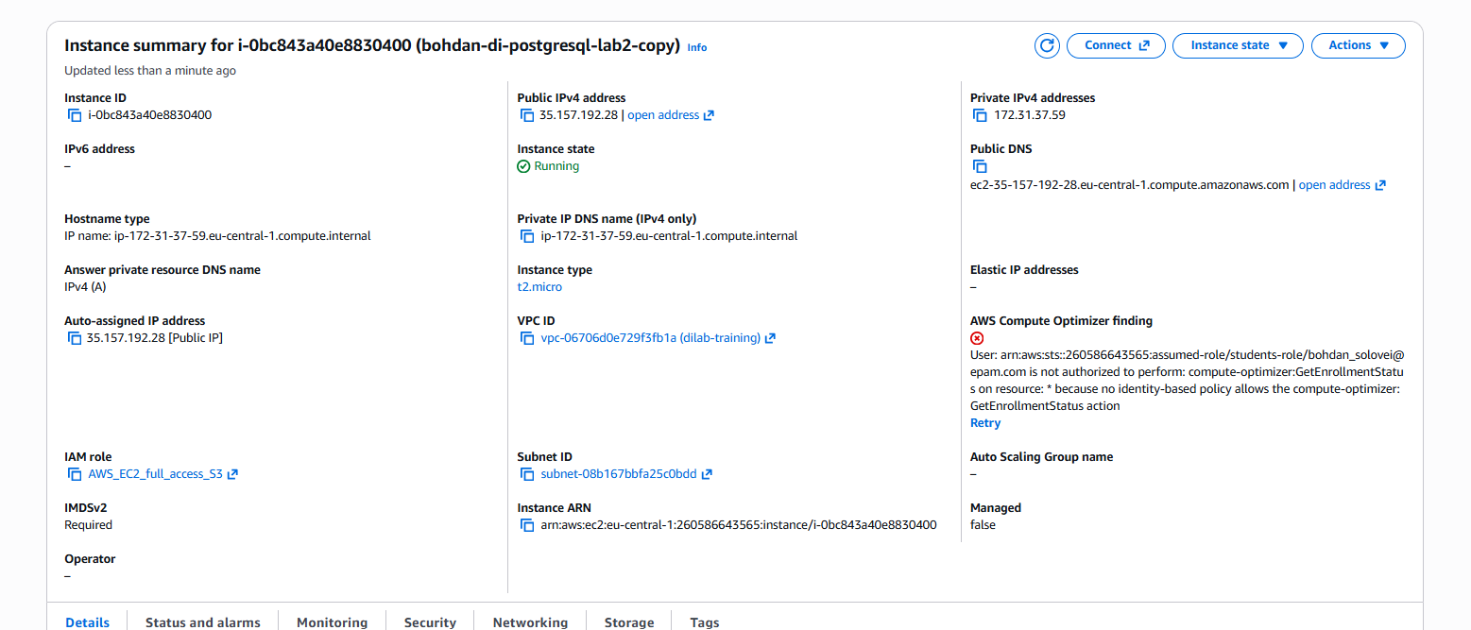
Fig.20. EC2 instance launched from the AMI, with Instance Metadata Service Version 2 (IMDSv2) required.

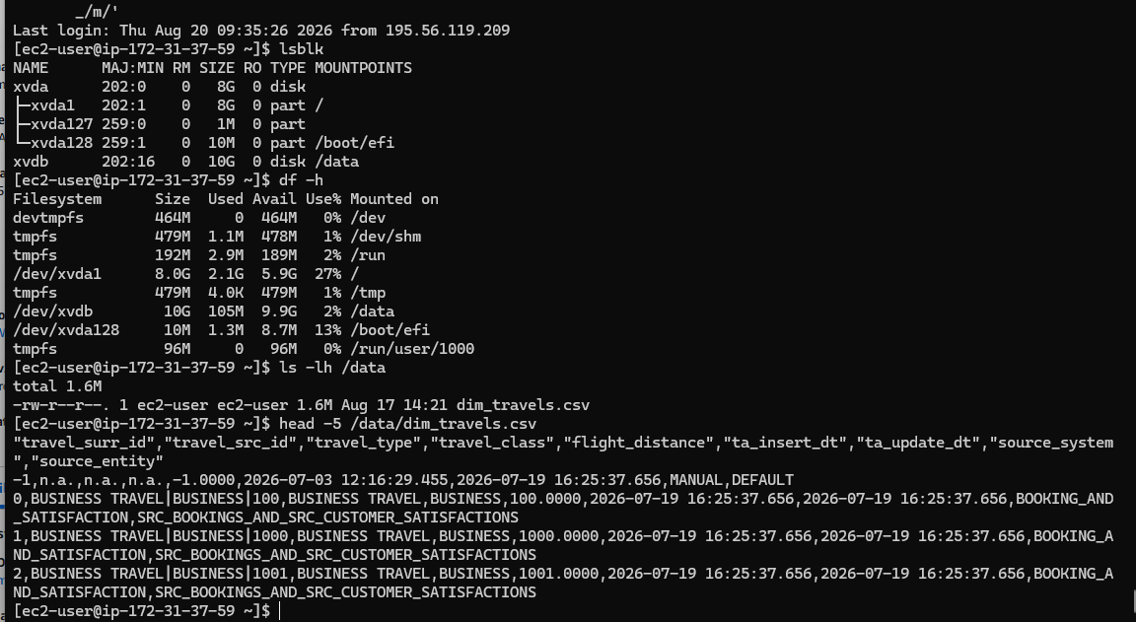
Fig.21. Verification that the EBS volume is mounted and that the copied S3 file is available on the EC2 instance created from the AMI.
2.5Create your first web page, install apache web server and push any html to the standard directory /var/www/html (apache web server installation and html example will be in the general folder).

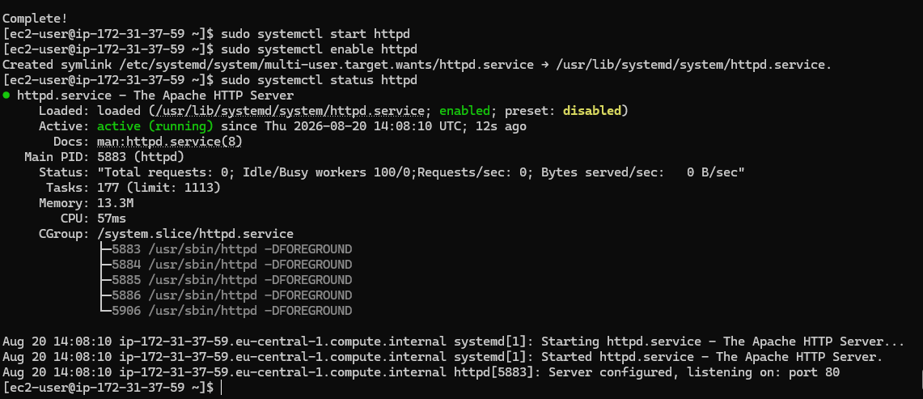
Fig.22. Apache HTTP Server started, enabled, and verified as running on port 80.

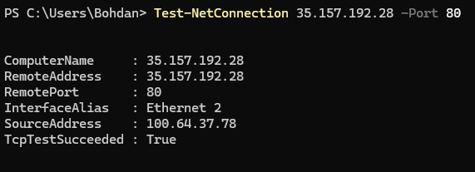
Fig.23. Successful network connectivity test to the EC2 instance on HTTP port 80.

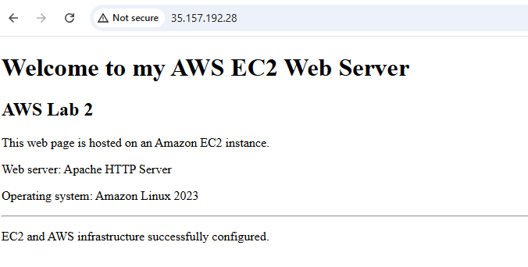
Fig.24. Custom web page successfully accessed through the public IP address of the Amazon EC2 instance.

2.6 Create Senseful CloudWatch Alarm for any events exceeding your EC2 resources and create your own SNS queue, that will send the results to your email (you specify email when creating SNS).
The bohdan-di-postgresql-lab2-copy instance CPU usage.
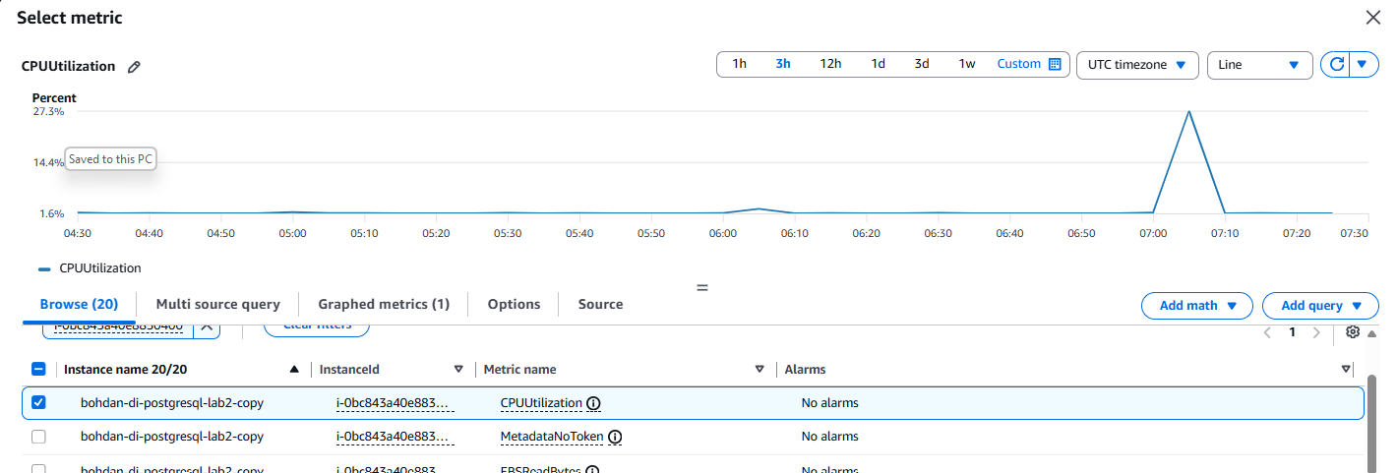
Fig.25. Selection of the CPUUtilization metric for the EC2 instance in Amazon CloudWatch.

The alert set to 70% CPU usage with 5 min alert
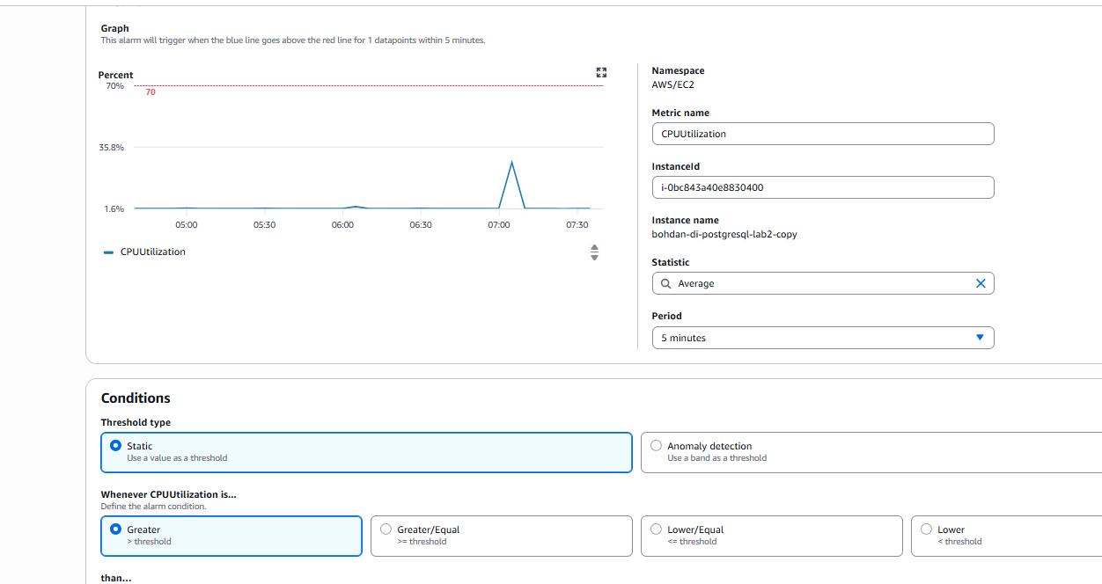
Fig.26. CloudWatch alarm configuration to trigger when average CPU utilization exceeds 70% during a five-minute period.

Alarm Confirmation details sent on Outlook
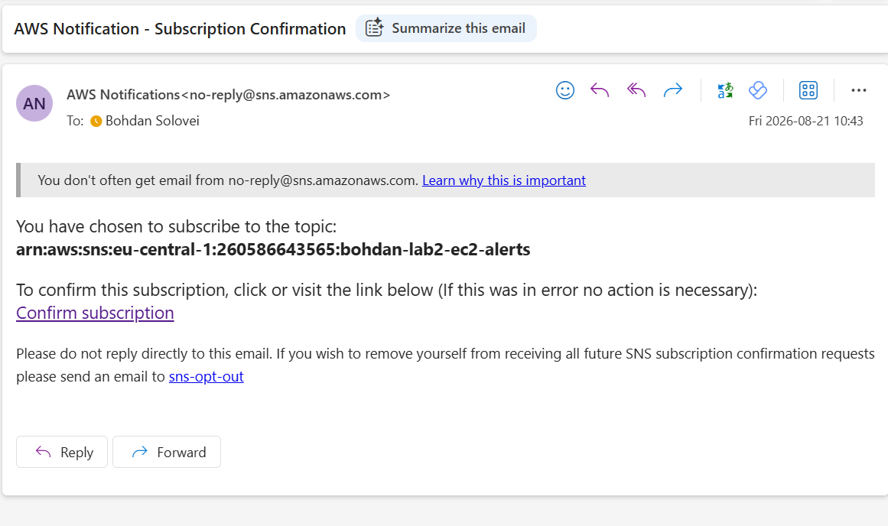
Fig.27. Amazon SNS email subscription confirmation message received in Outlook.

Final Result the bohdan-lab2-high-cpu-alarm is being created.
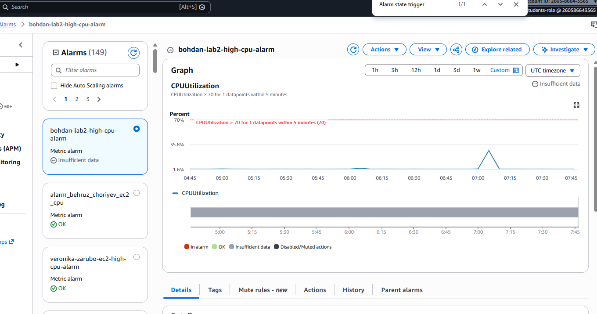
Fig.28. Successfully created CloudWatch high-CPU alarm for the EC2 instance.

The Amazon SNS subscription is in status Confirmed
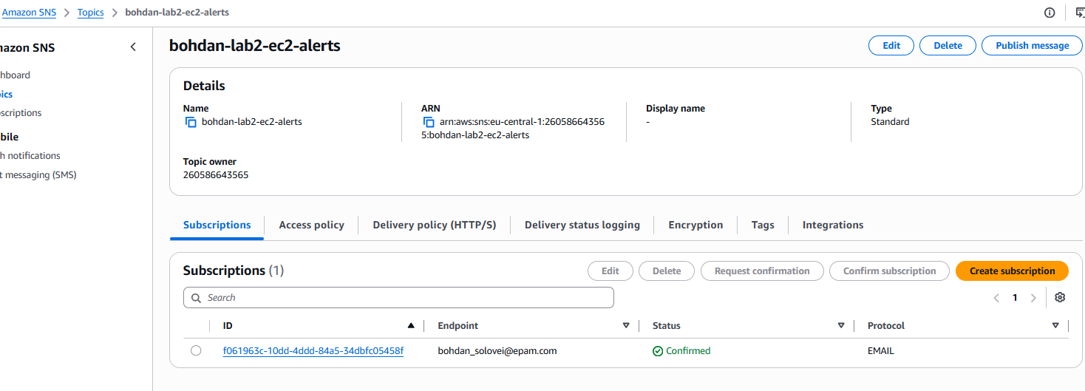
Fig.29. Amazon SNS topic showing the email subscription in the Confirmed status.

2.7 Try to create same EC2 virtual machine using a CloudFormation script. Save the script into your bucket and to the Report.

The .yaml file
AWSTemplateFormatVersion: '2010-09-09'
Description: >
AWS Lab 2 - EC2 instance created from the previously prepared AMI.
Reuses existing subnet, security groups, key pair, and IAM instance profile.
IMDSv2 is required.

Resources:
Lab2EC2Instance:
Type: AWS::EC2::Instance
Properties:
ImageId: ami-08e442296d0380db0
InstanceType: t2.micro
KeyName: bohdan_solovei-lab2-key

IamInstanceProfile: AWS_EC2_full_access_S3

MetadataOptions:
HttpEndpoint: enabled
HttpTokens: required
HttpPutResponseHopLimit: 2

NetworkInterfaces:
- DeviceIndex: "0"
AssociatePublicIpAddress: true
DeleteOnTermination: true
SubnetId: subnet-08b167bbfa25c0bdd
GroupSet:
- sg-0c9e0944abff93553
- sg-0fbf42a5fb4bc1004

Tags:
- Key: Name
Value: bohdan-di-postgresql-lab2-cfn

Outputs:
InstanceId:
Description: ID of the EC2 instance created by CloudFormation
Value: !Ref Lab2EC2Instance

PublicIp:
Description: Public IPv4 address of the EC2 instance
Value: !GetAtt Lab2EC2Instance.PublicIp

PublicDnsName:
Description: Public DNS name of the EC2 instance
Value: !GetAtt Lab2EC2Instance.PublicDnsName

The creation of the stack
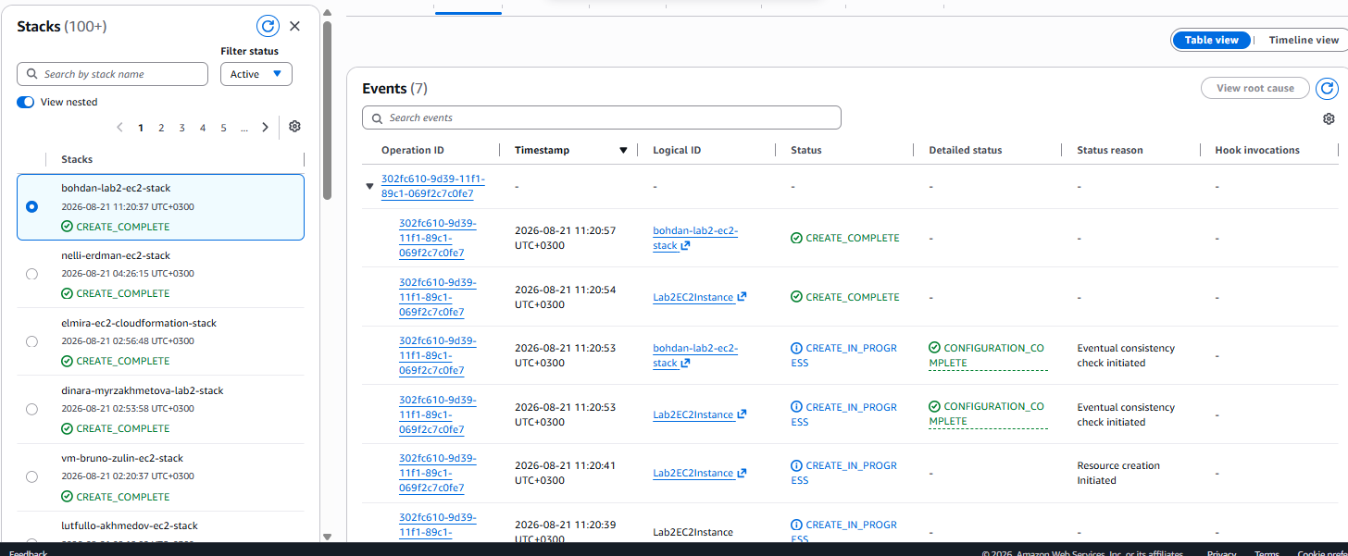
Fig.30. CloudFormation stack creation events showing successful deployment of the EC2 instance.

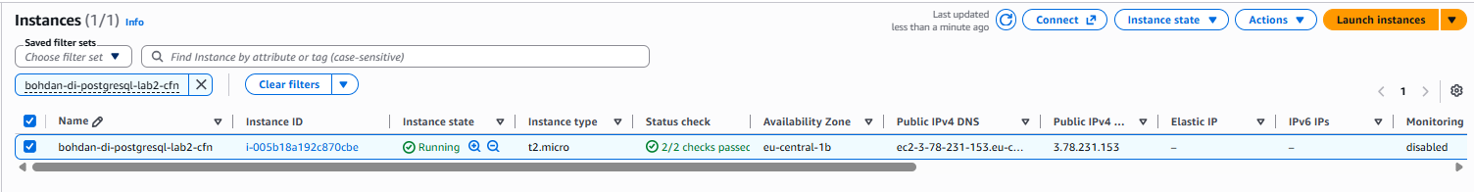
Fig.31. EC2 instance created successfully through the CloudFormation stack.

8.a Install any database or any program in EC2 using docker and provide access to this service from the outside.

Docker installation on EC2 virtual machine

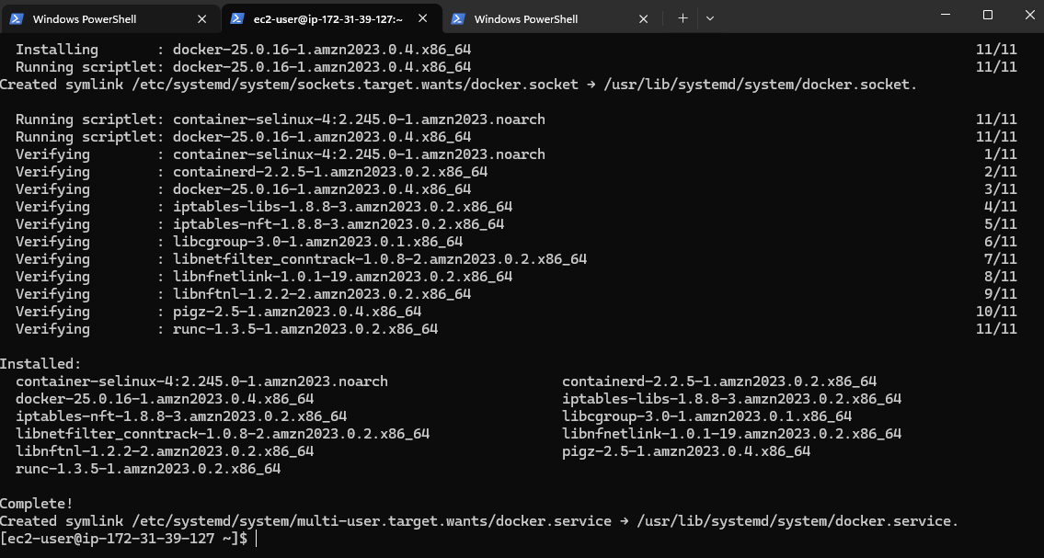
Fig.32. Docker installation completed successfully on the Amazon EC2 instance.

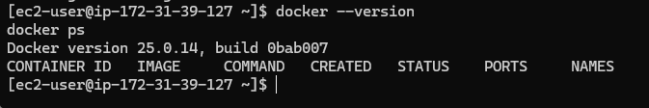
Fig.33. Verification of the installed Docker version and the current container status.

Downloading Nginx image on Docker.
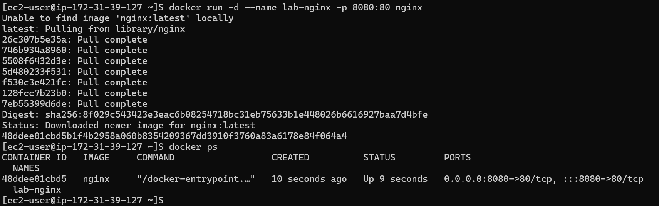
Fig.34. Nginx Docker image downloaded and started in a container with host port 8080 mapped to container port 80.

Running Ngix in Docker
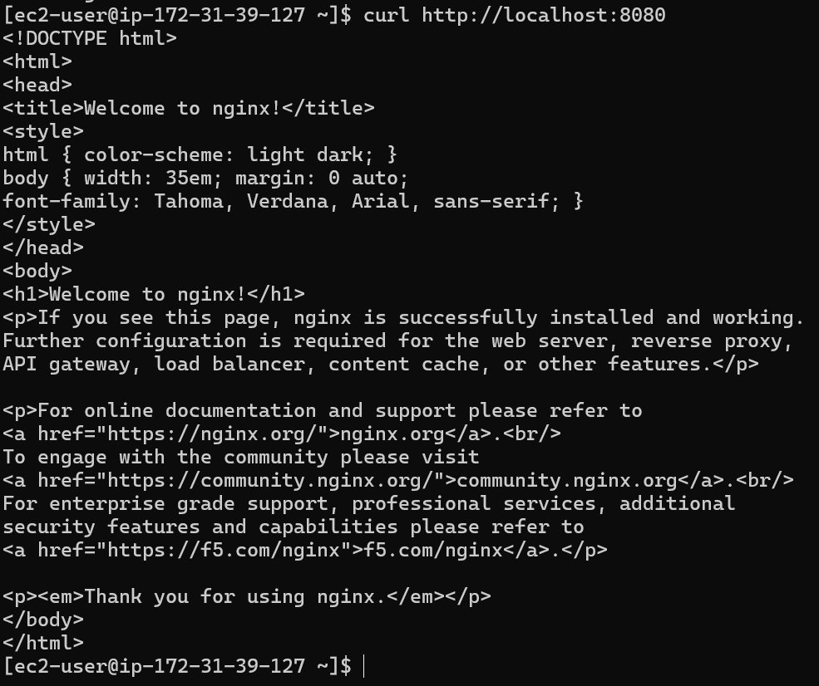
Fig.35. Verification that the Nginx web server is running successfully inside the Docker container using curl http://localhost:8080.

