AWS Cloud for Data Engineering
- Establish connection to AWS account:

1.h Check your aws config file
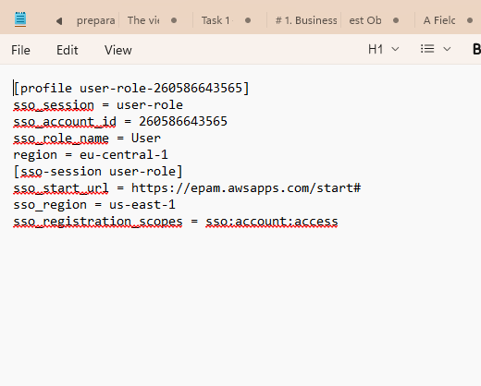
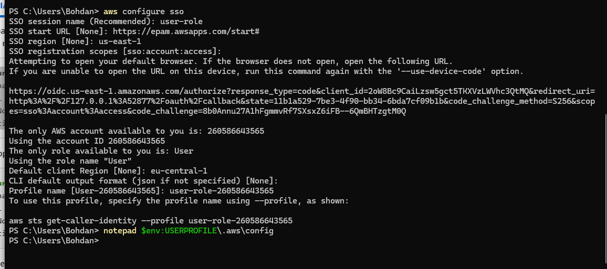

1.h Check your aws config file.
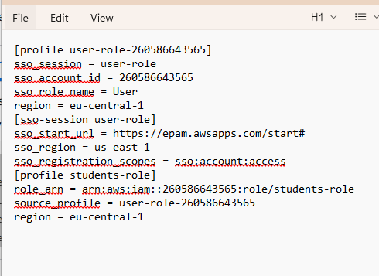

1.j Now run aws sts get-caller-identity --profile students-role in case you did all right you should see something like
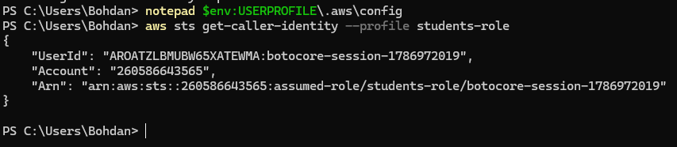

2a — Create your own bucket with recognizable naming S3 bucket
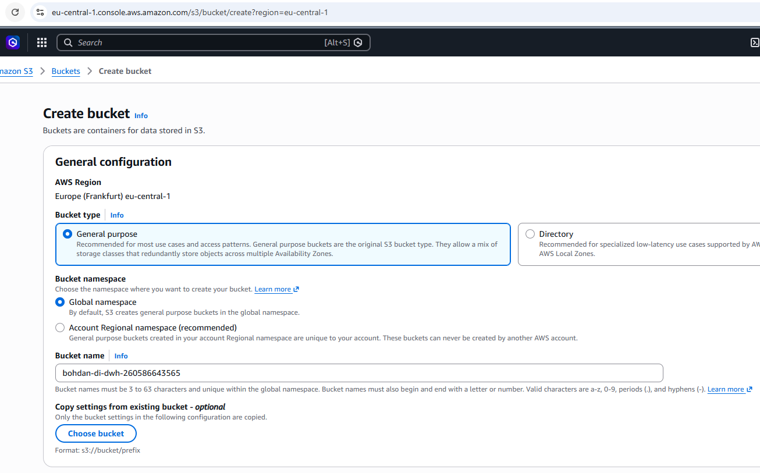
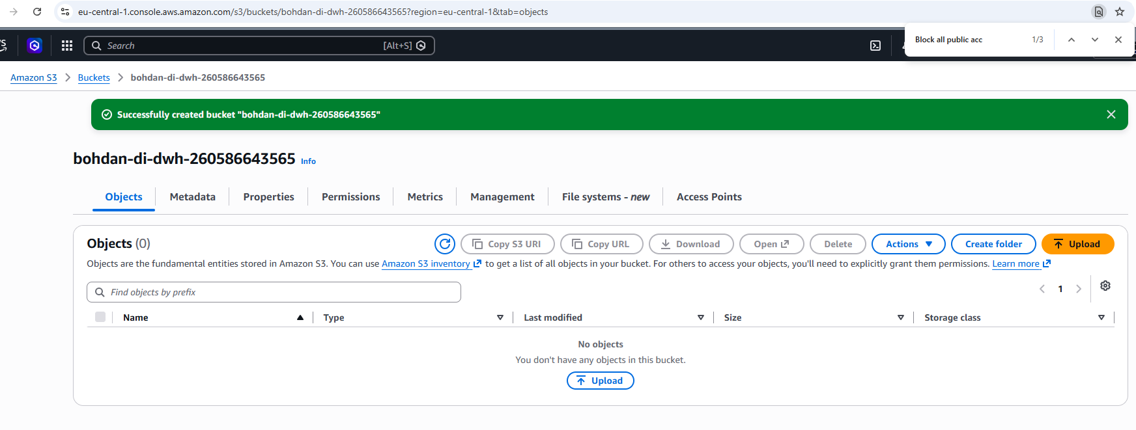

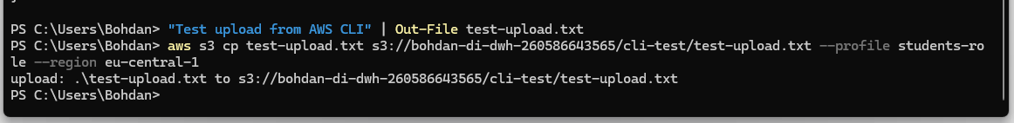

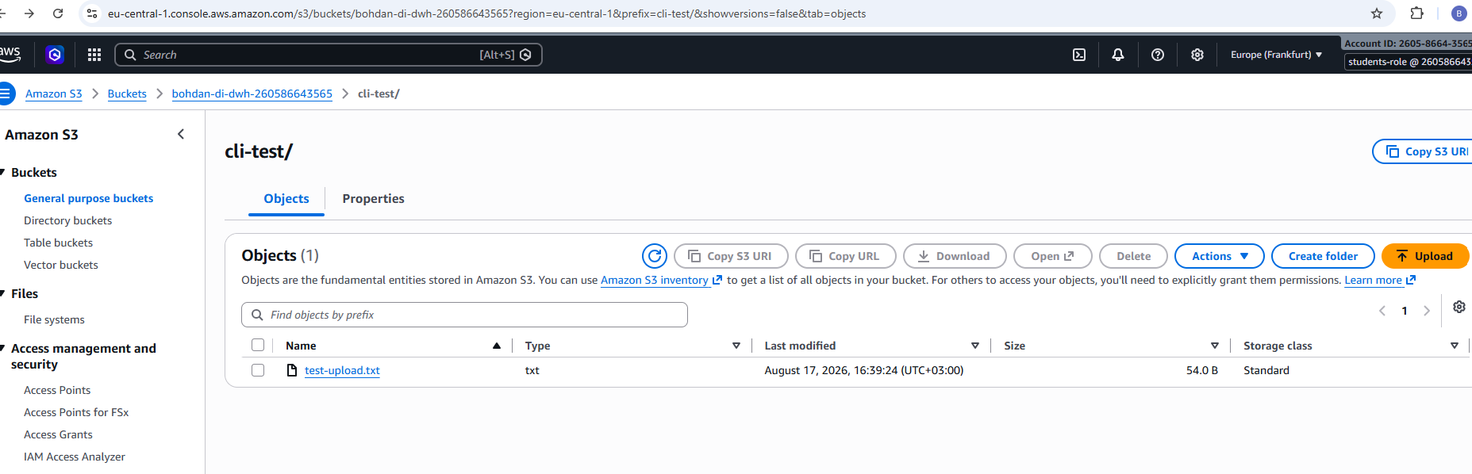
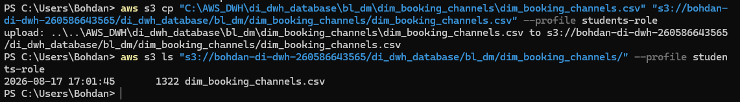
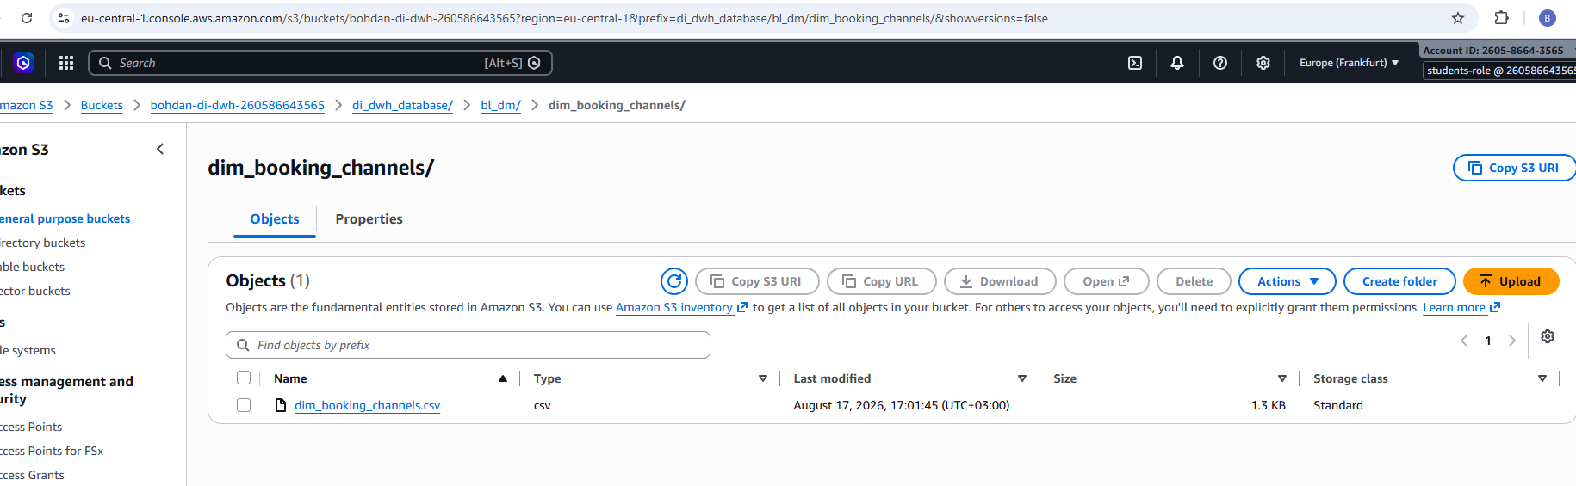

2.c Upload you tables from you previously created oracle BL_DM schema to S3 bucket with appropriate with next folders hierarchy
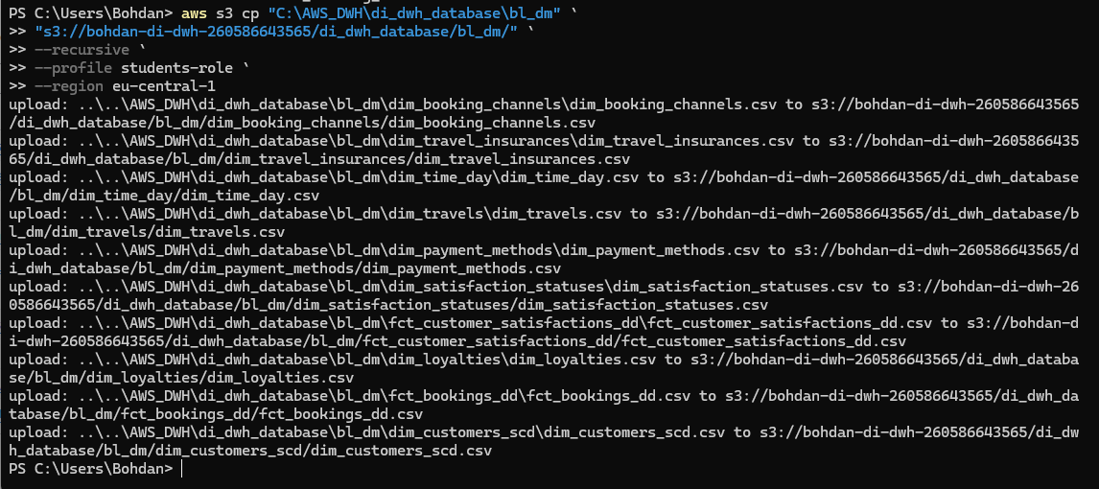
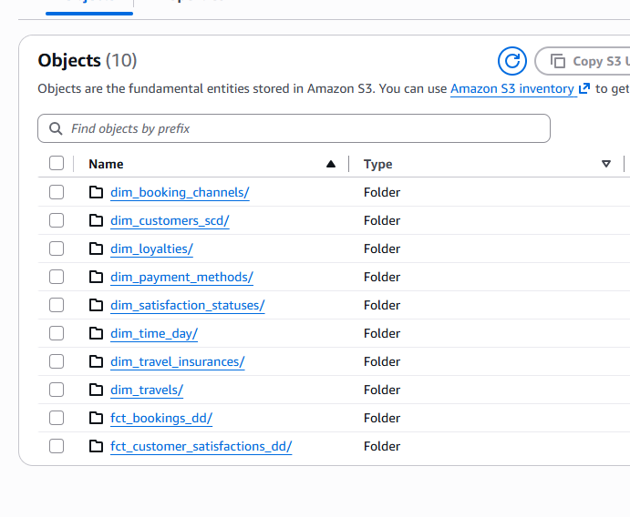

2.d Add path to your tables into Glue Crawler or create your own Crawler to find your tables in buckets and put them into the Glue DataCatalog Database
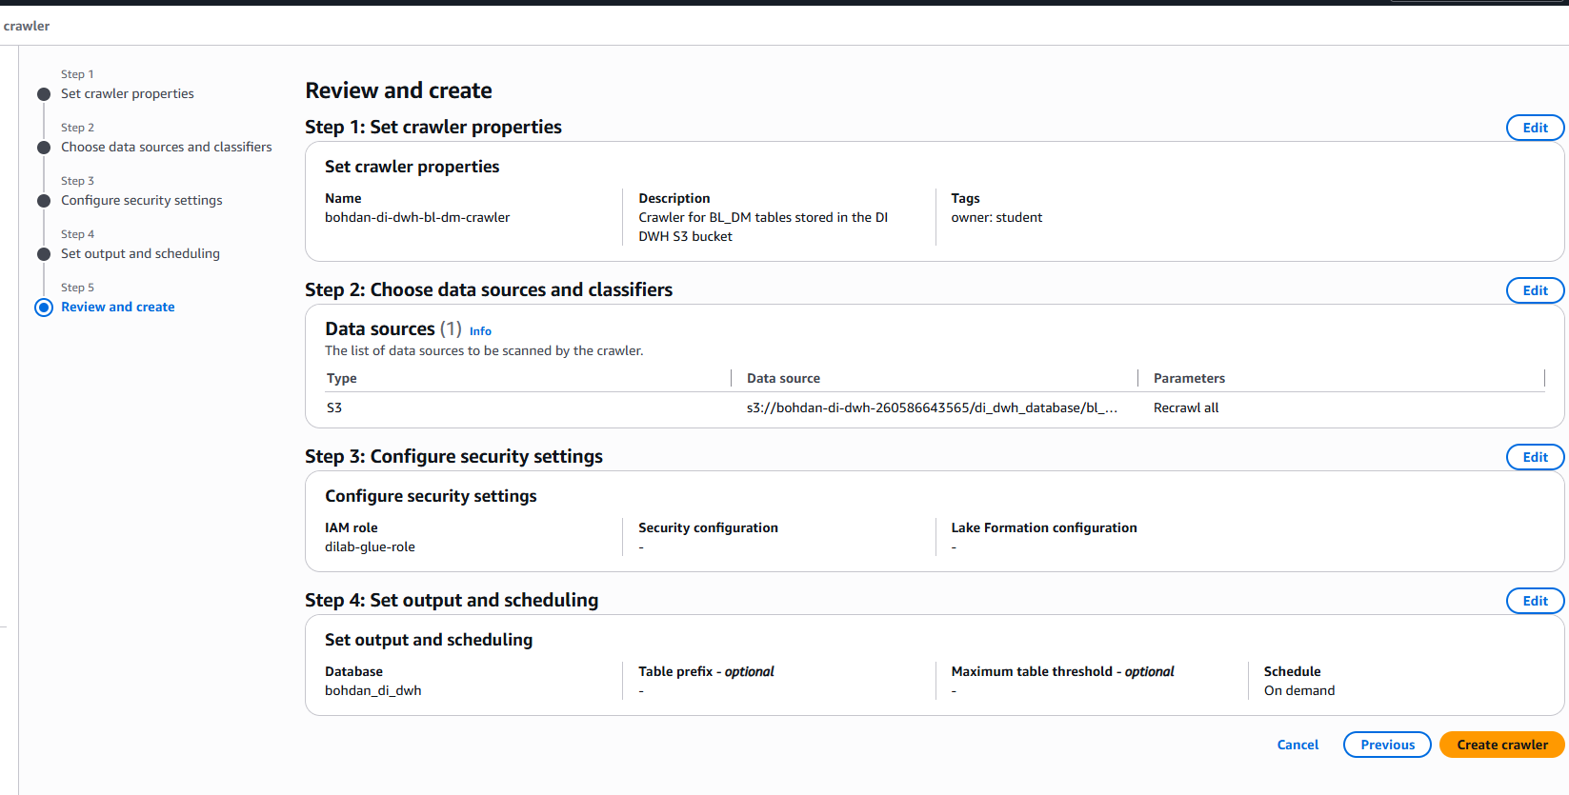
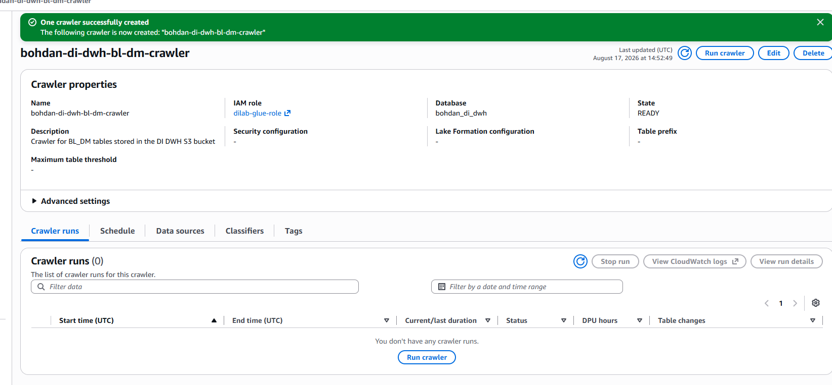
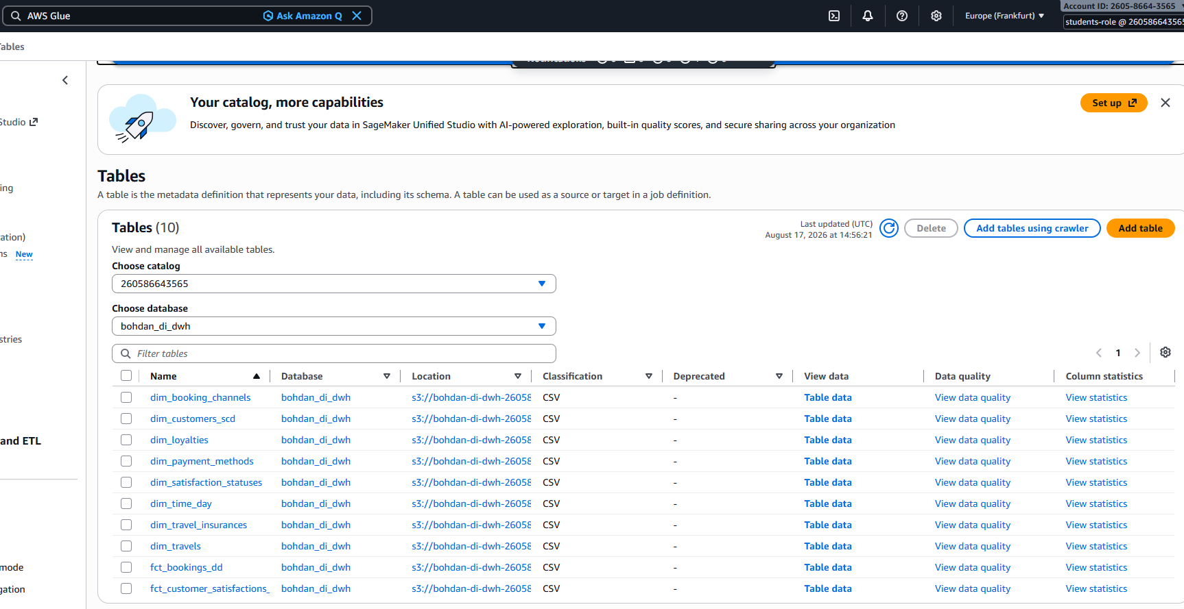
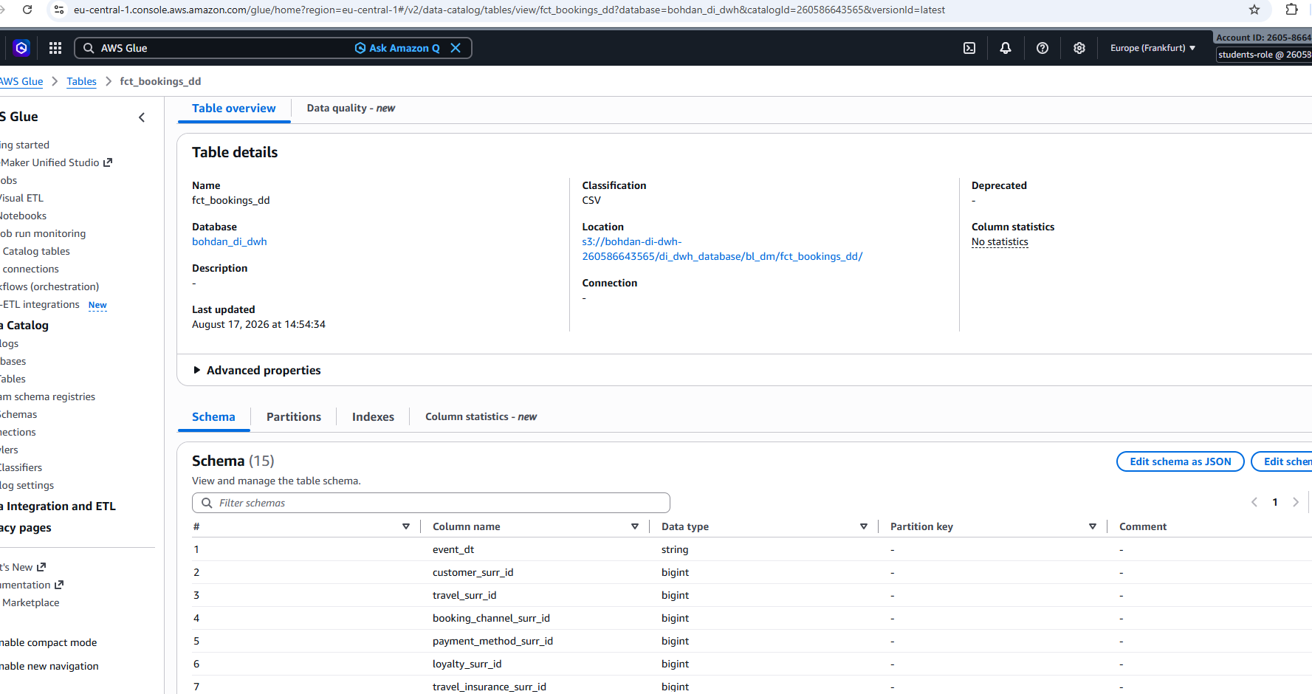
Execution of analytical query over BL_DM data using Amazon Athena
SELECT
t.travel_class,
bc.booking_channel,
COUNT(*) AS total_bookings,
ROUND(SUM(f.fct_ticket_price), 2) AS total_ticket_revenue,
ROUND(AVG(f.fct_ticket_price), 2) AS avg_ticket_price
FROM bohdan_di_dwh.fct_bookings_dd f
JOIN bohdan_di_dwh.dim_travels t
ON f.travel_surr_id = t.travel_surr_id
JOIN bohdan_di_dwh.dim_booking_channels bc
ON f.booking_channel_surr_id = bc.booking_channel_surr_id
GROUP BY
t.travel_class,
bc.booking_channel
ORDER BY
total_ticket_revenue DESC
LIMIT 100;
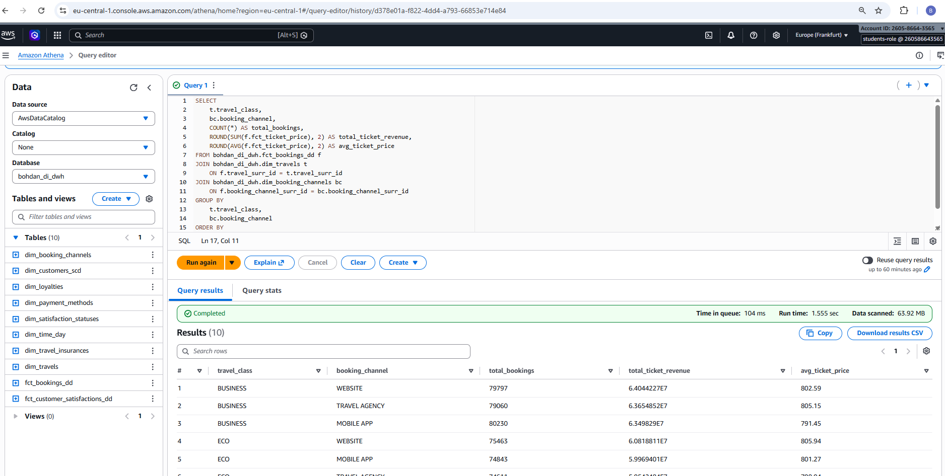
An analytical query was executed in Amazon Athena against tables registered in the AWS Glue Data Catalog. The query joins the fct_bookings_dd fact table with the dim_travels and dim_booking_channels dimension tables and aggregates booking and revenue indicators by travel class and booking channel. The successful execution confirms that the data uploaded to Amazon S3 can be queried through the AWS Glue Data Catalog using Athena.

