AWS CLOUD FOR DATA ENGINEERING

1.1 – 1.5 Configuration was done in AWS-Lab2
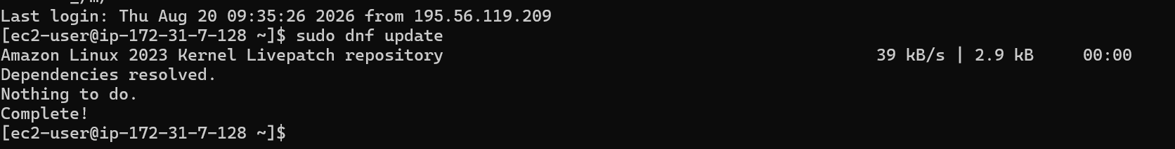
1.6. Use the following command to check connection between EC2 and Redshift
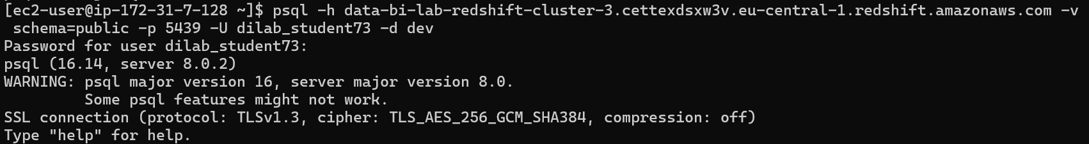
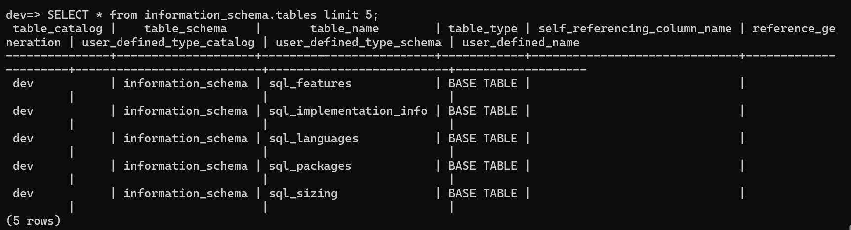
Fig. 1. Verification of PostgreSQL client installation and successful connection from the EC2 instance to the Amazon Redshift cluster using psql.
1.7 Configure connection settings
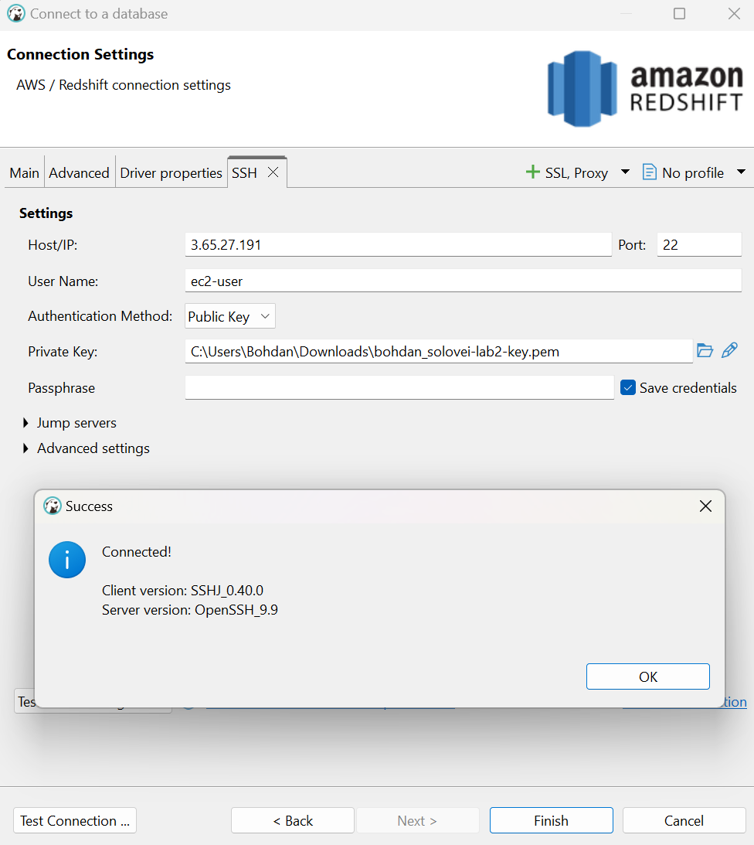
Fig. 2. SSH tunnel configuration in the database client using the EC2 instance, public key authentication, and port 22.
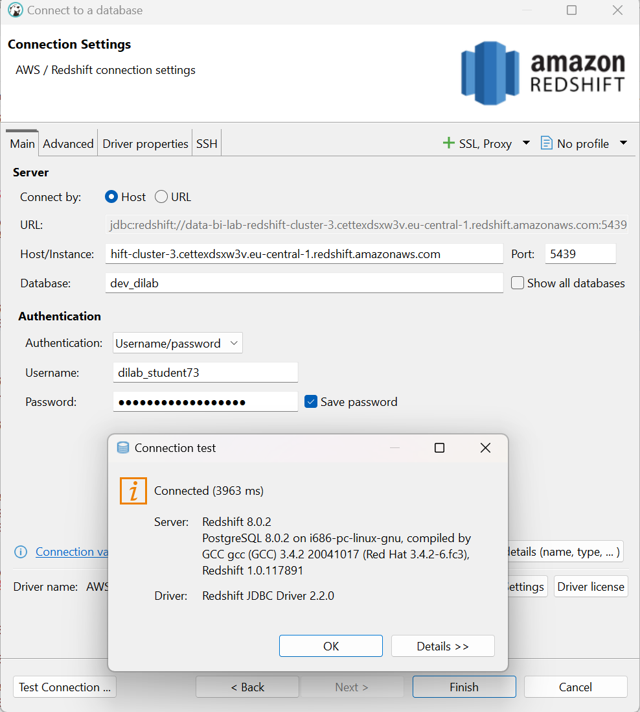
Fig3. Amazon Redshift connection configuration and successful connection test through the SSH tunnel.

2
After logging in you should provision data from data lake to Redshift to be able to transform it using stored procedures. One way of doing it is by using COPY command. Use this command to provision data into the table created by you in your schema (user_dilab_student(1..32)). Use AWS documentation and example of syntax below to load the data. Attached role you can find using web console or CLI.
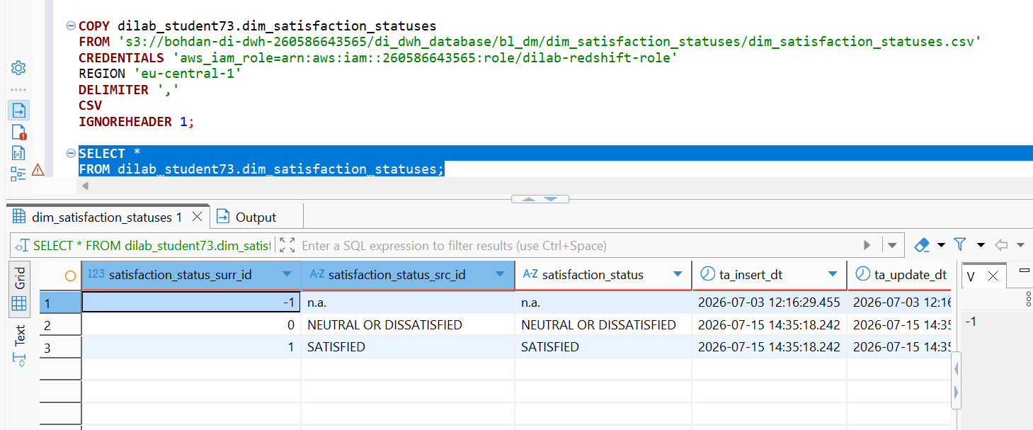
Fig. 4. Loading data into the dim_satisfaction_statuses dimension table from Amazon S3 using the Redshift COPY command.
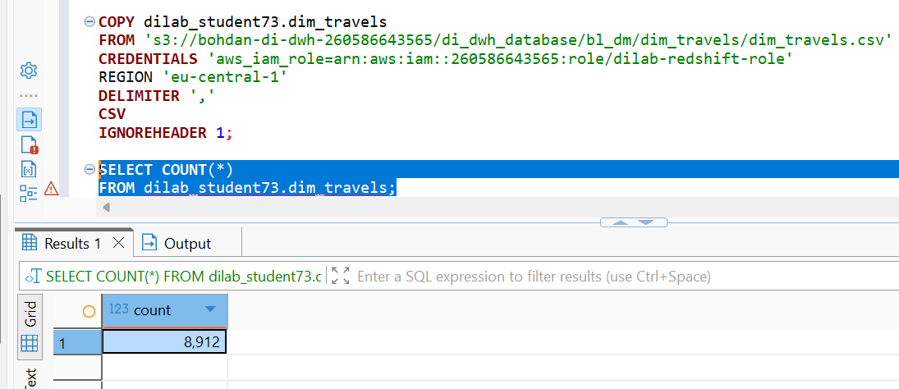
Fig. 5. Loading data into the dim_travels dimension table from Amazon S3 and validating the load by counting 8,912 records.
2.3
After loading your tables check its initial compression types, distribution style, sort keys. Make a description of your analysis.
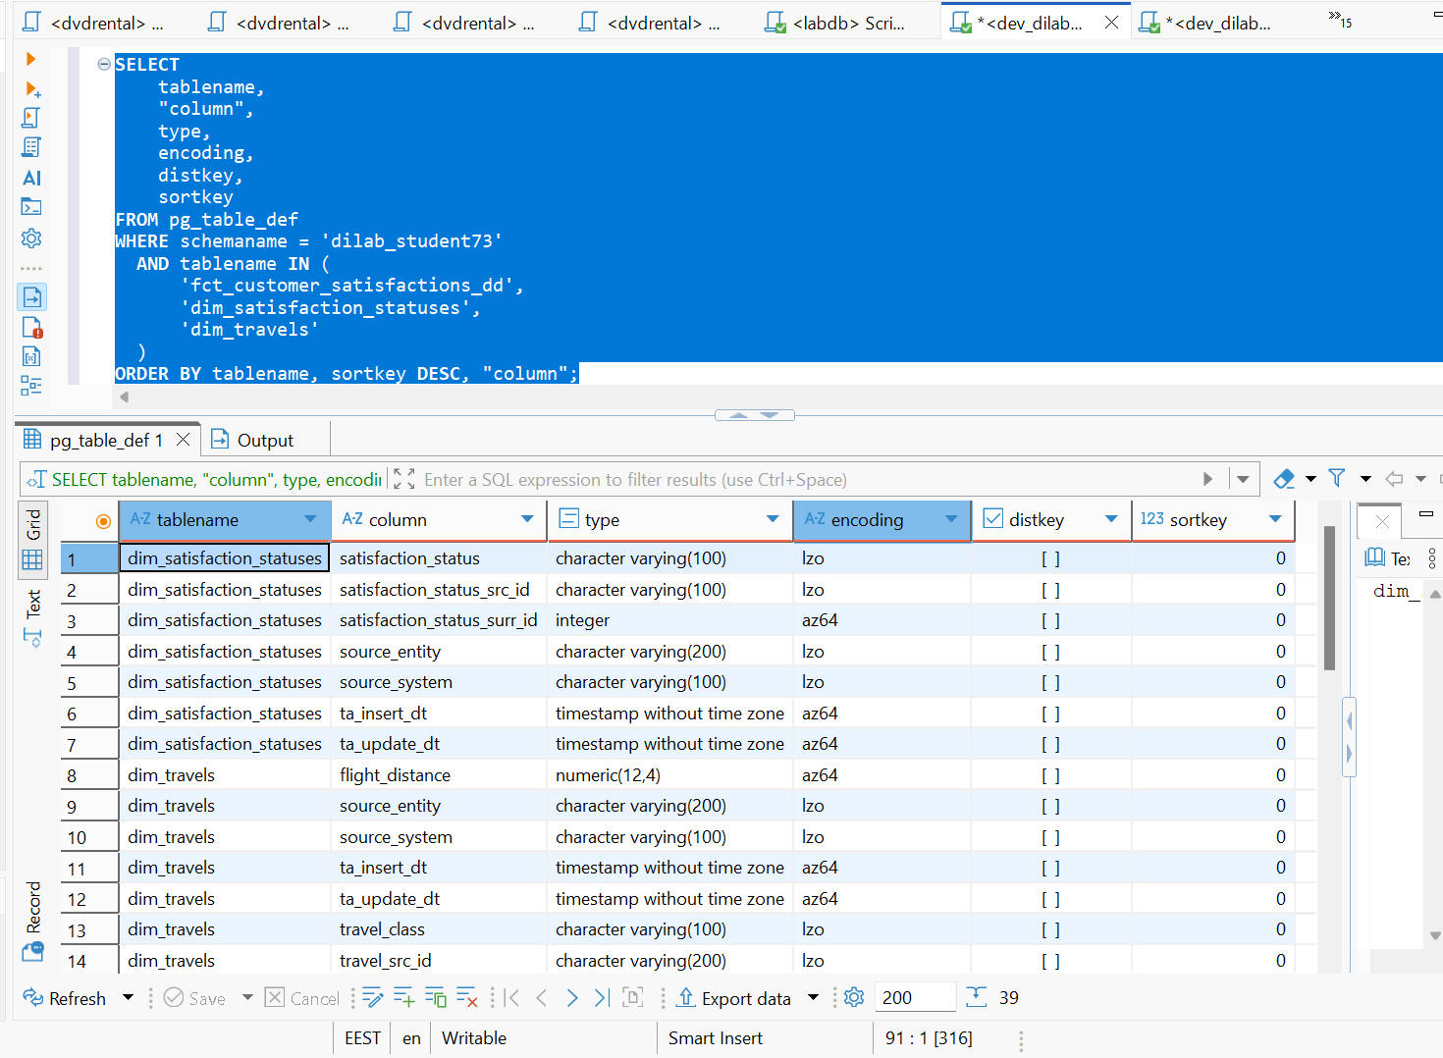
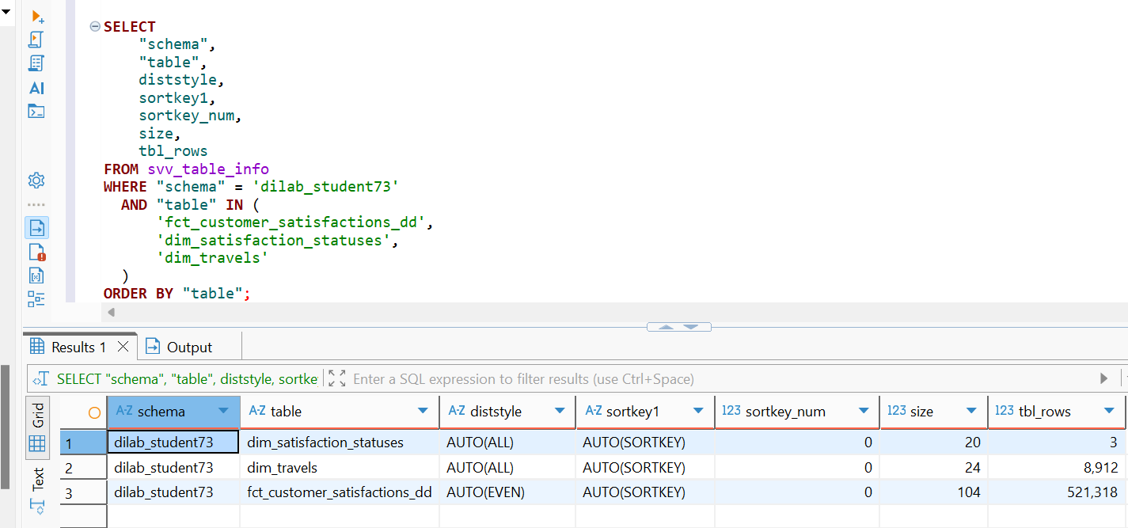
Fig. 6. Initial analysis of column encodings, data types, distribution styles, sort keys, table sizes, and row counts for the loaded Redshift tables.
Conclusion:
The dim_satisfaction_statuses table contains 3 rows and the dim_travels table contains 8,912 rows. Both dimension tables use the AUTO(ALL) distribution style. This is suitable for relatively small dimension tables because Redshift can replicate their data across compute nodes, reducing data movement when these dimensions are joined with the fact table.
The analysis of column encodings also showed that Redshift applied compression to the table columns. For example, character columns use LZO encoding, while integer, numeric, and timestamp columns use AZ64 encoding. Therefore, the initial tables already use compressed columnar storage.
Overall, the initial configuration demonstrates different distribution strategies for dimension and fact tables: the small dimensions use AUTO(ALL), while the substantially larger fact table uses AUTO(EVEN). This provides an appropriate baseline for further analysis and optimization of the report workload.
3. Take one of your USER_DILAB_STUDENTN schema tables.
a. Identify compression types (encoding) of each column of this table (YOUR_TABLE_defaultcomp)
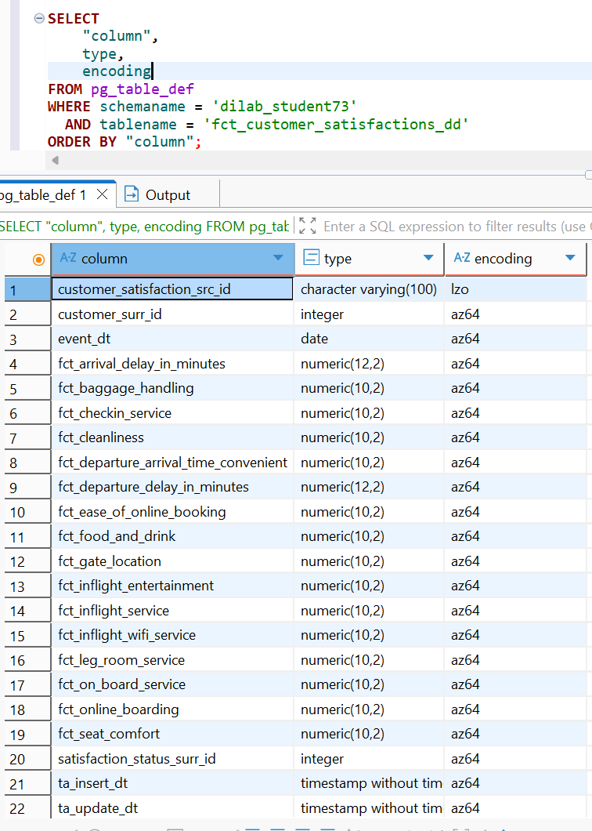
Fig. 7. Column data types and default compression encodings of the fct_customer_satisfactions_dd fact table.
Table created with defaultcomp
CREATE TABLE dilab_student73.fct_customer_satisfactions_defaultcomp (LIKE dilab_student73.fct_customer_satisfactions_dd);
INSERT INTO dilab_student73.fct_customer_satisfactions_defaultcomp SELECT * FROM dilab_student73.fct_customer_satisfactions_dd;
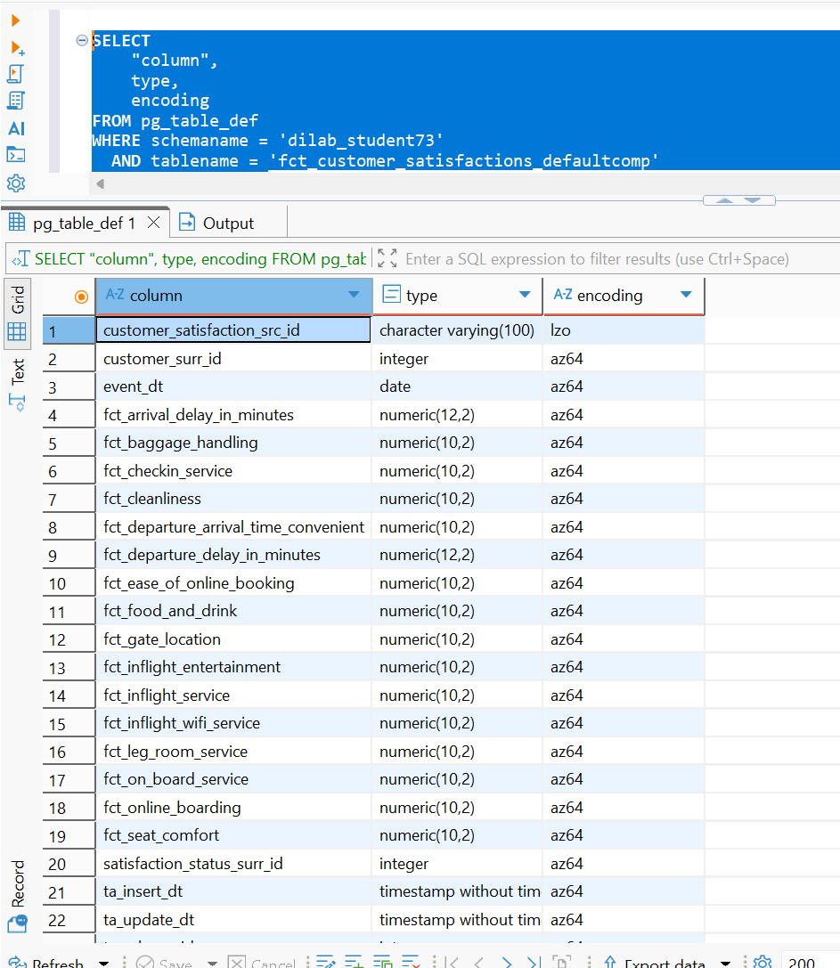
Fig. 8. Compression encodings of the fct_customer_satisfactions_defaultcomp table created with the LIKE clause; the original LZO and AZ64 encodings were preserved.
The defaultcomp created the table using LIKE and encoding styles doesn’t change
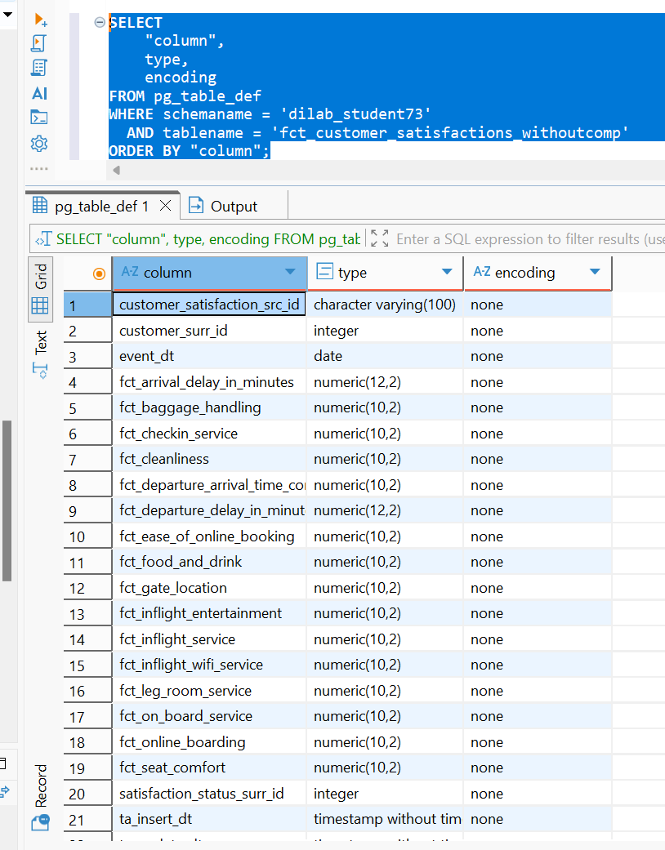
Fig. 9. Verification that the fct_customer_satisfactions_withoutcomp table was created without compression encodings.
3.c ANALYZE COMPRESSION for Redshift recommended compression.
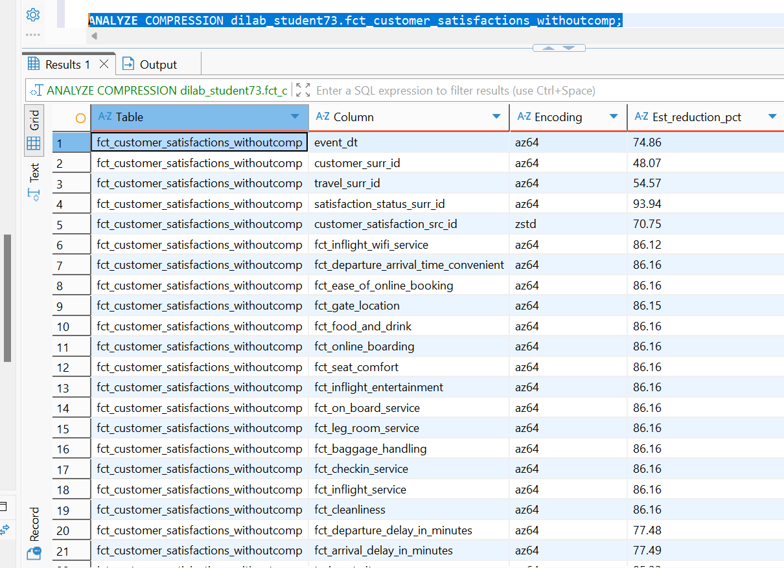
Fig. 10. Results of the ANALYZE COMPRESSION command showing Redshift-recommended encodings and estimated compression reductions by column.
Result is:
- Almost all numeric/date columns → AZ64
- customer_satisfaction_src_id → ZSTD
- Estimated reductions are substantial — many service-rating columns show about 86.16% reduction.
- satisfaction_status_surr_id is especially compressible at about 93.94%.

3.c Create a table YOUR_TABLE_analyzedcomp (same columns but applying recommended encoding types and put same data as in the YOUR_TABLE_defaultcomp table there).

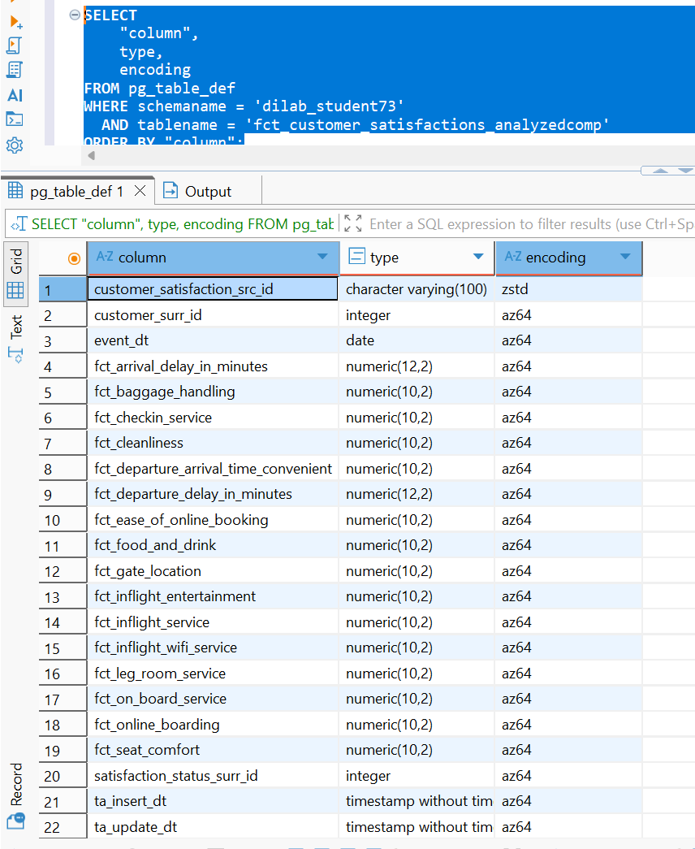
Fig. 11. Compression encodings of the fct_customer_satisfactions_analyzedcomp table created using the recommendations from ANALYZE COMPRESSION.
3.d Compare size of tables YOUR_TABLE_defaultcomp, YOUR_TABLE_withoutcomp and YOUR_TABLE_analyzedcomp. Size-row tables comparison 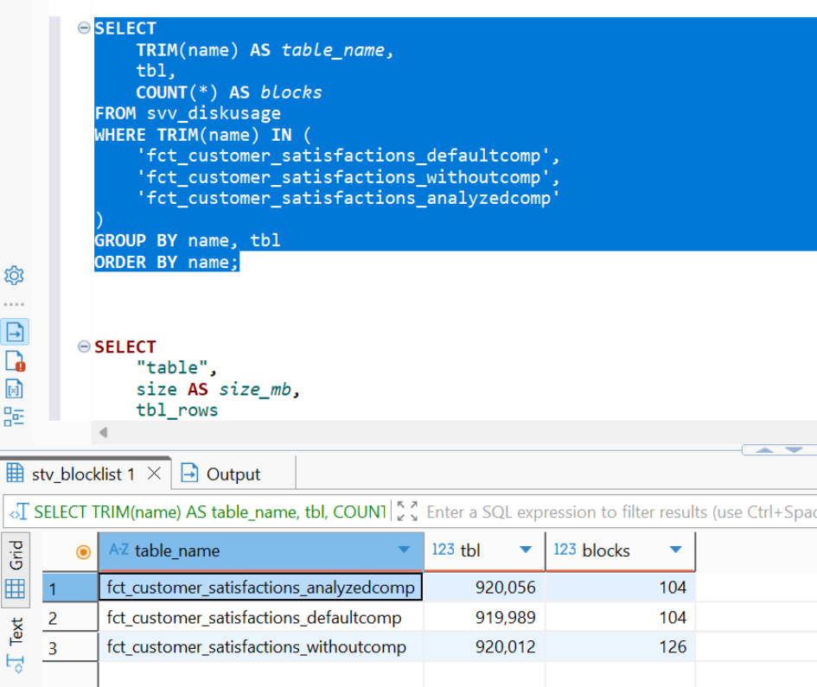
Fig. 13. Comparison of allocated disk blocks for the default-compressed, uncompressed, and analyzed-compressed fact tables.
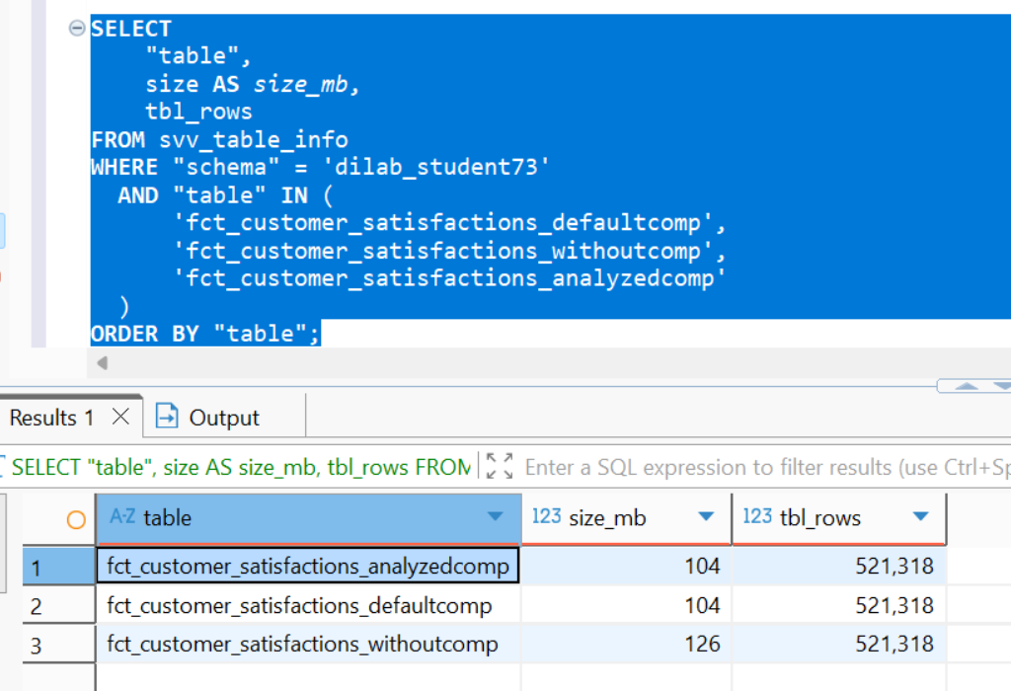
Fig. 14. Comparison of table sizes and row counts for the three compression scenarios: default compression, no compression, and recommended compression.

Table | Compression | Size
fct_customer_satisfactions_defaultcomp | Default: AZ64 + LZO | 104 MB
fct_customer_satisfactions_withoutcomp | None / RAW | 126 MB
fct_customer_satisfactions_analyzedcomp | ANALYZE: AZ64 + ZSTD | 104 MB

Compression reduces storage by (126-104)/126*100 = 17.46%
The analyzed table has the same total allocated size as the default table at this data volume. That does not mean ZSTD made no difference at the column level; Redshift storage is block-based, so a column-level improvement may not be large enough to reduce the total number of allocated MB blocks.
4.a Prepare a stored procedure that will load your report. The main part of the stored procedure is the SELECT statement that should use joins of all your tables

CREATE OR REPLACE PROCEDURE dilab_student73.sp_customer_satisfaction_report()
LANGUAGE plpgsql
AS $$
BEGIN

DROP TABLE IF EXISTS dilab_student73.customer_satisfaction_report;

CREATE TABLE dilab_student73.customer_satisfaction_report AS
SELECT
t.travel_class,
s.satisfaction_status,
COUNT(*) AS customer_count,
AVG(f.fct_inflight_wifi_service) AS avg_wifi_score,
AVG(f.fct_seat_comfort) AS avg_seat_comfort,
AVG(f.fct_inflight_service) AS avg_inflight_service,
AVG(f.fct_departure_delay_in_minutes) AS avg_departure_delay,
AVG(f.fct_arrival_delay_in_minutes) AS avg_arrival_delay
FROM dilab_student73.fct_customer_satisfactions_dd f
JOIN dilab_student73.dim_travels t
ON f.travel_surr_id = t.travel_surr_id
JOIN dilab_student73.dim_satisfaction_statuses s
ON f.satisfaction_status_surr_id = s.satisfaction_status_surr_id
GROUP BY
t.travel_class,
s.satisfaction_status;

END;
$$;

CALL dilab_student73.sp_customer_satisfaction_report();
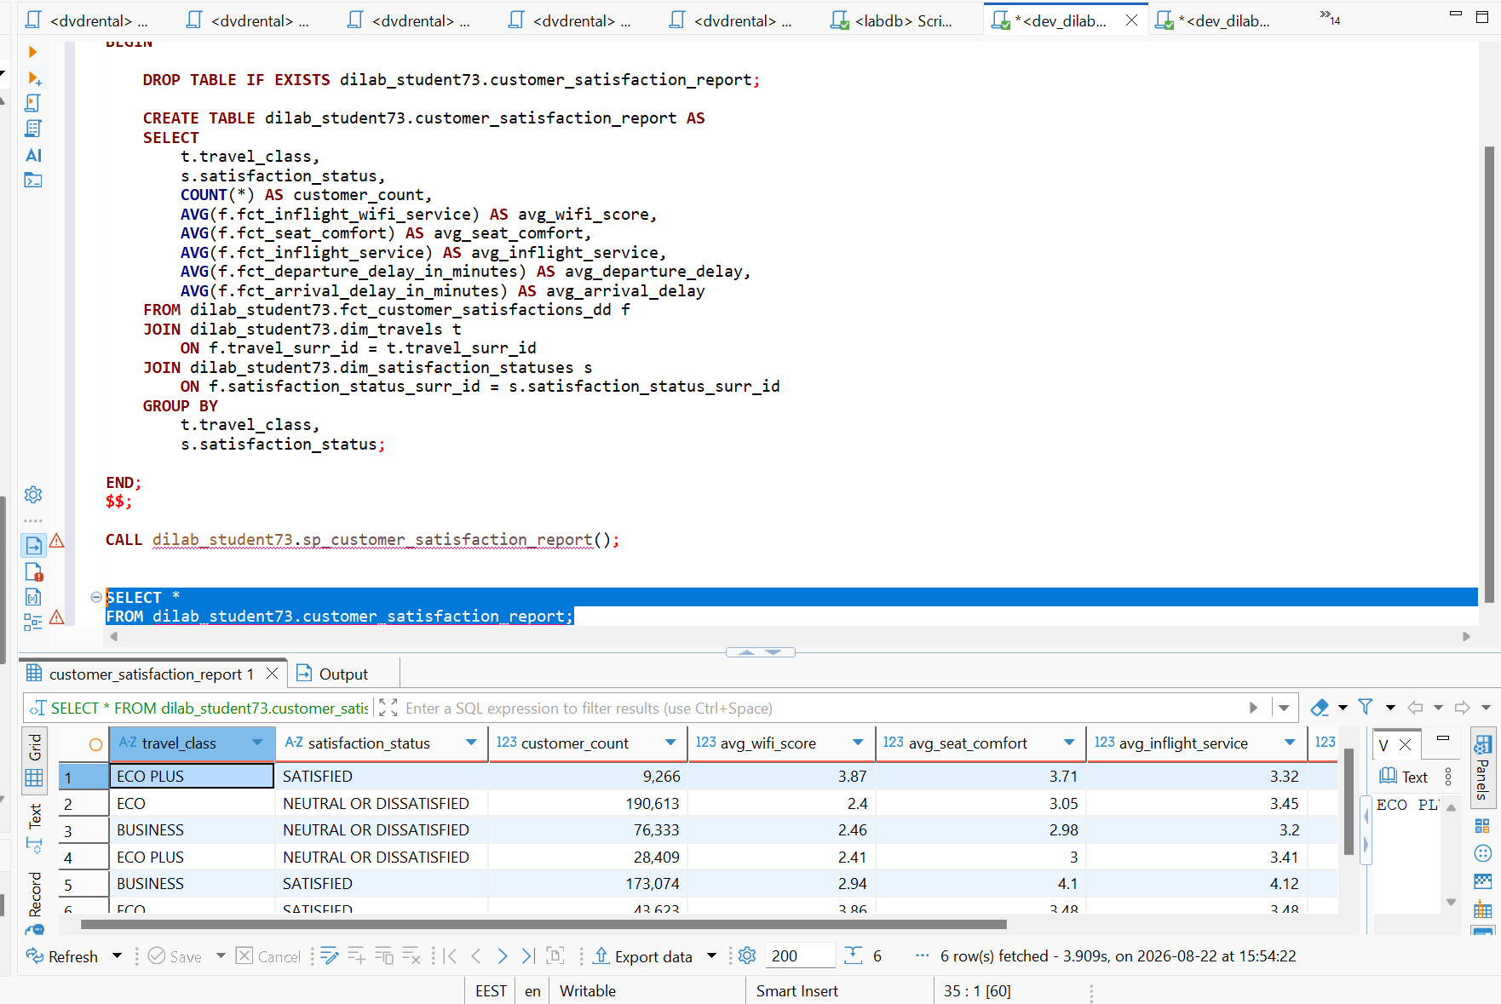
Fig. 15. Execution of the customer satisfaction reporting stored procedure and output of the aggregated customer satisfaction report.

4.b Describe the execution plan of this SELECT statement BEFORE optimization, log the time of query execution.
To collect statistics SQL statement was executed 3 times.
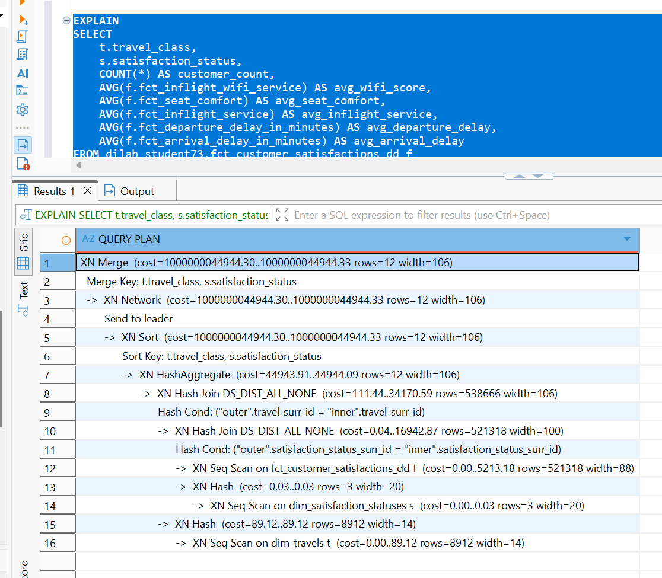
Fig. 16. Redshift execution plan for the report query before distribution and sort key optimization.
4.c Describe why the result of the first execution is not the best one to compare with.
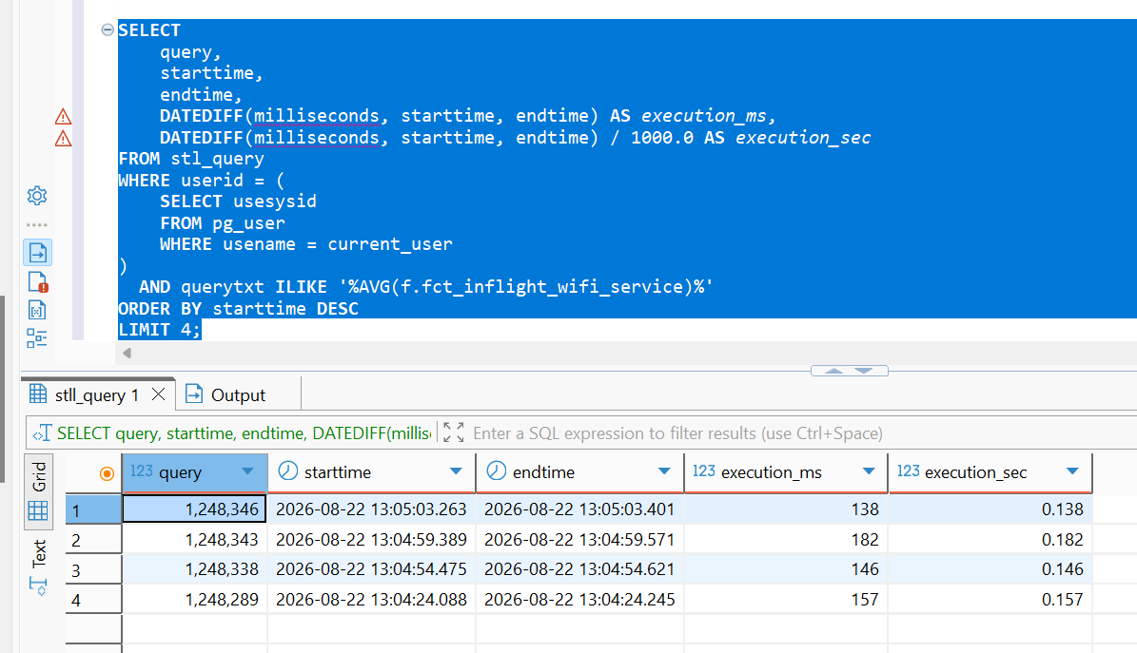
Fig. 17. Query execution times before optimization, collected from the STL_QUERY system table.
Time basiline = (T2+T3+T4)/3 = (0.182+0.146+0.138)/3 = 0.155
The query performance was evaluated with the Redshift result cache disabled. Four executions were performed. The first execution was excluded from the baseline calculation because the initial run can include additional initialization and cold-cache overhead and therefore may not represent steady-state query performance.

4.d Describe the existing distribution style of tables, its sort keys.

dim_satisfaction_statuses → AUTO(ALL)
dim_travels → AUTO(ALL)
fct_customer_satisfactions_dd → AUTO(EVEN)
all three → AUTO(SORTKEY) with sortkey_num = 0
5.Plan to optimize distribution style and sort keys is propused in the table below:
Table | Distribution | Sort key | Reason
Fact | DISTKEY(travel_surr_id) | (travel_surr_id, satisfaction_status_surr_id) | travel_surr_id is a frequent join with the larger dimension
dim_travels | DISTKEY(travel_surr_id) | travel_surr_id | co-locates rows with fact
dim_satisfaction_statuses | DISTSTYLE ALL | satisfaction_status_surr_id | only 3 rows, so replication is inexpensive

5.2. To evaluate the effect of optimization, the same report query was executed four times before and after changing the distribution style and sort keys. Redshift result caching was disabled. The first execution was excluded from each measurement because it can include additional initialization and cold-cache overhead.
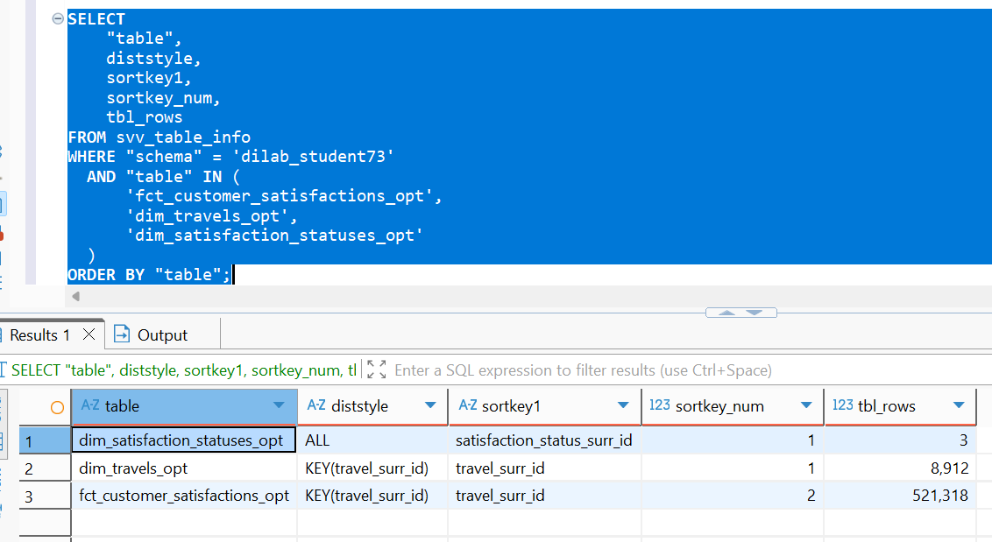
Fig. 18. Distribution styles and sort keys of the optimized fact and dimension tables.

5.b Describe the execution plan of this SELECT statement AFTER optimization, log the time of query execution. Compare it with BEFORE results. It is mandatory to describe changes in execution plans and how your optimization impacted it.

SELECT
query,
starttime,
endtime,
DATEDIFF(milliseconds, starttime, endtime) AS execution_ms,
DATEDIFF(milliseconds, starttime, endtime) / 1000.0 AS execution_sec
FROM stl_query
WHERE userid = (
SELECT usesysid
FROM pg_user
WHERE usename = current_user
)
AND querytxt ILIKE '%PT5_OPT%'
ORDER BY starttime DESC
LIMIT 4;

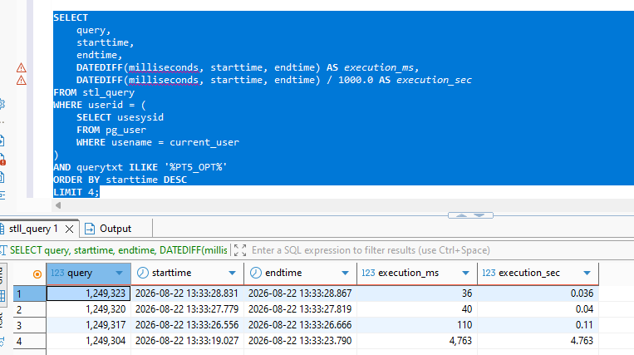
Fig. 19. Query execution times after optimization, demonstrating improved performance of the report query.

The results of the optimization
Test | Run 1 — ignore | Run 2 | Run 3 | Run 4 | Average runs 2–4
Before optimization | 0.157 s | 0.146 s | 0.182 s | 0.138 s | 0.155 s
After optimization | 4.763 s | 0.110 s | 0.040 s | 0.036 s | 0.062 s

Average of the Execution= (0.110+0.040+0.036)/3=0.062
Improvements ratio:
Improvments is (0.155−0.062)/0.155×100=60.0%
Conclusions:
Before optimization, the three measured executions took 0.146 s, 0.182 s, and 0.138 s, resulting in an average execution time of 0.155 s. After optimization, the corresponding executions took 0.110 s, 0.040 s, and 0.036 s, with an average of 0.062 s.
Therefore, the average execution time decreased from 0.155 s to 0.062 s, corresponding to an improvement of approximately 60%, or approximately 2.5 times faster execution. The first optimized execution took 4.763 s and was excluded according to the testing methodology
6. Run the stored procedure using optimized tables and load data to your report.
CREATE OR REPLACE PROCEDURE dilab_student73.sp_customer_satisfaction_report()
LANGUAGE plpgsql
AS $$
BEGIN

DROP TABLE IF EXISTS dilab_student73.customer_satisfaction_report;

CREATE TABLE dilab_student73.customer_satisfaction_report AS
SELECT
t.travel_class,
s.satisfaction_status,
COUNT(*) AS customer_count,
AVG(f.fct_inflight_wifi_service) AS avg_wifi_score,
AVG(f.fct_seat_comfort) AS avg_seat_comfort,
AVG(f.fct_inflight_service) AS avg_inflight_service,
AVG(f.fct_departure_delay_in_minutes) AS avg_departure_delay,
AVG(f.fct_arrival_delay_in_minutes) AS avg_arrival_delay
FROM dilab_student73.fct_customer_satisfactions_opt f
JOIN dilab_student73.dim_travels_opt t
ON f.travel_surr_id = t.travel_surr_id
JOIN dilab_student73.dim_satisfaction_statuses_opt s
ON f.satisfaction_status_surr_id = s.satisfaction_status_surr_id
GROUP BY
t.travel_class,
s.satisfaction_status;

END;
$$;
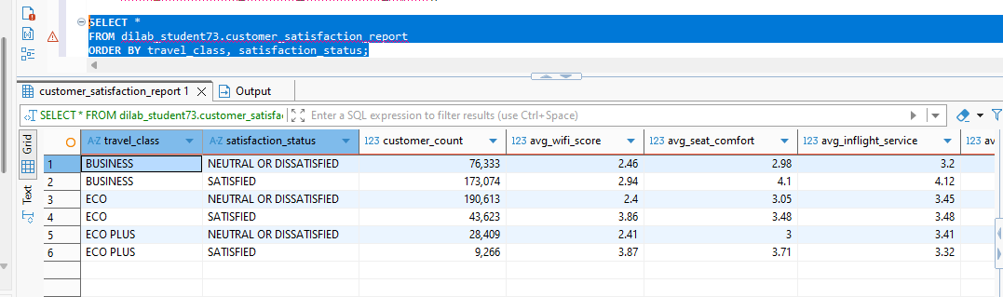
The stored procedure was updated to use the optimized fact and dimension tables and was executed successfully. The procedure joins customer satisfaction data with travel and satisfaction-status dimensions and calculates aggregated KPIs, including customer count, average Wi-Fi service score, average seat comfort, average inflight service score, and average departure and arrival delays.
COPY QUESTION
For this task one responsible student will be chosen. He will run statements below and run COPY statements. Execution time of both COPY commands should be written down and provisioned to all of the students. Each student should get this info and describe reasons of the resulting difference in execution.
1. Create tables lineorder_1 and lineorder_2 using following DDL statement
CREATE TABLE dilab_student73.lineorder_1 (
lo_orderkey INTEGER NOT NULL,
lo_linenumber INTEGER NOT NULL,
lo_custkey INTEGER NOT NULL,
lo_partkey INTEGER NOT NULL,
lo_suppkey INTEGER NOT NULL,
lo_orderdate INTEGER NOT NULL,
lo_orderpriority VARCHAR(15) NOT NULL,
lo_shippriority VARCHAR(1) NOT NULL,
lo_quantity INTEGER NOT NULL,
lo_extendedprice INTEGER NOT NULL,
lo_ordertotalprice INTEGER NOT NULL,
lo_discount INTEGER NOT NULL,
lo_revenue INTEGER NOT NULL,
lo_supplycost INTEGER NOT NULL,
lo_tax INTEGER NOT NULL,
lo_commitdate INTEGER NOT NULL,
lo_shipmode VARCHAR(10) NOT NULL
);

CREATE TABLE dilab_student73.lineorder_2
(LIKE dilab_student73.lineorder_1);
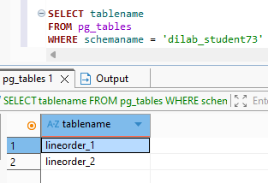
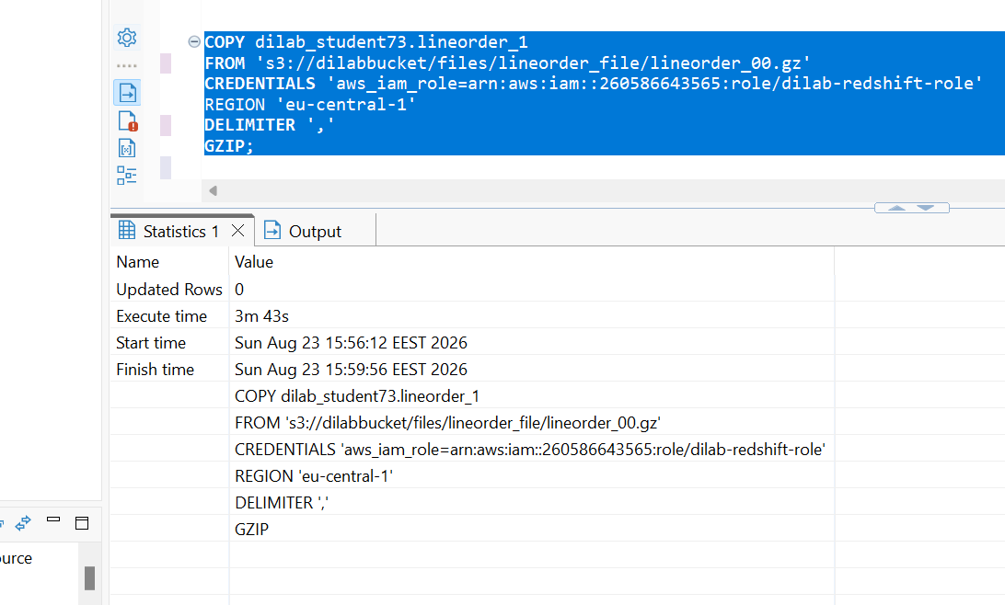
Load into table 'lineorder_1' completed, 100000008 record(s) loaded successfully.
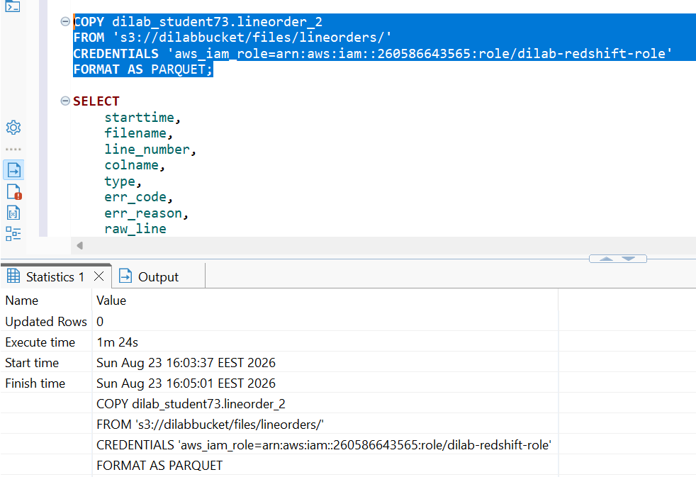
Load into table 'lineorder_2' completed, 100000008 record(s) loaded successfully.

The COPY operation for lineorder_1 took 3 min 43 s (223 s), while the load of lineorder_2 took 1 min 24 s (84 s). Thus, loading the multi-file Parquet dataset was approximately 2.65 times faster, corresponding to a reduction in execution time of approximately 62.3%. The main reason is that Amazon Redshift can process multiple source files in parallel across available compute resources, whereas a single large source file limits the degree of parallelism. In addition, the first source is a GZIP-compressed CSV file, which requires decompression and text parsing, while the second source consists of Parquet files, a binary columnar format that can be processed more efficiently. Therefore, the observed performance difference is caused by both the number of input files and their physical format.

WORKING WITH EXTERNAL TABLES
- Create external schema (user_dilab_student(1..32)_ext) pointing to your location and create several external tables on your files.

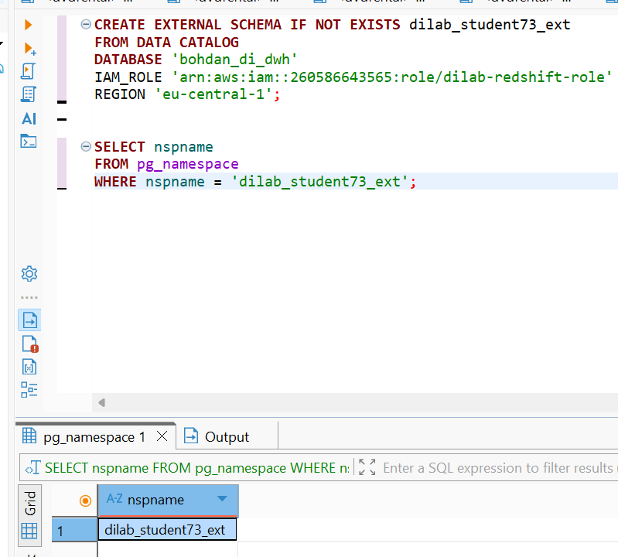
2.Partitioned external tables are extremely useful for the performance and cost cuts.
Number of records per month
SELECT
DATE_TRUNC('month', event_dt)::DATE AS event_month,
COUNT(*) AS row_count
FROM dilab_student73.fct_customer_satisfactions_dd
GROUP BY 1
ORDER BY 1;
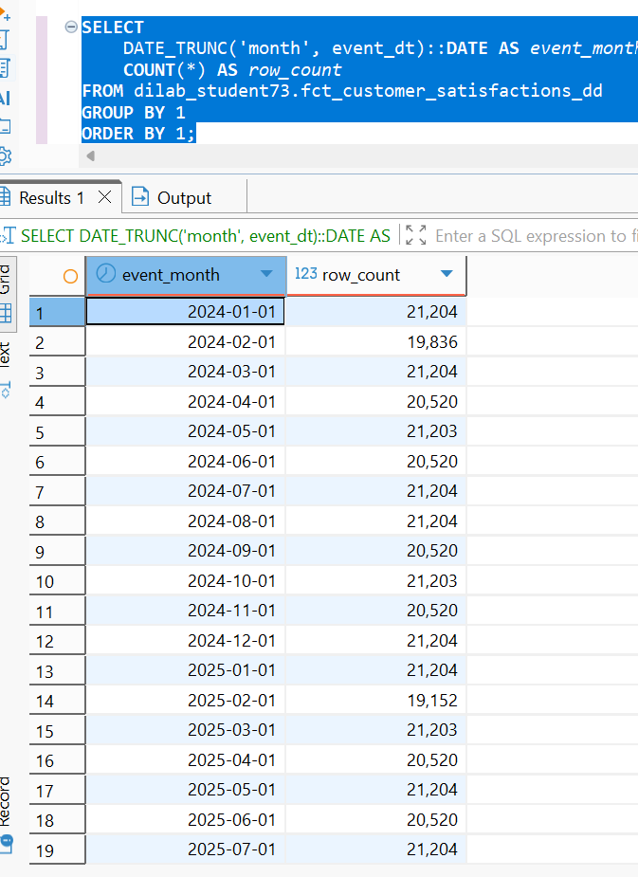
2.a Export any data which contain date column into S3 in a way, so each subfolder contains 1 month data

Data partitioned by month.
UNLOAD ('
SELECT
event_dt,
customer_surr_id,
travel_surr_id,
satisfaction_status_surr_id,
customer_satisfaction_src_id,
fct_inflight_wifi_service,
fct_departure_arrival_time_convenient,
fct_ease_of_online_booking,
fct_gate_location,
fct_food_and_drink,
fct_online_boarding,
fct_seat_comfort,
fct_inflight_entertainment,
fct_on_board_service,
fct_leg_room_service,
fct_baggage_handling,
fct_checkin_service,
fct_inflight_service,
fct_cleanliness,
fct_departure_delay_in_minutes,
fct_arrival_delay_in_minutes,
ta_insert_dt,
ta_update_dt,
DATE_TRUNC(''month'', event_dt)::DATE AS event_month
FROM dilab_student73.fct_customer_satisfactions_dd
')
TO 's3://bohdan-di-dwh-260586643565/redshift_spectrum/customer_satisfaction/'
IAM_ROLE 'arn:aws:iam::260586643565:role/dilab-redshift-role'
FORMAT AS PARQUET
PARTITION BY (event_month)
ALLOWOVERWRITE;

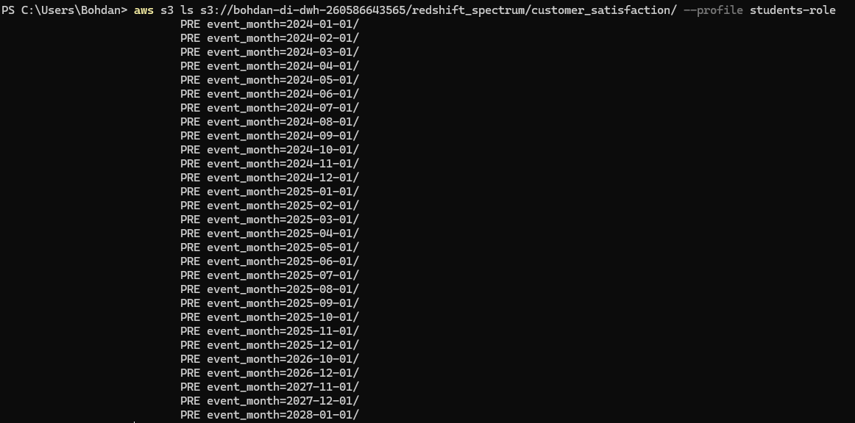
2.b Create PARTITIONED external table “ext_studentN_partitioned” (partition by
your_date_column).
New External partitioned table
CREATE EXTERNAL TABLE dilab_student73_ext.ext_student73_partitioned (
event_dt DATE,
customer_surr_id INTEGER,
travel_surr_id INTEGER,
satisfaction_status_surr_id INTEGER,
customer_satisfaction_src_id VARCHAR(100),
fct_inflight_wifi_service DECIMAL(10,2),
fct_departure_arrival_time_convenient DECIMAL(10,2),
fct_ease_of_online_booking DECIMAL(10,2),
fct_gate_location DECIMAL(10,2),
fct_food_and_drink DECIMAL(10,2),
fct_online_boarding DECIMAL(10,2),
fct_seat_comfort DECIMAL(10,2),
fct_inflight_entertainment DECIMAL(10,2),
fct_on_board_service DECIMAL(10,2),
fct_leg_room_service DECIMAL(10,2),
fct_baggage_handling DECIMAL(10,2),
fct_checkin_service DECIMAL(10,2),
fct_inflight_service DECIMAL(10,2),
fct_cleanliness DECIMAL(10,2),
fct_departure_delay_in_minutes DECIMAL(12,2),
fct_arrival_delay_in_minutes DECIMAL(12,2),
ta_insert_dt TIMESTAMP,
ta_update_dt TIMESTAMP
)
PARTITIONED BY (
event_month DATE
)
STORED AS PARQUET
LOCATION 's3://bohdan-di-dwh-260586643565/redshift_spectrum/customer_satisfaction/';

SELECT DISTINCT
'ALTER TABLE dilab_student73_ext.ext_student73_partitioned ' ||
'ADD IF NOT EXISTS PARTITION (event_month=''' ||
TO_CHAR(DATE_TRUNC('month', event_dt), 'YYYY-MM-DD') ||
''') LOCATION ''s3://bohdan-di-dwh-260586643565/redshift_spectrum/customer_satisfaction/event_month=' ||
TO_CHAR(DATE_TRUNC('month', event_dt), 'YYYY-MM-DD') ||
'/'';' AS partition_sql
FROM dilab_student73.fct_customer_satisfactions_dd
ORDER BY 1;

ALTER TABLE dilab_student73_ext.ext_student73_partitioned ADD IF NOT EXISTS PARTITION (event_month='2024-01-01') LOCATION 's3://bohdan-di-dwh-260586643565/redshift_spectrum/customer_satisfaction/event_month=2024-01-01/';
ALTER TABLE dilab_student73_ext.ext_student73_partitioned ADD IF NOT EXISTS PARTITION (event_month='2024-02-01') LOCATION 's3://bohdan-di-dwh-260586643565/redshift_spectrum/customer_satisfaction/event_month=2024-02-01/';
ALTER TABLE dilab_student73_ext.ext_student73_partitioned ADD IF NOT EXISTS PARTITION (event_month='2024-03-01') LOCATION 's3://bohdan-di-dwh-260586643565/redshift_spectrum/customer_satisfaction/event_month=2024-03-01/';
ALTER TABLE dilab_student73_ext.ext_student73_partitioned ADD IF NOT EXISTS PARTITION (event_month='2024-04-01') LOCATION 's3://bohdan-di-dwh-260586643565/redshift_spectrum/customer_satisfaction/event_month=2024-04-01/';
ALTER TABLE dilab_student73_ext.ext_student73_partitioned ADD IF NOT EXISTS PARTITION (event_month='2024-05-01') LOCATION 's3://bohdan-di-dwh-260586643565/redshift_spectrum/customer_satisfaction/event_month=2024-05-01/';
ALTER TABLE dilab_student73_ext.ext_student73_partitioned ADD IF NOT EXISTS PARTITION (event_month='2024-06-01') LOCATION 's3://bohdan-di-dwh-260586643565/redshift_spectrum/customer_satisfaction/event_month=2024-06-01/';
ALTER TABLE dilab_student73_ext.ext_student73_partitioned ADD IF NOT EXISTS PARTITION (event_month='2024-07-01') LOCATION 's3://bohdan-di-dwh-260586643565/redshift_spectrum/customer_satisfaction/event_month=2024-07-01/';
ALTER TABLE dilab_student73_ext.ext_student73_partitioned ADD IF NOT EXISTS PARTITION (event_month='2024-08-01') LOCATION 's3://bohdan-di-dwh-260586643565/redshift_spectrum/customer_satisfaction/event_month=2024-08-01/';
ALTER TABLE dilab_student73_ext.ext_student73_partitioned ADD IF NOT EXISTS PARTITION (event_month='2024-09-01') LOCATION 's3://bohdan-di-dwh-260586643565/redshift_spectrum/customer_satisfaction/event_month=2024-09-01/';
ALTER TABLE dilab_student73_ext.ext_student73_partitioned ADD IF NOT EXISTS PARTITION (event_month='2024-10-01') LOCATION 's3://bohdan-di-dwh-260586643565/redshift_spectrum/customer_satisfaction/event_month=2024-10-01/';
ALTER TABLE dilab_student73_ext.ext_student73_partitioned ADD IF NOT EXISTS PARTITION (event_month='2024-11-01') LOCATION 's3://bohdan-di-dwh-260586643565/redshift_spectrum/customer_satisfaction/event_month=2024-11-01/';
ALTER TABLE dilab_student73_ext.ext_student73_partitioned ADD IF NOT EXISTS PARTITION (event_month='2024-12-01') LOCATION 's3://bohdan-di-dwh-260586643565/redshift_spectrum/customer_satisfaction/event_month=2024-12-01/';
ALTER TABLE dilab_student73_ext.ext_student73_partitioned ADD IF NOT EXISTS PARTITION (event_month='2025-01-01') LOCATION 's3://bohdan-di-dwh-260586643565/redshift_spectrum/customer_satisfaction/event_month=2025-01-01/';
ALTER TABLE dilab_student73_ext.ext_student73_partitioned ADD IF NOT EXISTS PARTITION (event_month='2025-02-01') LOCATION 's3://bohdan-di-dwh-260586643565/redshift_spectrum/customer_satisfaction/event_month=2025-02-01/';
ALTER TABLE dilab_student73_ext.ext_student73_partitioned ADD IF NOT EXISTS PARTITION (event_month='2025-03-01') LOCATION 's3://bohdan-di-dwh-260586643565/redshift_spectrum/customer_satisfaction/event_month=2025-03-01/';
ALTER TABLE dilab_student73_ext.ext_student73_partitioned ADD IF NOT EXISTS PARTITION (event_month='2025-04-01') LOCATION 's3://bohdan-di-dwh-260586643565/redshift_spectrum/customer_satisfaction/event_month=2025-04-01/';
ALTER TABLE dilab_student73_ext.ext_student73_partitioned ADD IF NOT EXISTS PARTITION (event_month='2025-05-01') LOCATION 's3://bohdan-di-dwh-260586643565/redshift_spectrum/customer_satisfaction/event_month=2025-05-01/';
ALTER TABLE dilab_student73_ext.ext_student73_partitioned ADD IF NOT EXISTS PARTITION (event_month='2025-06-01') LOCATION 's3://bohdan-di-dwh-260586643565/redshift_spectrum/customer_satisfaction/event_month=2025-06-01/';
ALTER TABLE dilab_student73_ext.ext_student73_partitioned ADD IF NOT EXISTS PARTITION (event_month='2025-07-01') LOCATION 's3://bohdan-di-dwh-260586643565/redshift_spectrum/customer_satisfaction/event_month=2025-07-01/';
ALTER TABLE dilab_student73_ext.ext_student73_partitioned ADD IF NOT EXISTS PARTITION (event_month='2025-08-01') LOCATION 's3://bohdan-di-dwh-260586643565/redshift_spectrum/customer_satisfaction/event_month=2025-08-01/';
ALTER TABLE dilab_student73_ext.ext_student73_partitioned ADD IF NOT EXISTS PARTITION (event_month='2025-09-01') LOCATION 's3://bohdan-di-dwh-260586643565/redshift_spectrum/customer_satisfaction/event_month=2025-09-01/';
ALTER TABLE dilab_student73_ext.ext_student73_partitioned ADD IF NOT EXISTS PARTITION (event_month='2025-10-01') LOCATION 's3://bohdan-di-dwh-260586643565/redshift_spectrum/customer_satisfaction/event_month=2025-10-01/';
ALTER TABLE dilab_student73_ext.ext_student73_partitioned ADD IF NOT EXISTS PARTITION (event_month='2025-11-01') LOCATION 's3://bohdan-di-dwh-260586643565/redshift_spectrum/customer_satisfaction/event_month=2025-11-01/';
ALTER TABLE dilab_student73_ext.ext_student73_partitioned ADD IF NOT EXISTS PARTITION (event_month='2025-12-01') LOCATION 's3://bohdan-di-dwh-260586643565/redshift_spectrum/customer_satisfaction/event_month=2025-12-01/';
ALTER TABLE dilab_student73_ext.ext_student73_partitioned ADD IF NOT EXISTS PARTITION (event_month='2026-10-01') LOCATION 's3://bohdan-di-dwh-260586643565/redshift_spectrum/customer_satisfaction/event_month=2026-10-01/';
ALTER TABLE dilab_student73_ext.ext_student73_partitioned ADD IF NOT EXISTS PARTITION (event_month='2026-12-01') LOCATION 's3://bohdan-di-dwh-260586643565/redshift_spectrum/customer_satisfaction/event_month=2026-12-01/';
ALTER TABLE dilab_student73_ext.ext_student73_partitioned ADD IF NOT EXISTS PARTITION (event_month='2027-11-01') LOCATION 's3://bohdan-di-dwh-260586643565/redshift_spectrum/customer_satisfaction/event_month=2027-11-01/';
ALTER TABLE dilab_student73_ext.ext_student73_partitioned ADD IF NOT EXISTS PARTITION (event_month='2027-12-01') LOCATION 's3://bohdan-di-dwh-260586643565/redshift_spectrum/customer_satisfaction/event_month=2027-12-01/';
ALTER TABLE dilab_student73_ext.ext_student73_partitioned ADD IF NOT EXISTS PARTITION (event_month='2028-01-01') LOCATION 's3://bohdan-di-dwh-260586643565/redshift_spectrum/customer_satisfaction/event_month=2028-01-01/';
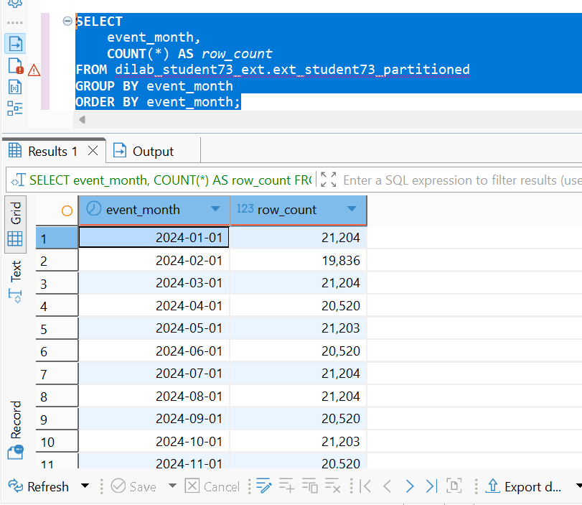
2.c Verify data in partitioned external table (compare number of records per month to original table from which you prepared files or just with rows in the files). Prepare the test script that will show 0 difference (if it is not 0 – there is an issue).

WITH original AS (
SELECT
DATE_TRUNC('month', event_dt)::DATE AS event_month,
COUNT(*) AS original_count
FROM dilab_student73.fct_customer_satisfactions_dd
GROUP BY 1
),
external_data AS (
SELECT
event_month,
COUNT(*) AS external_count
FROM dilab_student73_ext.ext_student73_partitioned
GROUP BY 1
)
SELECT
COALESCE(o.event_month, e.event_month) AS event_month,
COALESCE(o.original_count, 0) AS original_count,
COALESCE(e.external_count, 0) AS external_count,
COALESCE(o.original_count, 0) -
COALESCE(e.external_count, 0) AS difference
FROM original o
FULL OUTER JOIN external_data e
ON o.event_month = e.event_month
ORDER BY event_month;
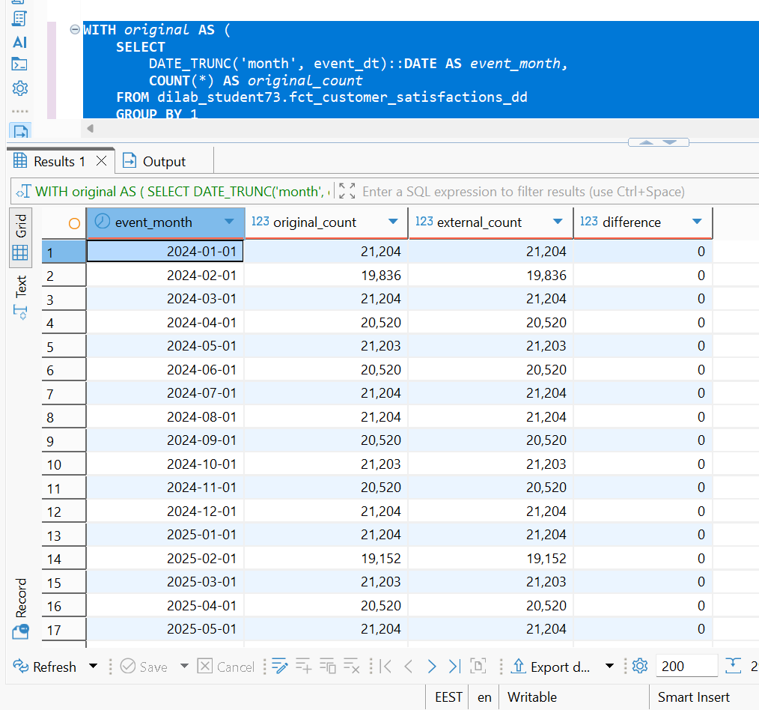
2.d Examine query plan where you select from ext_studentN_partitioned with a WHERE clause containing your_date_column condition.
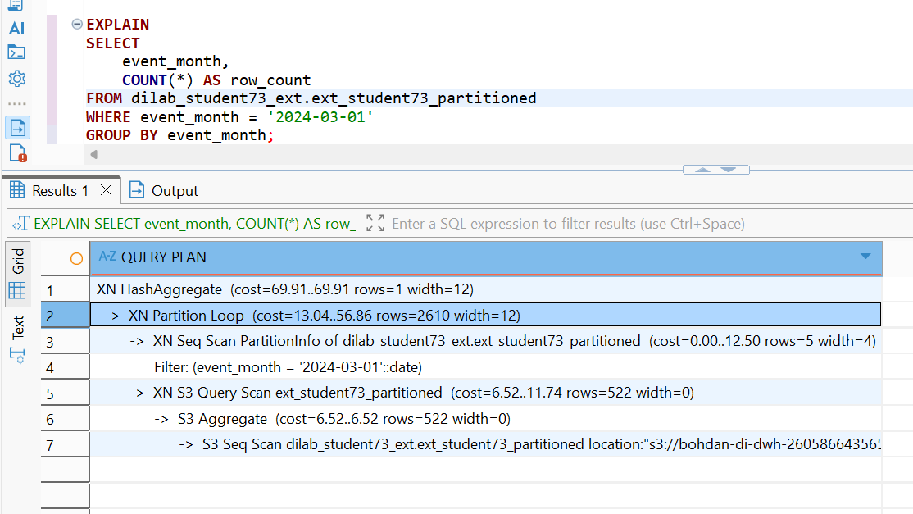

Artition pruning analysis.
The external table ext_student73_partitioned was partitioned by event_month. An EXPLAIN query with the condition WHERE event_month = '2024-03-01' was used to analyze access to the external data.
This reduces the amount of data read from S3 and therefore improves query performance and reduces Spectrum scan cost. The query returned 21,204 records for March 2024, which matches the corresponding record count in the original Redshift table.

