AWS CLOUD FOR DATA ENGINEERING

TASK 1. RDS MYSQL

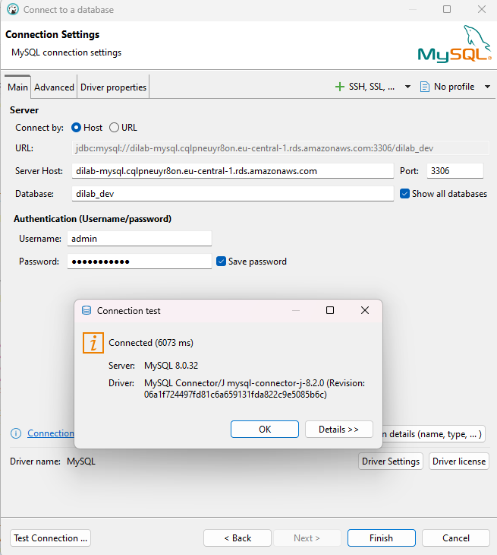

Creation of a new user – bohdan_solovei
The administrator account was used only for the initial creation of the personal database user. After the required privileges were granted, all subsequent database operations were performed using the bohdan_solovei account, which follows the task requirement to avoid using the shared administrator account.
SELECT USER(), CURRENT_USER(), DATABASE();

CREATE USER IF NOT EXISTS 'bohdan_solovei'@'%'
IDENTIFIED BY 'BohdanLab73_2026!';

GRANT CREATE, ALTER, DROP,
SELECT, INSERT, UPDATE, DELETE,
CREATE VIEW, SHOW VIEW,
CREATE ROUTINE, ALTER ROUTINE, EXECUTE
ON *.*
TO 'bohdan_solovei'@'%';

SHOW GRANTS FOR 'bohdan_solovei'@'%';

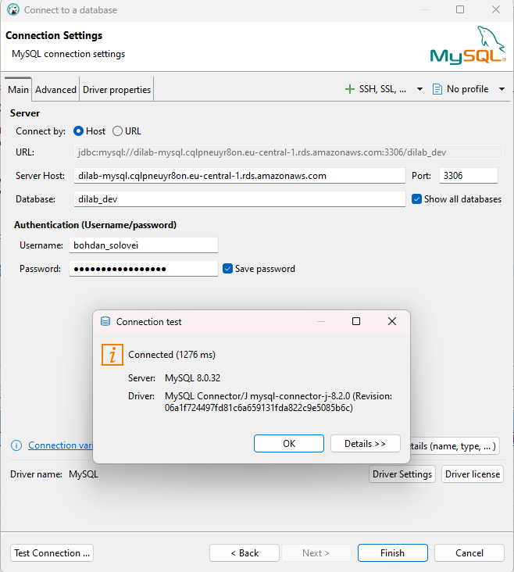

Creation of a separate schema – bohdan_solovei_db
A separate schema, bohdan_solovei_db, was created to isolate the objects used in this laboratory work from other users and schemas on the shared RDS MySQL instance. SELECT DATABASE() was used to verify that the active schema was changed successfully.
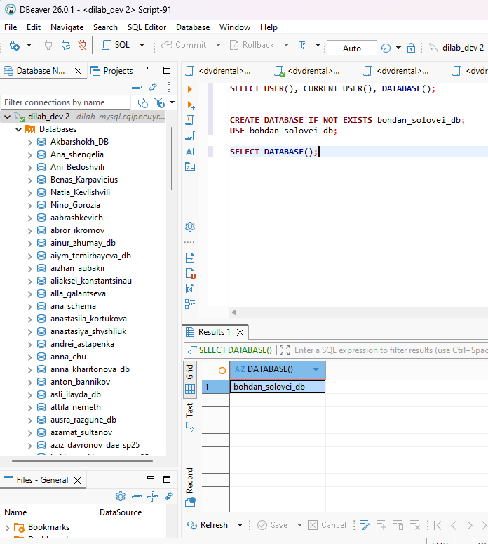
Creation of table bookings on schema Bohdan_solovei_db
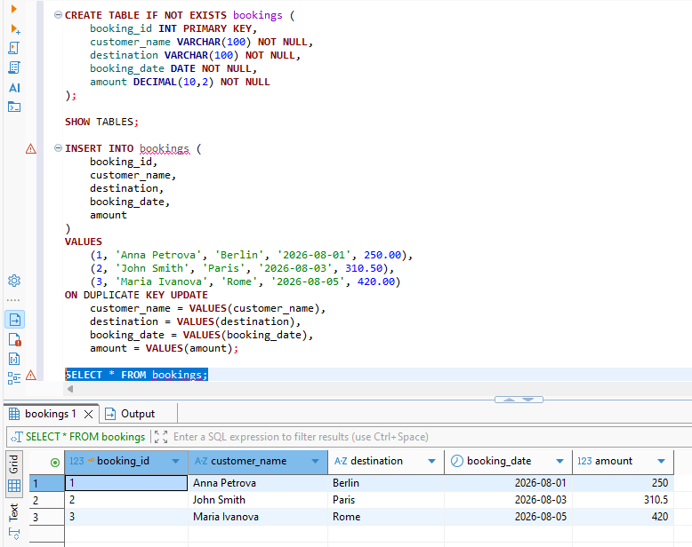
The bookings table represents a simple booking dataset and contains a primary key together with customer, destination, booking date, and amount attributes. CREATE TABLE IF NOT EXISTS makes table creation safe to repeat, while ON DUPLICATE KEY UPDATE makes the initial data load restartable without creating duplicate rows.
Creation of View v_booking_summary
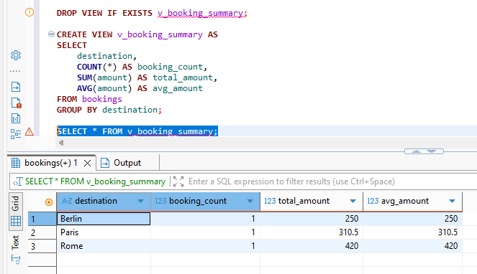
The v_booking_summary view aggregates booking information by destination and provides the booking count, total amount, and average amount. The view demonstrates how a reusable analytical layer can be created on top of the base table without duplicating the underlying data.

Created the procedure sp_add_booking
The sp_add_booking stored procedure encapsulates insertion and update logic for a booking. If the supplied booking_id already exists, ON DUPLICATE KEY UPDATE refreshes the existing values instead of failing or creating a duplicate, which supports the restartable design of the initialization process.
DROP PROCEDURE IF EXISTS sp_add_booking;

CREATE PROCEDURE sp_add_booking (
IN p_booking_id INT,
IN p_customer_name VARCHAR(100),
IN p_destination VARCHAR(100),
IN p_booking_date DATE,
IN p_amount DECIMAL(10,2)
)
BEGIN
INSERT INTO bookings (
booking_id,
customer_name,
destination,
booking_date,
amount
)
VALUES (
p_booking_id,
p_customer_name,
p_destination,
p_booking_date,
p_amount
)
ON DUPLICATE KEY UPDATE
customer_name = p_customer_name,
destination = p_destination,
booking_date = p_booking_date,
amount = p_amount;
END

CALL sp_add_booking(
4,
'Peter Brown',
'Vienna',
'2026-08-10',
285.00
);
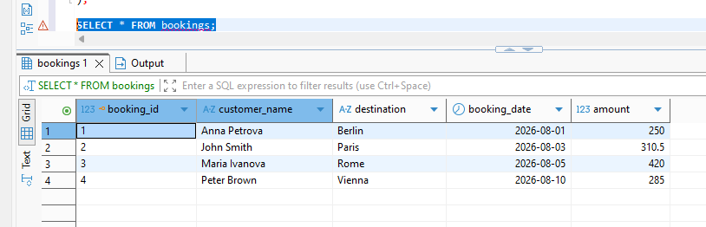
The Initial, re-runnable script:
The initialization script is restartable because database and table creation use IF NOT EXISTS, the view and procedure are dropped before being recreated, and the seed data uses ON DUPLICATE KEY UPDATE. Therefore, executing the script repeatedly leaves the database in a consistent state rather than duplicating objects or data.
CREATE DATABASE IF NOT EXISTS bohdan_solovei_db;
USE bohdan_solovei_db;

CREATE TABLE IF NOT EXISTS bookings (
booking_id INT PRIMARY KEY,
customer_name VARCHAR(100) NOT NULL,
destination VARCHAR(100) NOT NULL,
booking_date DATE NOT NULL,
amount DECIMAL(10,2) NOT NULL
);

INSERT INTO bookings (
booking_id,
customer_name,
destination,
booking_date,
amount
)
VALUES
(1, 'Anna Petrova', 'Berlin', '2026-08-01', 250.00),
(2, 'John Smith', 'Paris', '2026-08-03', 310.50),
(3, 'Maria Ivanova', 'Rome', '2026-08-05', 420.00)
ON DUPLICATE KEY UPDATE
customer_name = VALUES(customer_name),
destination = VALUES(destination),
booking_date = VALUES(booking_date),
amount = VALUES(amount);

DROP VIEW IF EXISTS v_booking_summary;

CREATE VIEW v_booking_summary AS
SELECT
destination,
COUNT(*) AS booking_count,
SUM(amount) AS total_amount,
AVG(amount) AS avg_amount
FROM bookings
GROUP BY destination;

DROP PROCEDURE IF EXISTS sp_add_booking;

DELIMITER //

CREATE PROCEDURE sp_add_booking (
IN p_booking_id INT,
IN p_customer_name VARCHAR(100),
IN p_destination VARCHAR(100),
IN p_booking_date DATE,
IN p_amount DECIMAL(10,2)
)
BEGIN
INSERT INTO bookings (
booking_id,
customer_name,
destination,
booking_date,
amount
)
VALUES (
p_booking_id,
p_customer_name,
p_destination,
p_booking_date,
p_amount
)
ON DUPLICATE KEY UPDATE
customer_name = p_customer_name,
destination = p_destination,
booking_date = p_booking_date,
amount = p_amount;
END //

DELIMITER ;

Task 2: RDS Aurora

1.Use Query editor to create several meaningful (not simple) queries to the data in the Aurora db.

1.1 Top 10 most rented films
This query joins film, inventory, and rental data to identify the films with the highest number of rentals. Grouping by film and ordering the rental count in descending order provides a useful popularity ranking.

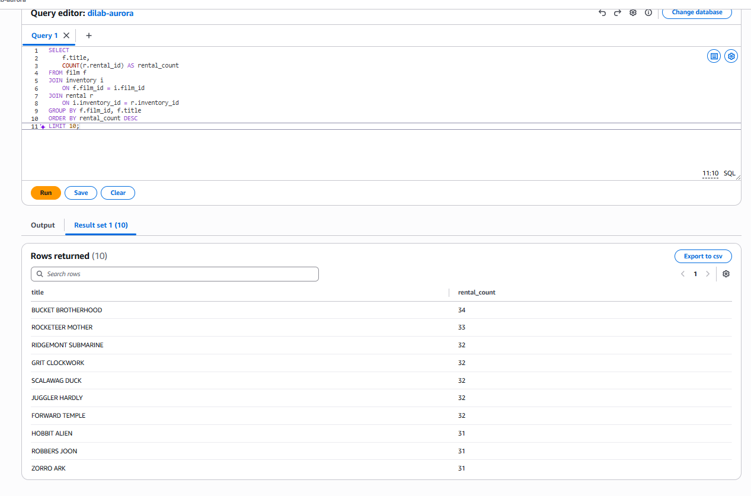

1.2 Revenue by film category
This query combines category, film, inventory, rental, and payment information to evaluate financial performance by film category. The aggregated payment count, total revenue, and average payment make it possible to compare categories from both activity and revenue perspectives.
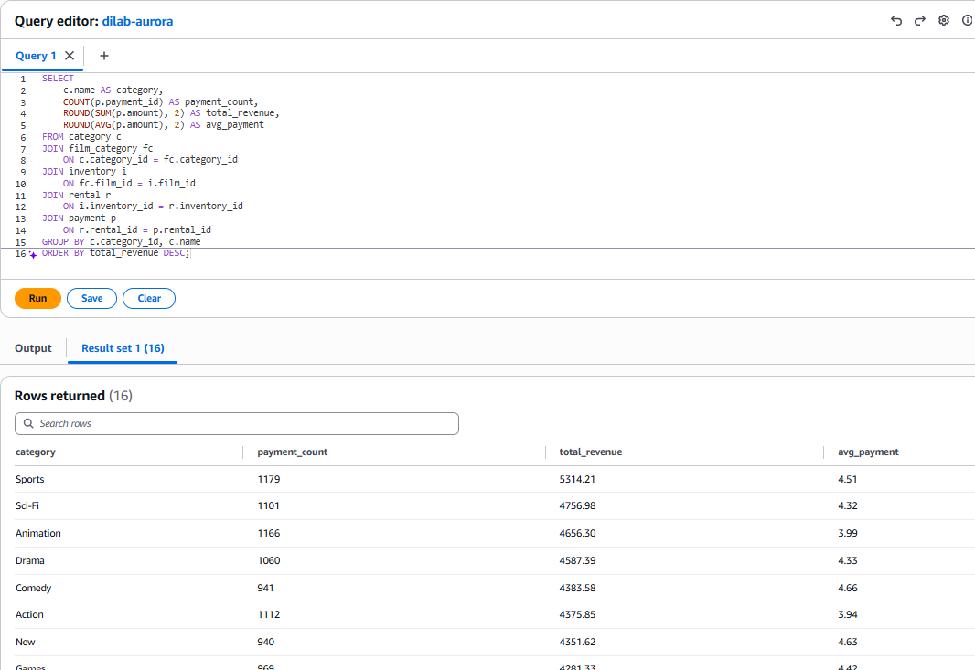

1.3 Top 10 customers by total spending and how many payments they made and their average payment amount
This query identifies the highest-value customers by aggregating their payment history. In addition to total spending, the payment count and average payment provide context about customer activity and typical transaction value.

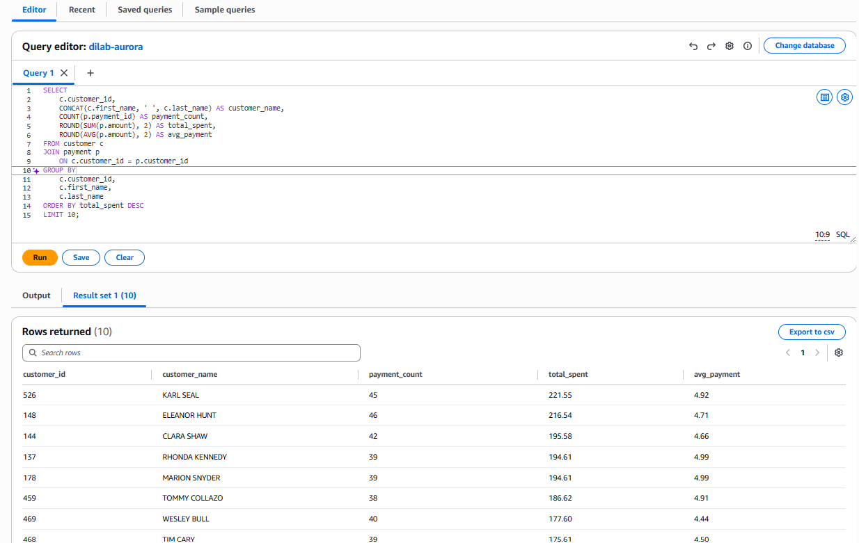
1.4 Revenue by store with customer and rental activity
SELECT
This query compares store performance using several business measures: distinct customers, rental activity, total revenue, and average payment. Joining store location data makes the result easier to interpret from an operational perspective.
s.store_id,
CONCAT(a.address, ', ', ci.city) AS store_location,
COUNT(DISTINCT c.customer_id) AS customer_count,
COUNT(DISTINCT r.rental_id) AS rental_count,
ROUND(SUM(p.amount), 2) AS total_revenue,
ROUND(AVG(p.amount), 2) AS avg_payment
FROM store s
JOIN address a
ON s.address_id = a.address_id
JOIN city ci
ON a.city_id = ci.city_id
JOIN customer c
ON s.store_id = c.store_id
JOIN rental r
ON c.customer_id = r.customer_id
JOIN payment p
ON r.rental_id = p.rental_id
GROUP BY
s.store_id,
a.address,
ci.city
ORDER BY total_revenue DESC;
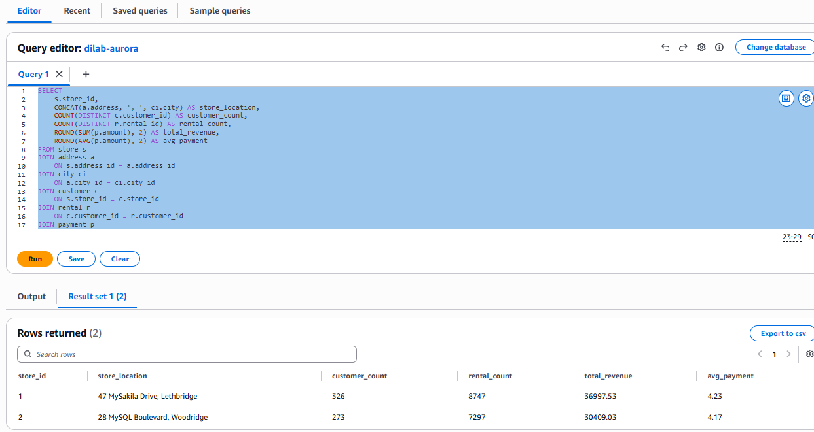

Task 2 conclusion
The Aurora Query Editor successfully executed multi-table analytical queries against the Sakila schema. The results demonstrate that Aurora MySQL supports familiar SQL joins, grouping, aggregation, ordering, and business-oriented analysis directly from the AWS Console.

Task 3. Add table in dynamodb using AWS Console and populate it manually.

The created table using AWS console - bohdan_bookings_console
The first DynamoDB table was created and populated manually in the AWS Console to demonstrate the basic console workflow. After this verification, the console table was deleted as required and the remaining DynamoDB operations were performed through AWS CLI API calls.
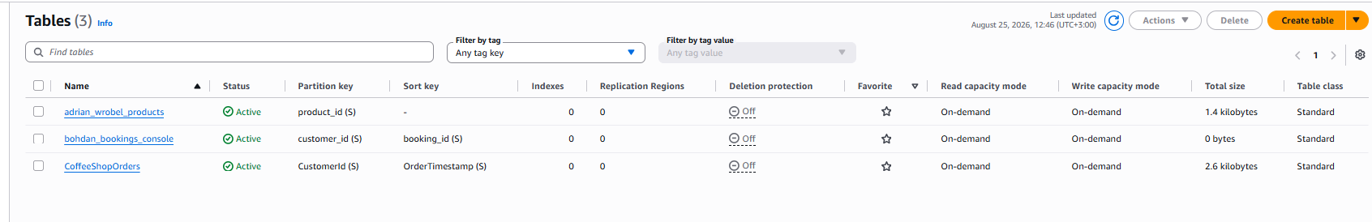
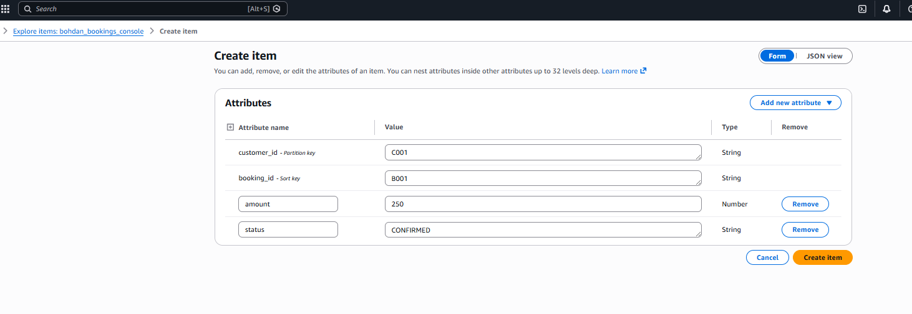
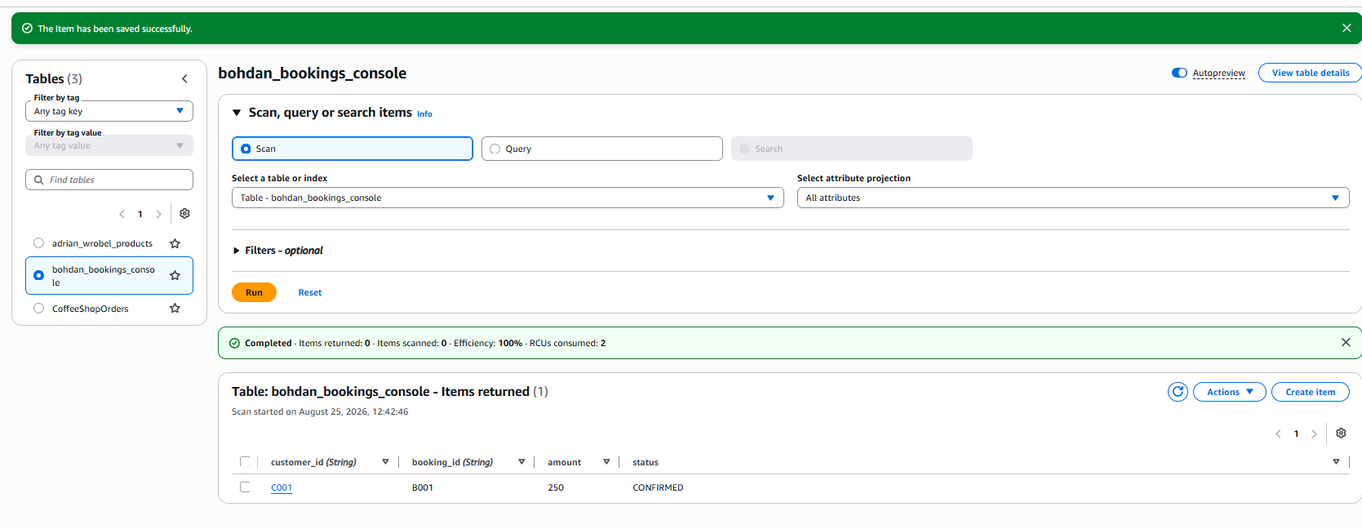

Add table in dynamodb using AWS Console and populate it manually.
PS C:\Users\Bohdan> aws dynamodb create-table `
>> --table-name bohdan_bookings `
>> --attribute-definitions AttributeName=customer_id,AttributeType=S AttributeName=booking_id,AttributeType=S `
>> --key-schema AttributeName=customer_id,KeyType=HASH AttributeName=booking_id,KeyType=RANGE `
>> --billing-mode PAY_PER_REQUEST `
>> --region eu-central-1 `
>> --profile students-role
{
"TableDescription": {
"AttributeDefinitions": [
{
"AttributeName": "booking_id",
"AttributeType": "S"
},
{
"AttributeName": "customer_id",
"AttributeType": "S"
}
],
"TableName": "bohdan_bookings",
"KeySchema": [
{
"AttributeName": "customer_id",
"KeyType": "HASH"
},
{
"AttributeName": "booking_id",
"KeyType": "RANGE"
}
],
"TableStatus": "CREATING",
"CreationDateTime": "2026-08-25T14:19:59.404000+03:00",
"ProvisionedThroughput": {
"NumberOfDecreasesToday": 0,
"ReadCapacityUnits": 0,
"WriteCapacityUnits": 0
},
"TableSizeBytes": 0,
"ItemCount": 0,
"TableArn": "arn:aws:dynamodb:eu-central-1:260586643565:table/bohdan_bookings",
"TableId": "0aec1ab1-e603-44fe-b8b2-b6ceea2ccf31",
"BillingModeSummary": {
"BillingMode": "PAY_PER_REQUEST"
},
"DeletionProtectionEnabled": false
}
}

customer_id is used as the partition key because bookings are naturally grouped by customer. booking_id is used as the sort key because one customer can have multiple bookings, and the combination of customer_id + booking_id uniquely identifies each item.
This composite primary key is appropriate for the access pattern used in the exercise: customer_id groups a customer's bookings in the same logical partition, while booking_id distinguishes individual bookings and allows sort-key conditions. The combination uniquely identifies each booking.

Create table in AWS DynamoDb. Primary key in this table is mandatory.
PS C:\Users\Bohdan> @'
>> {
>> "bohdan_bookings": [
>> {"PutRequest":{"Item":{"customer_id":{"S":"C001"},"booking_id":{"S":"B001"},"destination":{"S":"Berlin"},"amount":{"N":"250"},"status":{"S":"CONFIRMED"}}}},
>> {"PutRequest":{"Item":{"customer_id":{"S":"C001"},"booking_id":{"S":"B002"},"destination":{"S":"Paris"},"amount":{"N":"310"},"status":{"S":"CONFIRMED"}}}},
>> {"PutRequest":{"Item":{"customer_id":{"S":"C001"},"booking_id":{"S":"B003"},"destination":{"S":"Rome"},"amount":{"N":"420"},"status":{"S":"CANCELLED"}}}},
>>
>> {"PutRequest":{"Item":{"customer_id":{"S":"C002"},"booking_id":{"S":"B004"},"destination":{"S":"Vienna"},"amount":{"N":"285"},"status":{"S":"CONFIRMED"}}}},
>> {"PutRequest":{"Item":{"customer_id":{"S":"C002"},"booking_id":{"S":"B005"},"destination":{"S":"Prague"},"amount":{"N":"190"},"status":{"S":"CONFIRMED"}}}},
>> {"PutRequest":{"Item":{"customer_id":{"S":"C002"},"booking_id":{"S":"B006"},"destination":{"S":"Warsaw"},"amount":{"N":"215"},"status":{"S":"PENDING"}}}},
>>
>> {"PutRequest":{"Item":{"customer_id":{"S":"C003"},"booking_id":{"S":"B007"},"destination":{"S":"Madrid"},"amount":{"N":"350"},"status":{"S":"CONFIRMED"}}}},
>> {"PutRequest":{"Item":{"customer_id":{"S":"C003"},"booking_id":{"S":"B008"},"destination":{"S":"Lisbon"},"amount":{"N":"330"},"status":{"S":"CONFIRMED"}}}},
>> {"PutRequest":{"Item":{"customer_id":{"S":"C003"},"booking_id":{"S":"B009"},"destination":{"S":"Athens"},"amount":{"N":"295"},"status":{"S":"CANCELLED"}}}},
>>
>> {"PutRequest":{"Item":{"customer_id":{"S":"C004"},"booking_id":{"S":"B010"},"destination":{"S":"London"},"amount":{"N":"480"},"status":{"S":"CONFIRMED"}}}},
>> {"PutRequest":{"Item":{"customer_id":{"S":"C004"},"booking_id":{"S":"B011"},"destination":{"S":"Dublin"},"amount":{"N":"370"},"status":{"S":"PENDING"}}}},
>> {"PutRequest":{"Item":{"customer_id":{"S":"C004"},"booking_id":{"S":"B012"},"destination":{"S":"Amsterdam"},"amount":{"N":"390"},"status":{"S":"CONFIRMED"}}}},
>>
>> {"PutRequest":{"Item":{"customer_id":{"S":"C005"},"booking_id":{"S":"B013"},"destination":{"S":"Brussels"},"amount":{"N":"275"},"status":{"S":"CONFIRMED"}}}},
>> {"PutRequest":{"Item":{"customer_id":{"S":"C005"},"booking_id":{"S":"B014"},"destination":{"S":"Oslo"},"amount":{"N":"460"},"status":{"S":"CONFIRMED"}}}},
>> {"PutRequest":{"Item":{"customer_id":{"S":"C005"},"booking_id":{"S":"B015"},"destination":{"S":"Stockholm"},"amount":{"N":"440"},"status":{"S":"PENDING"}}}},
>>
>> {"PutRequest":{"Item":{"customer_id":{"S":"C006"},"booking_id":{"S":"B016"},"destination":{"S":"Copenhagen"},"amount":{"N":"410"},"status":{"S":"CONFIRMED"}}}},
>> {"PutRequest":{"Item":{"customer_id":{"S":"C006"},"booking_id":{"S":"B017"},"destination":{"S":"Helsinki"},"amount":{"N":"430"},"status":{"S":"CANCELLED"}}}},
>> {"PutRequest":{"Item":{"customer_id":{"S":"C006"},"booking_id":{"S":"B018"},"destination":{"S":"Munich"},"amount":{"N":"320"},"status":{"S":"CONFIRMED"}}}},
>>
>> {"PutRequest":{"Item":{"customer_id":{"S":"C007"},"booking_id":{"S":"B019"},"destination":{"S":"Zurich"},"amount":{"N":"510"},"status":{"S":"CONFIRMED"}}}},
>> {"PutRequest":{"Item":{"customer_id":{"S":"C007"},"booking_id":{"S":"B020"},"destination":{"S":"Budapest"},"amount":{"N":"230"},"status":{"S":"CONFIRMED"}}}},
>> {"PutRequest":{"Item":{"customer_id":{"S":"C007"},"booking_id":{"S":"B021"},"destination":{"S":"Sofia"},"amount":{"N":"205"},"status":{"S":"PENDING"}}}},
>> {"PutRequest":{"Item":{"customer_id":{"S":"C007"},"booking_id":{"S":"B022"},"destination":{"S":"Bucharest"},"amount":{"N":"225"},"status":{"S":"CONFIRMED"}}}}
>> ]
>> }
>> '@ | Set-Content -Encoding ascii C:\Users\Bohdan\bookings.json

Add 20+ rows to the table.
A batch write request was used to load 22 booking items. The empty UnprocessedItems result confirms that all requested writes were processed, and the subsequent COUNT scan verified that the table contained 22 items.

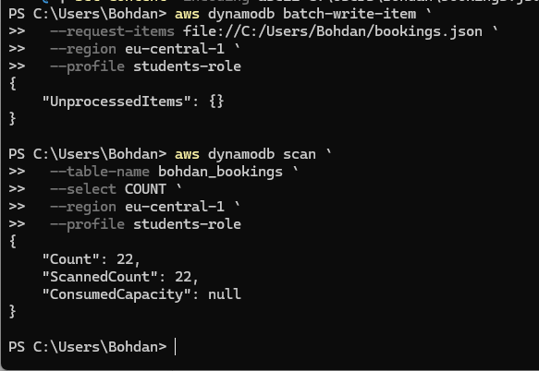

Retrieve 5+ rows from the table using keys
Six specific items were retrieved with BatchGetItem by providing their complete composite keys. The empty UnprocessedKeys object confirms that all requested key lookups were processed successfully.
PS C:\Users\Bohdan> @'
>> {
>> "bohdan_bookings": {
>> "Keys": [
>> {
>> "customer_id": {"S": "C001"},
>> "booking_id": {"S": "B001"}
>> },
>> {
>> "customer_id": {"S": "C001"},
>> "booking_id": {"S": "B002"}
>> },
>> {
>> "customer_id": {"S": "C002"},
>> "booking_id": {"S": "B004"}
>> },
>> {
>> "customer_id": {"S": "C003"},
>> "booking_id": {"S": "B007"}
>> },
>> {
>> "customer_id": {"S": "C004"},
>> "booking_id": {"S": "B010"}
>> },
>> {
>> "customer_id": {"S": "C005"},
>> "booking_id": {"S": "B013"}
>> }
>> ]
>> }
>> }
>> '@ | Set-Content -Encoding ascii C:\Users\Bohdan\get-bookings.json
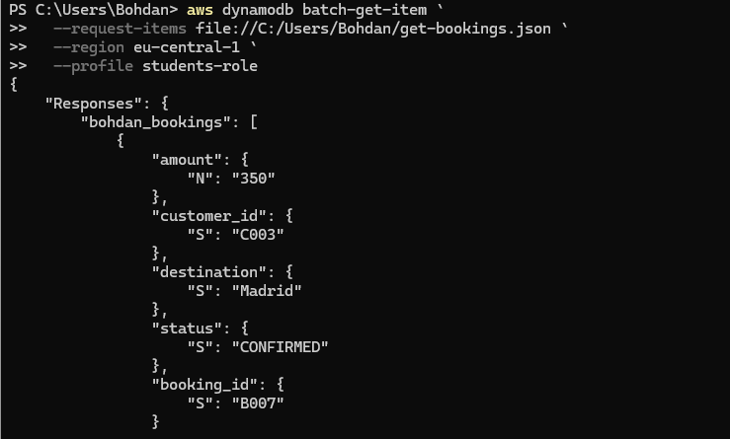
PS C:\Users\Bohdan> aws dynamodb batch-get-item `
>> --request-items file://C:/Users/Bohdan/get-bookings.json `
>> --region eu-central-1 `
>> --profile students-role
{
"Responses": {
"bohdan_bookings": [
{
"amount": {
"N": "350"
},
"customer_id": {
"S": "C003"
},
"destination": {
"S": "Madrid"
},
"status": {
"S": "CONFIRMED"
},
"booking_id": {
"S": "B007"
}
},
{
"amount": {
"N": "480"
},
"customer_id": {
"S": "C004"
},
"destination": {
"S": "London"
},
"status": {
"S": "CONFIRMED"
},
"booking_id": {
"S": "B010"
}
},
{
"amount": {
"N": "285"
},
"customer_id": {
"S": "C002"
},
"destination": {
"S": "Vienna"
},
"status": {
"S": "CONFIRMED"
},
"booking_id": {
"S": "B004"
}
},
{
"amount": {
"N": "275"
},
"customer_id": {
"S": "C005"
},
"destination": {
"S": "Brussels"
},
"status": {
"S": "CONFIRMED"
},
"booking_id": {
"S": "B013"
}
},
{
"amount": {
"N": "310"
},
"customer_id": {
"S": "C001"
},
"destination": {
"S": "Paris"
},
"status": {
"S": "CONFIRMED"
},
"booking_id": {
"S": "B002"
}
},
{
"amount": {
"N": "250"
},
"customer_id": {
"S": "C001"
},
"destination": {
"S": "Berlin"
},
"status": {
"S": "CONFIRMED"
},
"booking_id": {
"S": "B001"
}
}
]
},
"UnprocessedKeys": {}
}

Make several selects using syntax showed you on the lecture.

Query by partition key
The Query operation uses the table key schema instead of reading unrelated partitions. In this example, customer_id selects the customer partition and the booking_id condition restricts the result by sort key, returning the matching bookings.
PS C:\Users\Bohdan> @'
>> {
>> ":cid": {"S": "C001"},
>> ":bid": {"S": "B002"}
>> }
>> '@ | Set-Content -Encoding ascii C:\Users\Bohdan\query-range-values.json
PS C:\Users\Bohdan> aws dynamodb query `
>> --table-name bohdan_bookings `
>> --key-condition-expression "customer_id = :cid AND booking_id >= :bid" `
>> --expression-attribute-values file://C:/Users/Bohdan/query-range-values.json `
>> --region eu-central-1 `
>> --profile students-role
{
"Items": [
{
"amount": {
"N": "310"
},
"customer_id": {
"S": "C001"
},
"destination": {
"S": "Paris"
},
"status": {
"S": "CONFIRMED"
},
"booking_id": {
"S": "B002"
}
},
{
"amount": {
"N": "420"
},
"customer_id": {
"S": "C001"
},
"destination": {
"S": "Rome"
},
"status": {
"S": "CANCELLED"
},
"booking_id": {
"S": "B003"
}
}
],
"Count": 2,
"ScannedCount": 2,
"ConsumedCapacity": null
}

Filter by booking status using scan
The Scan operation reads the table and then applies a FilterExpression to return only CONFIRMED bookings. The result shows Count = 15 and ScannedCount = 22, illustrating that filtering a Scan does not reduce the number of items examined.

PS C:\Users\Bohdan> @'
>> {
>> ":status": {"S": "CONFIRMED"}
>> }
>> '@ | Set-Content -Encoding ascii C:\Users\Bohdan\scan-status-values.json
PS C:\Users\Bohdan> @'
>> {
>> "#st": "status"
>> }
>> '@ | Set-Content -Encoding ascii C:\Users\Bohdan\attr-names.json
PS C:\Users\Bohdan> aws dynamodb scan `
>> --table-name bohdan_bookings `
>> --filter-expression "#st = :status" `
>> --expression-attribute-names file://C:/Users/Bohdan/attr-names.json `
>> --expression-attribute-values file://C:/Users/Bohdan/scan-status-values.json `
>> --region eu-central-1 `
>> --profile students-role

"Items": [
{
"amount": {
"N": "285"
},
"customer_id": {
"S": "C002"
},
"destination": {
"S": "Vienna"
},
"booking_id": {
"S": "B004"
},
"status": {
"S": "CONFIRMED"
}
},
{
"amount": {
"N": "190"
},
"customer_id": {
"S": "C002"
},
"destination": {
"S": "Prague"
},
"booking_id": {
"S": "B005"
},
"status": {
"S": "CONFIRMED"
}
},
{
"amount": {
"N": "275"
},
"customer_id": {
"S": "C005"
},
"destination": {
"S": "Brussels"
},
"booking_id": {
"S": "B013"
},
"status": {
"S": "CONFIRMED"
}
},
{
"amount": {
"N": "460"
},
"customer_id": {
"S": "C005"
},
"destination": {
"S": "Oslo"
},
"booking_id": {
"S": "B014"
},
"status": {
"S": "CONFIRMED"
}
},
{
"amount": {
"N": "250"
},
"customer_id": {
"S": "C001"
},
"destination": {
"S": "Berlin"
},
"booking_id": {
"S": "B001"
},
"status": {
"S": "CONFIRMED"
}
},
{
"amount": {
"N": "310"
},
"customer_id": {
"S": "C001"
},
"destination": {
"S": "Paris"
},
"booking_id": {
"S": "B002"
},
"status": {
"S": "CONFIRMED"
}
},
{
"amount": {
"N": "410"
},
"customer_id": {
"S": "C006"
},
"destination": {
"S": "Copenhagen"
},
"booking_id": {
"S": "B016"
},
"status": {
"S": "CONFIRMED"
}
},
{
"amount": {
"N": "320"
},
"customer_id": {
"S": "C006"
},
"destination": {
"S": "Munich"
},
"booking_id": {
"S": "B018"
},
"status": {
"S": "CONFIRMED"
}
},
{
"amount": {
"N": "510"
},
"customer_id": {
"S": "C007"
},
"destination": {
"S": "Zurich"
},
"booking_id": {
"S": "B019"
},
"status": {
"S": "CONFIRMED"
}
},
{
"amount": {
"N": "230"
},
"customer_id": {
"S": "C007"
},
"destination": {
"S": "Budapest"
},
"booking_id": {
"S": "B020"
},
"status": {
"S": "CONFIRMED"
}
},
{
"amount": {
"N": "225"
},
"customer_id": {
"S": "C007"
},
"destination": {
"S": "Bucharest"
},
"booking_id": {
"S": "B022"
},
"status": {
"S": "CONFIRMED"
}
},
{
"amount": {
"N": "350"
},
"customer_id": {
"S": "C003"
},
"destination": {
"S": "Madrid"
},
"booking_id": {
"S": "B007"
},
"status": {
"S": "CONFIRMED"
}
},
{
"amount": {
"N": "330"
},
"customer_id": {
"S": "C003"
},
"destination": {
"S": "Lisbon"
},
"booking_id": {
"S": "B008"
},
"status": {
"S": "CONFIRMED"
}
},
{
"amount": {
"N": "480"
},
"customer_id": {
"S": "C004"
},
"destination": {
"S": "London"
},
"booking_id": {
"S": "B010"
},
"status": {
"S": "CONFIRMED"
}
},
{
"amount": {
"N": "390"
},
"customer_id": {
"S": "C004"
},
"destination": {
"S": "Amsterdam"
},
"booking_id": {
"S": "B012"
},
"status": {
"S": "CONFIRMED"
}
}
],
"Count": 15,
"ScannedCount": 22,
"ConsumedCapacity": null
}

Bookings where amount > 300
A second Scan demonstrates a numeric FilterExpression. Thirteen of the 22 scanned bookings had an amount greater than 300, showing how non-key attributes can be filtered when a suitable secondary index is not defined.
PS C:\Users\Bohdan> @'
>> {
>> ":min": {"N": "300"}
>> }
>> '@ | Set-Content -Encoding ascii C:\Users\Bohdan\scan-amount-values.json
PS C:\Users\Bohdan> aws dynamodb scan `
>> --table-name bohdan_bookings `
>> --filter-expression "amount > :min" `
>> --expression-attribute-values file://C:/Users/Bohdan/scan-amount-values.json `
>> --region eu-central-1 `
>> --profile students-role
{
"Items": [
{
"amount": {
"N": "460"
},
"customer_id": {
"S": "C005"
},
"destination": {
"S": "Oslo"
},
"booking_id": {
"S": "B014"
},
"status": {
"S": "CONFIRMED"
}
},
{
"amount": {
"N": "440"
},
"customer_id": {
"S": "C005"
},
"destination": {
"S": "Stockholm"
},
"booking_id": {
"S": "B015"
},
"status": {
"S": "PENDING"
}
},
{
"amount": {
"N": "310"
},
"customer_id": {
"S": "C001"
},
"destination": {
"S": "Paris"
},
"booking_id": {
"S": "B002"
},
"status": {
"S": "CONFIRMED"
}
},
{
"amount": {
"N": "420"
},
"customer_id": {
"S": "C001"
},
"destination": {
"S": "Rome"
},
"booking_id": {
"S": "B003"
},
"status": {
"S": "CANCELLED"
}
},
{
"amount": {
"N": "410"
},
"customer_id": {
"S": "C006"
},
"destination": {
"S": "Copenhagen"
},
"booking_id": {
"S": "B016"
},
"status": {
"S": "CONFIRMED"
}
},
{
"amount": {
"N": "430"
},
"customer_id": {
"S": "C006"
},
"destination": {
"S": "Helsinki"
},
"booking_id": {
"S": "B017"
},
"status": {
"S": "CANCELLED"
}
},
{
"amount": {
"N": "320"
},
"customer_id": {
"S": "C006"
},
"destination": {
"S": "Munich"
},
"booking_id": {
"S": "B018"
},
"status": {
"S": "CONFIRMED"
}
},
{
"amount": {
"N": "510"
},
"customer_id": {
"S": "C007"
},
"destination": {
"S": "Zurich"
},
"booking_id": {
"S": "B019"
},
"status": {
"S": "CONFIRMED"
}
},
{
"amount": {
"N": "350"
},
"customer_id": {
"S": "C003"
},
"destination": {
"S": "Madrid"
},
"booking_id": {
"S": "B007"
},
"status": {
"S": "CONFIRMED"
}
},
{
"amount": {
"N": "330"
},
"customer_id": {
"S": "C003"
},
"destination": {
"S": "Lisbon"
},
"booking_id": {
"S": "B008"
},
"status": {
"S": "CONFIRMED"
}
},
{
"amount": {
"N": "480"
},
"customer_id": {
"S": "C004"
},
"destination": {
"S": "London"
},
"booking_id": {
"S": "B010"
},
"status": {
"S": "CONFIRMED"
}
},
{
"amount": {
"N": "370"
},
"customer_id": {
"S": "C004"
},
"destination": {
"S": "Dublin"
},
"booking_id": {
"S": "B011"
},
"status": {
"S": "PENDING"
}
},
{
"amount": {
"N": "390"
},
"customer_id": {
"S": "C004"
},
"destination": {
"S": "Amsterdam"
},
"booking_id": {
"S": "B012"
},
"status": {
"S": "CONFIRMED"
}
}
],
"Count": 13,
"ScannedCount": 22,
"ConsumedCapacity": null
}

Delete 2 rows from the DynamoDB table and verify they are gone.
Two items were deleted by specifying their complete primary keys. A final COUNT operation returned 20 items instead of the original 22, confirming that both deletions were applied successfully.

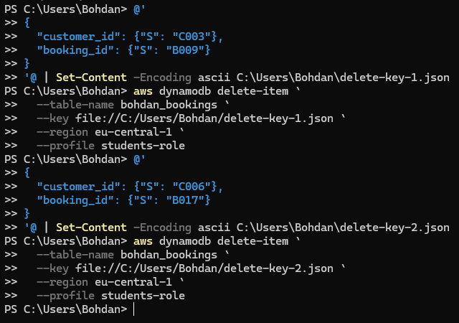

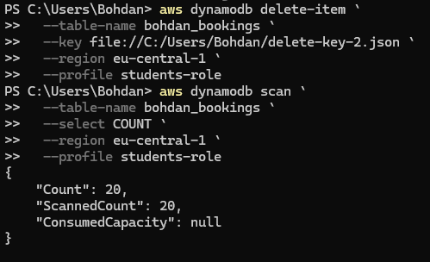
The original number of rows was 22, now we have deleted 2 rows and it became 20.

Conclusion
In this laboratory work, relational and NoSQL database services in AWS were practiced using RDS MySQL, Aurora MySQL, and DynamoDB. For RDS MySQL, a personal user and isolated schema were created together with a table, view, stored procedure, and a restartable initialization script. Aurora Query Editor was used to perform meaningful analytical queries on the Sakila dataset. DynamoDB was first tested through the AWS Console and then managed through AWS CLI API calls, including table creation, batch loading, key-based retrieval, Query and Scan operations, filtering, and deletion. The work demonstrates the different access patterns of relational databases and DynamoDB and confirms successful use of AWS database services through both graphical and command-line interfaces.

