FRAMEWORKS AND ADVANCED SELENIUM

Data Quality Task 13 Final Report
Test automation assessment, ROI calculation, and Pytest Selenium framework

Student | Bohdan Solovei
Selected SUT | Project B cloud data platform
Test framework | Pytest, Selenium, Page Object Model, Allure
Execution result | 6 of 6 tests passed
22 September 2026

Executive Summary
This report documents both parts of Data Quality Task 13. Task 1 evaluates the suitability and return on investment of test automation for Project B. Task 2 implements an executable Pytest and Selenium framework that combines unit, integration, and Power BI user-interface checks. The completed framework collected six tests and all six passed in 10.30 seconds. The Allure report confirms a 100 percent pass rate.
Requirement | Implementation | Evidence
Automation decision and ROI | Project B assessment with man-hour calculation | Task 1 analysis and ROI table
Previous tests integrated | API and cloud-storage integration tests | Tests/test_api_task.py
Two UI checks | Power BI Capture Report Views controls and validation | Tests/test_power_bi.py
Framework decomposition | Configs, Pages, Tests, Utils, fixtures, markers | Project structure and code excerpts
Executable with reporting | Pytest plus Allure results | 6 passed and 100 percent Allure screenshots

Task 1 Test Automation Assessment

Selected System Under Test
Project B was selected because it is a three-year cloud data-platform implementation that extracts on-premises data daily, processes it through ETL pipelines, and delivers dashboards containing new logic and complex calculations. The team includes two QA engineers and four developers, while the principal technology stack is Python and familiar cloud services.

Automation Decision and Scope
- Test automation is necessary because daily ETL processing and repeated regression cycles create stable, high-frequency checks that would otherwise consume substantial manual effort.
- Unit tests should validate transformation functions, calculation rules, boundary cases, and error handling.
- Integration tests should verify source extraction, cloud storage, ETL processing, API responses, and reconciliation between source and target layers.
- Data-quality checks should cover completeness, accuracy, consistency, uniqueness, validity, and timeliness.
- Selenium tests should verify critical dashboard controls, titles, filters, legends, validation messages, and displayed values.
- Pytest is appropriate because it matches the Python stack, supports fixtures and markers, and can combine unit, integration, and UI tests in one framework.
- The technical QA should maintain the automation code, while the manual QA can prepare scenarios, review failures, and expand business coverage.
- The project should establish coding standards, reusable fixtures, configuration management, code review, scheduled execution, and Allure reporting.

Return on Investment Calculation
The calculation uses a simplified man-hour approach. CM is the projected manual-testing cost, while I is the total automation investment. The estimates below are planning assumptions for a three-year project and should be recalculated if the regression frequency, scope, or team capacity changes.
Component | Assumption | Calculation | Hours
CM Manual testing | 20 h/week for 3 years | 20 x 52 x 3 | 3,120
FW Framework | Initial implementation | Estimated once | 120
S Scenarios | 12 h/week for 26 weeks | 12 x 26 | 312
E and R | 4 h/week for 3 years | 4 x 52 x 3 | 624
I Total investment | FW + S + E + R | 120 + 312 + 624 | 1,056

Calculation Steps
1. Manual cost: CM = 20 x 52 x 3 = 3,120 man-hours.
2. Automation investment: I = FW + S + E + R = 120 + 312 + 624 = 1,056 man-hours.
3. Net saving: CM - I = 3,120 - 1,056 = 2,064 man-hours.
4. ROI: ((CM - I) / I) x 100 percent = (2,064 / 1,056) x 100 percent = 195.45 percent.

ROI Conclusion
The estimated ROI is 195.45 percent and the projected saving is 2,064 man-hours. This positive result means that the automation investment is recovered and produces additional value during the project lifetime. Automation is therefore justified for Project B, particularly for repeatable ETL, API, reconciliation, and dashboard regression checks.

Task 2 Framework Implementation
The original framework skeleton was reorganized into packages and modules. Shared browser, configuration, API, AWS, and GCP fixtures are defined in conftest.py. Tests are separated by responsibility and marked as unit, integration, or UI tests in pytest.ini. Power BI interactions are encapsulated in a Page Object Model so that locators and actions are not duplicated in test cases.

Implemented Project Structure
DQE_LAB_2024-main/
|-- Configs/config_selenium.yaml
|-- Pages/__init__.py
|-- Pages/power_bi_page.py
|-- Tests/__init__.py
|-- Tests/test_api_task.py
|-- Tests/test_api_unit.py
|-- Tests/test_power_bi.py
|-- Utils/__init__.py
|-- Utils/api_validation.py
|-- conftest.py
|-- pytest.ini
|-- requirements.txt
|-- run_all_tests.bat
`-- README.md
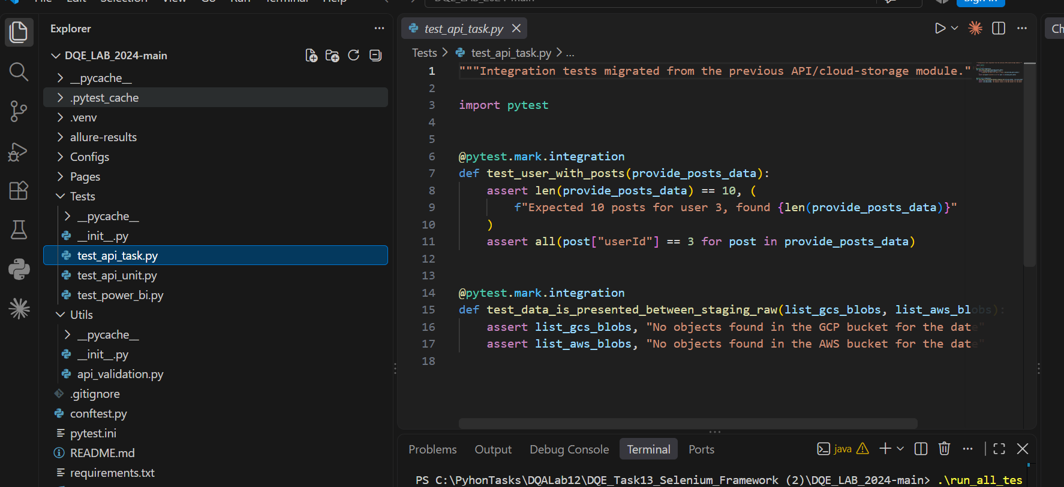
Figure 1. Implemented framework structure and integration-test code in Visual Studio Code

Integrated Unit and Integration Tests
The previous module tests were integrated as API and cloud-storage integration checks. Additional pure validation helpers provide fast unit-level coverage without external services.
@pytest.mark.integration
def test_user_with_posts(provide_posts_data):
assert len(provide_posts_data) == 10
assert all(post["userId"] == 3 for post in provide_posts_data)
@pytest.mark.integration
def test_data_is_presented_between_staging_raw(
list_gcs_blobs, list_aws_blobs):
assert list_gcs_blobs, "No objects found in the GCP bucket"
assert list_aws_blobs, "No objects found in the AWS bucket"

Shared Fixtures and Configuration
The shared fixture layer centralizes Selenium driver lifecycle, YAML configuration, JSONPlaceholder API access, and anonymous AWS/GCP storage clients. This decomposition keeps setup logic out of individual test modules and supports reusable execution across test types.
"""Shared fixtures for unit, integration, and Selenium UI tests."""
from pathlib import Path
import boto3
import pytest
import requests
import yaml
from botocore import UNSIGNED
from botocore.config import Config
from google.cloud import storage
from selenium import webdriver
from selenium.webdriver.chrome.options import Options
ROOT = Path(__file__).resolve().parent
@pytest.fixture(scope="session")
def selenium_config():
config_path = ROOT / "Configs" / "config_selenium.yaml"
with config_path.open(encoding="utf-8") as config_file:
return yaml.safe_load(config_file)["global"]
@pytest.fixture
def driver(selenium_config):
options = Options()
if selenium_config.get("headless", True):
options.add_argument("--headless=new")
options.add_argument("--window-size=1440,1000")
options.add_argument("--no-sandbox")
options.add_argument("--disable-dev-shm-usage")
browser = webdriver.Chrome(options=options)
browser.set_page_load_timeout(60)
yield browser
browser.quit()
@pytest.fixture(scope="session")
def provide_config():
return {
"prefix": "2024/01/01/KTLX/",
"gcp_bucket_name": "gcp-public-data-nexrad-l2",
"aws_bucket_name": "unidata-nexrad-level2",
"s3_anon_client": boto3.client(
# API and cloud-storage fixtures continue in the same module.

Pytest Markers
[pytest]
testpaths = Tests
python_files = test_*.py
addopts = -ra --strict-markers
markers =
unit: fast tests without external services
integration: tests that call APIs or cloud storage
ui: Selenium browser tests for Power BI
The markers allow focused execution with pytest -m unit, pytest -m integration, and pytest -m ui, while a full run produces one consolidated Allure result set.

Power BI Page Object Model
The Page Object Model stores stable element locators for Capture view, Saved views, the modal, the view-name field, the Save button, and the validation message. It also provides reusable methods for opening the showcase, reading labels, opening the dialog, submitting an empty name, and reading the resulting validation feedback.
class PowerBICaptureViewsPage:
CAPTURE_VIEW_BUTTON = (By.ID, "capture-btn")
SAVED_VIEWS_BUTTON = (By.ID, "display-btn")
CAPTURE_MODAL = (By.ID, "modal-action")
MODAL_TITLE = (By.ID, "my-modal-label")
VIEW_NAME_INPUT = (By.ID, "viewname")
SAVE_BUTTON = (By.ID, "save-bookmark-btn")
VALIDATION_MESSAGE = (
By.CSS_SELECTOR, "#save-view-div .invalid-feedback")
def open(self, url):
self.driver.get(url)
self.wait.until(EC.title_contains("Capture Report Views"))
def open_capture_dialog(self):
button = self.wait.until(
EC.presence_of_element_located(self.CAPTURE_VIEW_BUTTON))
self.driver.execute_script("arguments[0].click();", button)
def submit_empty_view_name(self):
name_input = self.wait.until(
EC.visibility_of_element_located(self.VIEW_NAME_INPUT))
name_input.clear()
save_button = self.wait.until(
EC.presence_of_element_located(self.SAVE_BUTTON))
self.driver.execute_script("arguments[0].click();", save_button)

Power BI UI Checks
"""Two UI checks required for the Power BI Capture Report Views showcase."""
import pytest
from Pages.power_bi_page import PowerBICaptureViewsPage
@pytest.mark.ui
def test_capture_and_saved_views_controls_are_visible(driver, selenium_config):
page = PowerBICaptureViewsPage(driver, selenium_config["delay"])
page.open(selenium_config["report_uri"])
assert page.capture_button_text() == "Capture view"
assert page.saved_views_button_text() == "Saved views"
@pytest.mark.ui
def test_empty_view_name_displays_validation_message(driver, selenium_config):
page = PowerBICaptureViewsPage(driver, selenium_config["delay"])
page.open(selenium_config["report_uri"])
page.open_capture_dialog()
assert page.modal_title() == "What would you like to do with this view?"
page.submit_empty_view_name()
assert page.validation_message() == "Please provide a valid name"
UI test | Action | Expected result
Controls visibility | Open Capture Report Views | Capture view and Saved views labels are present
Empty-name validation | Open dialog and save an empty view name | Please provide a valid name is displayed

Execution and Allure Evidence
The complete test suite was executed on Windows with Python 3.14.3, Pytest 8.4.2, and allure-pytest 2.15.0. Pytest collected six items: two integration tests, two unit tests, and two Selenium UI tests. All six completed successfully in 10.30 seconds.
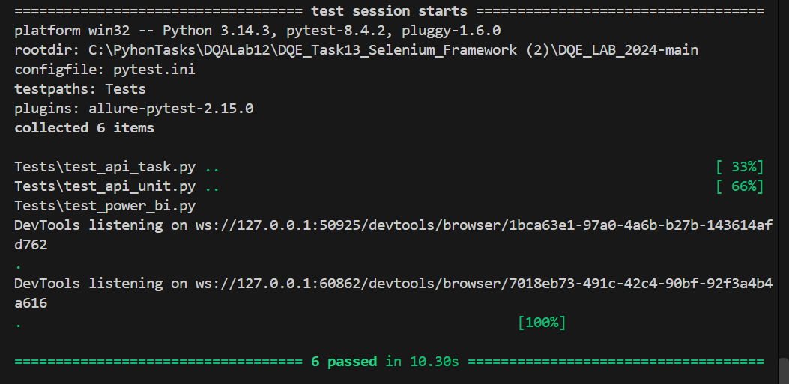
Figure 2. Pytest execution showing six collected tests and six passed results

Allure Report Results
The Allure overview provides the required consolidated report. It records six test cases with a 100 percent pass rate and no failed or broken tests. This confirms that the integrated framework, API/cloud-storage checks, unit checks, and Power BI UI checks executed successfully in one run.
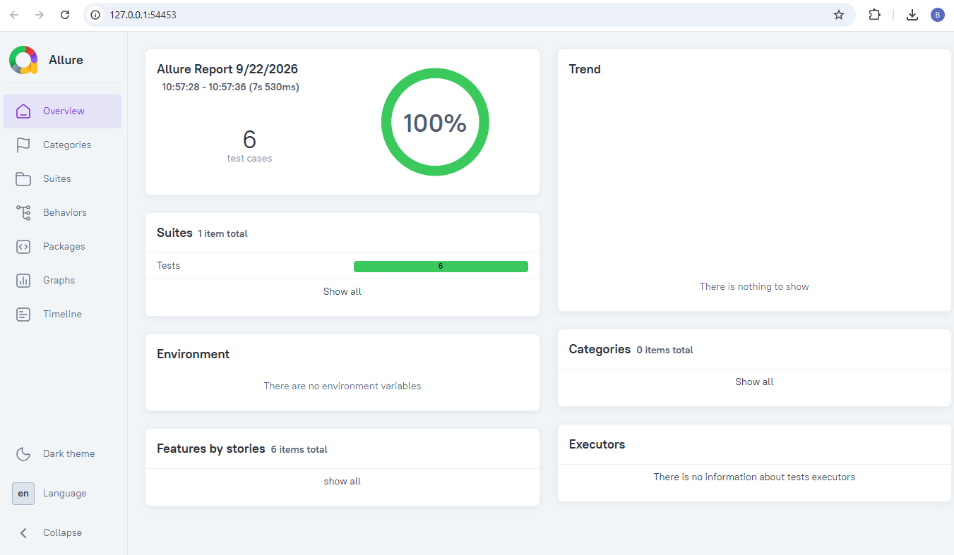
Figure 3. Allure overview showing six test cases and a 100 percent pass rate

Acceptance Criteria Evaluation
Acceptance criterion | Result | Evidence
Unit and integration tests integrated | Passed | Four tests executed
Packages, modules, conftest, pytest.ini, config | Passed | Framework structure and excerpts
Two UI checks added | Passed | test_power_bi.py
Executable without errors | Passed | 6 passed in 10.30 s
New Page Model methods and locators | Passed | power_bi_page.py
Allure report and screenshot | Passed | Figure 3

Final Conclusions
Task 1 demonstrates that Project B is a suitable candidate for automation. The estimated 195.45 percent ROI and 2,064-hour saving support investment in a maintainable automated regression suite. Task 2 translates this approach into a working framework that integrates multiple testing levels, isolates configuration and setup logic, applies Page Object Model practices, and produces an Allure report. The final execution result of six passed tests and a 100 percent pass rate satisfies the stated acceptance criteria.

