Data Warehouse Test Result Report
DWH validation and reconciliation results

1 Summary
The current DWH validation run completed successfully: all 10 selected TestRail cases passed, with no failed, blocked, skipped or untested cases. The run verified core constraints, valid sales quantities, client history dates, field lengths, product-cost precision and key uniqueness. Separately, the earlier source-to-target reconciliation identified 197 discrepancy records. These reconciliation defects remain relevant because they can affect downstream Power BI results, particularly the Sales dashboard.
Metric | Result
Planned and executed cases | 10 of 10
Passed | 10
Failed / blocked / untested | 0 / 0 / 0
Pass rate | 100%
Reconciliation discrepancy records | 197
Release assessment | DWH rule checks passed; reconciliation issues require correction before dashboard data acceptance.

2 Test Team
Name | Role | Responsibility
Bohdan Solovei | Data Quality Engineer | SQL preparation, DBeaver execution, TestRail updates, evidence collection, defect analysis and reporting.

3 Testing Process Description
Testing was performed against the PostgreSQL database dwh_hw_db using DBeaver. The target scope included dwh_clients, dwh_sales, dwh_products, dwh_channels, dwh_locations and dm_main_dashboard. TestRail run R13 organized ten cases into Smoke, Critical and Extended paths. Each SQL result was compared with the case expectation, recorded in TestRail and supported by screenshots. Source-to-target results stored in lnd.reconciliation_results were then analyzed independently to identify completeness and attribute mismatches from the earlier DWH reconciliation task.

4 Execution Results
Path | Cases | Passed | Failed | Pass rate
Smoke Path | 2 | 2 | 0 | 100%
Critical Path | 4 | 4 | 0 | 100%
Extended Path | 4 | 4 | 0 | 100%
Total | 10 | 10 | 0 | 100%

Case | Verification | Result
T105 | Primary keys are not NULL | Passed
T106 | Sales quantities are positive and non-NULL | Passed
T107 | Current client source IDs are unique | Passed
T108 | Client emails fit target length | Passed
T109 | Client validity date ranges are valid | Passed
T110 | Completion date is not before creation date | Passed
T111 | Product cost complies with NUMERIC(18,2) | Passed
T112 | Product names fit target length | Passed
T113 | Channel names fit target length | Passed
T114 | Location IDs are unique and non-NULL | Passed

5 New Defects Statistics
The current ten-case run produced no new failed cases. The reconciliation dataset from the previous DWH task contains 197 affected records. For reporting, related rows are grouped into nine defect entries by table and discrepancy type; affected-row totals are shown separately from defect-ticket counts.
Discrepancy type | Affected records | Share
Only in source | 187 | 94.9%
Only in target | 2 | 1.0%
Field mismatch | 8 | 4.1%
Total | 197 | 100%

Severity | Grouped defects | Affected records
Major | 4 | 187
Medium | 5 | 10
Critical | 0 | 0
Minor / Low | 0 | 0
Total | 9 | 197

6 New Defects List
ID | Severity | Area | Rows | Summary
DQR-001 | Medium | s1_channels | 6 | Channel attributes differ: five channel_location mismatches and one channel_name plus channel_location mismatch.
DQR-002 | Major | s1_channels | 2 | Source channels 157 and 158 are missing from the target.
DQR-003 | Medium | s1_clients | 1 | Client 699 has a last_name mismatch.
DQR-004 | Medium | s1_clients | 1 | Client 700 has a phone mismatch.
DQR-005 | Medium | s1_products | 1 | Product 50 exists only in the target.
DQR-006 | Major | s1_sales | 176 | Source sales records are missing from the target.
DQR-007 | Major | s2_client_sales | 5 | Source client-sales records are missing from the target.
DQR-008 | Major | s2_locations | 4 | Source location records are missing from the target; source ID 40 appears twice in the reconciliation output.
DQR-009 | Medium | s2_locations | 1 | Location 19 exists only in the target.

7 Analysis
The dominant issue is sales completeness: 181 sales-related source records are absent from the target (176 from s1_sales and 5 from s2_client_sales). These represent 91.9% of all reconciliation discrepancies and can understate sales quantities and related measures. Dimension discrepancies affect channels, clients, products and locations and can cause incorrect labels, filtering, grouping or unmatched fact records. The successful TestRail cases show that the loaded target data satisfies the selected structural and domain rules, but those checks do not prove that every source row was loaded correctly.

8 Recommendations
- Treat the missing s1 and s2 sales records as the highest-priority defect; inspect extraction filters, join conditions, key lookups, rejected-row handling and incremental-load boundaries.
- Correct channel location and name transformations, then reconcile channel IDs 151 through 158.
- Investigate client 699 last_name and client 700 phone mapping and cleansing logic.
- Resolve target-only product 50 and location 19 by confirming whether they are legitimate historical records or stale target data.
- Investigate s2 location IDs 38, 39 and 40, including the duplicate occurrence of source ID 40.
- Rerun reconciliation after fixes and require zero unexplained missing, extra or mismatched records before accepting dashboard data.
- Retain the ten successful SQL checks as a repeatable smoke, critical and extended regression suite.

9 Conclusion
The executed DWH rule-validation suite passed completely, demonstrating that the tested target records meet the selected integrity, domain, date, precision and length requirements. The solution is not yet ready for unconditional data acceptance because the independent reconciliation exposed 197 discrepancies, led by 181 missing sales records. Correcting and retesting these reconciliation defects is recommended before the Power BI dashboards are approved for business use.

10 Attachments and Visualizations
Figure 1 summarizes the final TestRail status. All ten selected cases passed.
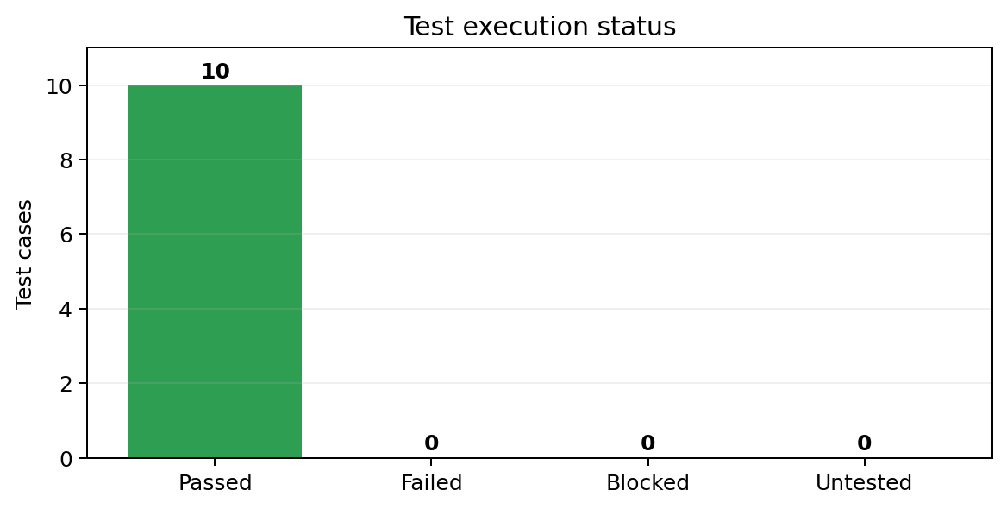
Figure 1 Test execution status
Figure 2 shows coverage across the three execution paths.
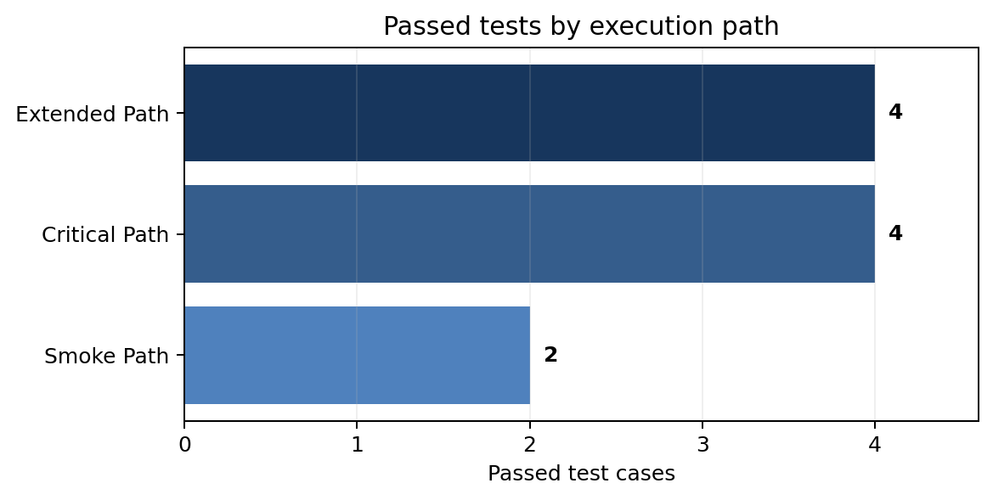
Figure 2 Passed tests by execution path
Figure 3 shows that s1_sales accounts for most reconciliation discrepancies.
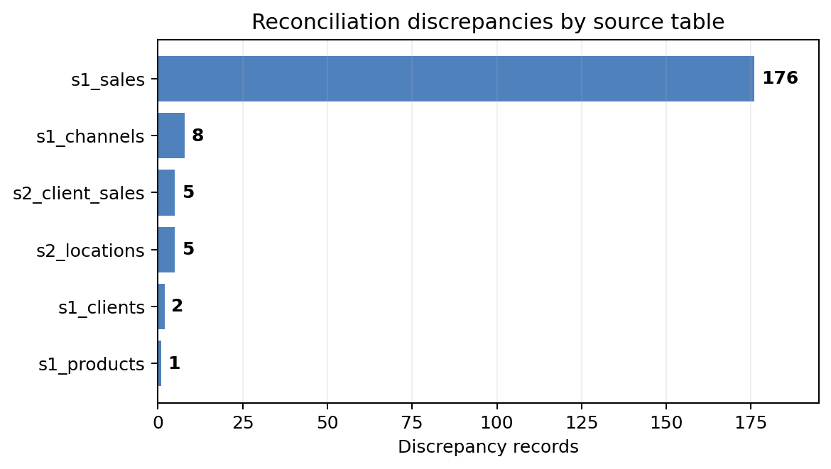
Figure 3 Reconciliation discrepancies by source table

11 Supporting Evidence
The screenshots below provide direct evidence from TestRail and DBeaver.
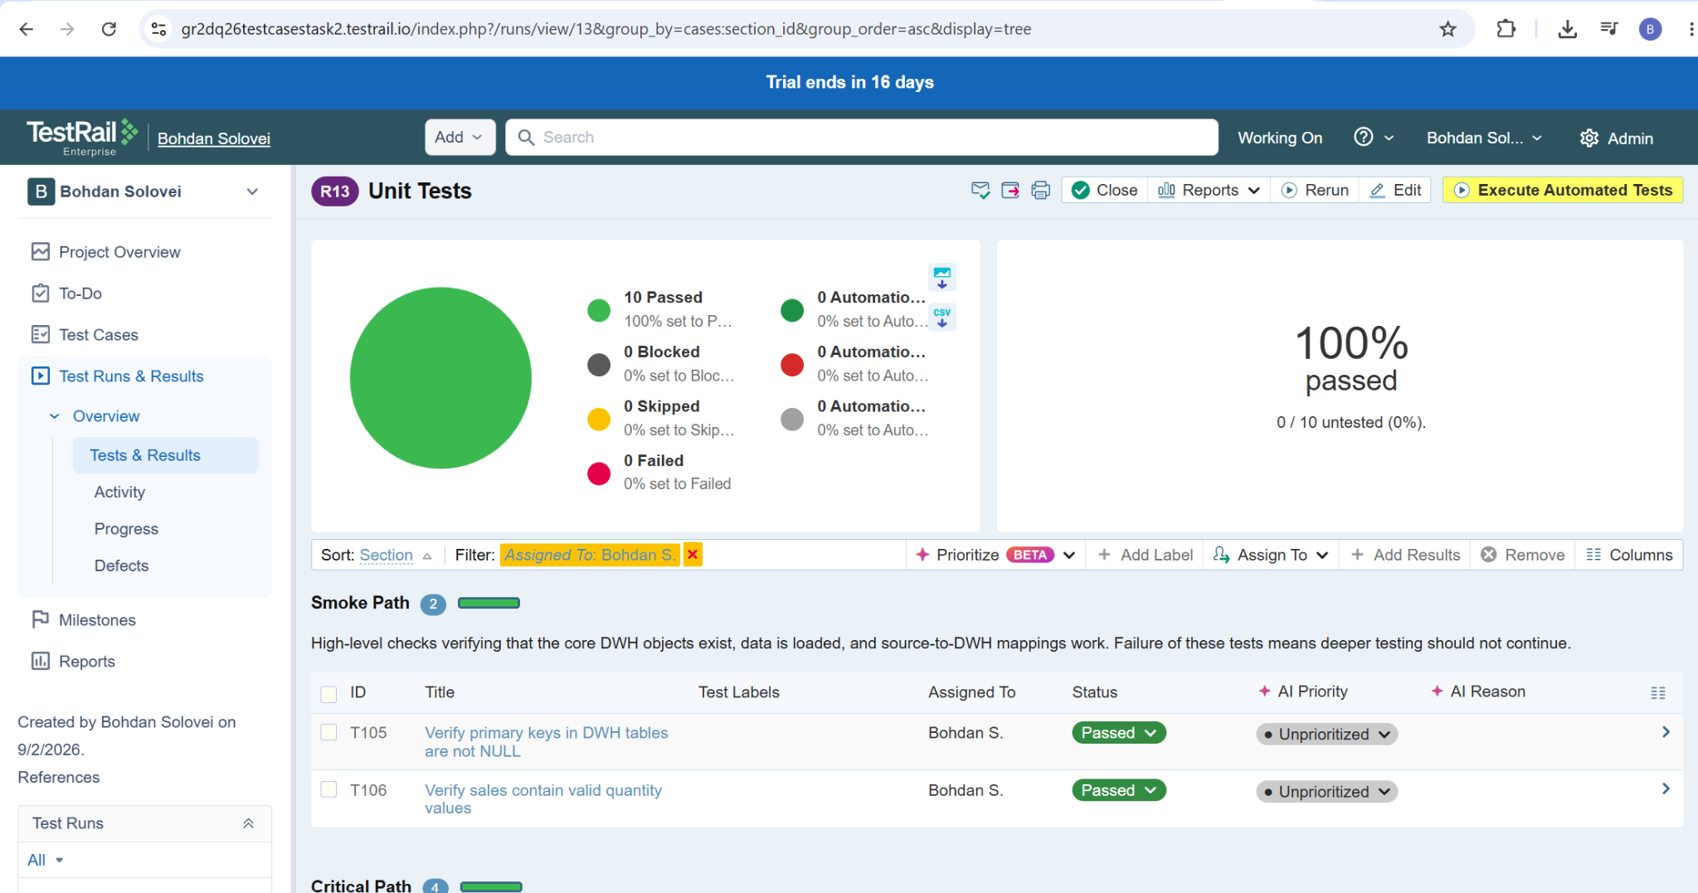
Evidence 1 TestRail run R13 showing 10 passed and 100% pass rate
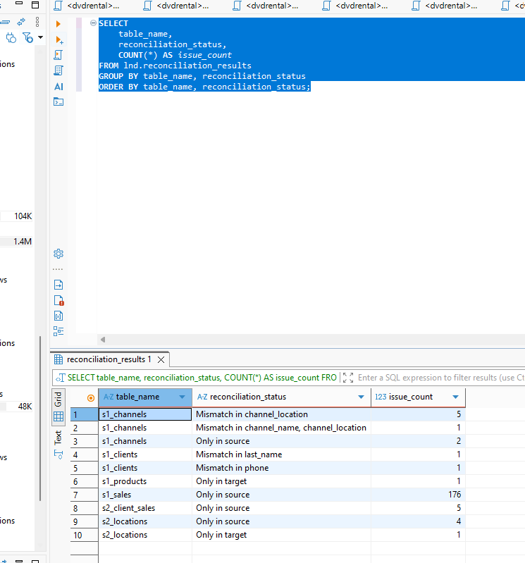
Evidence 2 Reconciliation discrepancy counts by table and status

