DATA QUALITY
DWH Testing — Data Reconciliation

SQL Solution Report

Bohdan Solovei
Task 06

1. Objective
The objective of this task is to validate data consistency between the source PostgreSQL database and the Landing layer of the DWH. The reconciliation identifies records that exist only in the source, records that exist only in the target, and records with attribute-level mismatches. Only problematic records are stored in lnd.reconciliation_results.

2. Environment and approach
Component | Implementation
Source database | dwh_src_hw_db
Target database | dwh_hw_db
Source schemas | s1, s2
Target schema | lnd
Cross-database access | PostgreSQL dblink
Comparison method | FULL OUTER JOIN / EXCEPT where appropriate
Null-safe comparison | IS DISTINCT FROM
Result table | lnd.reconciliation_results
For dimension-like tables, records were matched by their business key and non-key attributes were compared with IS DISTINCT FROM. For sales data, composite keys were used. The s1_sales table required an additional diagnostic step because the initial key-based result overstated missing rows; full-row EXCEPT checks confirmed that exactly 176 source rows were absent from Landing.

3. Reconciliation result structure
CREATE TABLE lnd.reconciliation_results (
table_name VARCHAR(100),
key_column VARCHAR(100),
src_id VARCHAR(256),
trg_id VARCHAR(256),
reconciliation_status VARCHAR(500)
);
The table stores the reconciled table name, the key definition, source and target identifiers, and a human-readable status.

4. Table-by-table reconciliation

4.1 s1_channels
The channel table was reconciled by channel_id. The comparison detected channel_location differences, one combined channel_name/channel_location difference, and two rows that existed only in the source.
Status | Count
Mismatch in channel_location | 5
Mismatch in channel_name, channel_location | 1
Only in source | 2
Total | 8
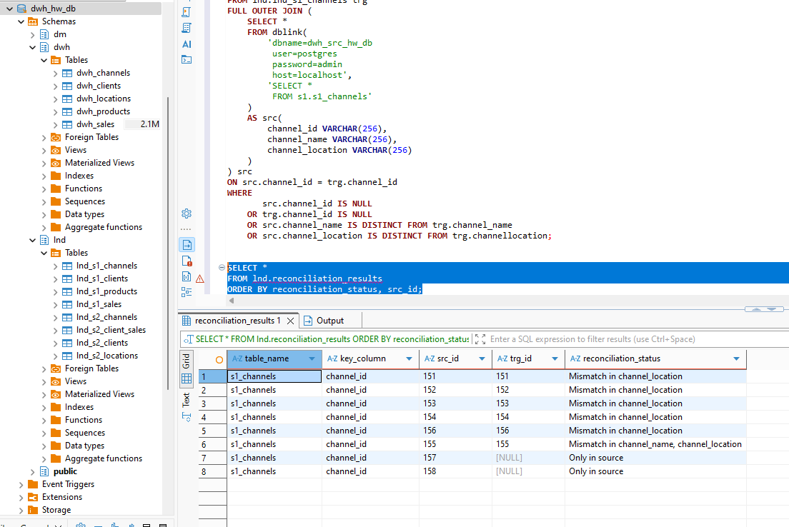
Figure 1. Detailed reconciliation results for s1_channels.

4.2 s1_clients
INSERT INTO lnd.reconciliation_results
(table_name, key_column, src_id, trg_id, reconciliation_status)
SELECT 's1_clients', 'client_id', src.client_id, trg.client_id,
CASE
WHEN src.client_id IS NULL THEN 'Only in target'
WHEN trg.client_id IS NULL THEN 'Only in source'
WHEN src.first_name IS DISTINCT FROM trg.first_name
OR src.middle_name IS DISTINCT FROM trg.middle_name
OR src.last_name IS DISTINCT FROM trg.last_name
OR src.email IS DISTINCT FROM trg.email
OR src.phone IS DISTINCT FROM trg.phone
OR src.first_purchase IS DISTINCT FROM trg.first_purchase
THEN CONCAT('Mismatch in ', CONCAT_WS(', ',
CASE WHEN src.first_name IS DISTINCT FROM trg.first_name THEN 'first_name' END,
CASE WHEN src.middle_name IS DISTINCT FROM trg.middle_name THEN 'middle_name' END,
CASE WHEN src.last_name IS DISTINCT FROM trg.last_name THEN 'last_name' END,
CASE WHEN src.email IS DISTINCT FROM trg.email THEN 'email' END,
CASE WHEN src.phone IS DISTINCT FROM trg.phone THEN 'phone' END,
CASE WHEN src.first_purchase IS DISTINCT FROM trg.first_purchase THEN 'first_purchase' END))
END
FROM lnd.lnd_s1_clients trg
FULL OUTER JOIN (
SELECT * FROM dblink(
'dbname=dwh_src_hw_db user=postgres password=admin host=localhost',
'SELECT client_id, first_name, middle_name, last_name, email, phone, first_purchase
FROM s1.s1_clients')
AS src(client_id VARCHAR(256), first_name VARCHAR(256), middle_name VARCHAR(256),
last_name VARCHAR(256), email VARCHAR(256), phone VARCHAR(256),
first_purchase VARCHAR(256))
) src ON src.client_id = trg.client_id
WHERE src.client_id IS NULL OR trg.client_id IS NULL
OR src.first_name IS DISTINCT FROM trg.first_name
OR src.middle_name IS DISTINCT FROM trg.middle_name
OR src.last_name IS DISTINCT FROM trg.last_name
OR src.email IS DISTINCT FROM trg.email
OR src.phone IS DISTINCT FROM trg.phone
OR src.first_purchase IS DISTINCT FROM trg.first_purchase;
client_id | Result
699 | Mismatch in last_name
700 | Mismatch in phone
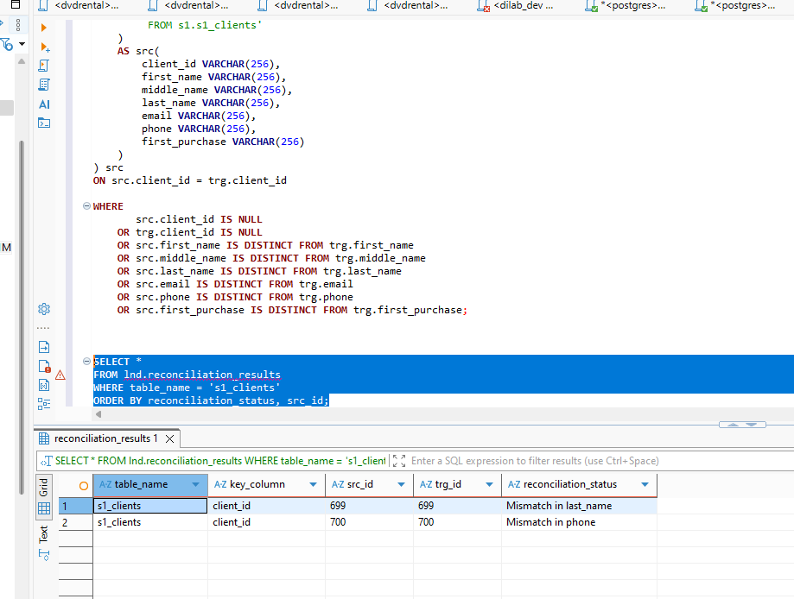
Figure 2. Detailed reconciliation results for s1_clients.

4.3 s1_products
INSERT INTO lnd.reconciliation_results
(table_name, key_column, src_id, trg_id, reconciliation_status)
SELECT 's1_products', 'product_id', src.product_id, trg.product_id,
CASE
WHEN src.product_id IS NULL THEN 'Only in target'
WHEN trg.product_id IS NULL THEN 'Only in source'
WHEN src.cost IS DISTINCT FROM trg.cost
AND src.product_name IS DISTINCT FROM trg.product_name
THEN 'Mismatch in cost, product_name'
WHEN src.cost IS DISTINCT FROM trg.cost THEN 'Mismatch in cost'
WHEN src.product_name IS DISTINCT FROM trg.product_name THEN 'Mismatch in product_name'
END
FROM lnd.lnd_s1_products trg
FULL OUTER JOIN (
SELECT * FROM dblink(
'dbname=dwh_src_hw_db user=postgres password=admin host=localhost',
'SELECT product_id, cost, product_name FROM s1.s1_products')
AS src(product_id VARCHAR(256), cost VARCHAR(256), product_name VARCHAR(256))
) src ON src.product_id = trg.product_id
WHERE src.product_id IS NULL OR trg.product_id IS NULL
OR src.cost IS DISTINCT FROM trg.cost
OR src.product_name IS DISTINCT FROM trg.product_name;
Result: one record (product_id = 50) exists only in the Landing target.
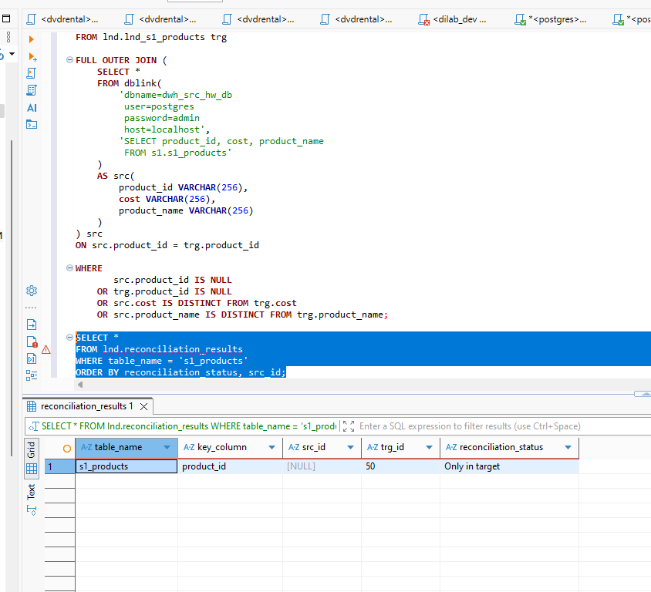
Figure 3. Reconciliation result for s1_products: product 50 exists only in target.

4.4 s1_sales
The source contained 22,400 rows and Landing contained 22,224 rows. Duplicate checks on the composite key (client_id, channel_id, sale_date, product_id) returned no duplicates. Bidirectional full-row EXCEPT checks returned 176 rows for Source → Landing and 0 rows for Landing → Source. Therefore, the final classification for this table is 176 records 'Only in source'.
DELETE FROM lnd.reconciliation_results
WHERE table_name = 's1_sales';

INSERT INTO lnd.reconciliation_results
(table_name, key_column, src_id, trg_id, reconciliation_status)
SELECT
's1_sales',
'client_id, channel_id, sale_date, product_id',
CONCAT_WS('|', src.client_id, src.channel_id, src.sale_date, src.product_id),
NULL,
'Only in source'
FROM (
SELECT *
FROM dblink(
'dbname=dwh_src_hw_db user=postgres password=admin host=localhost',
'SELECT client_id, channel_id, sale_date, units, product_id, purchase_date
FROM s1.s1_sales')
AS src(client_id VARCHAR(256), channel_id VARCHAR(256), sale_date VARCHAR(256),
units VARCHAR(256), product_id VARCHAR(256), purchase_date VARCHAR(256))
EXCEPT
SELECT client_id::VARCHAR, channel_id::VARCHAR, sale_date::VARCHAR,
units::VARCHAR, product_id::VARCHAR, purchase_date::VARCHAR
FROM lnd.lnd_s1_sales
) src;
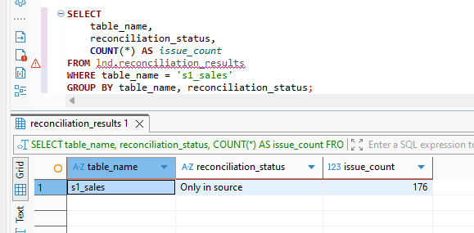
Figure 4. Final s1_sales reconciliation summary: 176 records only in source.

4.5 s2_channels
The table was reconciled by channel_id and channel_name/location_id were compared. No discrepancies were found; therefore, s2_channels contributes 0 rows to reconciliation_results.

4.6 s2_client_sales
INSERT INTO lnd.reconciliation_results
(table_name, key_column, src_id, trg_id, reconciliation_status)
SELECT 's2_client_sales',
'client_id, channel_id, saled_at, product_id',
CASE WHEN src.client_id IS NOT NULL
THEN CONCAT_WS('|',src.client_id,src.channel_id,src.saled_at,src.product_id) END,
CASE WHEN trg.client_id IS NOT NULL
THEN CONCAT_WS('|',trg.client_id,trg.channel_id,trg.saled_at,trg.product_id) END,
CASE
WHEN src.client_id IS NULL THEN 'Only in target'
WHEN trg.client_id IS NULL THEN 'Only in source'
ELSE CONCAT('Mismatch in ', CONCAT_WS(', ',
CASE WHEN src.product_name IS DISTINCT FROM trg.product_name THEN 'product_name' END,
CASE WHEN src.product_price IS DISTINCT FROM trg.product_price THEN 'product_price' END,
CASE WHEN src.product_amount IS DISTINCT FROM trg.product_amount THEN 'product_amount' END,
CASE WHEN src.sold_date IS DISTINCT FROM trg.sold_date THEN 'sold_date' END))
END
FROM lnd.lnd_s2_client_sales trg
FULL OUTER JOIN (
SELECT * FROM dblink(
'dbname=dwh_src_hw_db user=postgres password=admin host=localhost',
'SELECT client_id, channel_id, saled_at, product_id, product_name,
product_price, product_amount, sold_date FROM s2.s2_client_sales')
AS src(client_id VARCHAR(256), channel_id VARCHAR(256), saled_at VARCHAR(256),
product_id VARCHAR(256), product_name VARCHAR(256), product_price VARCHAR(256),
product_amount VARCHAR(256), sold_date VARCHAR(256))
) src ON src.client_id=trg.client_id AND src.channel_id=trg.channel_id
AND src.saled_at=trg.saled_at AND src.product_id=trg.product_id
WHERE src.client_id IS NULL OR trg.client_id IS NULL
OR src.product_name IS DISTINCT FROM trg.product_name
OR src.product_price IS DISTINCT FROM trg.product_price
OR src.product_amount IS DISTINCT FROM trg.product_amount
OR src.sold_date IS DISTINCT FROM trg.sold_date;
Result: 5 records exist only in the source.
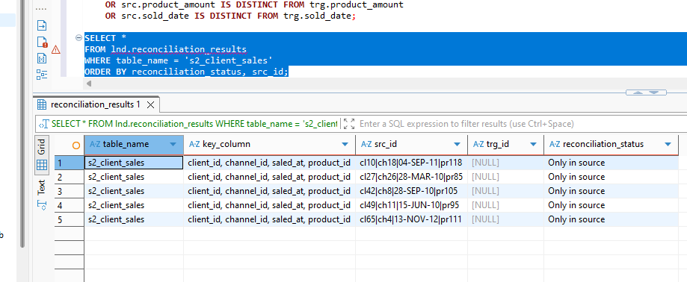
Figure 5. Detailed reconciliation results for s2_client_sales.

4.7 s2_clients
The table was reconciled by client_id, comparing first_name, last_name, email, phone_code, phone_number, first_purchase, valid_from and valid_to. No discrepancies were found; therefore, s2_clients contributes 0 rows.

4.8 s2_locations
INSERT INTO lnd.reconciliation_results
(table_name, key_column, src_id, trg_id, reconciliation_status)
SELECT 's2_locations', 'location_id', src.location_id, trg.location_id,
CASE
WHEN src.location_id IS NULL THEN 'Only in target'
WHEN trg.location_id IS NULL THEN 'Only in source'
WHEN src.location_name IS DISTINCT FROM trg.location_name
THEN 'Mismatch in location_name'
END
FROM lnd.lnd_s2_locations trg
FULL OUTER JOIN (
SELECT * FROM dblink(
'dbname=dwh_src_hw_db user=postgres password=admin host=localhost',
'SELECT location_id, location_name FROM s2.s2_locations')
AS src(location_id VARCHAR(230), location_name VARCHAR(230))
) src ON src.location_id = trg.location_id
WHERE src.location_id IS NULL OR trg.location_id IS NULL
OR src.location_name IS DISTINCT FROM trg.location_name;
Status | Count
Only in source | 4
Only in target | 1
Total | 5
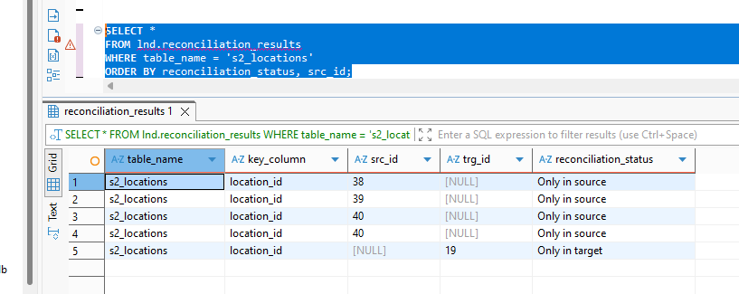
Figure 6. Detailed reconciliation results for s2_locations.

5. Final reconciliation results
Table | Problems
s1_channels | 8
s1_clients | 2
s1_products | 1
s1_sales | 176
s2_channels | 0
s2_client_sales | 5
s2_clients | 0
s2_locations | 5
TOTAL | 197
The final result table contains 197 problematic records. The largest contribution is s1_sales with 176 missing Landing rows. Two tables, s2_channels and s2_clients, were fully consistent and produced no anomaly records.
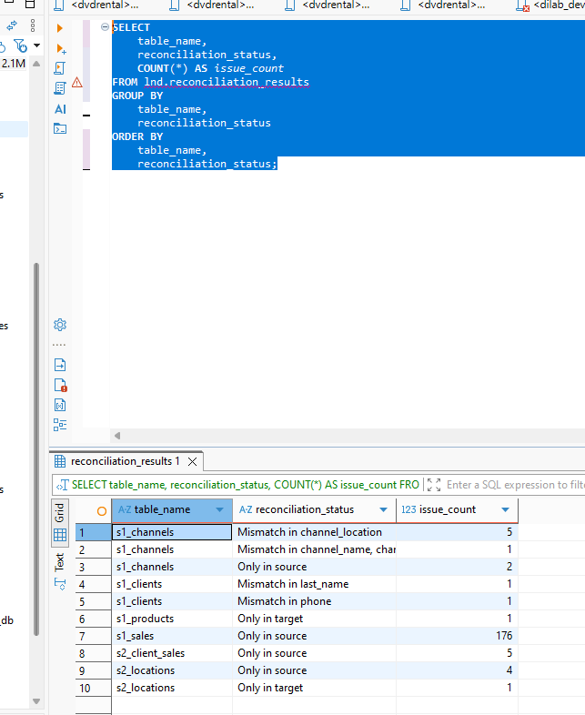
Figure 7. Final reconciliation summary by table and status.
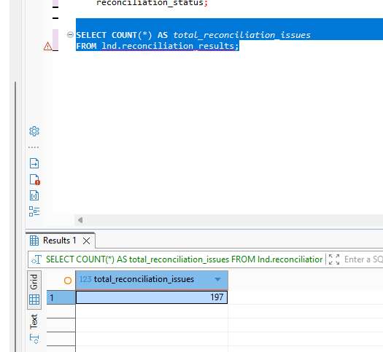
Figure 8. Validation of the total number of reconciliation issues (197).

6. CSV export
The final lnd.reconciliation_results table was exported from DBeaver to reconciliation_results.csv with column headers. The exported dataset contains 197 data records and the columns table_name, key_column, src_id, trg_id, and reconciliation_status.
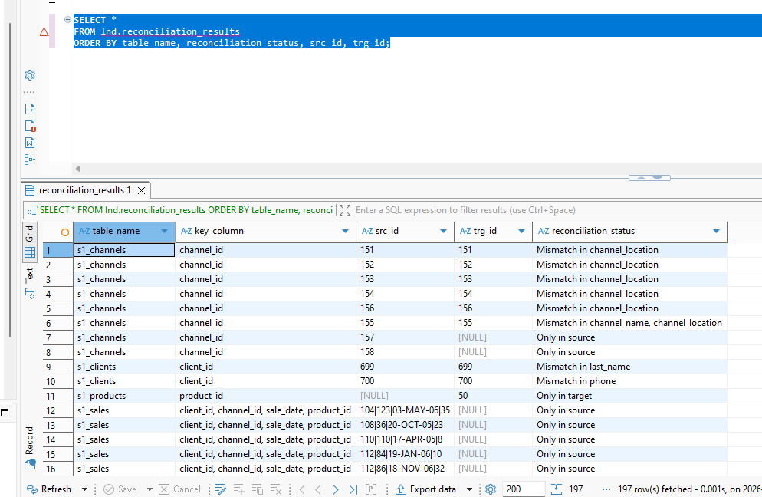
Figure 9. Final reconciliation result set prepared for CSV export.

7. Conclusions
The reconciliation successfully validated eight Source-to-Landing table pairs. In total, 197 problematic records were identified and stored in a dedicated reconciliation table. The detected issues include missing source/target records and attribute-level mismatches.
The most significant discrepancy was found in s1_sales, where 176 complete source rows were absent from Landing. The s1_channels table contained eight issues, including five channel_location mismatches, one combined channel_name/channel_location mismatch, and two source-only rows. s1_clients contained two attribute mismatches, s1_products contained one target-only row, s2_client_sales contained five source-only rows, and s2_locations contained five missing-side discrepancies. No anomalies were detected in s2_channels or s2_clients.
Using FULL OUTER JOIN, IS DISTINCT FROM, and bidirectional EXCEPT checks provided a robust way to distinguish missing records from value mismatches. The final reconciliation_results table and CSV export provide an auditable output that can be used for further data-quality investigation and correction of the ETL/ELT loading process.

