DATA PROFILING REPORT
  - bank.csv and car_prices.parquet
Prepared by: Bohdan Solovei
Date: 3 September 2026
Scope: File conversion, dataset description, anomaly detection and DQ recommendations
Selected approaches: Manual analysis in Excel for bank.csv; automated analysis using ydata-profiling for car_prices.parquet.
Executive summary. The bank file contains 4,521 records and 10 attributes; the car file contains 558,837 records and 16 attributes. Profiling identified invalid domain values, inconsistent category encoding, missing data, malformed identifiers, possible column-shift corruption and extreme sentinel-like values that should be addressed before analytical use.

1. Parquet and CSV size comparison
File | Size | Relative size
car_prices.parquet | 17,728,477 bytes (16.91 MiB) | 1.00×
car_prices.csv | 91,936,398 bytes (87.68 MiB) | 5.19×
Difference: the CSV export is approximately 74.21 MiB larger. Parquet stores values in a binary, column-oriented representation and applies efficient encoding/compression, especially to repeated categorical values. CSV stores every value as human-readable text and repeats delimiters and recurring strings on every row; it also does not preserve native data types in its file structure. These characteristics explain why the CSV is about 5.19 times larger for the same 558,837 records.
Conversion used: pandas.read_parquet(...) followed by DataFrame.to_csv(..., index=False).

2. Dataset descriptions and business use

2.1 bank.csv
The bank dataset contains demographic and financial/contact-campaign information for 4,521 customers. Its attributes include age, occupation, marital status, education, default status, account balance, housing and personal loan indicators, contact method and interaction duration. A bank could use this data to segment customers, analyze channel effectiveness, identify suitable audiences for campaigns, and study how customer characteristics relate to engagement. Because the file lacks an explicit campaign outcome or customer identifier, its use for supervised response modelling or record-level integration is limited unless such fields are supplied separately.

2.2 car_prices
The car-prices dataset contains 558,837 vehicle auction/sale observations. It records the model year, make, model, trim, body type, transmission, VIN, state, condition, odometer, exterior/interior color, seller, market reference value (MMR), selling price and sale date. Businesses can use it for price benchmarking, residual-value analysis, inventory sourcing, seller and regional performance analysis, and predictive pricing. Reliable VINs, dates, condition scores and prices are essential because errors in these fields can materially distort valuations and trend analysis.

3. Data anomalies and recommended controls

3.1 bank.csv — manual spreadsheet-style profiling
Method: the file was reviewed as a tabular spreadsheet using sorting, filtering, distinct-value counts, blank checks and numeric range checks. The following issues should be raised:
Attribute | Issue | Evidence / example | How found | DQ interpretation / control
age | Invalid range | 19 rows outside 18–100; examples: −11, 4, 6, 132, 144, 150, 192, 200. | Numeric sort/filter and range rule. | Impossible or implausible customer ages. Enforce integer 18–100 and quarantine failures.
duration | Negative sentinel | 45 rows have −999. | Filter duration < 0. | A contact duration cannot be negative. Treat −999 as missing/error and require duration ≥ 0.
job | Invalid category | 946 rows contain “boogieman”. | Distinct-value count/filter. | Not a valid banking occupation category. Map only if a documented source code exists; otherwise quarantine.
education | Invalid category | 6 rows contain “Duck”. | Distinct-value count/filter. | Value is outside the expected primary/secondary/tertiary/unknown domain.
default | Inconsistent encoding | 43 rows contain “N”; standard values are “yes”/“no”. | Distinct-value frequency review. | Likely means “no”, but must be confirmed. Standardize through an approved mapping.
loan | Case inconsistency | 8 “NO” and 7 “YES” values coexist with lowercase values. | Case-sensitive distinct-value review. | Creates duplicate logical categories. Normalize case after validation.
contact | Missing/variant values | 5 nulls and 7 “Unkn”; “unknown” also occurs 1,312 times. | Blank check and distinct-value review. | Null, “Unkn” and “unknown” represent inconsistent missing/unknown semantics. Standardize one approved representation.
balance | Extreme/negative values | Min −3,313; max 71,188; 366 negatives; 506 IQR outliers. | Sort, summary statistics and IQR rule. | Negative balances may be valid overdrafts and high balances may be genuine; flag for business validation rather than automatically reject.

3.2 car_prices — automated profiling using ydata-profiling
Method: The car_prices.parquet file was loaded using pandas and converted to car_prices.csv as required by the task. The ydata-profiling library was then used to generate an automated interactive HTML report. The report was reviewed to identify missing values, data types, distributions, frequent and distinct values, cardinality, extreme values, and other potential data-quality anomalies.
Attribute | Issue | Evidence / example | How found | DQ interpretation / control
Multiple | Missing values | Transmission 65,321; body 13,195; condition 11,820; trim 10,715; model 10,399; make 10,301. Smaller gaps occur in other fields. | YData Overview and variable-level missing-value statistics | Define mandatory fields by use case; report completeness by column and quarantine records missing valuation-critical fields.
condition | Invalid domain | 10 rows outside expected 1–50; values include 0, 193, 289, 313, 849 and 982. | YData minimum/maximum statistics and distribution chart | Likely data-entry or parsing errors. Add CHECK(condition BETWEEN 1 AND 50).
vin / row structure | Malformed or shifted data | 26 non-null VINs are not 17 characters: 22 values are “automatic” (9 chars) and 4 are 3 chars/other corruption. Some affected rows show displaced state/condition fields. | YData distinct/frequent-values analysis followed by record inspection | Indicates identifier corruption or column shifting. Validate 17-character VIN format and CSV column count before ingestion.
transmission | Invalid categories | 274 “horse-driven”, 15 “sedan”, 11 “Sedan”; 300 invalid non-null values total. | YData word cloud and frequent-values analysis | “sedan” is a body type; “horse-driven” is invalid for this vehicle dataset. Enforce automatic/manual domain or documented additional values.
body | Case inconsistency | Examples include “Sedan” and “sedan”, “SUV” and “suv”, “Hatchback” and “hatchback”. | YData word cloud and category review | Splits the same category in reports. Standardize capitalization through a reference mapping.
color / interior | Placeholder text | Exterior color contains 24,685 “—”; interior contains 17,077 “—”, in addition to 749 nulls each. | YData frequent-values and missing-value analysis | A dash is a hidden missing-value code. Convert it to a governed unknown/null representation.
odometer | Sentinel/extreme values | 152 zero-mile rows and 72 rows at 999,999 miles (224 combined). | YData minimum/maximum and distribution analysis | Some zero values may be new vehicles, but repeated 999,999 strongly resembles a cap/sentinel. Flag for source confirmation.
sellingprice | Implausibly low value | 4 vehicles have a selling price of $1 while MMR ranges from $375 to $20,800. | YData minimum/maximum statistics and distribution chart | Could be placeholder, failed sale or special transaction. Require a transaction-status field or exception review.
saledate | Invalid/misaligned date | 12 null values; parsing found 38 invalid entries overall. Some corrupted rows contain numeric prices in the date field. | YData missing-value and distinct-values analysis | Store as a typed timestamp; reject values that fail the approved format and timezone rule.
vin | Non-unique identifier | 558,837 rows but only 550,298 distinct non-null VIN values; examples appear 3–5 times. | YData distinct-value statistics | May be legitimate repeated auctions/resales, so define the business key as VIN + sale date/event ID rather than VIN alone.

Key automated profile results
- Overview: 558,837 observations, 16 variables, 123,494 missing cells and six alerts
- make, model, trim, and body: missing-value evidence
- transmission: 65,321 missing values and the suspicious horse-driven category
- vin: four missing values and suspicious automatic value
- condition: 11,820 missing values and invalid maximum of 982
- sellingprice: 12 missing values and suspicious minimum of $1
- saledate: 12 missing values

4. Suggested DQ framework rules
- Completeness: monitor null percentages for all attributes and establish mandatory fields for each business process.
- Validity: enforce controlled domains for bank categories, transmission/body values, condition score and boolean indicators.
- Range: validate age, duration, condition, odometer, MMR and selling price against approved business thresholds.
- Format: validate VIN length/pattern and parse sale dates into a typed timestamp during ingestion.
- Consistency: normalize case and missing-value representations; use reference tables for categorical mappings.
- Uniqueness: introduce a stable row/event identifier and test candidate business keys rather than assuming VIN is unique.
- Observability: publish rejected-row counts, anomaly rates and sample failures for every load, with thresholds and ownership.

5. Conclusion
The two datasets are usable for exploratory and business analysis, but neither should be consumed without validation and standardization. The bank file contains obvious injected corruptions and inconsistent categorical encodings, while the car dataset has broader completeness issues and several signs of row/field corruption. Implementing the proposed checks at ingestion will prevent invalid values from entering downstream reports and models, while exception handling will preserve potentially legitimate outliers for review.

Appendix A. Evidence of automated profiling
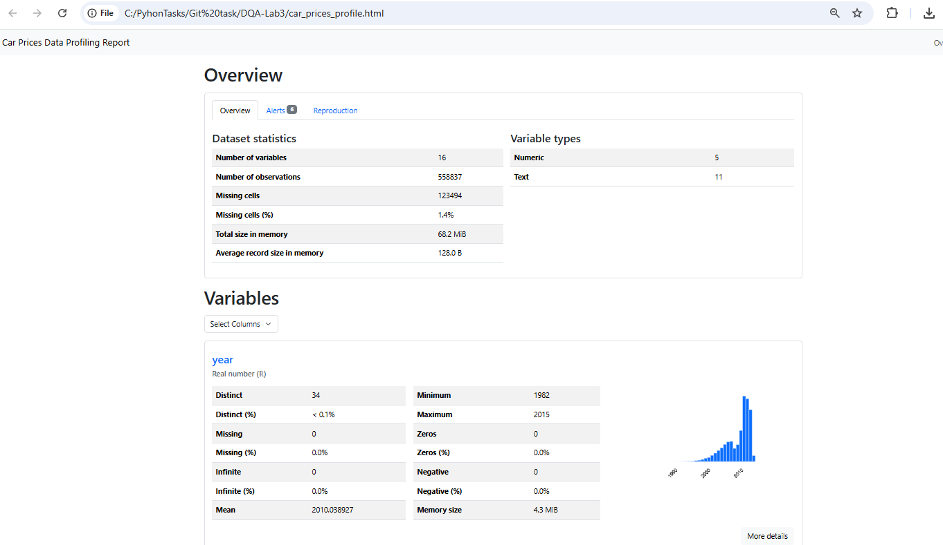
Figure 1. Dataset overview and automatically generated profile statistics.
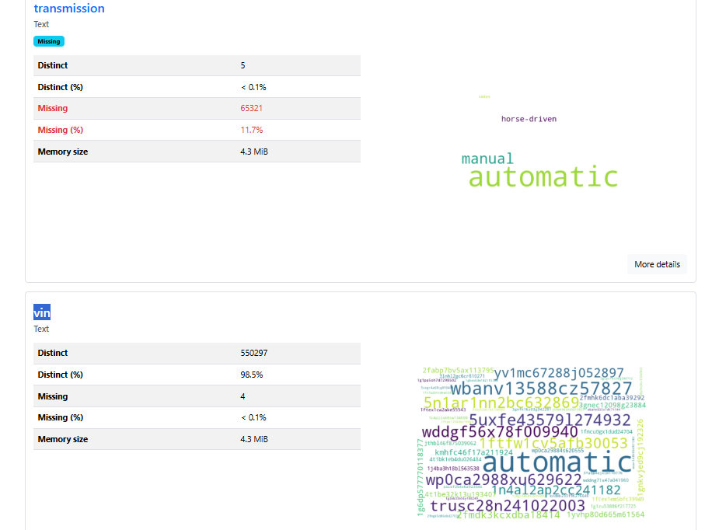
Figure 2. Transmission and VIN statistics showing missing and suspicious values.
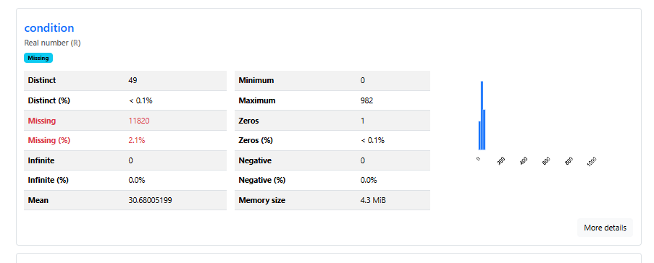
Figure 3. Condition statistics showing missing values and an invalid maximum of 982.
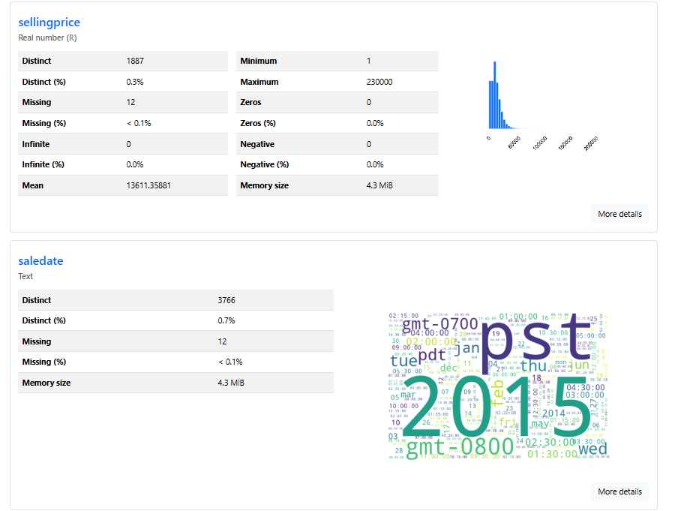
Figure 4. Selling-price and sale-date statistics highlighting extreme and missing values.

Appendix B. References
Databricks. “What is Parquet?” https://www.databricks.com/glossary/what-is-parquet
YData. “YData Profiling documentation.” https://docs.profiling.ydata.ai/latest/

