Business Template

Airline Ticket Retail Sales

Contents
1 Business Description 3
1.1 Business background 3
1.2 Problems because of poor data management 3
1.3 Benefits from implementing a Data Warehouse 3
1.4 DATASETS DESCRIPTION 4
1.5 GRAIN / DIM / FACT 5
2 TASK 2.1 5
3 TASK 2.2 8
3.1.1 Description of the 4-Step Dimensional Modeling Process 8
3.1.1 Normalization Steps from Star Schema to Snowflake Schema 9
3.1.2 DimCustomer 9
3.1.3 DimDate 10
3.1.4 DimTravel 10
3.1.5 DimBooking 10
3.1.6 DimLoyalty 10
3.1.7 DimSatisfaction 11
3.1.8 FactSales 11
3.1.9 FactCustomerSatisfaction 11
3.2 2.3 Snowflake Lookup Tables 11
3.3 2.4 Example Rows 12
4 Business Layer 3NF 12
5 Business Layer Dimensional Model 12
6 Logical Scheme 12
7 Data Flow 12
8 Fact Table Partitioning Strategy 12

Business Description

Business background
The selected business domain is Airline Ticket Retail Sales. The company sells airline tickets through multiple sales channels, including websites, mobile applications, and travel agencies. The company also collects customer feedback after flights to evaluate service quality and customer satisfaction.
The objective of the future data warehouse is to integrate sales transactions and customer satisfaction information into a unified analytical environment for revenue, cost, profitability, and customer experience analysis.
Two source systems are used to populate the data warehouse.
Source System 1 – Customer Satisfaction System
This system contains post-flight customer survey information. Each record represents a completed customer satisfaction survey associated with a particular flight experience.
The dataset contains customer demographic information, travel characteristics, service quality ratings, delay information, and overall satisfaction assessment.
Source System 2 – Booking and Sales System
This system contains ticket booking transactions. Each record represents a ticket sale performed through a specific sales channel.
The dataset contains customer information, booking details, payment information, loyalty program information, ticket prices, operating costs, airport fees, discounts, and calculated profit.
The two source systems share customer identifiers, which enables integration through a common customer dimension.

Problems because of poor data management
Currently, the organization operates multiple independent information systems, including a customer satisfaction system and a booking and sales system. These systems are designed to support operational activities rather than enterprise-wide analytical reporting. As a result, several data management challenges arise.
Inconsistent Customer Information
The same customer may appear in multiple source systems. Without a centralized repository and common business definitions, inconsistencies may occur in customer-related information, making customer analysis difficult and potentially reducing data reliability.
Data Quality Issues
The existence of multiple independent systems increases the likelihood of duplicated records, inconsistent data definitions, missing values, and data synchronization problems. Such issues may negatively affect the accuracy of business reports and analytical results.

Benefits from implementing a Data Warehouse
The implementation of a data warehouse will provide a centralized analytical platform that integrates information from the customer satisfaction system and the booking and sales system. The data warehouse will support consistent, reliable, and efficient business analysis.
Revenue and Profitability Analysis
The warehouse will support detailed analysis of:
Ticket sales revenue
Operating costs
Airport fees
Promotional discounts
Profit margins
Business users will be able to evaluate profitability by customer segment, travel class, booking channel, loyalty level, and time period.
Improved Data Quality
The Extract-Transform-Load (ETL) process will standardize data from different source systems, reducing duplication, inconsistencies, and missing values. This will improve the overall reliability and trustworthiness of analytical reports.
Scalability for Future Growth
The dimensional model is designed to support future business requirements. Additional data sources, dimensions, and fact tables can be integrated into the warehouse without major architectural changes.

DATASETS DESCRIPTION
1.2 Dataset Characteristics
The source data consists of approximately 1,000,000 records distributed across two operational systems.

Customer Satisfaction Dataset -Approximate size: 500,000 records.
Each record contains:
* Customer identifier
* Gender
* Customer type
* Age
* Travel type
* Travel class
* Flight distance
* Service quality ratings
* Departure delay
* Arrival delay
* Satisfaction status
Purpose:
* Customer experience analysis
* Service quality monitoring
* Satisfaction reporting

Booking and Sales Dataset-Approximate size: 500,000 records.
Each record contains:
* Booking identifier
* Customer identifier
* Travel information
* Booking channel
* Payment method
* Loyalty level
* Travel insurance information
* Booking date
* Ticket price
* Operating cost
* Airport fee
* Promotion discount
* Profit
Purpose:
* Sales analysis
* Revenue monitoring
* Cost analysis
* Profitability reporting

GRAIN / DIM / FACT

TASK 2.1
Step1. Business Process: Sales Transactions
The schema models individual product sales made by stores to customers. Each record represents one completed sales transaction and contains references to the customer, employee, product, store, location, and date.
Step 2. Grain
One row represents one completed sales transaction (SALE_ID).
Each record stores:
Date of sale
Customer
Employee
Product sold
Store
Geographic information
Sales amount

Step 3. Identify and Conform the Dimensions
Dimension | Business Description
DIM_DATE | Date when the sale occurred
DIM_CUSTOMER | Customer who made the purchase
DIM_EMPLOYEE | Employee responsible for the sale
DIM_PRODUCT | Product that was sold
DIM_STORE | Store where the transaction occurred
DIM_ADDRESS | Physical address information
DIM_CITY | City information
DIM_COUNTRY | Country information
DIM_PRODUCT_CATEGORY | Product classification

Step 4. Identify the Facts
Fact Table- FACT_SALES
Primary Measure- AMOUNT – monetary value of the sales transaction.
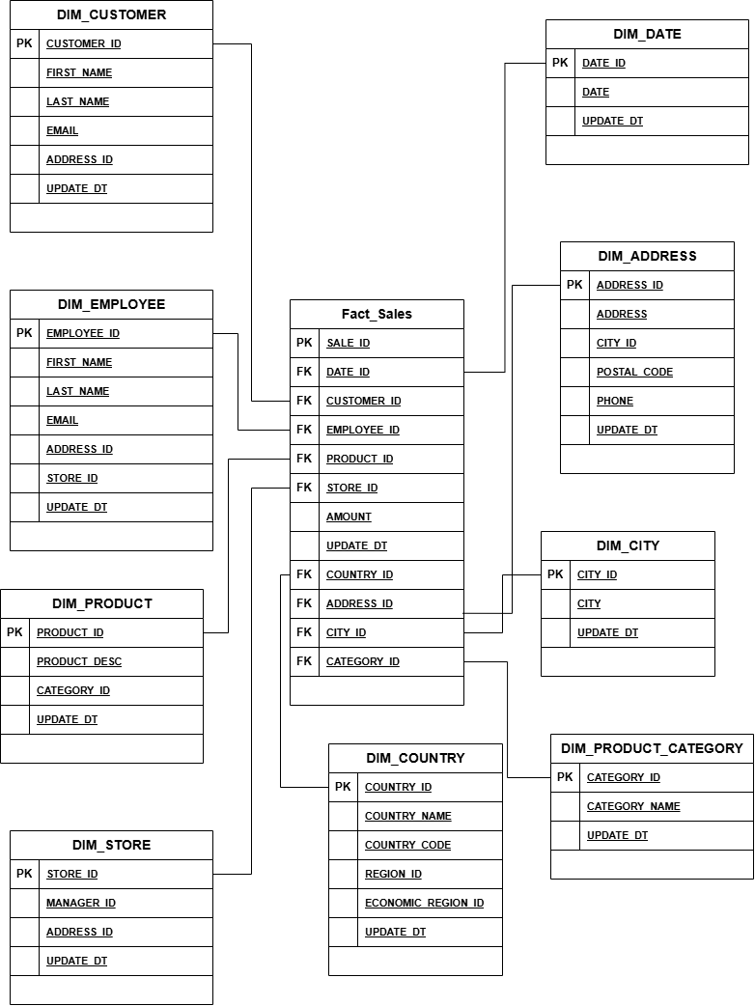
Figure 1. Star schema model
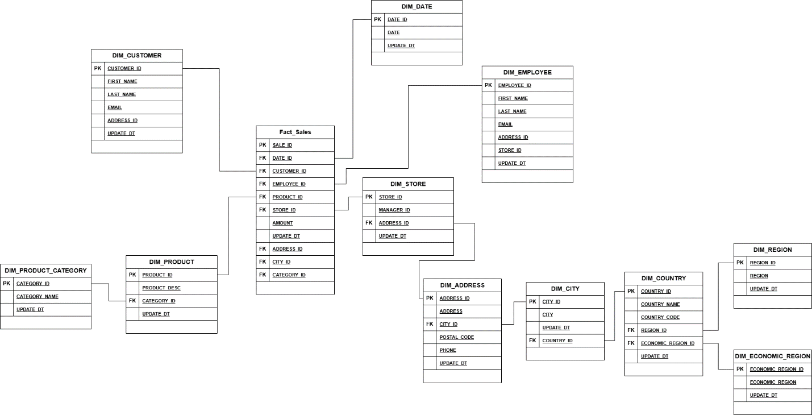
Figure 2. Snowflake schema model with normalized dimensions.
Normalization Steps from Star Schema to Snowflake Schema
The DIM_PRODUCT table contains product information and a reference to product category.
To normalize this structure, the product category attributes are moved into a separate table:
DIM_PRODUCT_CATEGORY
The relationship becomes:
DIM_PRODUCT.CATEGORY_ID → DIM_PRODUCT_CATEGORY.CATEGORY_ID
Normalize the Geographic Hierarchy
The address dimension contains a city reference. To avoid storing city and country information repeatedly, the geographic hierarchy is normalized into separate tables.
The relationships become:
DIM_ADDRESS.CITY_ID → DIM_CITY.CITY_ID
DIM_CITY.COUNTRY_ID → DIM_COUNTRY.COUNTRY_ID
DIM_COUNTRY.REGION_ID → DIM_REGION.REGION_ID
DIM_COUNTRY.ECONOMIC_REGION_ID → DIM_ECONOMIC_REGION.ECONOMIC_REGION_ID

TASK 2.2

Description of the 4-Step Dimensional Modeling Process
Step | Description
1. Select the business process | The selected business processes are airline ticket sales and customer satisfaction collection. Ticket sales is the primary process because it generates revenue, cost, and profit measures. Customer satisfaction is an additional process that captures service quality measurements after the trip.
2. Declare the grain | FactSales grain: one row represents one ticket booking transaction made by one customer through one channel at a specific date and time. FactCustomerSatisfaction grain: one row represents one completed customer survey response related to one customer travel experience.
3. Identify the dimensions | Dimensions are DimCustomer, DimDate, DimTravel, DimBooking, DimLoyalty, and DimSatisfaction. These dimensions describe who bought the ticket, when it was booked, what travel/service characteristics were involved, how the ticket was booked and paid for, loyalty status, and satisfaction status.
4. Identify the facts | FactSales contains numeric business measurements such as TicketPrice, OperatingCost, AirportFee, PromotionDiscount, Profit, and FlightDistance. FactCustomerSatisfaction contains numeric ratings and delay measures such as WifiRating, FoodRating, SeatComfortRating, CleanlinessRating, DepartureDelayMinutes, and ArrivalDelayMinutes.

Normalization Steps from Star Schema to Snowflake Schema
Normalization Step | Description
1. Normalize DimDate | DimDate is split into DimDate, DimMonth, DimQuarter, and DimYear to represent the date hierarchy Year -> Quarter -> Month -> Day.
2. Normalize DimCustomer | AgeGroup is separated into DimAgeGroup and referenced from DimCustomer. This avoids repeating age group descriptions for many customers.
3. Normalize DimTravel | TravelType, TravelClass, and DistanceCategory are separated into lookup dimensions and referenced by DimTravel. This normalizes repeated travel descriptions.
4. Normalize DimBooking | BookingChannel, PaymentMethod, and TravelInsurance are separated into lookup dimensions and referenced by DimBooking. This normalizes repeated booking characteristics.
5. Preserve fact grain | The fact tables keep the same atomic grain. Only descriptive dimension structures are normalized. Numeric measurements remain in the fact tables.

DimCustomer
Stores descriptive customer data integrated from both source systems. CustomerID is the shared business key between Customer Satisfaction and Booking/Sales sources.
Column name | Description | Data type | Key / Notes
CustomerKey | Surrogate primary key for customer dimension | INT | PK
CustomerID | Customer natural identifier from source systems | INT | Business key
Gender | Customer gender | VARCHAR(20) | Attribute
Age | Customer age | INT | Attribute
CustomerType | Customer status from satisfaction source | VARCHAR(50) | Attribute
AgeGroup | Derived age group for analysis | VARCHAR(30) | Attribute / hierarchy level

DimDate
Stores date attributes and supports the required time hierarchy.
Column name | Description | Data type | Key / Notes
DateKey | Date key in YYYYMMDD format | INT | PK
FullDate | Calendar date | DATE | Attribute
Day | Day number in month | INT | Hierarchy level
Month | Month number | INT | Hierarchy level
MonthName | Name of month | VARCHAR(20) | Attribute
Quarter | Quarter number | INT | Hierarchy level
Year | Calendar year | INT | Hierarchy level
Week | ISO week number | INT | Attribute
DayOfWeek | Name of day | VARCHAR(20) | Attribute

DimTravel
Stores travel-related context used by both sales and satisfaction analysis.
Column name | Description | Data type | Key / Notes
TravelKey | Surrogate primary key for travel dimension | INT | PK
TravelType | Purpose of travel, such as Business travel or Personal Travel | VARCHAR(50) | Attribute
TravelClass | Ticket class, such as Eco, Eco Plus, or Business | VARCHAR(30) | Attribute
FlightDistance | Flight distance value from source | INT | Attribute
DistanceCategory | Derived distance category | VARCHAR(30) | Attribute / hierarchy level

DimBooking
Stores booking channel and payment context for sales transactions.
Column name | Description | Data type | Key / Notes
BookingKey | Surrogate primary key for booking dimension | INT | PK
BookingID | Natural booking identifier from source system | VARCHAR(30) | Business key
BookingChannel | Channel used to book the ticket | VARCHAR(30) | Attribute
PaymentMethod | Payment method used by customer | VARCHAR(30) | Attribute
TravelInsurance | Whether travel insurance was selected | VARCHAR(10) | Attribute

DimLoyalty
Stores loyalty program context.
Column name | Description | Data type | Key / Notes
LoyaltyKey | Surrogate primary key for loyalty dimension | INT | PK
LoyaltyLevel | Customer loyalty level | VARCHAR(30) | Attribute
LoyaltyRank | Numeric rank of loyalty level | INT | Attribute
PriorityServiceFlag | Indicates whether priority service applies | BOOLEAN | Attribute

DimSatisfaction
Stores descriptive satisfaction status. Detailed ratings are facts in FactCustomerSatisfaction, not dimension attributes.
Column name | Description | Data type | Key / Notes
SatisfactionKey | Surrogate primary key for satisfaction dimension | INT | PK
SatisfactionStatus | Overall customer satisfaction status | VARCHAR(50) | Attribute

FactSales
Central fact table for the airline ticket sales process. Grain: one row per ticket booking transaction.
Column name | Description | Data type | Key / Notes
FactSalesKey | Surrogate primary key for sales fact row | BIGINT | PK
CustomerKey | Reference to customer dimension | INT | FK to DimCustomer
DateKey | Reference to booking date | INT | FK to DimDate
TravelKey | Reference to travel context | INT | FK to DimTravel
BookingKey | Reference to booking context | INT | FK to DimBooking
LoyaltyKey | Reference to loyalty context | INT | FK to DimLoyalty
TicketPrice | Sales amount paid for ticket | DECIMAL(10,2) | Measure - additive
OperatingCost | Estimated operational cost | DECIMAL(10,2) | Measure - additive
AirportFee | Airport service fee | DECIMAL(10,2) | Measure - additive
PromotionDiscount | Promotion discount amount | DECIMAL(10,2) | Measure - additive
Profit | TicketPrice - OperatingCost - PromotionDiscount | DECIMAL(10,2) | Measure - additive
FlightDistance | Distance associated with the booking | INT | Measure / analytical numeric value

FactCustomerSatisfaction
Fact table for customer satisfaction survey process. Grain: one row per completed customer survey response.
Column name | Description | Data type | Key / Notes
FactSatisfactionKey | Surrogate primary key for satisfaction fact row | BIGINT | PK
CustomerKey | Reference to customer dimension | INT | FK to DimCustomer
DateKey | Reference to survey date | INT | FK to DimDate
TravelKey | Reference to travel context | INT | FK to DimTravel
SatisfactionKey | Reference to satisfaction status | INT | FK to DimSatisfaction
WifiRating | Inflight wifi service rating | INT | Measure
FoodRating | Food and drink rating | INT | Measure
SeatComfortRating | Seat comfort rating | INT | Measure
EntertainmentRating | Inflight entertainment rating | INT | Measure
CleanlinessRating | Cleanliness rating | INT | Measure
DepartureDelayMinutes | Departure delay in minutes | INT | Measure
ArrivalDelayMinutes | Arrival delay in minutes | INT | Measure

2.3 Snowflake Lookup Tables
The following lookup dimensions are used only in the snowflake schema. They normalize repeated descriptive values from the denormalized star dimensions.
Lookup table | Primary key | Main attributes | Parent / Usage
DimAgeGroup | AgeGroupKey INT | AgeGroup VARCHAR(30) | Referenced by DimCustomer
DimYear | YearKey INT | Year INT | Referenced by DimQuarter
DimQuarter | QuarterKey INT | Quarter INT, YearKey INT | Referenced by DimMonth
DimMonth | MonthKey INT | Month INT, MonthName VARCHAR(20), QuarterKey INT | Referenced by DimDate
DimTravelType | TravelTypeKey INT | TravelType VARCHAR(50) | Referenced by DimTravel
DimTravelClass | TravelClassKey INT | TravelClass VARCHAR(30) | Referenced by DimTravel
DimDistanceCategory | DistanceCategoryKey INT | DistanceCategory VARCHAR(30) | Referenced by DimTravel
DimBookingChannel | BookingChannelKey INT | BookingChannel VARCHAR(30) | Referenced by DimBooking
DimPaymentMethod | PaymentMethodKey INT | PaymentMethod VARCHAR(30) | Referenced by DimBooking
DimTravelInsurance | TravelInsuranceKey INT | TravelInsurance VARCHAR(10) | Referenced by DimBooking

2.4 Example Rows
The following rows illustrate how generated source values are represented in the dimensional model.
Table | Example row
DimCustomer | CustomerKey=1, CustomerID=70172, Gender=Male, Age=13, CustomerType=Loyal Customer, AgeGroup=Under 18
DimDate | DateKey=20240101, FullDate=2024-01-01, Day=1, Month=1, MonthName=January, Quarter=1, Year=2024
DimTravel | TravelKey=1, TravelType=Personal Travel, TravelClass=Eco Plus, FlightDistance=460, DistanceCategory=Short Haul
DimBooking | BookingKey=1, BookingID=BK70172, BookingChannel=Travel Agency, PaymentMethod=Debit Card, TravelInsurance=No
DimLoyalty | LoyaltyKey=3, LoyaltyLevel=Platinum, LoyaltyRank=3, PriorityServiceFlag=True
FactSales | FactSalesKey=1, CustomerKey=1, DateKey=20240101, TravelKey=1, BookingKey=1, LoyaltyKey=3, TicketPrice=1110.00, OperatingCost=..., AirportFee=..., PromotionDiscount=..., Profit=...

2. Business Layer 3NF

3NF Business Layer Model
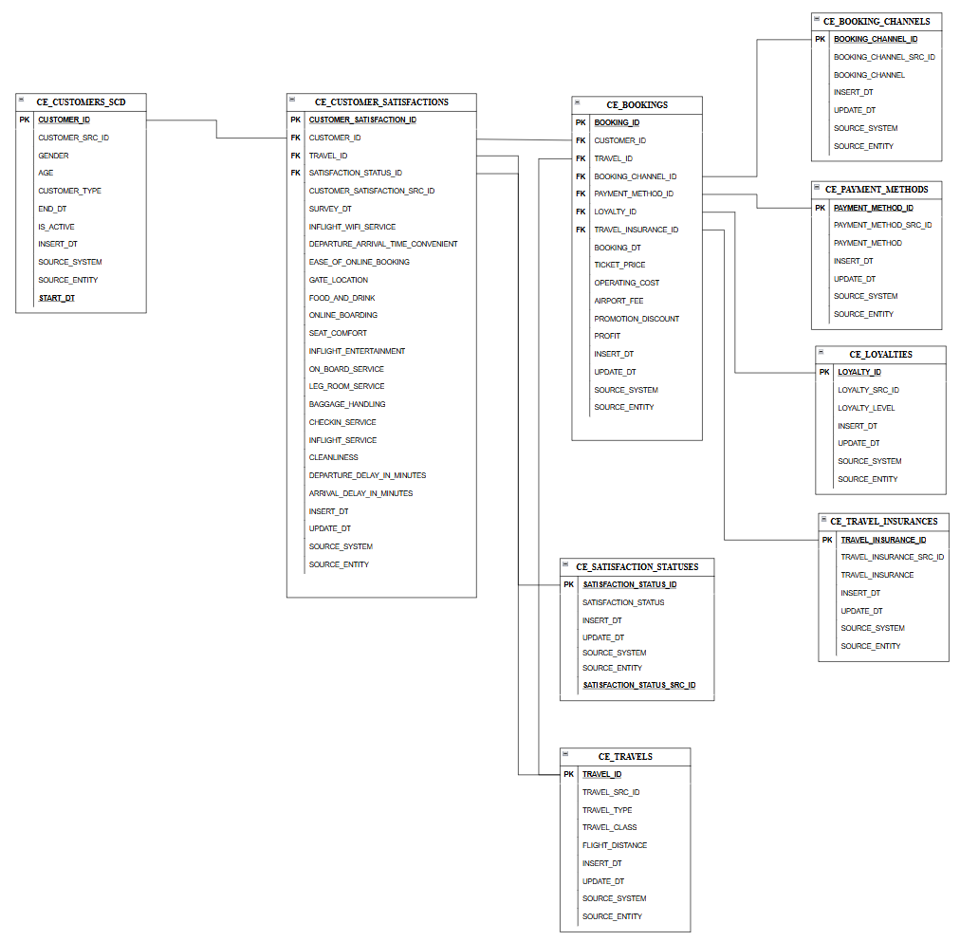

3NF Table Specifications
CE_CUSTOMERS_SCD
Column name | Description | Data type | Key / notes
CUSTOMER_ID | Surrogate identifier of customer | NUMBER | PK
CUSTOMER_SRC_ID | Customer identifier from source system | VARCHAR(50) | Natural/source key
GENDER | Customer gender | VARCHAR(20)
AGE | Customer age | NUMBER
CUSTOMER_TYPE | Type of customer | VARCHAR(50) | SCD2 attribute
START_DT | Start date of record validity | DATE | SCD2 required
END_DT | End date of record validity | DATE | SCD2 required
IS_ACTIVE | Shows current active version | CHAR(1) | Y/N
INSERT_DT | Record insert date | TIMESTAMP | Audit
SOURCE_SYSTEM | Source system name | VARCHAR(50) | Source triplet
SOURCE_ENTITY | Source table/file/entity | VARCHAR(100) | Source triplet

CE_CUSTOMER_SATISFACTIONS
Column name | Description | Data type | Key / notes
CUSTOMER_SATISFACTION_ID | Surrogate identifier of satisfaction record | NUMBER | PK
CUSTOMER_ID | Customer identifier | NUMBER | FK to BL_CUSTOMER_SCD2
TRAVEL_ID | Travel characteristics identifier | NUMBER | FK to BL_TRAVELS
SATISFACTION_STATUS_ID | Satisfaction status identifier | NUMBER | FK to BL_SATISFACTION_STATUSES
CUSTOMER_SATISFACTION_SRC_ID | Source identifier of satisfaction record | VARCHAR(50) | Natural/source key
SURVEY_DT | Date of survey | DATE
INFLIGHT_WIFI_SERVICE | Rating of inflight Wi-Fi service | NUMBER
DEPARTURE_ARRIVAL_TIME_CONVENIENT | Rating of time convenience | NUMBER
EASE_OF_ONLINE_BOOKING | Rating of online booking ease | NUMBER
GATE_LOCATION | Rating of gate location | NUMBER
FOOD_AND_DRINK | Rating of food and drink | NUMBER
ONLINE_BOARDING | Rating of online boarding | NUMBER
SEAT_COMFORT | Rating of seat comfort | NUMBER
INFLIGHT_ENTERTAINMENT | Rating of entertainment | NUMBER
ON_BOARD_SERVICE | Rating of onboard service | NUMBER
LEG_ROOM_SERVICE | Rating of leg room service | NUMBER
BAGGAGE_HANDLING | Rating of baggage handling | NUMBER
CHECKIN_SERVICE | Rating of check-in service | NUMBER
INFLIGHT_SERVICE | Rating of inflight service | NUMBER
CLEANLINESS | Rating of cleanliness | NUMBER
DEPARTURE_DELAY_IN_MINUTES | Departure delay in minutes | NUMBER
ARRIVAL_DELAY_IN_MINUTES | Arrival delay in minutes | NUMBER
INSERT_DT | Record insert date | TIMESTAMP | Audit
UPDATE_DT | Record update date | TIMESTAMP | Audit
SOURCE_SYSTEM | Source system name | VARCHAR(50) | Source triplet
SOURCE_ENTITY | Source table/file/entity | VARCHAR(100) | Source triplet

CE_BOOKINGS
Column name | Description | Data type | Key / notes
BOOKING_ID | Surrogate identifier of booking | NUMBER | PK
CUSTOMER_ID | Customer identifier | NUMBER | FK to BL_CUSTOMER_SCD2
TRAVEL_ID | Travel characteristics identifier | NUMBER | FK to BL_TRAVELS
BOOKING_CHANNEL_ID | Booking channel identifier | NUMBER | FK to BL_BOOKING_CHANNELS
PAYMENT_METHOD_ID | Payment method identifier | NUMBER | FK to BL_PAYMENT_METHODS
LOYALTY_ID | Loyalty level identifier | NUMBER | FK to BL_LOYALTIES
TRAVEL_INSURANCE_ID | Travel insurance identifier | NUMBER | FK to BL_TRAVEL_INSURANCES
BOOKING_DT | Date and time of booking | TIMESTAMP
TICKET_PRICE | Ticket price | DECIMAL(10,2) | Measure
OPERATING_COST | Operating cost | DECIMAL(10,2) | Measure
AIRPORT_FEE | Airport fee | DECIMAL(10,2) | Measure
PROMOTION_DISCOUNT | Promotion discount | DECIMAL(10,2) | Measure
PROFIT | Profit amount | DECIMAL(10,2) | Measure
INSERT_DT | Record insert date | TIMESTAMP | Audit
UPDATE_DT | Record update date | TIMESTAMP | Audit
SOURCE_SYSTEM | Source system name | VARCHAR(50) | Source triplet
SOURCE_ENTITY | Source table/file/entity | VARCHAR(100) | Source triplet

CE_TRAVELS
Column name | Description | Data type | Key / notes
TRAVEL_ID | Surrogate identifier of travel characteristics | NUMBER | PK
TRAVEL_SRC_ID | Travel identifier from source system | VARCHAR(50) | Natural/source key
TRAVEL_TYPE | Type of travel | VARCHAR(50) | Example: Business, Personal
TRAVEL_CLASS | Travel class | VARCHAR(50) | Example: Eco, Eco Plus, Business
FLIGHT_DISTANCE | Flight distance | NUMBER
INSERT_DT | Record insert date | TIMESTAMP | Audit
UPDATE_DT | Record update date | TIMESTAMP | Audit
SOURCE_SYSTEM | Source system name | VARCHAR(50) | Source triplet
SOURCE_ENTITY | Source table/file/entity | VARCHAR(100) | Source triplet

CE_BOOKING_CHANNELS
Column name | Description | Data type | Key / notes
BOOKING_CHANNEL_ID | Surrogate identifier of booking channel | NUMBER | PK
BOOKING_CHANNEL_SRC_ID | Booking channel identifier from source | VARCHAR(50) | Natural/source key
BOOKING_CHANNEL | Name of booking channel | VARCHAR(100)
INSERT_DT | Record insert date | TIMESTAMP | Audit
UPDATE_DT | Record update date | TIMESTAMP | Audit
SOURCE_SYSTEM | Source system name | VARCHAR(50) | Source triplet
SOURCE_ENTITY | Source table/file/entity | VARCHAR(100) | Source triplet

CE_PAYMENT_METHODS
Column name | Description | Data type | Key / notes
PAYMENT_METHOD_ID | Surrogate identifier of payment method | NUMBER | PK
PAYMENT_METHOD_SRC_ID | Payment method identifier from source | VARCHAR(50) | Natural/source key
PAYMENT_METHOD | Payment method name | VARCHAR(100)
INSERT_DT | Record insert date | TIMESTAMP | Audit
UPDATE_DT | Record update date | TIMESTAMP | Audit
SOURCE_SYSTEM | Source system name | VARCHAR(50) | Source triplet
SOURCE_ENTITY | Source table/file/entity | VARCHAR(100) | Source triplet

CE_LOYALTIES
Column name | Description | Data type | Key / notes
LOYALTY_ID | Surrogate identifier of loyalty level | NUMBER | PK
LOYALTY_SRC_ID | Loyalty identifier from source | VARCHAR(50) | Natural/source key
LOYALTY_LEVEL | Loyalty level name | VARCHAR(100)
INSERT_DT | Record insert date | TIMESTAMP | Audit
UPDATE_DT | Record update date | TIMESTAMP | Audit
SOURCE_SYSTEM | Source system name | VARCHAR(50) | Source triplet
SOURCE_ENTITY | Source table/file/entity | VARCHAR(100) | Source triplet

CE_TRAVEL_INSURANCES
Column name | Description | Data type | Key / notes
TRAVEL_INSURANCE_ID | Surrogate identifier of travel insurance option | NUMBER | PK
TRAVEL_INSURANCE_SRC_ID | Travel insurance identifier from source | VARCHAR(50) | Natural/source key
TRAVEL_INSURANCE | Travel insurance value | VARCHAR(50) | Example: Yes/No
INSERT_DT | Record insert date | TIMESTAMP | Audit
UPDATE_DT | Record update date | TIMESTAMP | Audit
SOURCE_SYSTEM | Source system name | VARCHAR(50) | Source triplet
SOURCE_ENTITY | Source table/file/entity | VARCHAR(100) | Source triplet

CE_SATISFACTION_STATUSES
Column name | Description | Data type | Key / notes
SATISFACTION_STATUS_ID | Surrogate identifier of satisfaction status | NUMBER | PK
SATISFACTION_STATUS_SRC_ID | Satisfaction status identifier from source | VARCHAR(50) | Natural/source key
SATISFACTION_STATUS | Customer satisfaction status | VARCHAR(100) | Example: satisfied, neutral or dissatisfied
INSERT_DT | Record insert date | TIMESTAMP | Audit
UPDATE_DT | Record update date | TIMESTAMP | Audit
SOURCE_SYSTEM | Source system name | VARCHAR(50) | Source triplet
SOURCE_ENTITY | Source table/file/entity | VARCHAR(100) | Source triplet

3. Business Layer Dimensional Model
Dimension Layer Design
According to standard DW naming conventions, every dimension should contain metadata columns.

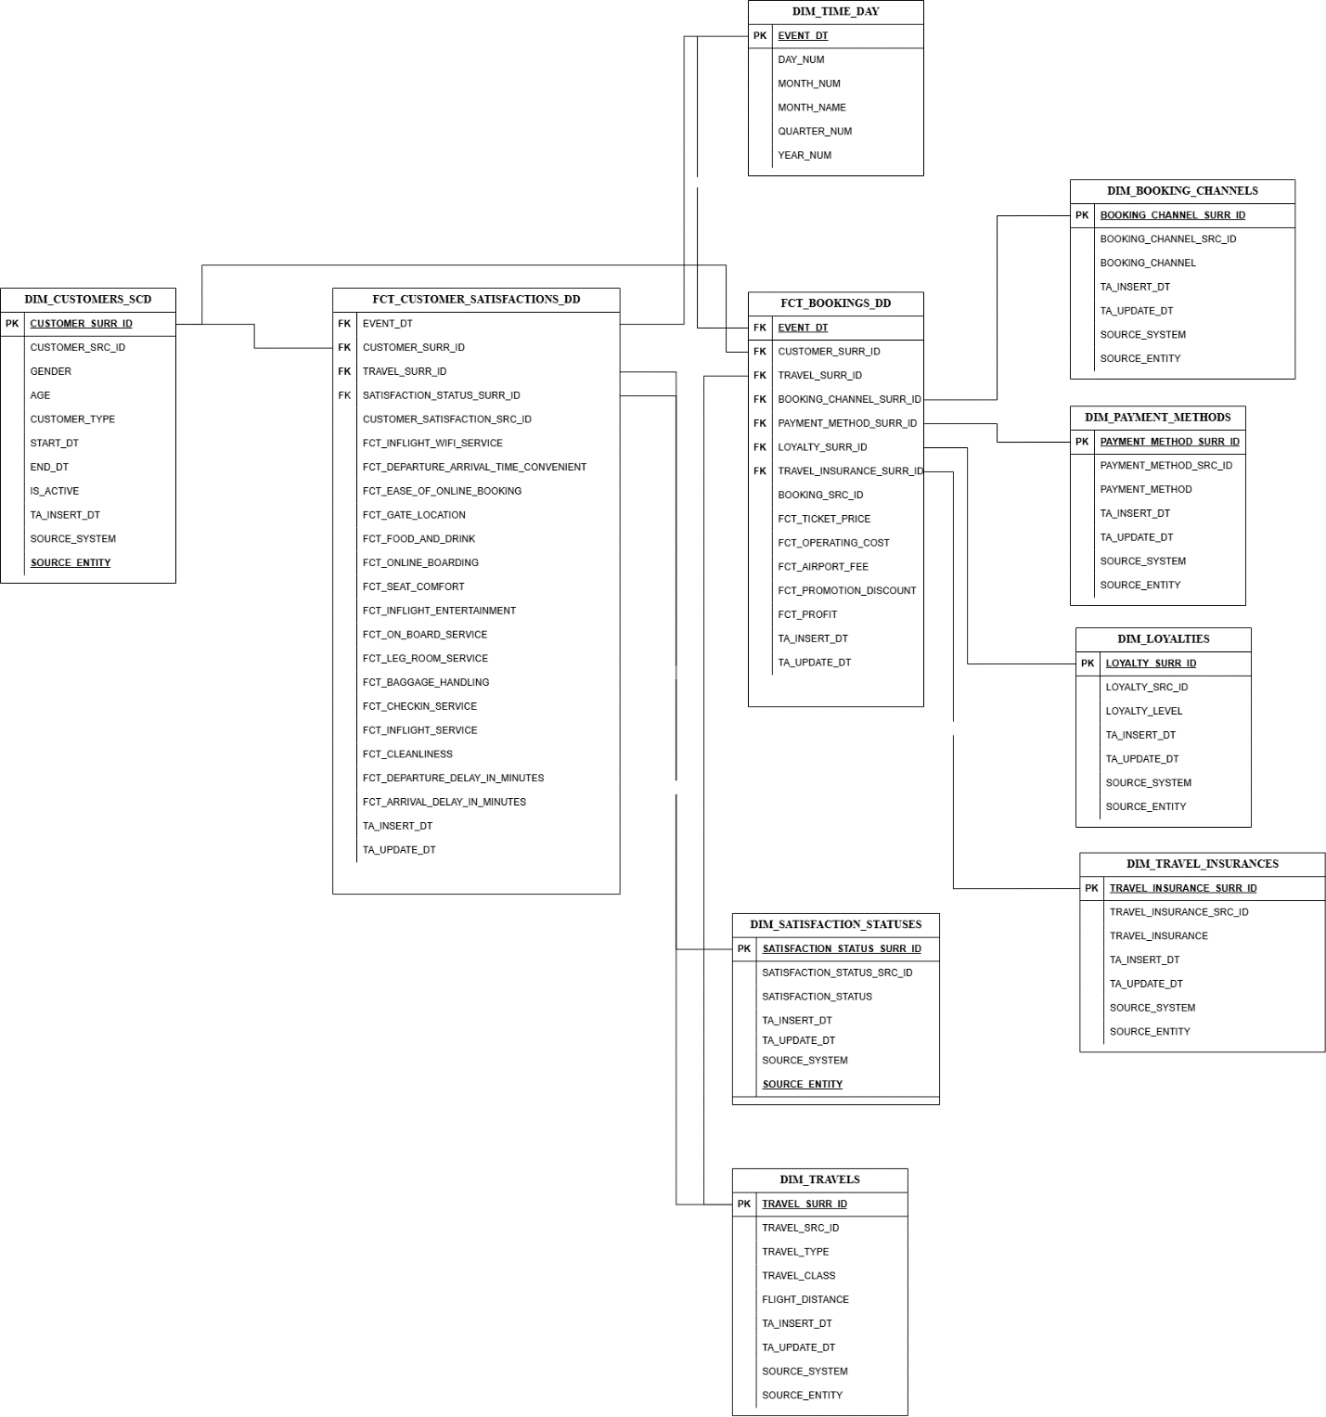
Fact Table Metrics Description FCT_BOOKINGS_DD

FCT_TICKET_PRICE Base ticket price paid by the customer
FCT_OPERATING_COST Airline operating cost associated with the booking
FCT_AIRPORT_FEE Airport taxes and airport service fees
FCT_PROMOTION_DISCOUNT Discount applied through promotions or loyalty programs
FCT_PROFIT Net profit generated from the booking
BOOKING_SRC_ID Booking business identifier (degenerate dimension)
Calculated Metric
Metric | Formula | Description
NET_REVENUE | FCT_TICKET_PRICE − FCT_PROMOTION_DISCOUNT | Revenue received after discount application
PROFIT_MARGIN_PCT | (FCT_PROFIT / FCT_TICKET_PRICE) × 100 | Percentage profit margin for the booking
TOTAL_COST | FCT_OPERATING_COST + FCT_AIRPORT_FEE | Total booking-related cost
NET_PROFIT_AFTER_DISCOUNT | NET_REVENUE − TOTAL_COST | Actual profit after discounts and costs

4. Dates script
CREATE TABLE DIM_TIME_DAY (
EVENT_DT DATE PRIMARY KEY,
DAY_NUM NUMBER,
MONTH_NUM NUMBER,
MONTH_NAME VARCHAR2(20),
QUARTER_NUM NUMBER,
YEAR_NUM NUMBER
);

BEGIN
FOR i IN 0 .. 36524 LOOP
INSERT INTO DIM_TIME_DAY (
EVENT_DT,
DAY_NUM,
MONTH_NUM,
MONTH_NAME,
QUARTER_NUM,
YEAR_NUM
)
SELECT
DATE '2020-01-01' + i,
EXTRACT(DAY FROM DATE '2020-01-01' + i),
EXTRACT(MONTH FROM DATE '2020-01-01' + i),
TRIM(TO_CHAR(DATE '2020-01-01' + i, 'MONTH')),
TO_NUMBER(TO_CHAR(DATE '2020-01-01' + i, 'Q')),
EXTRACT(YEAR FROM DATE '2020-01-01' + i)
FROM dual;
END LOOP;

COMMIT;
END;

Business Layer 3NF

Business Layer Dimensional Model

Logical Scheme
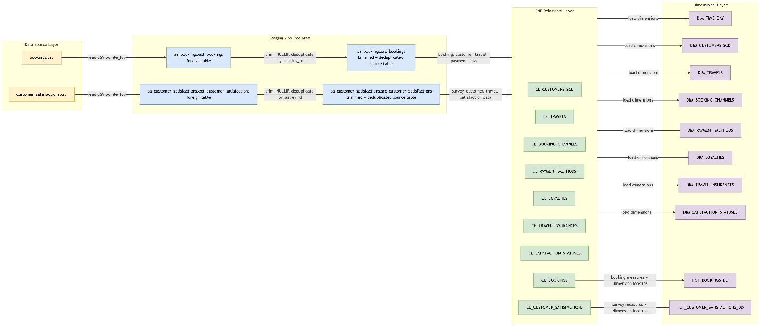
Logical Scheme

Data Flow
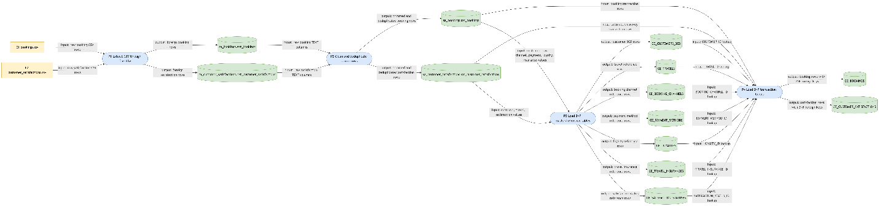
Data Flow Part-1
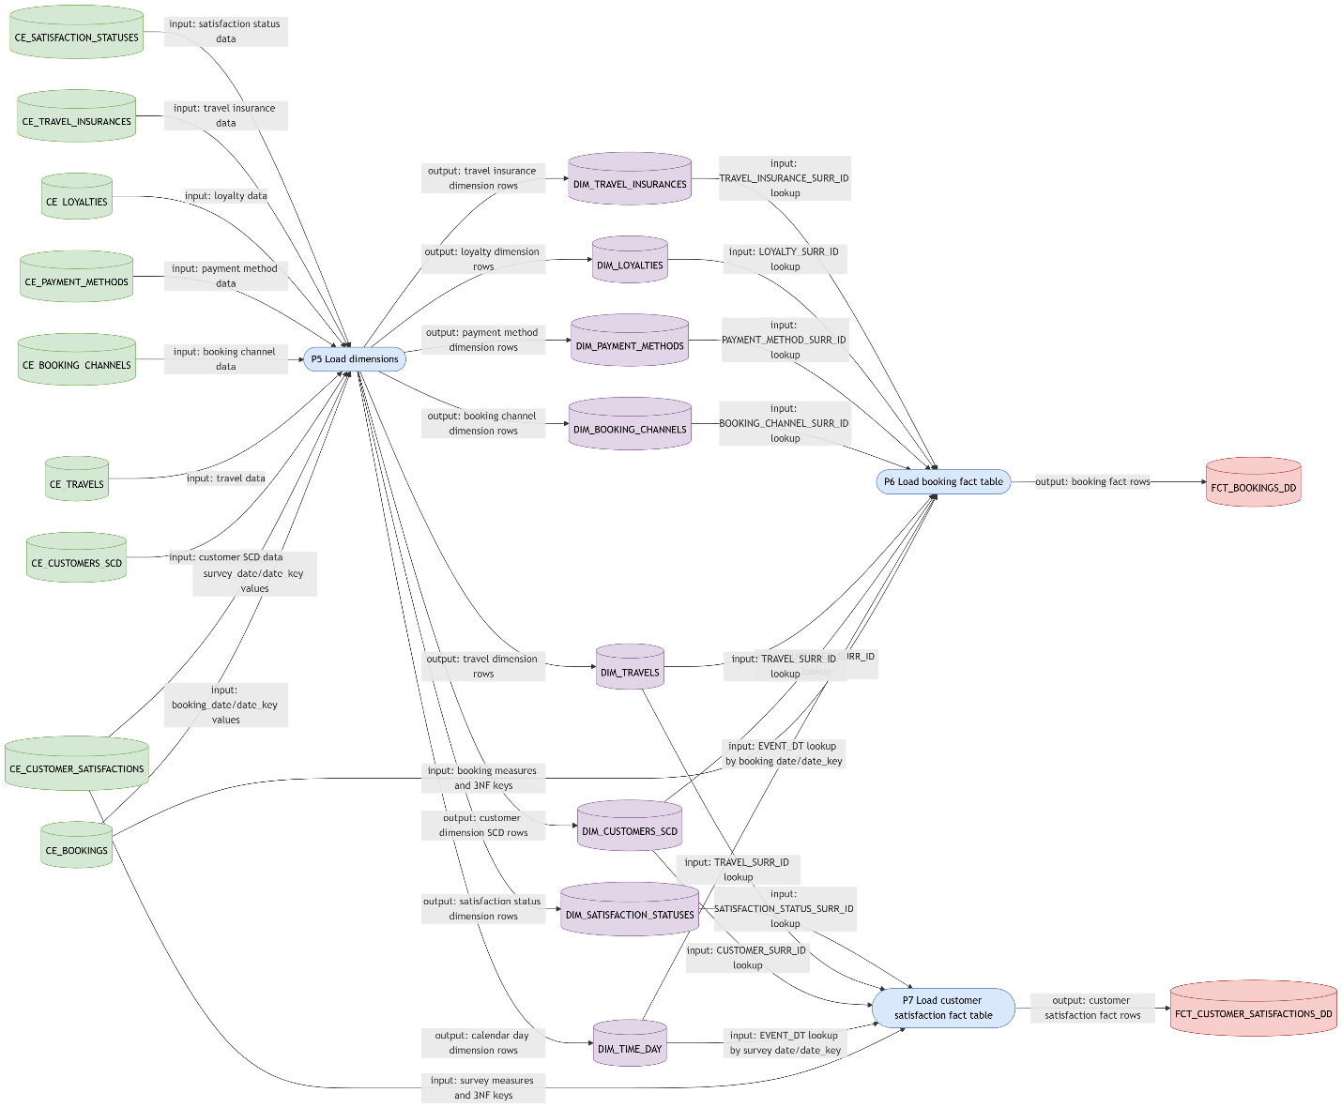
Data Flow Part 2

Fact Table Partitioning Strategy

