EPAM Systems, RD Dep., RD Dep.

Test Automation & UNIT TESTING Basics
DQE

1.Task Provide the Python code based on the fixture_task.py which will contain 2 fixtures
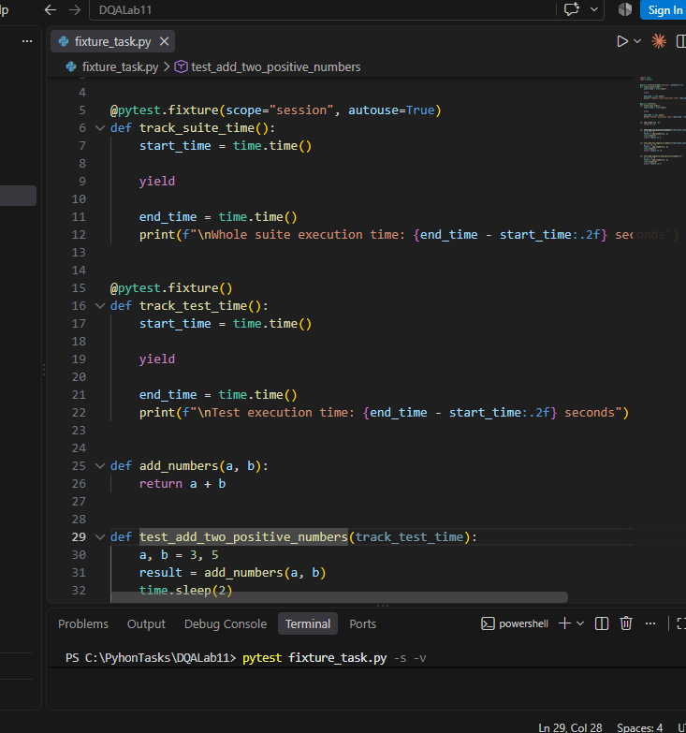
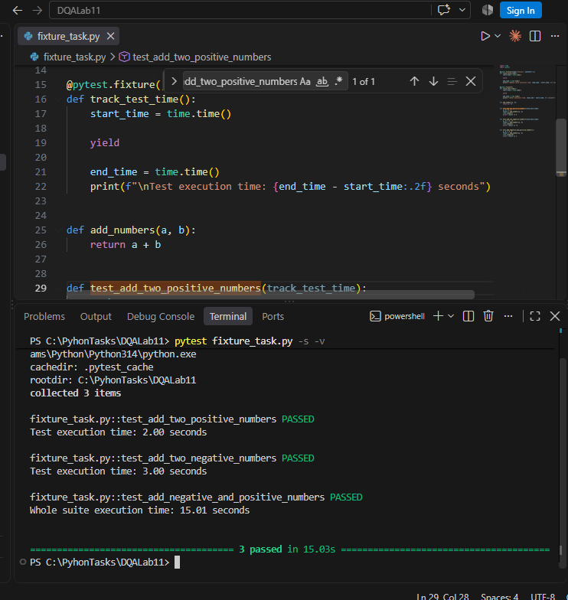

Task 2: You need to write the logic for the tests and use parametrisation for the test_add_numbers function based on the code parametrize_task.py

The Smoke path test run successfully
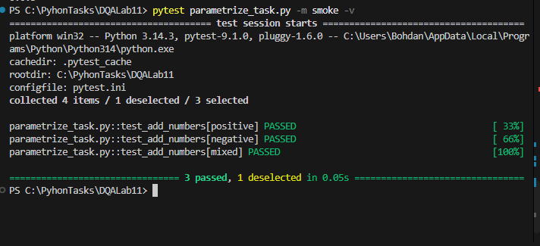
The Critical path test run successfully
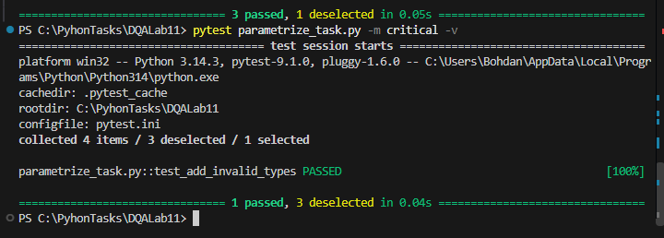
The full suite run:
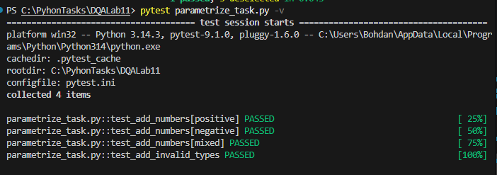

Task 3
General Overview: You need to implement the basic framework to test the tables in your database.

3.1 . 6 tests must be implemented: 3 for smoke tests like the presence of the objects. 3 for the critical path.
Type | Test | Expected
Smoke | dwh.dwh_clients exists | 1
Smoke | dwh.dwh_products exists | 1
Smoke | dwh.dwh_sales exists | 1
Critical | Duplicate client_id | 0
Critical | Duplicate product_id | 0
Critical | Sales with invalid client_id | 0
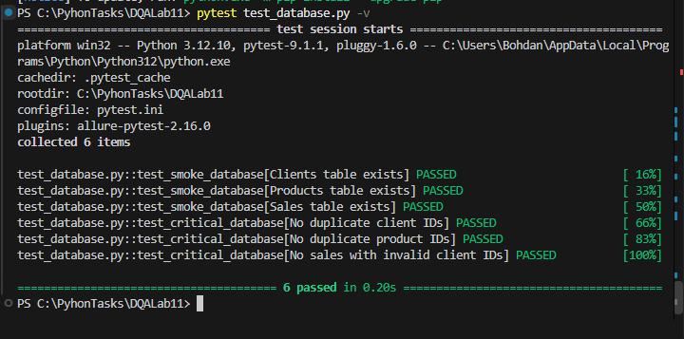

The result of the test run must be provided using the allure.

The smoke path report
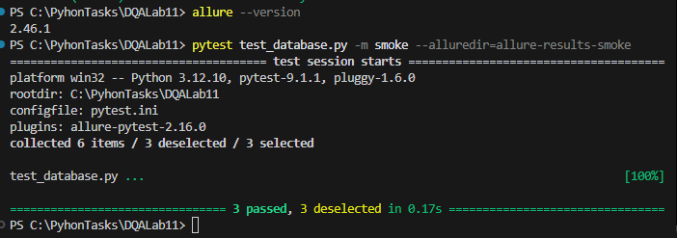
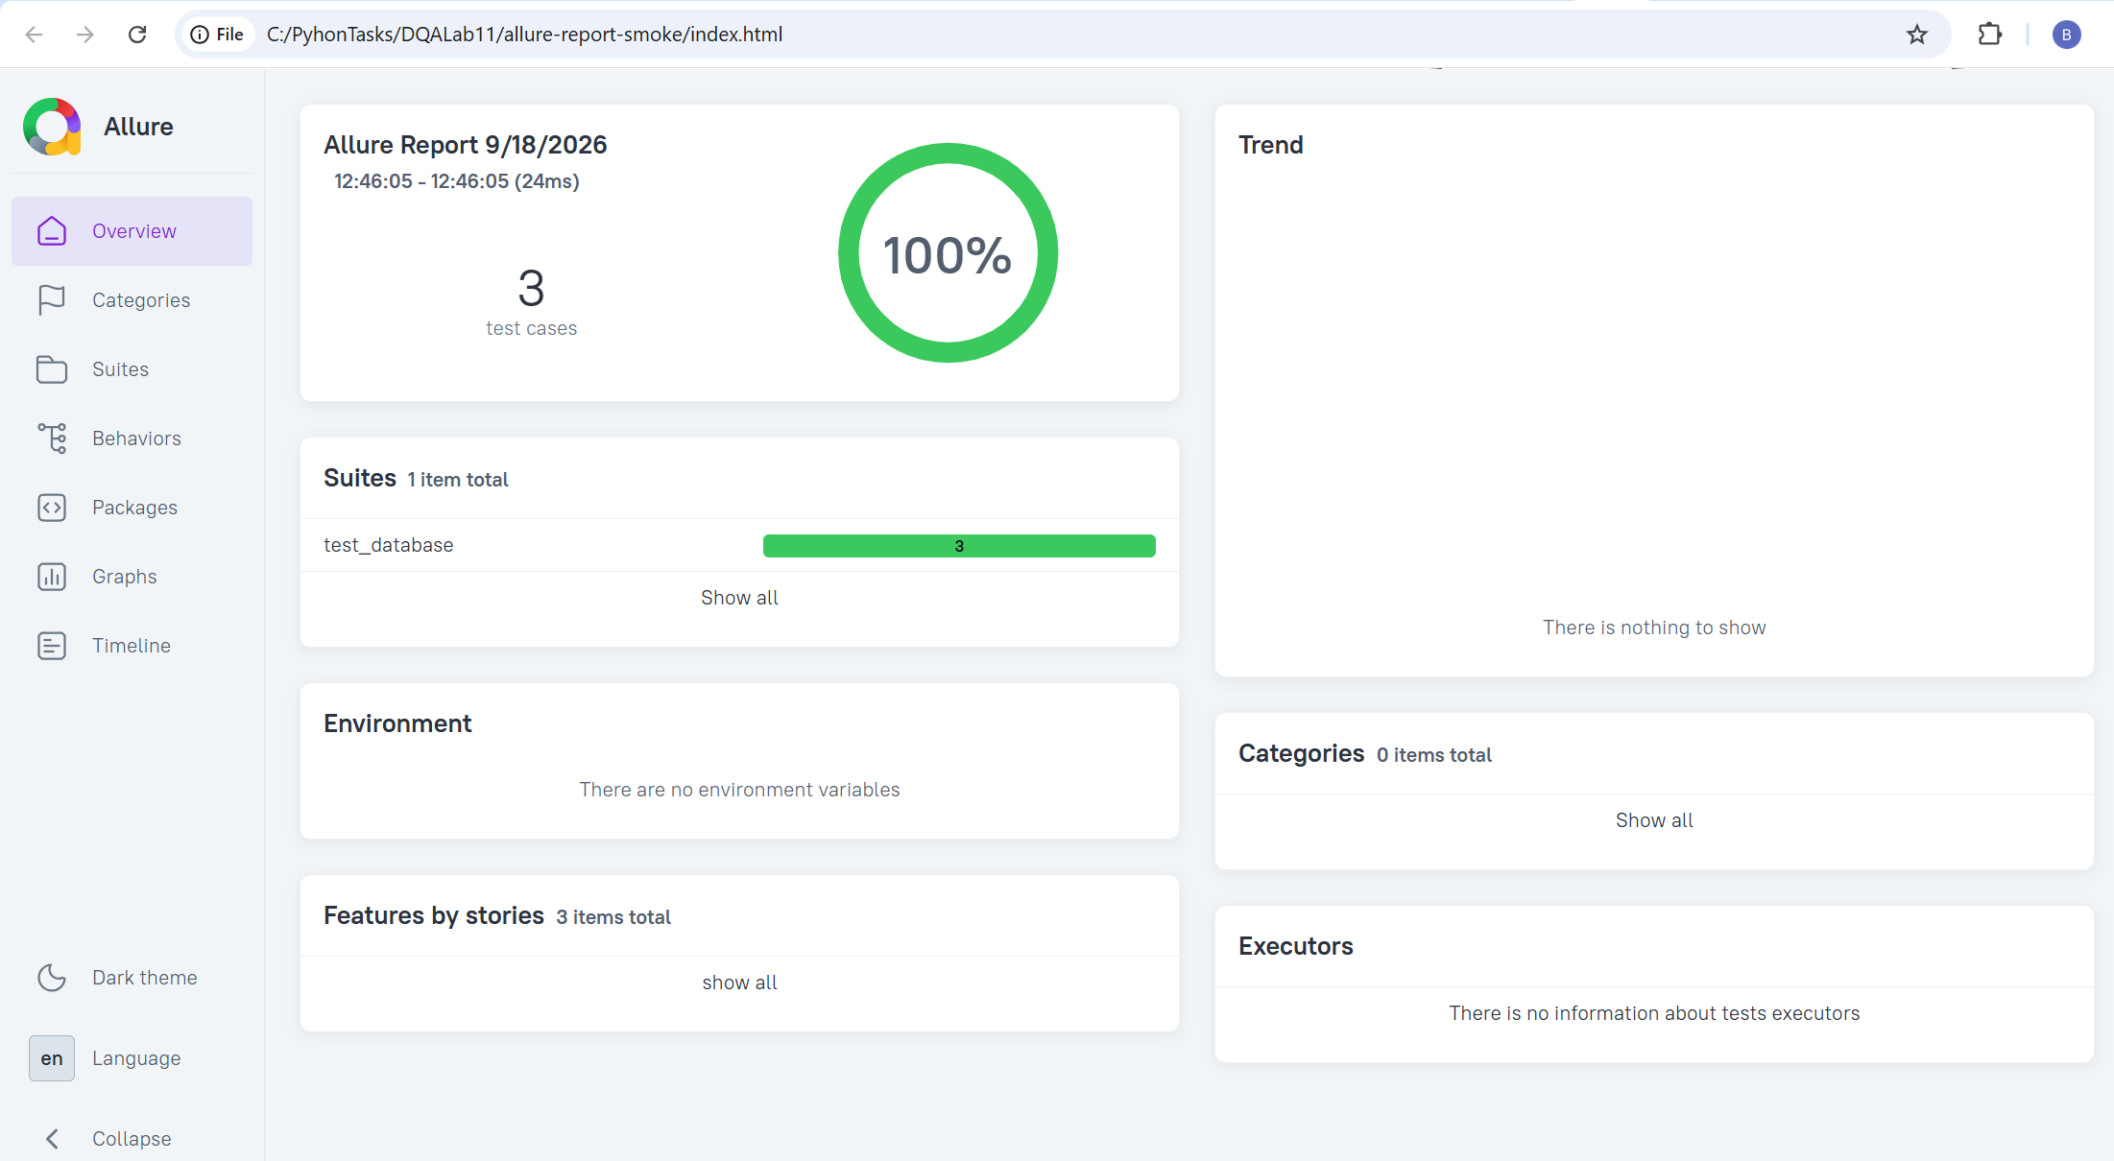

Critical path report using Alure
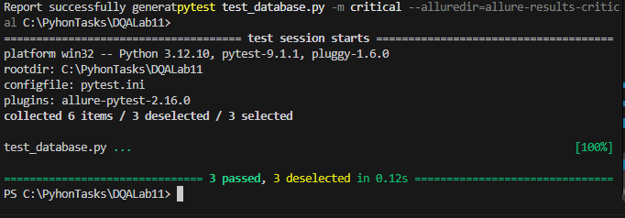

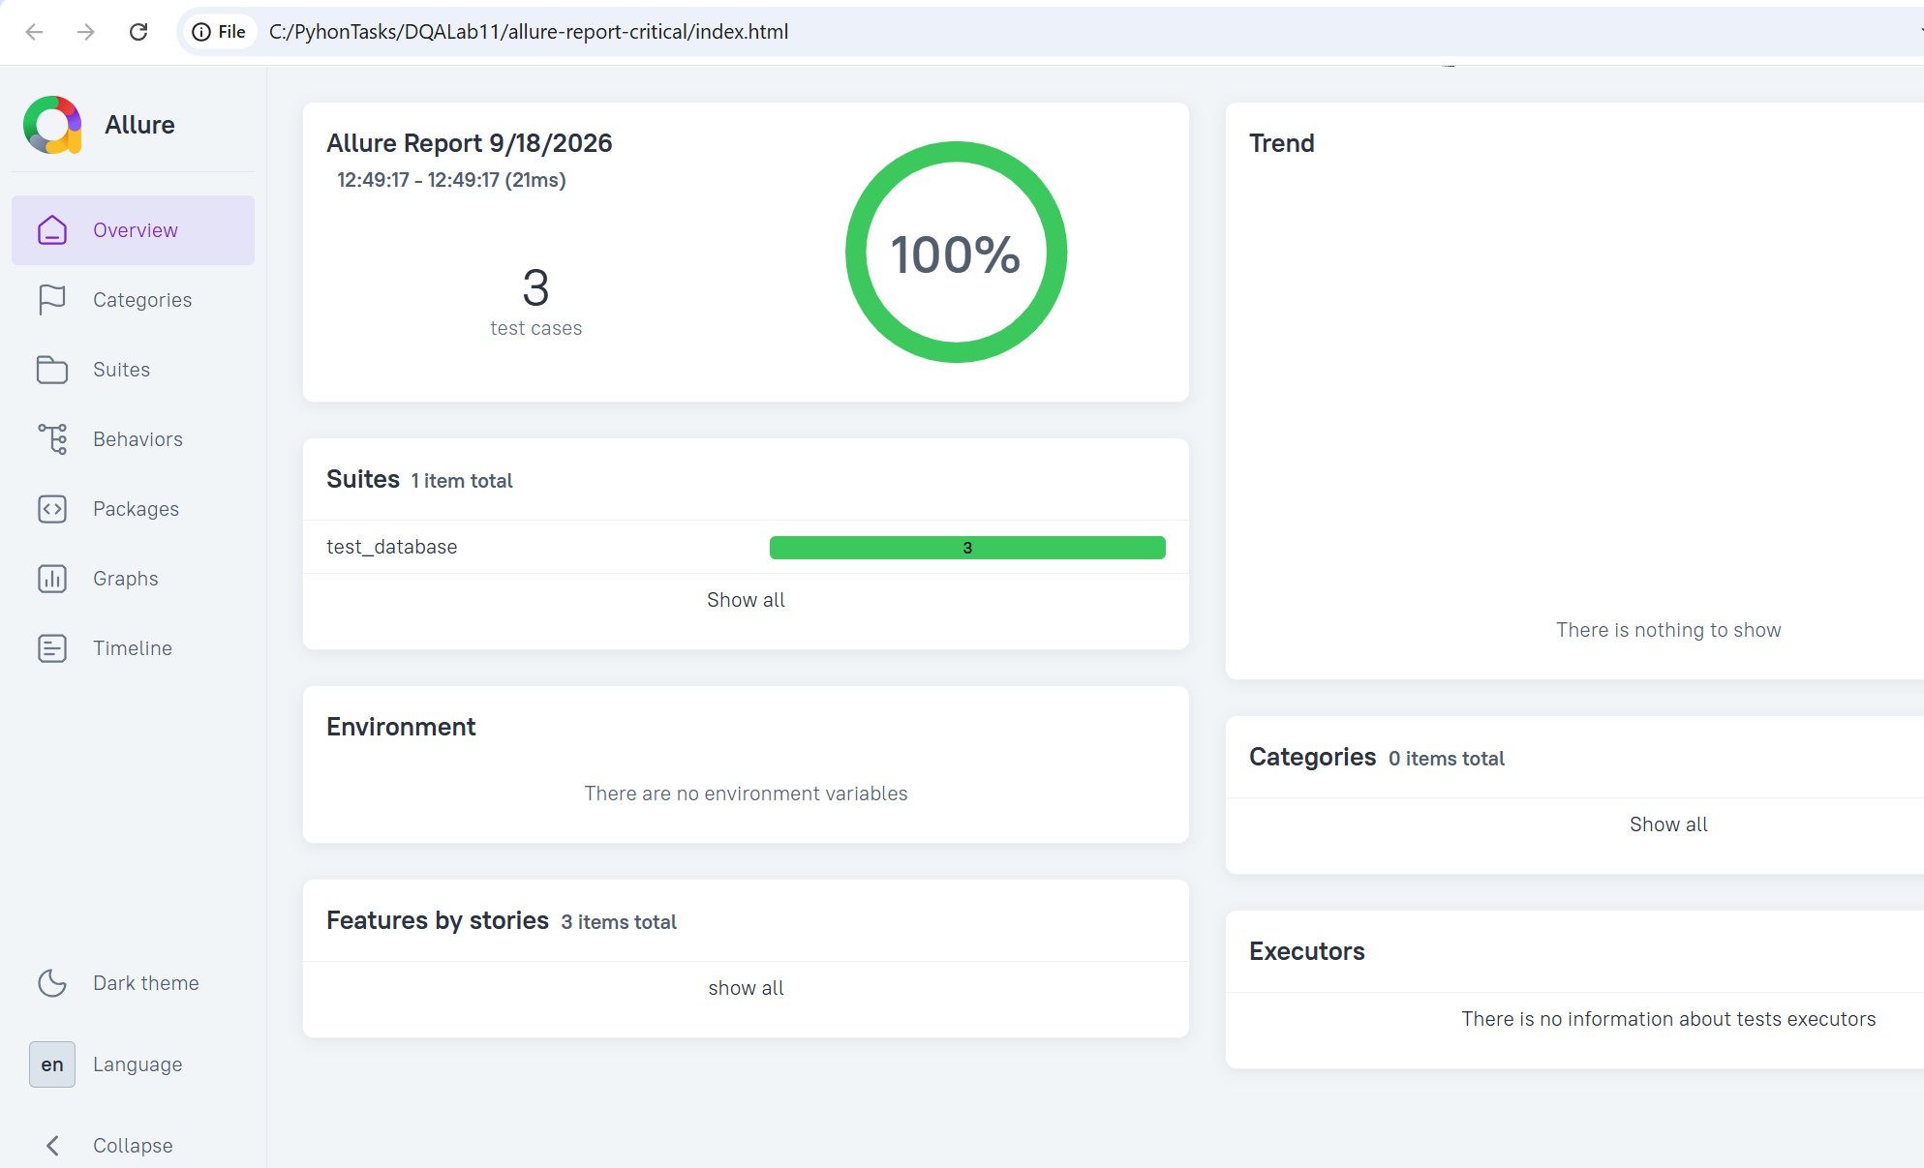

The Full Suite report
