EPAM Systems
Data Quality Engineering

TEST AUTOMATION & SELENIUM BASICS
Task 12 — Final Report with Full Code Implementation

Prepared by: Bohdan Solovei
Date: 21 September 2026

1. Objective and Environment
The work covers API/integration testing with Pytest and browser automation with Selenium. The report now includes the complete implementation used for every task, not only excerpts.
Component | Used in the work
Python | 3.12.10
Pytest | 9.1.1
Selenium | 4.49.0
Browsers | Google Chrome and Mozilla Firefox
Firefox driver | GeckoDriver 0.37.1 at C:\WebDriver\geckodriver.exe
Reporting | Allure Pytest 2.16.0

2. Task 1 — API and Integration Testing
Task 1 contains two Pytest scenarios: validation that user ID 3 has exactly 10 posts, and validation that the configured GCP and AWS NEXRAD locations contain objects. Reusable configuration and data retrieval are implemented as fixtures in conftest.py.

2.1 Complete implementation — conftest.py
import boto3
import pytest
import requests

from botocore import UNSIGNED
from botocore.config import Config
from google.cloud import storage

@pytest.fixture
def provide_config():
return {
"prefix": "2024/01/01/KTLX/",
"gcp_bucket_name": "gcp-public-data-nexrad-l2",
"aws_bucket_name": "unidata-nexrad-level2",
"s3_anon_client": boto3.client(
"s3",
config=Config(signature_version=UNSIGNED)
),
"gcp_storage_anon_client":
storage.Client.create_anonymous_client()
}

@pytest.fixture
def list_gcs_blobs(provide_config):
client = provide_config["gcp_storage_anon_client"]

blobs = client.list_blobs(
provide_config["gcp_bucket_name"],
prefix=provide_config["prefix"]
)

return [blob.name for blob in blobs]

@pytest.fixture
def list_aws_blobs(provide_config):
config = provide_config

response = config["s3_anon_client"].list_objects(
Bucket=config["aws_bucket_name"],
Prefix=config["prefix"]
)

objects = [
content["Key"]
for content in response.get("Contents", [])
]

return objects

@pytest.fixture
def provide_posts_data():
response = requests.get(
"https://jsonplaceholder.typicode.com/posts",
params={"userId": 3},
timeout=10
)

assert response.status_code == 200, (
f"Expected status code 200, "
f"but received {response.status_code}"
)

return response.json()

2.2 Complete implementation — test_api_task.py
def test_user_with_posts(provide_posts_data):
assert len(provide_posts_data) == 10, (
f"Expected 10 posts for user 3, "
f"but found {len(provide_posts_data)}"
)

def test_data_is_presented_between_staging_raw(
list_gcs_blobs,
list_aws_blobs
):
assert len(list_gcs_blobs) > 0, (
"No objects were found in the GCP bucket "
"for the specified date."
)

assert len(list_aws_blobs) > 0, (
"No objects were found in the AWS bucket "
"for the specified date."
)

The HTTP fixture requests posts with userId=3 and checks HTTP 200 before returning JSON. The cloud fixtures anonymously list objects under prefix 2024/01/01/KTLX/. The tests then assert exactly 10 posts and non-empty GCP/AWS object lists. The AWS bucket was updated to 'unidata-nexrad-level2' because the starter bucket no longer allowed the required anonymous listing.
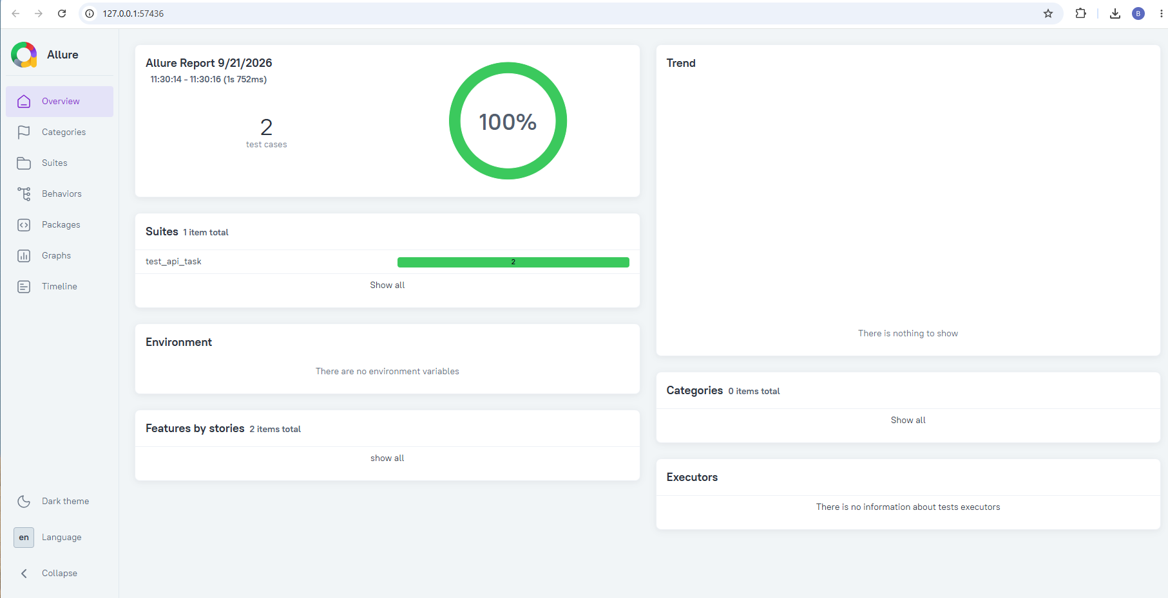
Figure 1 — Allure report: both Task 1 tests passed (2 test cases, 100%).

3. Task 2 — Chrome and Firefox Browser Automation
Chrome demonstrates automatic driver management through Selenium Manager. Firefox demonstrates the manual approach by passing the hard-coded GeckoDriver executable path to FirefoxService.

3.1 Complete implementation — task2_browsers.py
from selenium import webdriver
from selenium.webdriver.firefox.service import Service as FirefoxService

def open_chrome():
"""Open Google in Chrome using automatic Selenium Manager."""
driver = webdriver.Chrome()

try:
driver.get("https://www.google.com")
print(f"Chrome page title: {driver.title}")
finally:
driver.quit()

def open_firefox():
"""Open Google in Firefox using a manually specified driver."""
firefox_service = FirefoxService(
executable_path=r"C:\WebDriver\geckodriver.exe"
)

driver = webdriver.Firefox(service=firefox_service)

try:
driver.get("https://www.google.com")
print(f"Firefox page title: {driver.title}")
finally:
driver.quit()

if __name__ == "__main__":
open_chrome()
open_firefox()

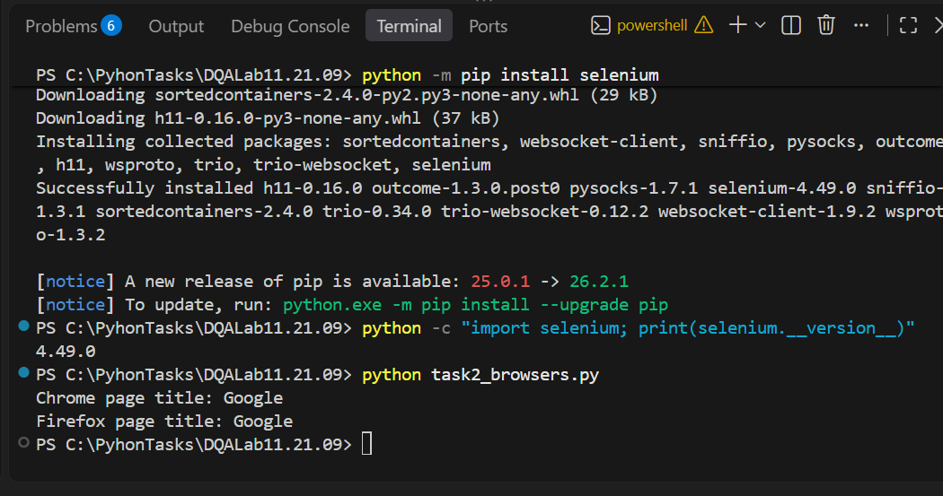
Figure 2 — Chrome and Firefox both opened Google and returned the title 'Google'.
Both browser sessions are enclosed in try/finally blocks, ensuring driver.quit() executes even if navigation or title retrieval fails.

4. Task 3 — Selenium Locator Strategies
The implementation contains two examples for each required locator strategy—Class Name, ID, Name, CSS Selector, and XPath—plus two optional Relative Locator examples. The helper check_locator() uses find_elements() and asserts that each locator resolves to exactly one element.

4.1 Complete implementation — task3_locators.py
from selenium import webdriver
from selenium.webdriver.common.by import By
from selenium.webdriver.support.relative_locator import locate_with

def check_locator(driver, locator_type, locator_value, description):
"""Find one element and print the result."""
elements = driver.find_elements(locator_type, locator_value)

assert len(elements) == 1, (
f"{description}: expected exactly 1 element, "
f"but found {len(elements)}"
)

print(f"PASS | {description} | exactly 1 element found")
return elements[0]

driver = webdriver.Chrome()

try:
driver.get("https://phptravels.com/demo")
driver.maximize_window()

print("\n--- CLASS NAME LOCATORS ---")

check_locator(
driver,
By.CLASS_NAME,
"first_name",
"CLASS_NAME: First Name input"
)

check_locator(
driver,
By.CLASS_NAME,
"last_name",
"CLASS_NAME: Last Name input"
)

print("\n--- ID LOCATORS ---")

check_locator(
driver,
By.ID,
"demo",
"ID: Access Live Demo button"
)

check_locator(
driver,
By.ID,
"number",
"ID: Math captcha input"
)

print("\n--- CSS SELECTOR LOCATORS ---")

check_locator(
driver,
By.CSS_SELECTOR,
"input.company_name",
"CSS: Business Name input"
)

check_locator(
driver,
By.CSS_SELECTOR,
"input.email[type='email']",
"CSS: Email input"
)

print("\n--- XPATH LOCATORS ---")

check_locator(
driver,
By.XPATH,
"//input[@placeholder='Enter WhatsApp number']",
"XPATH: WhatsApp Number input"
)

check_locator(
driver,
By.XPATH,
"//button[@id='demo']/span[text()='Access Live Demo']",
"XPATH: Access Live Demo text"
)

print("\nAll Demo page locators passed.")

print("\n--- NAME LOCATORS ---")

driver.get("https://phptravels.org/register.php")

check_locator(
driver,
By.NAME,
"firstname",
"NAME: First Name input"
)

check_locator(
driver,
By.NAME,
"lastname",
"NAME: Last Name input"
)

print("\nAll 10 required locators passed.")

print("\n--- RELATIVE LOCATORS ---")

first_name = driver.find_element(By.ID, "inputFirstName")

# 1. Find Last Name input to the right of First Name
relative_last_name = driver.find_element(
locate_with(By.TAG_NAME, "input").to_right_of(first_name)
)

assert relative_last_name.get_attribute("id") == "inputLastName"
print(
"PASS | RELATIVE: Last Name to the right of First Name "
"| correct element found"
)

# 2. Find Email input below First Name
relative_email = driver.find_element(
locate_with(By.TAG_NAME, "input").below(first_name)
)

assert relative_email.get_attribute("id") == "inputEmail"
print(
"PASS | RELATIVE: Email below First Name "
"| correct element found"
)

print("\nAll 12 Task 3 locators passed.")

finally:
driver.quit()

Locator strategy | Examples | Execution result
Class Name | 2 | PASS
ID | 2 | PASS
Name | 2 | PASS
CSS Selector | 2 | PASS
XPath | 2 | PASS
Relative Locator (optional) | 2 | PASS
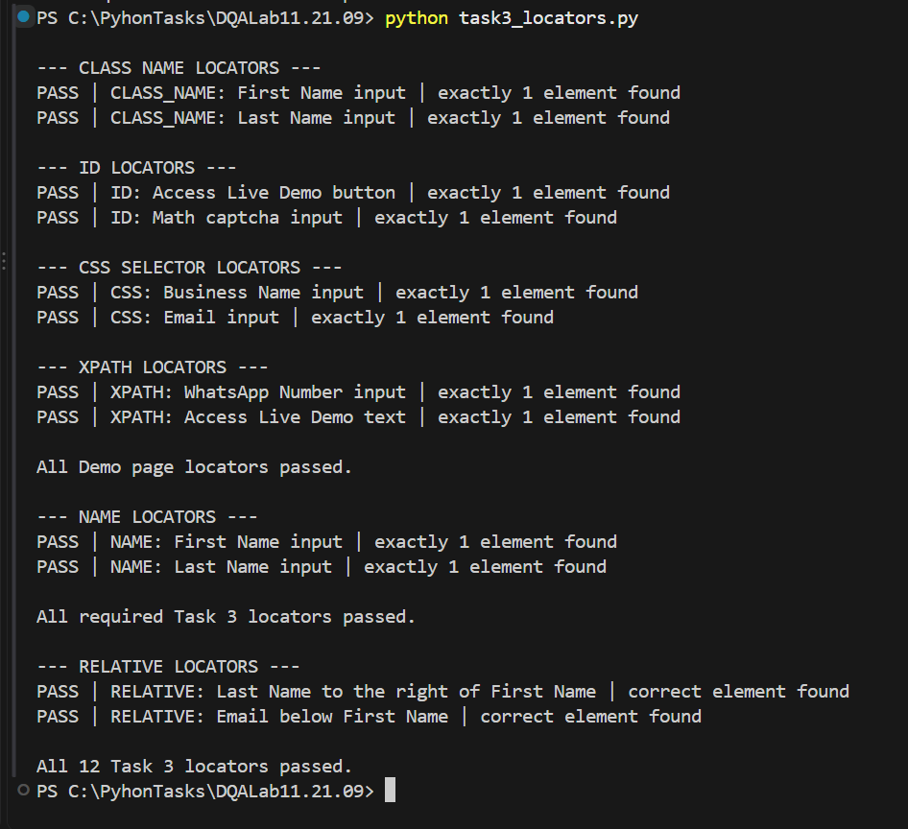
Figure 3 — All 10 required locators and 2 optional relative locators passed.

5. Task 4 — Implicit and Explicit Waits
The final script demonstrates an implicit wait of 10 seconds and an explicit WebDriverWait. Google is opened first. Because Google repeatedly returned an anti-automation CAPTCHA during the literal automated search flow, the challenge was not bypassed; the Selenium site is opened directly and the explicit wait verifies that its navigation element becomes visible.

5.1 Complete implementation — task4_waits.py
from selenium import webdriver
from selenium.webdriver.common.by import By
from selenium.webdriver.support.ui import WebDriverWait
from selenium.webdriver.support import expected_conditions as EC

driver = webdriver.Chrome()

try:
# ---------- IMPLICIT WAIT ----------
driver.implicitly_wait(10)
print("PASS | Implicit wait set to 10 seconds")

# Open Google
driver.get("https://www.google.com")
driver.maximize_window()

print("PASS | Google opened")

# Google blocks automated search with repeated CAPTCHA
# in the current environment, so open the expected
# Selenium result directly.
driver.get("https://www.selenium.dev/")

# ---------- EXPLICIT WAIT ----------
wait = WebDriverWait(driver, 10)

selenium_logo = wait.until(
EC.visibility_of_element_located(
(By.CSS_SELECTOR, "a.navbar-brand")
)
)

assert selenium_logo.is_displayed()

print("PASS | Explicit wait: Selenium page loaded")
print(f"Page title: {driver.title}")
print(f"URL: {driver.current_url}")

print("\nTask 4 completed successfully.")

finally:
driver.quit()

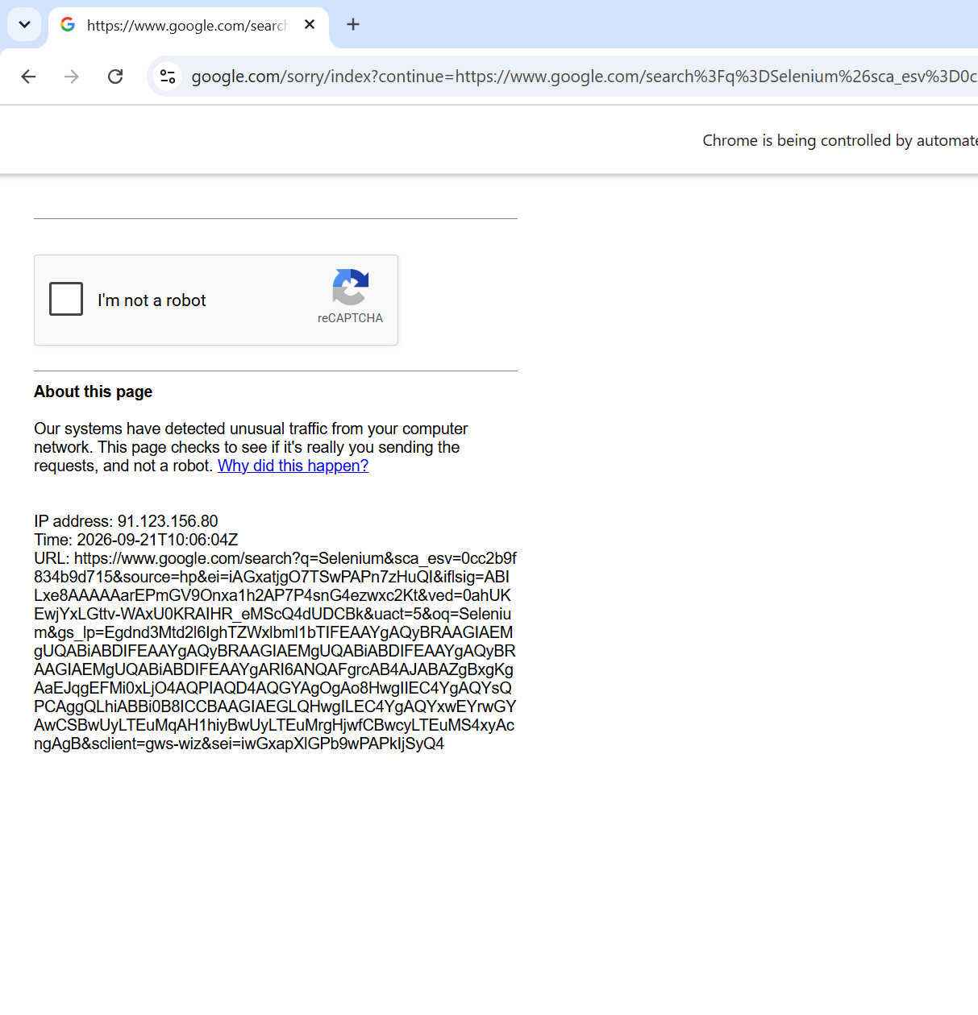
Figure 4 — Google anti-automation CAPTCHA encountered during the original search attempt.
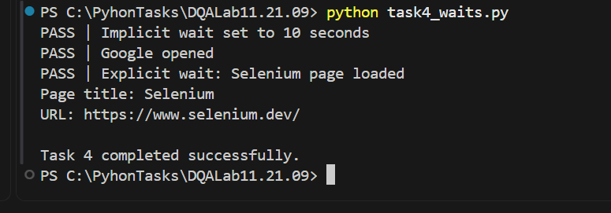
Figure 5 — Final Task 4 execution: implicit wait, Google opening, explicit wait, and Selenium page load succeeded.

6. Implementation Review Against the Rubric
The solution separates API fixtures from tests, uses focused browser functions, avoids duplicated locator validation through a helper function, includes clear assertion messages, and closes browser sessions reliably. The Task 3 implementation also demonstrates optional relative locators.
One documented limitation remains in Task 4: the exact automated Google-search-and-click sequence could not be completed in this environment because Google repeatedly served a CAPTCHA. The report records this limitation explicitly instead of presenting the workaround as an exact execution of the blocked step.

7. Conclusions
Task 1 completed two passing Pytest integration checks and produced a 100% Allure result. Task 2 demonstrated automatic Chrome driver management and manual Firefox GeckoDriver configuration. Task 3 validated all 10 required locator examples and 2 optional relative locators. Task 4 demonstrated both implicit and explicit waits while transparently documenting Google's anti-automation restriction.

