AWS for data quality engineers
AWS Lambda & Step Function

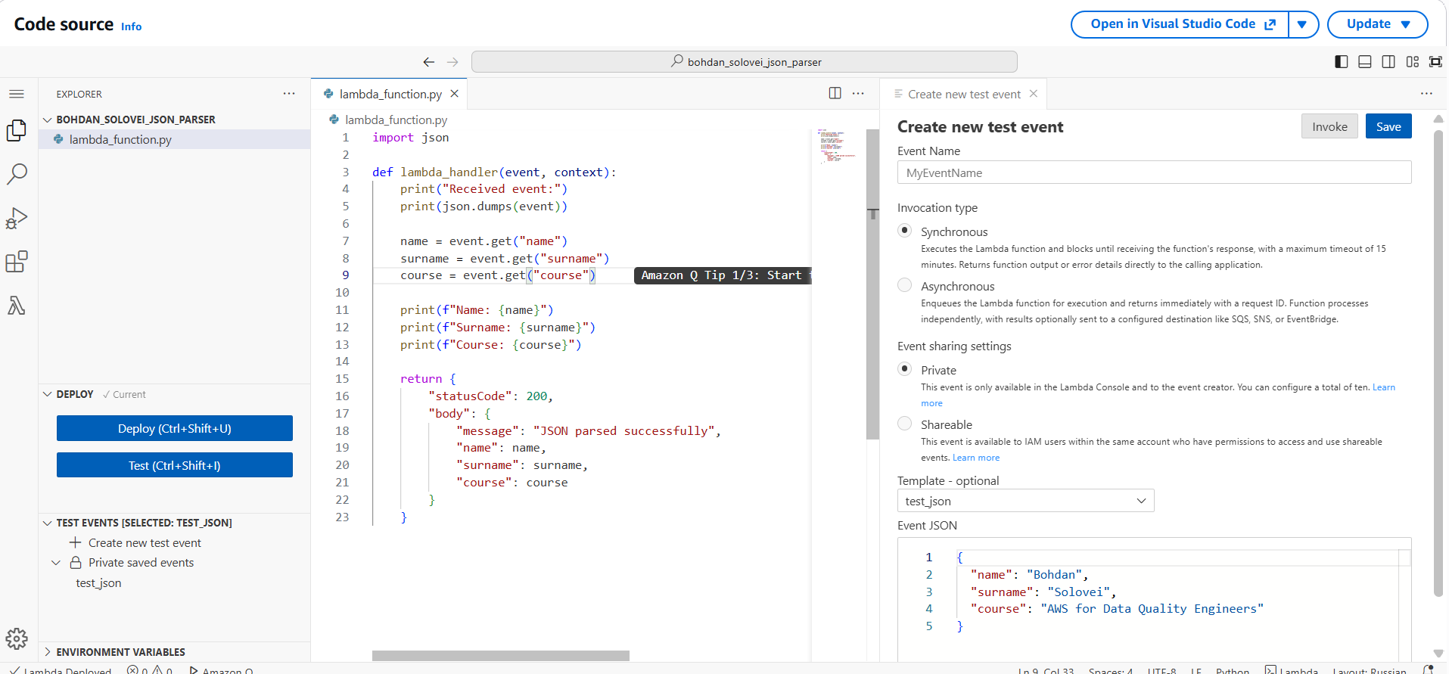

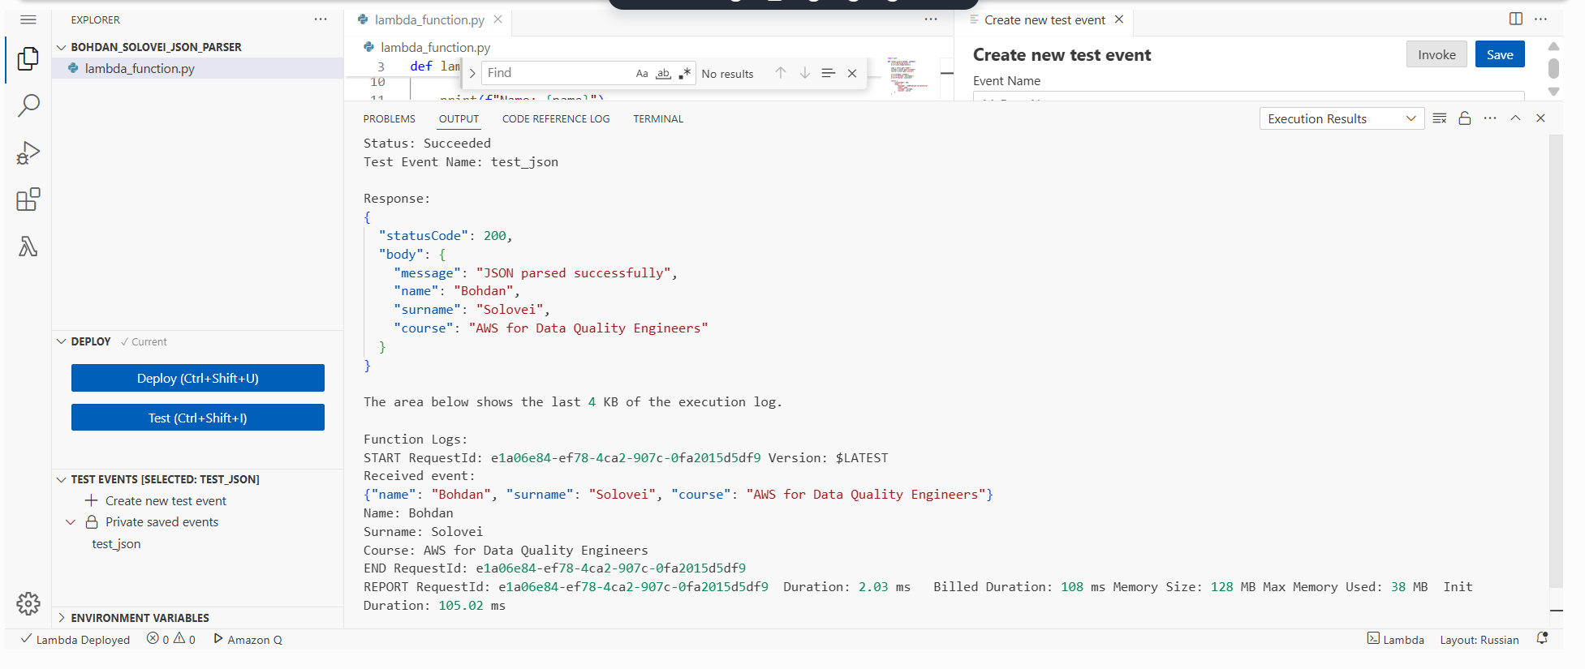
Figure 1. Lambda JSON/event processing test. The invocation succeeds and the execution log confirms that the input was processed and a successful response was returned.
Task 1(a) — AWS Lambda and Athena SELECT
The Lambda function uses the boto3 Athena client to submit a SQL query to the bohdan_lambda_db database, waits until execution reaches a terminal state, retrieves the result set, and returns a successful response containing the Athena query execution ID. This verifies that the function can invoke Athena and read query results programmatically.
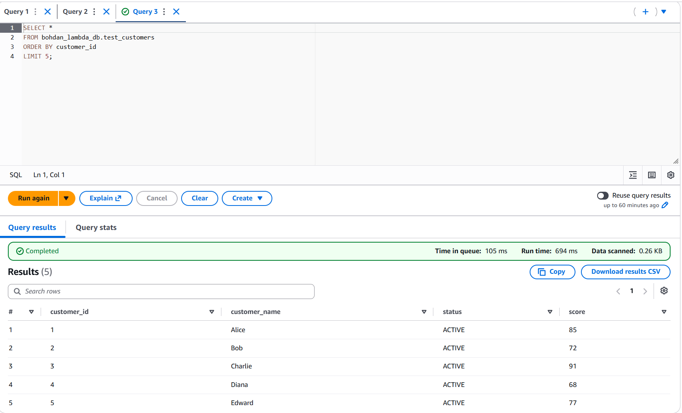
Figure 2. Athena query executed against bohdan_lambda_db.test_customers. The result set provides the source data used by the Lambda/Athena validation scenario.

import boto3
import time
import json

athena = boto3.client("athena")

DATABASE = "bohdan_lambda_db"
OUTPUT_LOCATION = "s3://bohdan-di-dwh-260586643565/athena_results/"

def lambda_handler(event, context):
query = """
SELECT *
FROM bohdan_lambda_db.test_customers
ORDER BY customer_id
LIMIT 5
"""

print("Starting Athena query:")
print(query)

response = athena.start_query_execution(
QueryString=query,
QueryExecutionContext={
"Database": DATABASE
},
ResultConfiguration={
"OutputLocation": OUTPUT_LOCATION
}
)

query_execution_id = response["QueryExecutionId"]
print("QueryExecutionId:", query_execution_id)

while True:
status_response = athena.get_query_execution(
QueryExecutionId=query_execution_id
)

status = status_response["QueryExecution"]["Status"]["State"]
print("Query status:", status)

if status in ["SUCCEEDED", "FAILED", "CANCELLED"]:
break

time.sleep(1)

if status != "SUCCEEDED":
reason = status_response["QueryExecution"]["Status"].get(
"StateChangeReason",
"Unknown error"
)
raise Exception(f"Athena query failed: {reason}")

results = athena.get_query_results(
QueryExecutionId=query_execution_id
)

print("Athena query results:")

for row in results["ResultSet"]["Rows"]:
values = [
column.get("VarCharValue", "")
for column in row["Data"]
]
print(values)

return {
"statusCode": 200,
"body": json.dumps({
"message": "Athena query completed successfully",
"queryExecutionId": query_execution_id
})
}

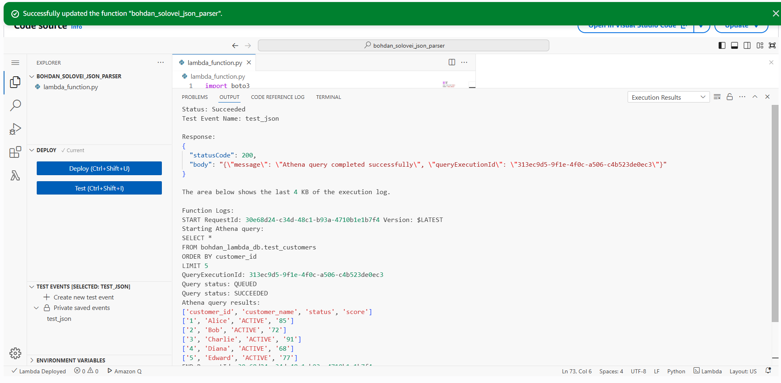
Figure 3. Successful Lambda execution for the Athena SELECT operation. The log shows the query lifecycle and the returned rows.

Task 1(b) — UPDATE through AWS Lambda
For the update scenario, the Lambda function performs three sequential operations: SELECT the target record, UPDATE its score, and SELECT the same record again. Waiting for each Athena query to reach SUCCEEDED ensures that the next operation starts only after the previous one has completed. Task 1(c), the optional extension, was not implemented.

import boto3
import time
import json

athena = boto3.client("athena")

DATABASE = "bohdan_lambda_db"
OUTPUT_LOCATION = "s3://bohdan-di-dwh-260586643565/athena_results/"

def run_athena_query(query):
print("\nRunning Athena query:")
print(query)

response = athena.start_query_execution(
QueryString=query,
QueryExecutionContext={
"Database": DATABASE
},
ResultConfiguration={
"OutputLocation": OUTPUT_LOCATION
}
)

query_execution_id = response["QueryExecutionId"]
print("QueryExecutionId:", query_execution_id)

while True:
execution = athena.get_query_execution(
QueryExecutionId=query_execution_id
)

status = execution["QueryExecution"]["Status"]["State"]
print("Query status:", status)

if status in ["SUCCEEDED", "FAILED", "CANCELLED"]:
break

time.sleep(1)

if status != "SUCCEEDED":
reason = execution["QueryExecution"]["Status"].get(
"StateChangeReason",
"Unknown error"
)
raise Exception(f"Athena query failed: {reason}")

return query_execution_id

def get_query_results(query_execution_id):
response = athena.get_query_results(
QueryExecutionId=query_execution_id
)

rows = []

for row in response["ResultSet"]["Rows"]:
values = [
column.get("VarCharValue", "")
for column in row["Data"]
]
rows.append(values)

return rows

def lambda_handler(event, context):

# ---------------------------------------------------------
# STEP 1 - SELECT BEFORE UPDATE
# ---------------------------------------------------------

print("\n========== STEP 1: SELECT BEFORE UPDATE ==========")

select_before = """
SELECT customer_id, customer_name, status, score
FROM bohdan_lambda_db.test_customers
WHERE customer_id = 2
"""

query_id = run_athena_query(select_before)
before_rows = get_query_results(query_id)

print("Result before update:")

for row in before_rows:
print(row)

# ---------------------------------------------------------
# STEP 2 - UPDATE
# ---------------------------------------------------------

print("\n========== STEP 2: UPDATE ==========")

update_query = """
UPDATE bohdan_lambda_db.test_customers
SET score = 95
WHERE customer_id = 2
"""

update_id = run_athena_query(update_query)

print("UPDATE completed successfully.")
print("Updated customer_id = 2, score = 95")

# ---------------------------------------------------------
# STEP 3 - SELECT AFTER UPDATE
# ---------------------------------------------------------

print("\n========== STEP 3: SELECT AFTER UPDATE ==========")

select_after = """
SELECT customer_id, customer_name, status, score
FROM bohdan_lambda_db.test_customers
WHERE customer_id = 2
"""

query_id = run_athena_query(select_after)
after_rows = get_query_results(query_id)

print("Result after update:")

for row in after_rows:
print(row)

# ---------------------------------------------------------
# RETURN
# ---------------------------------------------------------

return {
"statusCode": 200,
"body": json.dumps({
"message": "SELECT -> UPDATE -> SELECT completed successfully",
"customer_id": 2,
"new_score": 95
})
}

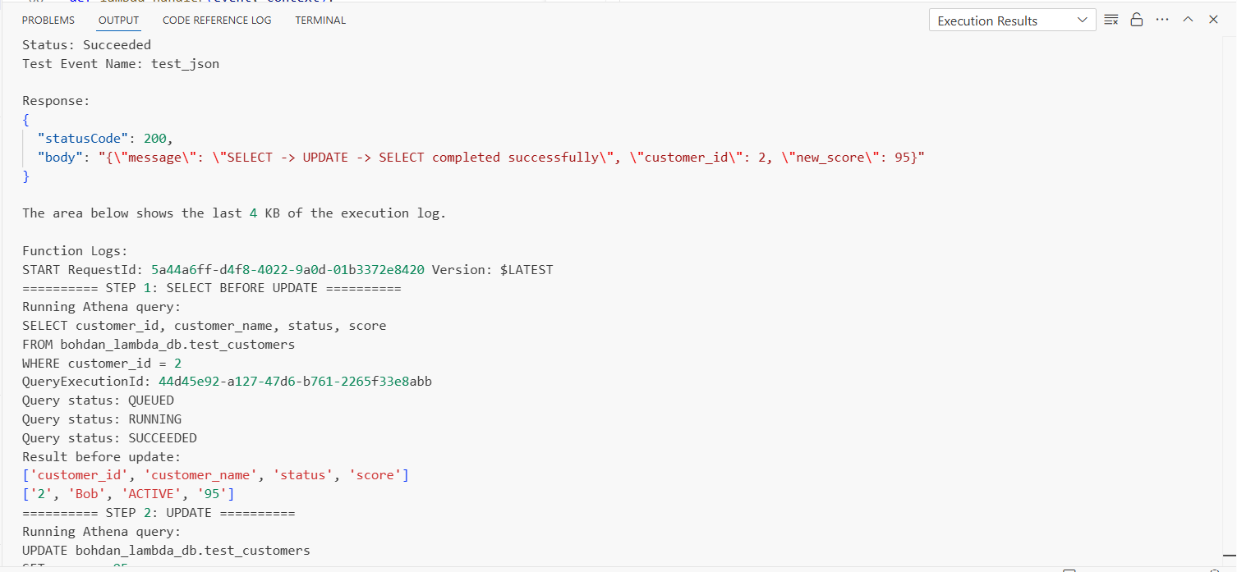
Figure 4. Successful SELECT → UPDATE → SELECT Lambda execution. The response reports statusCode 200 and confirms the new score value.

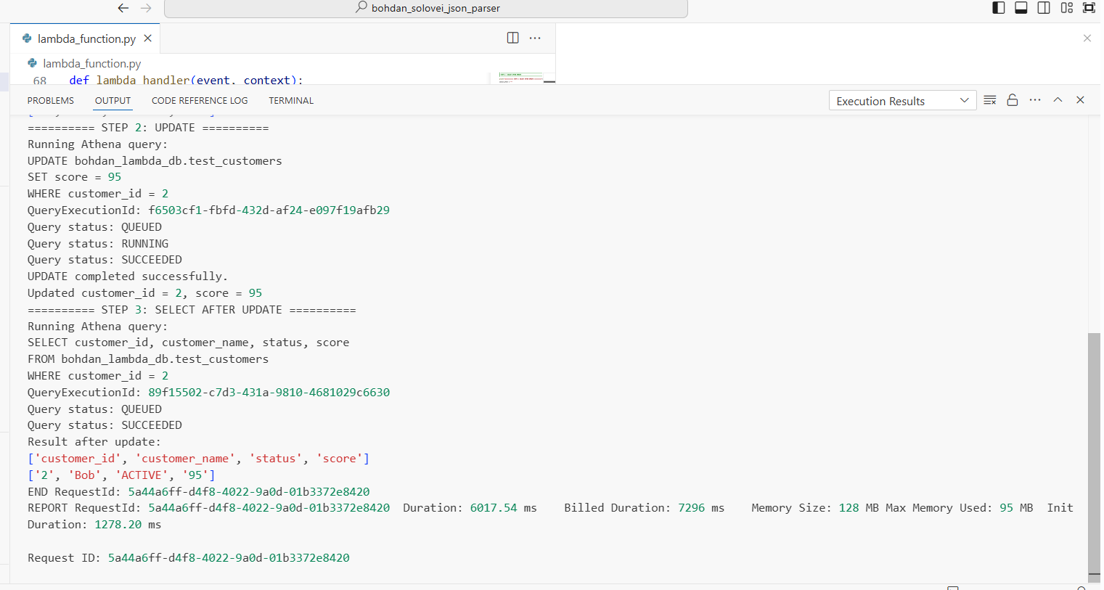
Figure 5. Data-quality worker Lambda test. The test_before action compares the actual score with the expected value and returns passed = true.

Task 1 result: the Lambda/Athena integration was validated successfully. The SELECT → UPDATE → SELECT sequence completed with statusCode 200, and the post-update query confirmed customer_id = 2 with score = 95.
Task 2 — AWS Step Functions workflow
A dedicated Lambda handler was used as the worker for the state machine. The event field action determines which operation is executed: test_before validates the initial score, update changes the value, and test_after validates the updated value. Each test returns a Boolean passed field that is evaluated by the Step Functions Choice state.

import boto3
import time

athena = boto3.client("athena")

DATABASE = "bohdan_lambda_db"
OUTPUT_LOCATION = "s3://bohdan-di-dwh-260586643565/athena_results/"

def run_query(query):
response = athena.start_query_execution(
QueryString=query,
QueryExecutionContext={
"Database": DATABASE
},
ResultConfiguration={
"OutputLocation": OUTPUT_LOCATION
}
)

query_id = response["QueryExecutionId"]

while True:
execution = athena.get_query_execution(
QueryExecutionId=query_id
)

status = execution["QueryExecution"]["Status"]["State"]

if status in ["SUCCEEDED", "FAILED", "CANCELLED"]:
break

time.sleep(1)

if status != "SUCCEEDED":
reason = execution["QueryExecution"]["Status"].get(
"StateChangeReason",
"Unknown error"
)
raise Exception(f"Athena query failed: {reason}")

return query_id

def get_score():
query = """
SELECT score
FROM bohdan_lambda_db.test_customers
WHERE customer_id = 2
"""

query_id = run_query(query)

result = athena.get_query_results(
QueryExecutionId=query_id
)

rows = result["ResultSet"]["Rows"]

# first row = header, second row = value
score = int(rows[1]["Data"][0]["VarCharValue"])

return score

def lambda_handler(event, context):

action = event.get("action")

print("Action:", action)

# ------------------------------------------
# FIRST DATA QUALITY TEST
# ------------------------------------------

if action == "test_before":

score = get_score()

passed = score == 95

print("FIRST TEST")
print("Customer ID: 2")
print("Expected score: 95")
print("Actual score:", score)
print("Test passed:", passed)

return {
"passed": passed,
"expected": 95,
"actual": score
}

# ------------------------------------------
# UPDATE DATA
# ------------------------------------------

elif action == "update":

query = """
UPDATE bohdan_lambda_db.test_customers
SET score = 72
WHERE customer_id = 2
"""

run_query(query)

print("UPDATE COMPLETED")
print("Customer ID 2 score changed to 72")

return {
"updated": True,
"customer_id": 2,
"new_score": 72
}

# ------------------------------------------
# SECOND DATA QUALITY TEST
# ------------------------------------------

elif action == "test_after":

score = get_score()

passed = score == 72

print("SECOND TEST")
print("Customer ID: 2")
print("Expected score: 72")
print("Actual score:", score)
print("Test passed:", passed)

return {
"passed": passed,
"expected": 72,
"actual": score
}

else:
raise ValueError("Unknown action")

Workflow configuration and execution evidence
The state machine uses the Standard workflow type. FirstTest checks that the initial score is 95; UpdateData changes the score to 72; SecondTest verifies that the new value is 72. The Choice state CheckBothTests routes execution to BothTestsPassed only when both returned passed values are true; otherwise, the default branch terminates in SomeTestFailed.
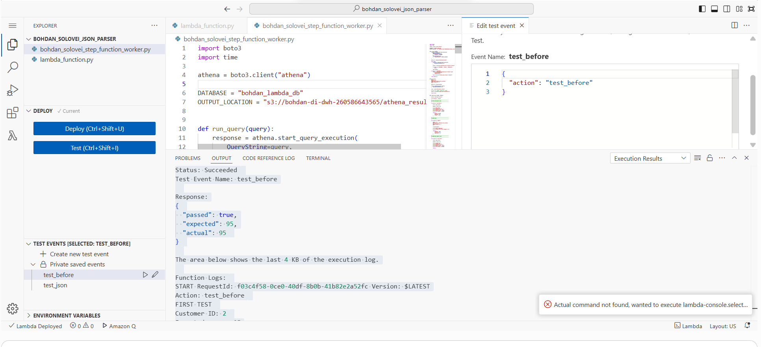
Figure 6. AWS Step Functions workflow definition. FirstTest, UpdateData, and SecondTest are executed sequentially, followed by the CheckBothTests Choice state.
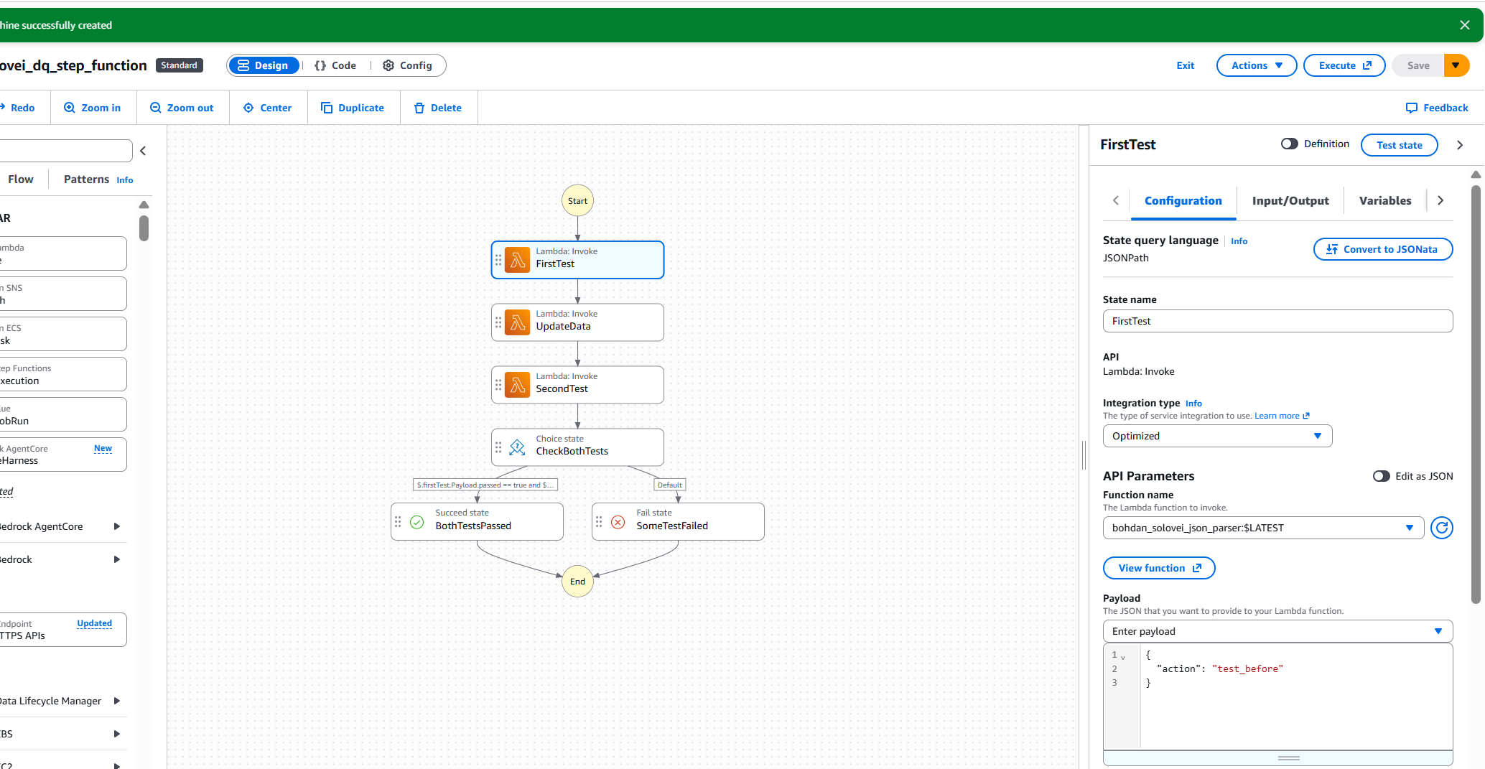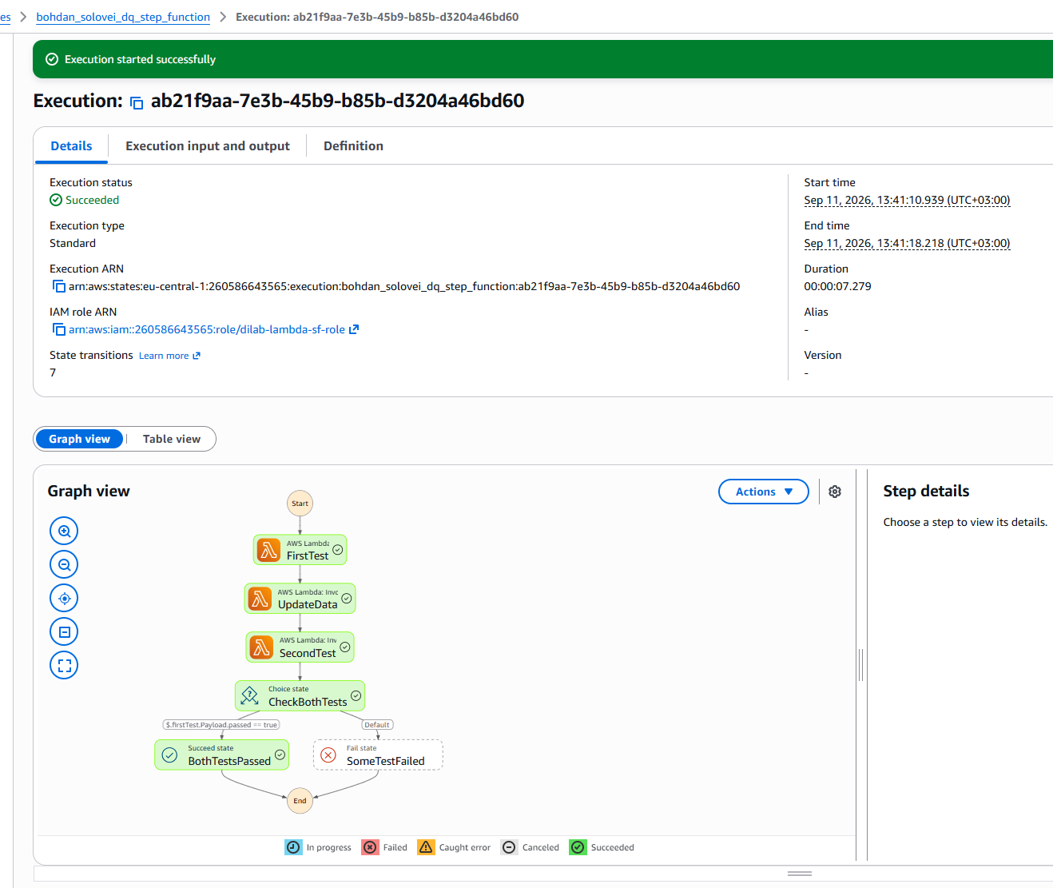
Figure 7. Successful Step Functions execution. All Lambda states and CheckBothTests completed successfully, and the workflow followed the BothTestsPassed branch.
Conclusion
The practical task was completed successfully. AWS Lambda was configured to interact with Amazon Athena, execute SQL queries, wait for asynchronous query completion, retrieve results, and perform an UPDATE followed by verification. The Step Functions workflow then orchestrated two data-quality checks around a controlled update and used conditional branching to determine the final outcome. The successful execution reached BothTestsPassed, demonstrating that the individual Lambda actions, Athena operations, state transitions, and Choice logic worked together correctly.

