Business Template

CAR SHARING Service
Logo / Image

Contents
Business Description 3
1.1 the Benefits of implementing a database. Project Vision 3
2 Model description 3
2.1 Definitions & Acronyms 3
2.2 Logical Scheme 4
2.3 Objects 5
2.3.1 Table Name: vehicle_type 5
2.3.2 Table Name: vehicle 5
2.3.3 Table Name: app_user 6
2.3.4 Table Name: employee 6
2.3.5 Table Name: maintenance_event 7
2.3.6 Table Name: maintenance_event_employee 8
2.3.7 Table Name: inspection_event 8
2.3.8 Table Name: reservation 9
2.3.9 Table Name: trip 10
2.3.10 Table Name: payment 10
2.3.11 Table Name: rating 11
2.3.12 Table Name: vehicle_status_history 12

Business Description

the Benefits of implementing a database. Project Vision
To answer these questions, you can rely on the following questions:
- How will the database solve the problems listed in the description?
The database addresses operational challenges such as tracking vehicle usage, maintenance, reservations, and user interactions by:
Structuring data into normalized tables for vehicles, users, employees, events, and bridge tables for relationships.
Enforcing clear relationships and roles, preventing ambiguity about who performed which action.
Supporting processes like reservations, trips, maintenance, and inspections with dedicated tables and status fields, ensuring each step is recorded and managed.
- How will it ensure data integrity, consistency, and traceability?
Unique constraints on identifiers (e.g., VIN, email, reservation_id) prevent duplicates.
Not Null constraints ensure essential data is always present.
Timestamp fields (e.g., created_at, recorded_at, commissioned_at) record when actions occur.
- How does your model store the history of changes?
The vehicle_status_history table records every change in vehicle status, including references to related reservations, trips, maintenance, and inspection events.
- How does your structure allow the system to scale without major redesign?
Separation of entities (vehicles, users, employees, events) and use of bridge tables for many-to-many relationships allows for easy addition of new attributes, roles, or event types.
- Which constraints and checks have you added to keep data correct as volume grows?
Check Constraints
Not Null Constraints
Default Values

Model description

Definitions & Acronyms
To answer these questions, you can rely on the following questions:
- Which key entities, roles, or processes require formal definitions for correct interpretation of the model?
User (app_user): Represents the person who uses the system to make reservations, take trips, and provide ratings.
Employee (employee): Represents staff members who perform maintenance, inspections, or other operational tasks.
Vehicle: The asset being reserved, used, maintained, or inspected.
Reservation, Trip, Maintenance Event, Inspection Event: Each represents a distinct process or event in the system, with specific relationships to users, employees, and vehicles.
- Which terms could be misunderstood without clarification?
Status Codes:
Terms like "in_use", "reserved", "maintenance", "inspection", "unavailable" for vehicles, or "active", "fulfilled", "cancelled" for reservations, need clear definitions.
- Which abbreviations or role names appear repeatedly in tables or relationships?
PK: Primary Key
FK: Foreign Key
UNIQUE, NOT NULL, CHECK: Constraint keywords

Logical Scheme
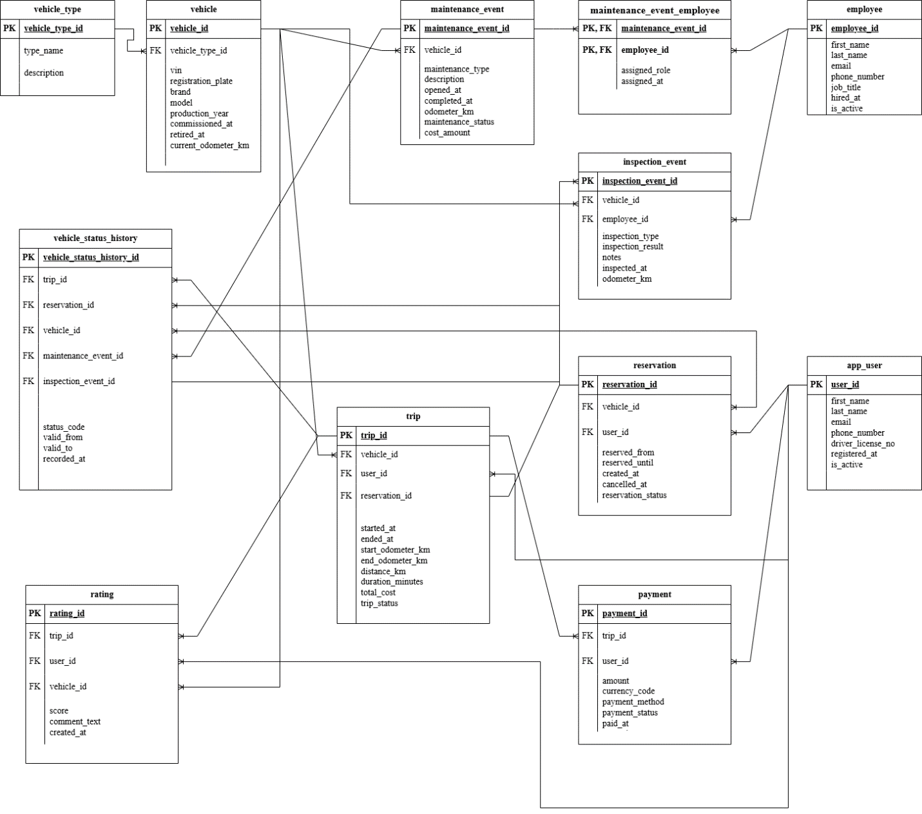
Answer following questions:
- Which modeling decision was the most difficult and why?
The most difficult modeling decision was designing the bridge tables (such as maintenance_event_employee) and handling many-to-many relationships between events and participants.
- Provide examples of potential data anomalies that your design prevents. Explain which constraints or structure elements prevent them.
Missing Required Data: NOT NULL constraints on key fields (e.g., user_id, vehicle_id, reservation_status) ensure that essential information is always present.
- If you were to add new attributes or participants, would the model remain scalable and why?
Yes, the model would remain scalable.
- Which part of your model would most likely change if requirements expand?
The parts most likely to change are the event-related tables (maintenance_event, inspection_event, trip, etc.) and their bridge tables.

Objects

Table Name: vehicle_type
Table Description: this table represents a classification of vehicles, such as car, scooter, bike, or van.
This table is in 3NF because all attributes are atomic and depend only on vehicle_type_id. There are no partial or transitive dependencies. Both type_name and description depend only on the primary key.
primary key - vehicle_type_id.
No foreign keys are needed because this is a reference table.
Comments on table relationships:
VEHICLE_TYPE → VEHICLE (1:M)
One vehicle type can describe many vehicles, but each vehicle has one vehicle type.

Table Name | Field name | Field Description | Data Type
vehicle_type | vehicle_type_id | Unique vehicle type identifier, PK | bigint
vehicle_type | type_name | Vehicle type name, UNIQUE, NOT NULL | varchar(50)
vehicle_type | description | Description of the vehicle type | text
Sample values
vehicle_type_id | type_name | description
1 | Sedan | Standard passenger car

Table Name: vehicle
Table Description: This table represents a physical vehicle.
A vehicle is a central entity involved in reservations, trips, maintenance, inspections, status history, and ratings. Keeping it separate prevents heavy redundancy and supports multiple relationships.
This table is in 3NF. Each attribute is atomic, the primary key is simple, and all non-key attributes depend only on vehicle_id. Vehicle type details are separated into vehicle_type. There are no partial dependencies.
vehicle_id is used as a PK for referencing. vehicle_type_id is included as an FK to link each vehicle to its type.
Comments on table relationships:
VEHICLE → VEHICLE_STATUS_HISTORY (1:M)
One vehicle can have many status history records, but each status history record belongs to one vehicle.
VEHICLE → INSPECTION_EVENT (1:M)
One vehicle can have many inspection events, but each inspection event is related to one vehicle.
VEHICLE → MAINTENANCE_EVENT (1:M)
One vehicle can have many maintenance events, but each maintenance event is related to one vehicle.
Comments on table relationships:
VEHICLE → TRIP (1:M)
One vehicle can be used in many trips, but each trip uses one vehicle.

Table Name | Field name | Field Description | Data Type
vehicle | vehicle_id | Unique vehicle identifier, PK | bigint
vehicle | vehicle_type_id | Vehicle type identifier, FK to vehicle_type, NOT NULL | bigint
vehicle | vin | Vehicle identification number, UNIQUE, NOT NULL | varchar(50)
vehicle | registration_plate | License plate number, UNIQUE, NOT NULL | varchar(20)
vehicle | brand | Vehicle brand, NOT NULL | varchar(100)
vehicle | model | Vehicle model, NOT NULL | varchar(100)
vehicle | production_year | Year of manufacture, NOT NULL | integer
vehicle | commissioned_at | Date when vehicle entered service, | date
vehicle | retired_at | Date when vehicle was retired from service | date
vehicle | current_odometer_km | Current odometer reading, DEFAULT 0, NOT NULL | numeric(12,2)
Sample values
vehicle_id | vehicle_type_id | vin | registration_plate | brand | model | production_year | commissioned_at | retired_at | current_odometer_km
1001 | 1 | 1HGCM82633A004352 | AB1234CD | Toyota | Corolla | 2015 | 6/15/2015 | 12/1/2023 | 75200.5

Table Name: app_user

Table Description: This table represents a registered customer of the car sharing service. A user can reserve vehicles, take trips, make payments, and submit ratings.
This table is in 3NF. All values are atomic, the primary key is simple, and all non-key attributes depend only on user_id. There are no partial dependencies because the table uses a single-column primary key. There are no transitive dependencies because all non-key attributes (first_name, last_name, email, phone_number, driver_license_no, registered_at, is_active) depend directly only on user_id.
user_id was chosen as primary key. A composite key is unnecessary here. No foreign keys are needed because this is a parent entity.
Comments on table relationships:
APP_USER → PAYMENT (1:M)
One application user can own or manage many payments, but each payment is linked to one application user.
Comments on table relationships:
APP_USER → RESERVATION (1:M)
One application user can create many reservations, but each reservation belongs to one application user.
Comments on table relationships:
APP_USER → RATING (1:M)
One application user can create many ratings, but each rating belongs to one application user.

Table 1.
Table Name | Field name | Field Description | Data Type
app_user | user_id | Unique user identifier, PK | bigint
app_user | first_name | User first name, NOT NULL | varchar(100)
app_user | last_name | User last name, NOT NULL | varchar(100)
app_user | email | User email address, UNIQUE, NOT NULL | varchar(255)
app_user | phone_number | User phone number, UNIQUE, NOT NULL | varchar(30)
app_user | driver_license_no | Driver license number, UNIQUE, NOT NULL | varchar(50)
app_user | registered_at | Registration timestamp, DEFAULT now(), NOT NULL | timestamptz
app_user | is_active | Indicates whether the account is active, DEFAULT true, NOT NULL | boolean
Sample values
user_id | first_name | last_name | email | phone_number | driver_license_no | registered_at | is_active
1 | Anna | Shevchenko | anna.shev@example.com | 380671234567 | AB1234567 | 2024-03-13 10:15:00+02 | TRUE

Table Name: employee
Table Description: This table represents an employee who performs inspections or participates in maintenance work. One employee can participate in many inspections and maintenance events. This table is in 3NF because it has atomic attributes, a simple primary key, and all non-key attributes depend only on employee_id. There are no partial or transitive dependencies. All descriptive attributes depend directly on the primary key.
employee_id is a primary key. A composite key is not needed. No foreign keys are included because this is also a parent entity.

Table Name | Field name | Field Description | Data Type
employee | employee_id | Unique employee identifier, PK | bigint
employee | first_name | Employee first name, NOT NULL | varchar(100)
employee | last_name | Employee last name, NOT NULL | varchar(100)
employee | email | Employee email, UNIQUE, NOT NULL | varchar(255)
employee | phone_number | Employee phone number, UNIQUE | varchar(30)
employee | job_title | Employee position/title, NOT NULL | varchar(100)
employee | hired_at | Hiring date, NOT NULL | date
employee | is_active | Indicates whether the employee is active, DEFAULT true, NOT NULL | boolean

Sample value
employee_id | first_name | last_name | email | phone_number | job_title | hired_at | is_active
101 | Olena | Petrenko | olena.petrenko@company.com | 380671234567 | Accountant | 5/10/2022 | TRUE

Table Name: maintenance_event

Table Description: This table represents a maintenance activity performed or planned for a vehicle.
One vehicle may have many maintenance records over time.
This table is in 3NF because all non-key attributes describe one maintenance event and depend only on maintenance_event_id. There are no partial or transitive dependencies. vehicle_id, maintenance_type, description, opened_at, completed_at, odometer_km, maintenance_status, and cost_amount depend only on the PK.
maintenance_event_id was chosen as a PK because a vehicle can have multiple maintenance events, even on the same day. vehicle_id is an FK because each maintenance event belongs to one vehicle. Employees are linked through a bridge table to support many-to-many participation.

Table Name | Field name | Field Description | Data Type
maintenance_event | maintenance_event_id | Unique maintenance event identifier, PK | bigint
maintenance_event | vehicle_id | Vehicle under maintenance, FK, NOT NULL | bigint
maintenance_event | maintenance_type | Type of maintenance activity, NOT NULL | varchar(50)
maintenance_event | description | Maintenance description/details | text
maintenance_event | opened_at | Maintenance start timestamp, NOT NULL | timestamptz
maintenance_event | completed_at | Maintenance completion timestamp | timestamptz
maintenance_event | odometer_km | Vehicle odometer reading at maintenance time, CHECK >= 0, NOT NULL | numeric(12,2)
maintenance_event | maintenance_status | Maintenance status: planned, in_progress, completed, cancelled, NOT NULL | varchar(20)
maintenance_event | cost_amount | Maintenance cost, CHECK >= 0 | numeric(10,2)
Sample Values
maintenance_event_id | vehicle_id | maintenance_type | description | opened_at | completed_at | odometer_km | maintenance_status | cost_amount
5001 | 1001 | Oil Change | Changed engine oil & filter | 2024-02-10 09:00:00+02 | 2024-02-10 10:00:00+02 | 75500 | completed | 120.5

Table Name: maintenance_event_employee
Table Description: This table represents employee participation in maintenance events. It is a bridge table implementing a many-to-many relationship. One maintenance event may involve many employees, and one employee may participate in many maintenance events. This table is in 3NF.
The primary key is composite: (maintenance_event_id, employee_id). assigned_role and assigned_at depend on the whole composite key, not on just one part. There are no transitive dependencies.
A composite primary key is the correct choice here because each row is uniquely identified by the combination of one maintenance event and one employee. FKs were added to maintenance_event and employee to resolve the many-to-many relationship.
Comments on table relationships:
EMPLOYEE → MAINTENANCE_EVENT (M:M)
Many employees can participate in many maintenance event assignments.

Table Name | Field name | Field Description | Data Type
maintenance_event_employee | maintenance_event_id | Maintenance event identifier, PK, FK, NOT NULL | bigint
maintenance_event_employee | employee_id | Employee identifier, PK, FK, NOT NULL | bigint
maintenance_event_employee | assigned_role | Employee role in the maintenance event, NOT NULL | varchar(50)
maintenance_event_employee | assigned_at | Assignment timestamp, DEFAULT now(), NOT NULL | timestamptz
Sample values
maintenance_event_id | employee_id | assigned_role | assigned_at
5001 | 101 | Technician | 2024-02-10 08:45:00+02

Table Name: inspection_event

Table Description: This table represents a vehicle inspection performed by an employee.
Inspections are independent historical events with their own date, result, notes, and responsible employee.
The table is in 3NF because all attributes depend only on inspection_event_id. There are no partial or transitive dependencies. Vehicle and employee data are referenced via foreign keys instead of being duplicated.
inspection_event_id is the PK because inspections are distinct events. FKs were added to vehicle and employee because each inspection belongs to one vehicle and is performed by one employee.

Table Name | Field name | Field Description | Data Type
inspection_event | inspection_event_id | Unique inspection event identifier, PK | bigint
inspection_event | vehicle_id | Inspected vehicle, FK, NOT NULL | bigint
inspection_event | employee_id | Employee who performed the inspection, FK, NOT NULL | bigint
inspection_event | inspection_type | Type of inspection, NOT NULL | varchar(50)
inspection_event | inspection_result | Result: passed, failed, requires_follow_up, NOT NULL | varchar(20)
inspection_event | notes | Inspector notes/comments | text
inspection_event | inspected_at | Inspection timestamp, NOT NULL | timestamptz
inspection_event | odometer_km | Vehicle odometer at inspection time, CHECK >= 0, NOT NULL | numeric(12,2)

Sample values
inspection_event_id | vehicle_id | employee_id | inspection_type | inspection_result | notes | inspected_at | odometer_km
3001 | 1001 | 101 | Annual Check | passed | All systems functional | 2024-02-01 14:30:00+02 | 75000

Table Name: reservation

Table Description: This table represents a reservation made by a user for a specific vehicle and time interval. This table is in 3NF because all fields are atomic and all non-key attributes depend only on reservation_id. There are no partial or transitive dependencies. user_id, vehicle_id, reserved_from, reserved_until, created_at, cancelled_at, and reservation_status all depend directly on reservation_id.
reservation_id is a PK. user_id and vehicle_id are FKs because each reservation belongs to one user and one vehicle.
Comments on table relationships:
RESERVATION → TRIP One reservation can be linked to one trip.

Table Name | Field name | Field Description | Data Type
reservation | reservation_id | Unique reservation identifier, PK | bigint
reservation | user_id | User who created the reservation, FK, NOT NULL | bigint
reservation | vehicle_id | Reserved vehicle, FK, NOT NULL | bigint
reservation | reserved_from | Reservation start timestamp, NOT NULL | timestamptz
reservation | reserved_until | Reservation end timestamp, NOT NULL | timestamptz
reservation | created_at | Reservation creation timestamp, DEFAULT now(), NOT NULL | timestamptz
reservation | cancelled_at | Reservation cancellation timestamp | timestamptz
reservation | reservation_status | Reservation status: active, fulfilled, cancelled, expired, NOT NULL | varchar(20)

Sample values
reservation_id | user_id | vehicle_id | reserved_from | reserved_until | created_at | cancelled_at | reservation_status
2001 | 1 | 1001 | 2024-03-20 09:00:00+02 | 2024-03-20 18:00:00+02 | 2024-03-13 12:00:00+02 | NULL | active

Table Name: trip

Table Description: This table represents an actual vehicle usage event, beginning when a user unlocks a vehicle and ending when the vehicle is returned. The table is in 3NF because all non-key attributes depend only on trip_id, and pricing details are not duplicated but referenced through pricing_policy.
There are no partial dependencies because the PK is simple. Transitive dependencies were avoided by separating pricing policy into its own table. user_id, vehicle_id, reservation_id, started_at, ended_at, start_odometer_km, end_odometer_km, distance_km, duration_minutes, total_cost, and trip_status depend only on trip_id.
trip_id was chosen as a PK. FKs were added to app_user, vehicle, reservation to reflect who took the trip, which vehicle was used, whether it originated from a reservation, and which tariff applied.
Comments on table relationships:
TRIP → PAYMENT (1:M)
One trip can be associated with many payment records in the current structure.

Comments on table relationships:
TRIP → RATING (1:M)
One trip can be associated with many ratings in the current structure.

Table Name | Field name | Field Description | Data Type
trip | trip_id | Unique trip identifier, PK | bigint
trip | user_id | User who took the trip, FK, NOT NULL | bigint
trip | vehicle_id | Vehicle used in the trip, FK, NOT NULL | bigint
trip | reservation_id | Related reservation, FK, UNIQUE, nullable | bigint
trip | started_at | Trip start timestamp, NOT NULL | timestamptz
trip | ended_at | Trip end timestamp | timestamptz
trip | start_odometer_km | Odometer reading at trip start, CHECK >= 0, NOT NULL | numeric(12,2)
trip | end_odometer_km | Odometer reading at trip end, must be >= start_odometer_km | numeric(12,2)
trip | distance_km | Distance traveled in kilometers, CHECK >= 0 | numeric(12,2)
trip | duration_minutes | Trip duration in minutes, CHECK >= 0 | integer
trip | total_cost | Total trip cost, CHECK >= 0 | numeric(10,2)
trip | trip_status | Trip status: in_progress, completed, cancelled, NOT NULL | varchar(20)
Sample Values
trip_id | user_id | vehicle_id | reservation_id | started_at | ended_at | start_odometer_km | end_odometer_km | distance_km | duration_minutes | total_cost | trip_status
4001 | 1 | 1001 | 2001 | 2024-03-20 09:15:00+02 | 2024-03-20 10:45:00+02 | 75200.5 | 75250.5 | 50 | 90 | 350 | completed

Table Name: payment

Table Description: This table represents a payment recorded for a trip. Payment is a separate business fact with its own status, timestamp, method, and amount.
The table is in 3NF because all non-key fields describe one payment and depend only on payment_id.
There are no partial or transitive dependencies. trip_id, user_id, amount, currency_code, payment_method, payment_status, paid_at, and created_at depend directly on payment_id.
payment_id was chosen as the PK because it is a stable surrogate key. trip_id is marked UNIQUE to enforce one primary payment per trip in this model. trip_id and user_id are FKs to preserve traceability.

Table Name | Field name | Field Description | Data Type
payment | payment_id | Unique payment identifier, PK | bigint
payment | trip_id | Trip for which the payment was made, FK, UNIQUE, NOT NULL | bigint
payment | user_id | User who made the payment, FK, NOT NULL | bigint
payment | amount | Payment amount, CHECK >= 0, NOT NULL | numeric(10,2)
payment | currency_code | ISO currency code, DEFAULT 'USD', NOT NULL | char(3)
payment | payment_method | Payment method: card, wallet, bank_transfer, NOT NULL | varchar(30)
payment | payment_status | Payment status: pending, paid, failed, refunded, NOT NULL | varchar(20)
payment | paid_at | Timestamp when payment was completed | timestamptz
payment | created_at | Payment record creation timestamp, DEFAULT now(), NOT NULL | timestamptz

Sample Values
payment_id | trip_id | user_id | amount | currency_code | payment_method | payment_status | paid_at | created_at
6001 | 4001 | 1 | 350 | USD | card | paid | 2024-03-20 10:50:00+02 | 2024-03-20 10:46:00+02

Table Name: rating
Table Description: This table represents a rating and optional comment submitted by a user after a trip. Ratings are optional and belong to the feedback.The table is in 3NF because all non-key attributes depend only on rating_id. There are no partial or transitive dependencies. trip_id, user_id, vehicle_id, score, comment_text, and created_at depend only on the primary key.
rating_id was chosen as a PK. trip_id is UNIQUE because this model assumes at most one rating per trip. FKs connect the rating to the trip, user, and vehicle for reporting and referential integrity.

Table Name | Field name | Field Description | Data Type
rating | rating_id | Unique rating identifier, PK | bigint
rating | trip_id | Related trip, FK, UNIQUE, NOT NULL | bigint
rating | user_id | User who submitted the rating, FK, NOT NULL | bigint
rating | vehicle_id | Vehicle being rated, FK, NOT NULL | bigint
rating | score | Rating score from 1 to 5, CHECK BETWEEN 1 AND 5, NOT NULL | integer
rating | comment_text | Optional textual review | text
rating | created_at | Rating creation timestamp, DEFAULT now(), NOT NULL | timestamptz
Sample Values
rating_id | trip_id | user_id | vehicle_id | score | comment_text | created_at
7001 | 4001 | 1 | 1001 | 5 | Excellent ride, very clean! | 2024-03-20 11:00:00+02

Table Name: vehicle_status_history

Table Description: This table represents the historical availability and assignment state of a vehicle over time. A separate status history table allows each status interval to be stored as a new fact. The table is in 3NF. Each row stores one status period for one vehicle, and all non-key attributes depend only on vehicle_status_history_id.
There are no partial dependencies because the PK is simple. There are no transitive dependencies because reservation, trip, maintenance, and inspection details are referenced via FKs rather than duplicated.
vehicle_status_history_id was chosen as a PK. FKs were added to vehicle, reservation, trip, maintenance_event, and inspection_event to explain why the vehicle had that status.

Comments on table relationships:
VEHICLE_STATUS_HISTORY → INSPECTION_EVENT (1:M)
One vehicle status history record can be associated with many inspection events, but each inspection event refers to one status history record.

Table Name | Field name | Field Description | Data Type
vehicle_status_history | vehicle_status_history_id | Unique status history identifier, PK | bigint
vehicle_status_history | vehicle_id | Vehicle whose status is recorded, FK, NOT NULL | bigint
vehicle_status_history | status_code | Vehicle status: available, reserved, in_use, maintenance, inspection, unavailable, NOT NULL | varchar(30)
vehicle_status_history | reservation_id | Reservation that caused the status, FK | bigint
vehicle_status_history | trip_id | Trip that caused the status, FK | bigint
vehicle_status_history | maintenance_event_id | Maintenance event that caused the status, FK | bigint
vehicle_status_history | inspection_event_id | Inspection event that caused the status, FK | bigint
vehicle_status_history | valid_from | Status validity start timestamp, NOT NULL | timestamptz
vehicle_status_history | valid_to | Status validity end timestamp, must be greater than valid_from if present | timestamptz
vehicle_status_history | recorded_at | Timestamp when the history row was recorded, DEFAULT now(), NOT NULL | timestamptz

Sample Values
vehicle_status_history_id | vehicle_id | status_code | reservation_id | trip_id | maintenance_event_id | inspection_event_id | valid_from | valid_to | recorded_at
8001 | 1001 | in_use | 2001 | 4001 | NULL | NULL | 2024-03-20 09:15:00+02 | 2024-03-20 10:45:00+02 | 2024-03-20 09:15:01+02

