**“WATCH”**

# First of all, I want you write this script by using only HTML syntax, table(s) and DOM object.

I will not accept to use CSS (Cascading Sytle Sheets) and/or any other framework(s) and/or any library(s) and/or image(s) in HTML.

You have to write it in an editor (for example Notepad++) to learn pure HTML and JavaScript...

# Also, you may use **“onClick”** event for buttons.

# You have to write it by using functions()... (for example: startWatch(…), stopWatch(…), showWatch(…) etc...)

# Also, you will need **"id"** attribute in tags (like <TABLE id="mytable"> ... </TABLE>).

Like this, you may access the element(s) of table(s) by using DOM syntax and you can change the attributes of that element(s). (DOM subject will be explained in the next weeks but, for the present, only know the following syntax of DOM).

Example:

...

<table id="mytable">

...

</table>

then you may use in your script :

…

// To get the HTML element(s) in your script, use :

var cells = document.getElementById("mytable").getElementsByTagName("td");

// To change any attribute of an HTML element, you may use for example :

cells[7].innerHTML = seconds;

...

# Your HTML must look exactly like following:

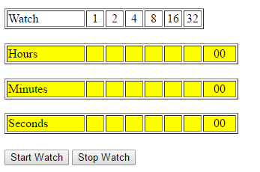

# When you click “Start Watch” button your script will run and will show the current hours, minutes and seconds like following:

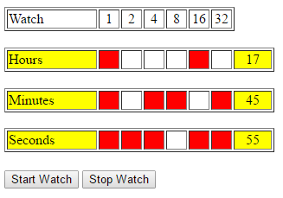

# When you click “Stop Watch” button you have to stop to show the watch (i.e. hours, minutes and seconds).