学号：16219111310
姓名：鲍水琴
班级：16 计算机科学与技术 三
主题：爬虫期末作业报告

- 项目简单介绍
我的爬虫期末作业包括了：
- scrapy——爬取豆瓣电影TOP250，将数据放入csv文件中保存；
- 实现12306的自动登录与验证码的处理；
- redis分布式爬虫的实践——书中例子；
- 解决中文乱码的问题；
- 深度优先的递归爬虫与广度优先的多线程爬虫——百度百科词条链接

- 项目详细介绍
- scrapy——爬取豆瓣电影top250
- 步骤简介
第一步，创建初始的爬虫项目；
第二步，更改items.py文件中的代码；
第三步，修改settings.py文件中的代码；
第四步，创建名为mySpider.py的文件，然后输入代码；
第五步，运行爬虫，展示效果。

（2）效果图展示
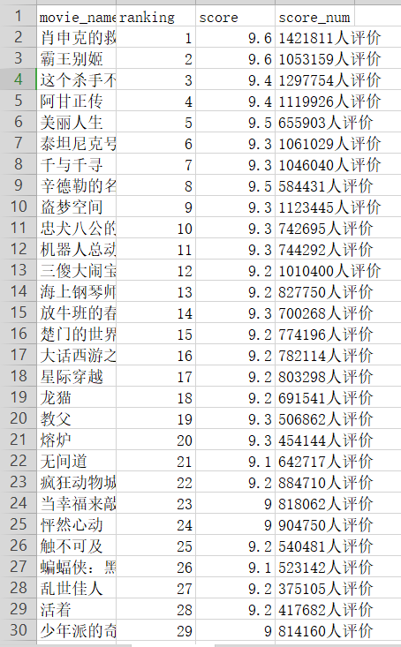
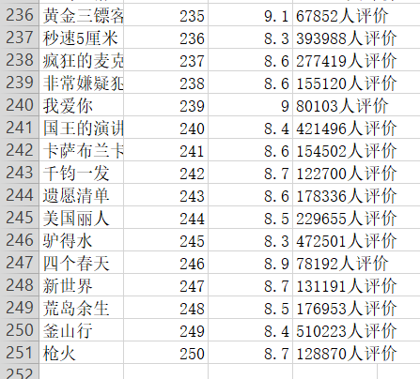
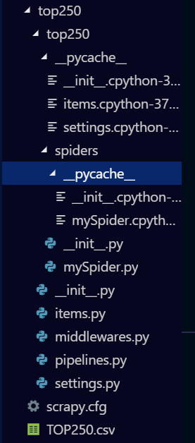

（3）部分代码设计
Items.py
import scrapy

class Top250Item(scrapy.Item):
ranking = scrapy.Field()
movie_name = scrapy.Field()
score = scrapy.Field()
score_num = scrapy.Field()

mySpider.py
import scrapy
from top250.items import Top250Item
from scrapy.spiders import Spider

class mySpider(scrapy.Spider):
name = 'movies'
headers = {
'User-Agent': 'Mozilla/5.0 (Windows NT 6.1; Win64; x64) AppleWebKit/537.36 (KHTML, like Gecko) Chrome/53.0.2785.143 Safari/537.36',
}

def start_requests(self):
url = 'https://movie.douban.com/top250'
yield scrapy.Request(url, headers=self.headers)

def parse(self,response):
item = Top250Item()
movies = response.xpath('//ol[@class="grid_view"]/li')
for movie in movies:
item['ranking'] = movie.xpath('.//div[@class="pic"]/em/text()').extract()[0]
item['movie_name'] = movie.xpath('.//div[@class="hd"]/a/span[1]/text()').extract()[0]
item['score'] = movie.xpath('.//div[@class="star"]/span[@class="rating_num"]/text()').extract()[0]
item['score_num'] = movie.xpath('.//div[@class="star"]/span[4]/text()').extract()[0]
yield item

next_url = response.xpath('//span[@class="next"]/a/@href').extract()
if next_url:
next_url = 'https://movie.douban.com/top250' + next_url[0]
yield scrapy.Request(next_url, headers=self.headers)

- 12306的自动登录与验证码的处理
- 简介
通过selenium模拟浏览器来实现12306的自动登录，在此过程中，会打开火狐浏览器，自动输入12306的网址，加载网页，然后自动输入用户名和密码，完成验证码的验证，进行登录。

- 效果图展示
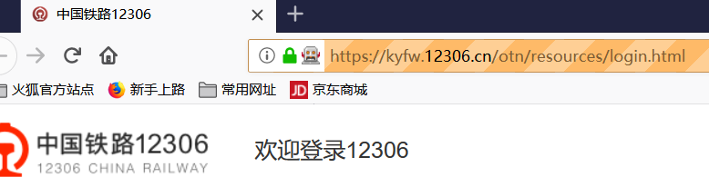
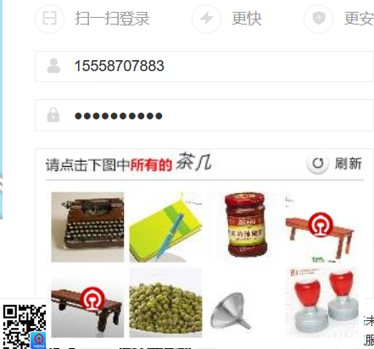


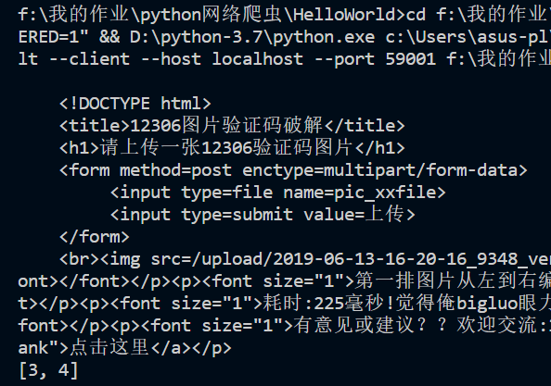

- 部分代码设计
#coding:u8
from selenium import webdriver
from selenium.webdriver.common.keys import Keys
from selenium.webdriver.common.by import By
from selenium.webdriver.support.ui import WebDriverWait
from selenium.webdriver.support import expected_conditions as EC
from selenium.webdriver.common.action_chains import ActionChains
import requests
import base64
import re
import time

class Demo():
def __init__(self):
self.coordinate=[[-105,-20],[-35,-20],[40,-20],[110,-20],[-105,50],[-35,50],[40,50],[110,50]]
def login(self):
login_url="https://kyfw.12306.cn/otn/resources/login.html"
driver = webdriver.Firefox()
driver.set_window_size(1200, 900)
driver.get(login_url)
account=driver.find_element_by_class_name("login-hd-account")
account.click()
userName=driver.find_element_by_id("J-userName")
userName.send_keys("***")
password=driver.find_element_by_id("J-password")
password.send_keys("***")
self.driver=driver
def getVerifyImage(self):
try:

img_element =WebDriverWait(self.driver, 100).until(
EC.presence_of_element_located((By.ID, "J-loginImg"))
)

except Exception as e:
print(u"网络开小差,请稍后尝试")
base64_str=img_element.get_attribute("src").split(",")[-1]
imgdata=base64.b64decode(base64_str)
with open('verify.jpg','wb') as file:
file.write(imgdata)
self.img_element=img_element
def getVerifyResult(self):
url="http://littlebigluo.qicp.net:47720/"
response=requests.request("POST",url,data={"type":"1"},files={'pic_xxfile':open('verify.jpg','rb')})
result=[]
print(response.text)
for i in re.findall("<B>(.*)</B>",response.text)[0].split(" "):
result.append(int(i)-1)
self.result=result
print(result)
def moveAndClick(self):
try:
Action=ActionChains(self.driver)
for i in self.result:
Action.move_to_element(self.img_element).move_by_offset(self.coordinate[i][0],self.coordinate[i][1]).click()
Action.perform()
except Exception as e:
print("cuowu!")
def submit(self):
self.driver.find_element_by_id("J-login").click()
def __call__(self):
self.login()
time.sleep(10)
self.getVerifyImage()
time.sleep(10)
self.getVerifyResult()
time.sleep(10)
self.moveAndClick()
time.sleep(10)
self.submit()
time.sleep(10000)

Demo()()

- redis分布式爬虫的实践
- 简介
通过使用分布式爬虫，一方面能极大地提高爬虫的效率；另一方面，不同服务器之间的统一管理能够实现从不同服务器爬虫的队列管理到数据存储的优化。

- 效果图展示
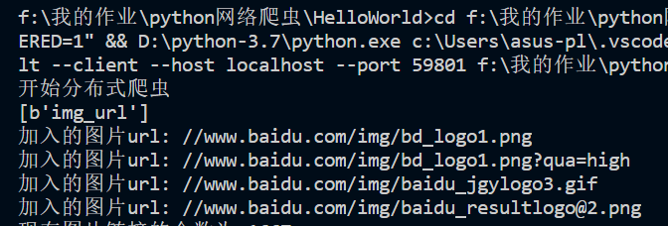
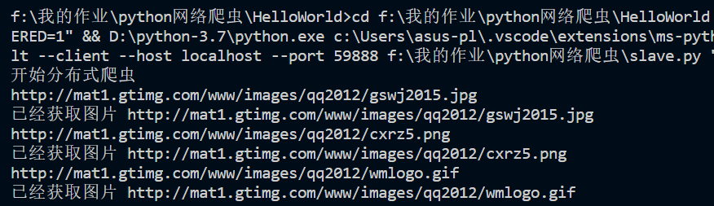
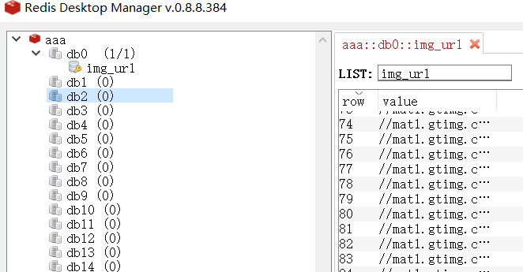



- 部分代码设计
Master.py
import requests
from bs4 import BeautifulSoup
import re
import time
from redis import Redis
headers={'User-Agent':'Mozilla/5.0 (Windows NT 6.1) AppleWebKit/537.36 (KHTML, like Gecko) Chrome/52.0.2743.116 Safari/537.36'}

def push_redis_list():
r=Redis(host='10.218.63.42',port=6379)
print(r.keys('*'))

link_list=[]
with open('alexa.txt','r') as file:
file_list=file.readlines()
for eachone in file_list:
link=eachone.split('\t')[1]
link=link.replace('\n','')
link_list.append(link)
if len(link_list)==3:
break

for url in link_list:
response=requests.get(url,headers=headers,timeout=60)
soup=BeautifulSoup(response.text,'lxml')
img_list=soup.find_all('img')
for img in img_list :
img_url=img['src']
if img_url !='':
print("加入的图片url:",img_url)
r.lpush('img_url',img_url)
print('现在图片链接的个数为',r.llen('img_url'))
return

def get_img():
r=Redis(host='10.218.63.42',port=6379)
while True:
try:
url=r.lpop('img_url')
url=url.decode('ascii')
if url[:2] =='//':
url='http:'+url
print (url)
try:
response=requests.get(url,headers=headers,timeout=60)
name=int(time.time())
f=open(str(name)+url[-4:],'wb')
f.write(response.content)
f.close()
print('已经获取图片',url)
except Exception as e:
print('爬取图片过程出问题',e)
time.sleep(10)
except Exception as e:
print(e)
time.sleep(15)
break
return

if __name__=='__main__':
this_machine='master'
print('开始分布式爬虫')
if this_machine =='master':
push_redis_list()
else:
get_img()

Slave.py
import requests
from bs4 import BeautifulSoup
import re
import time
from redis import Redis
headers={'User-Agent':'Mozilla/5.0 (Windows NT 6.1) AppleWebKit/537.36 (KHTML, like Gecko) Chrome/52.0.2743.116 Safari/537.36'}

def push_redis_list():
r=Redis(host='10.218.63.42',port=6379)
print(r.keys('*'))

link_list=[]
with open('alexa.txt','r') as file:
file_list=file.readlines()
for eachone in file_list:
link=eachone.split('\t')[1]
link=link.replace('\n','')
link_list.append(link)
if len(link_list)==3:
break

for url in link_list:
response=requests.get(url,headers=headers,timeout=60)
soup=BeautifulSoup(response.text,'lxml')
img_list=soup.find_all('img')
for img in img_list :
img_url=img['src']
if img_url !='':
print("加入的图片url:",img_url)
r.lpush('img_url',img_url)
print('现在图片链接的个数为',r.llen('img_url'))
return

def get_img():
r=Redis(host='10.218.63.42',port=6379)
while True:
try:
url=r.lpop('img_url')
url=url.decode('ascii')
if url[:2] =='//':
url='http:'+url
print (url)
try:
response=requests.get(url,headers=headers,timeout=60)
name=int(time.time())
f=open(str(name)+url[-4:],'wb')
f.write(response.content)
f.close()
print('已经获取图片',url)
except Exception as e:
print('爬取图片过程出问题',e)
time.sleep(10)
except Exception as e:
print(e)
time.sleep(15)
break
return

if __name__=='__main__':
this_machine='slave'
print('开始分布式爬虫')
if this_machine=='master':
push_redis_list()
else:
get_img()

- 解决中文乱码的问题
- 简介
在使用python的过程中，总会遇到中文乱码的问题，为了更好的使用python，我们致力于解决中文乱码问题。

- 效果图展示
1.
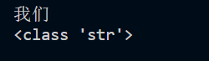

2.
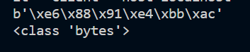

3.
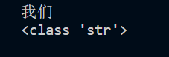

4.

7.
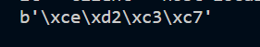

网页压缩1.
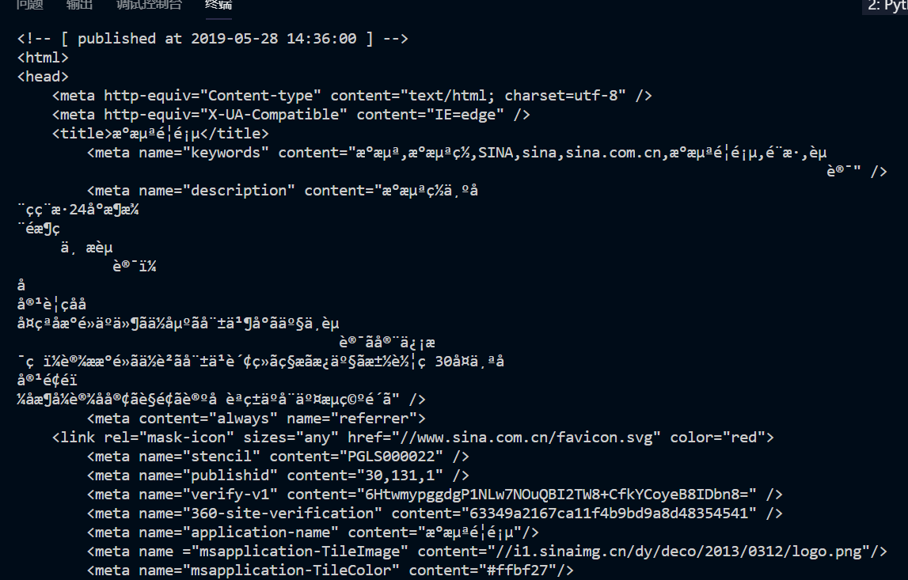
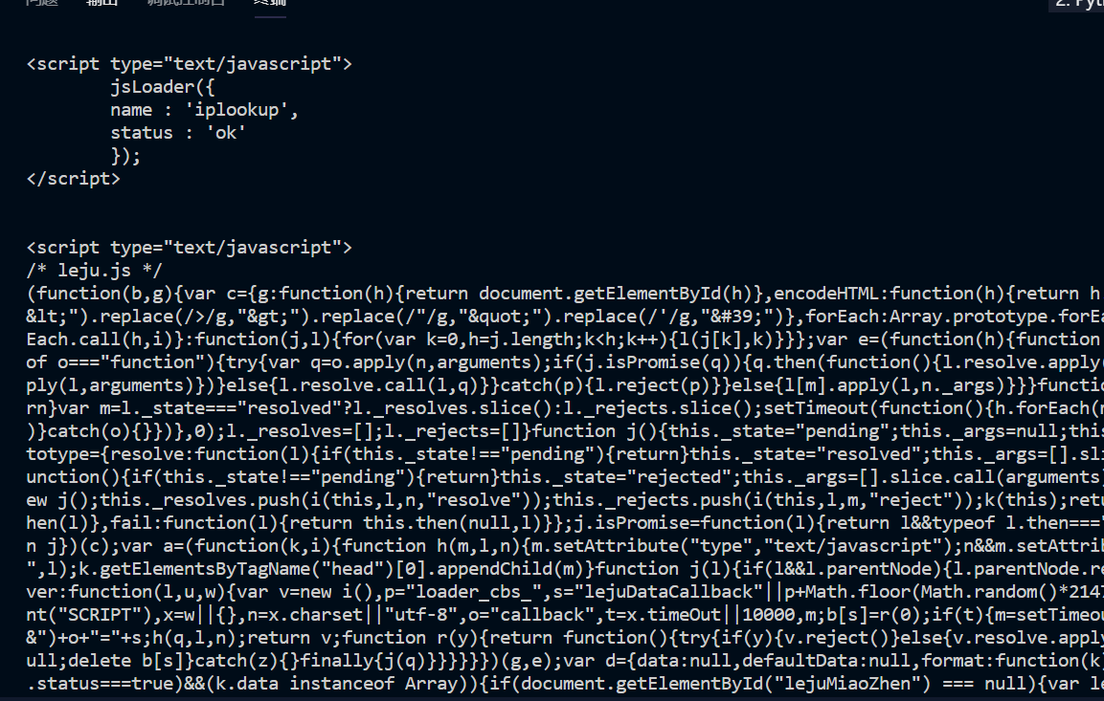

网页压缩2.
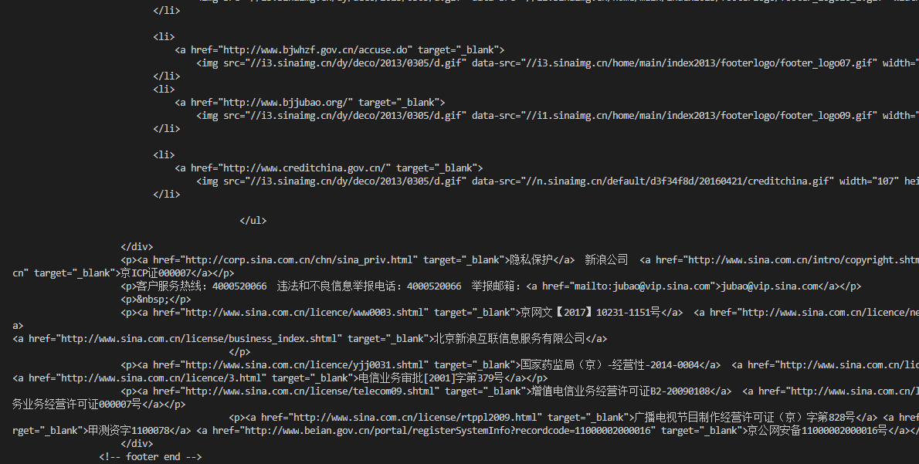

58.
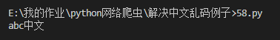

59.
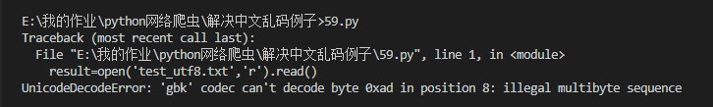

59-1.
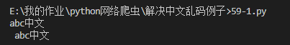

Title.
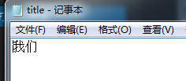


Json1.
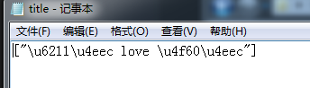

Json2.
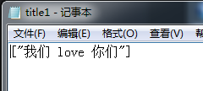

获取网站的中文显示乱码——错误版.
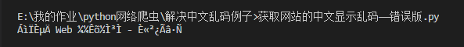

获取网站的中文显示乱码——正确版.
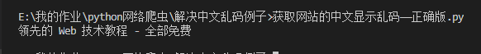

- 部分代码设计
1.
str1="我们"
print(str1)
print(type(str1))

2.
str1="我们"
str_utf8=str1.encode('utf-8')
print(str_utf8)
print(type(str_utf8))

3.
str1="我们"
str_decode=str1.encode('utf-8')
str_decode1=str_decode.decode('utf-8')
print(str_decode1)
print(type(str_decode1))

4.
import chardet
str_gbk="我们".encode('gbk')
print(chardet.detect(str_gbk))

7.
str_utf8="我们".encode('utf-8')
str_gbk=str_utf8.decode('utf-8')
str_gbk1=str_gbk.encode('gbk')
print(str_gbk1)

网页压缩1.
import requests
url='http://www.sina.com.cn/'
r=requests.get(url)
print(r.text)

网页压缩2.
import chardet
import requests
url='http://www.sina.com.cn/'
r=requests.get(url)
after_gzip=r.content
print('解压后字符串的编码为',chardet.detect(after_gzip))
print(after_gzip.decode('utf-8'))

58.
result=open('test_ANSI.txt','r').read()
print(result)

59.
result=open('test_utf8.txt','r').read()
print(result)

59-1.
result_ANSI=open('test_ANSI.txt','r',encoding='ANSI').read()
print(result_ANSI)
result_utf8=open('test_utf8.txt','r',encoding='utf-8').read()
print(result_utf8)

Title.
title='我们'
with open('title.txt','a+',encoding='utf-8') as f:
f.write(title)
f.close()

Json1.
import json
title='我们 love 你们'
with open('title.json','w',encoding='utf-8') as f:
json.dump([title],f)

Json2.
import json
title='我们 love 你们'
with open('title1.json','w',encoding='utf-8') as f:
json.dump([title],f,ensure_ascii=False)

获取网站的中文显示乱码——错误版.
import requests
from bs4 import BeautifulSoup

url='http://w3school.com.cn/'
r=requests.get(url)
soup=BeautifulSoup(r.text,"lxml")
xx=soup.find('div',id='d1').h2.text
print(xx)

获取网站的中文显示乱码——正确版.
import requests
from bs4 import BeautifulSoup

url='http://w3school.com.cn/'
r=requests.get(url)
r.encoding='gb2312'
soup=BeautifulSoup(r.text,"lxml")
xx=soup.find('div',id='d1').h2.text
print(xx)

- 深度优先的递归爬虫与广度优先的多线程爬虫——百度百科词条链接
- 简介
目的是爬取百度百科上的词条链接。通过两种方法，分别是深度优先和广度优先。同时比较，这两种方法的速度，找到最适合的方法。

- 效果图展示
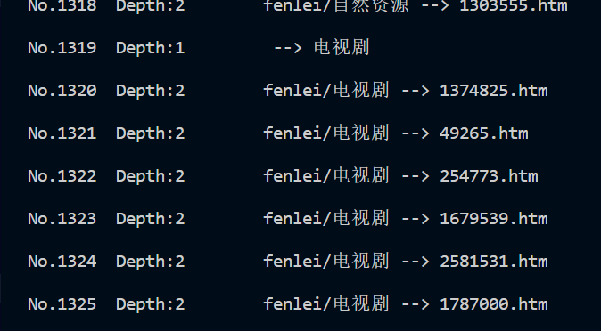
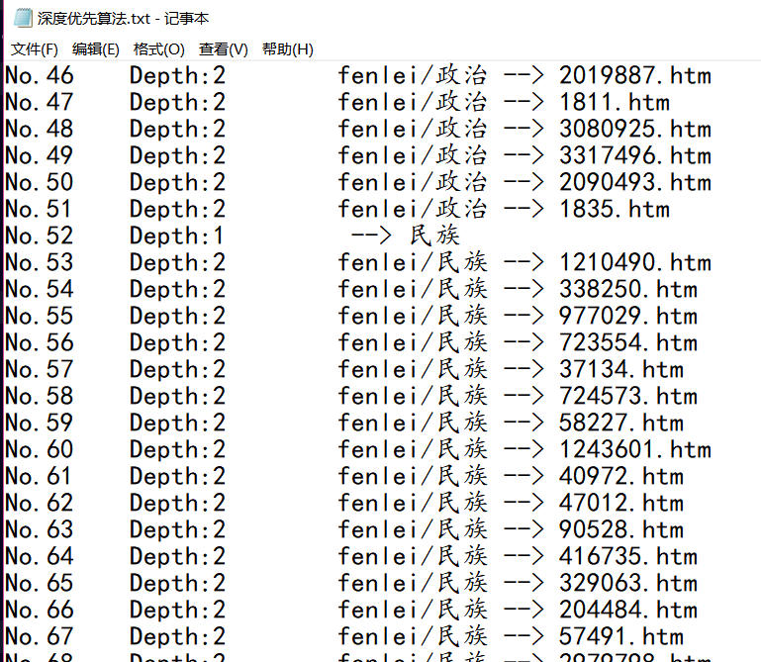

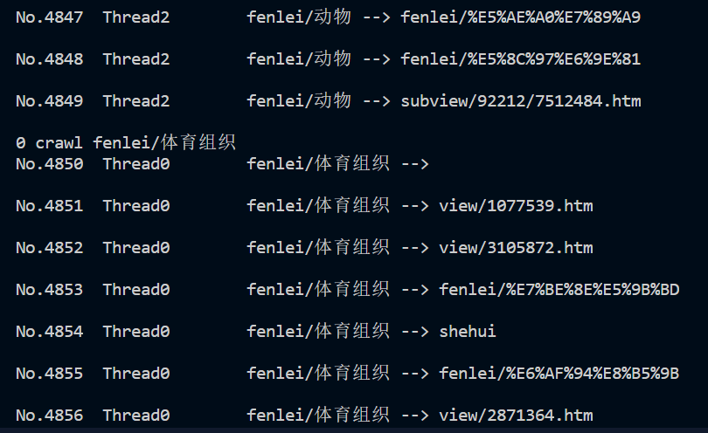
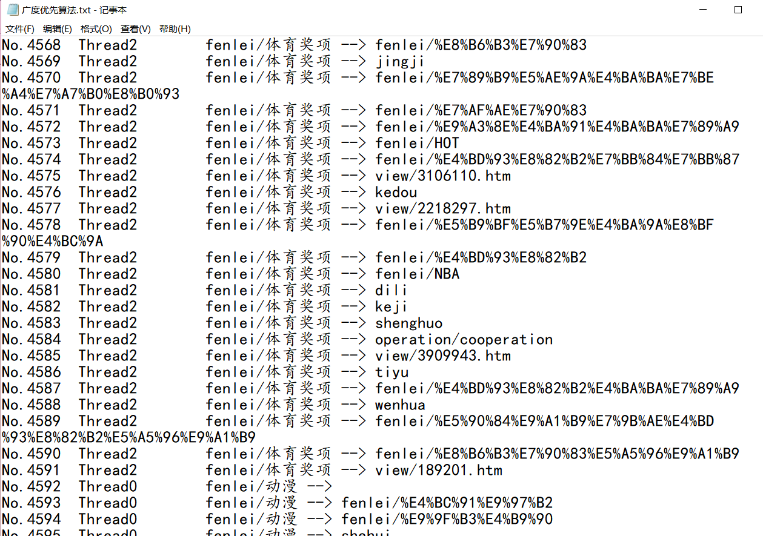

- 部分代码设计
深度优先方法
import requests
import re
import time

time1=time.time()
exist_url=[]
g_writecount=0

def scrappy(url,depth=1):
global g_writecount
try:
headers={'User-Agent':'Mozilla/5.0 (Windows;U;Windows NT 6.1;en-US; rv:1.9.1.6) Gecko/20091201 Firefox/3.5.6'}
r=requests.get("https://baike.baidu.com/"+url,headers=headers)
html=r.content.decode("utf-8")
except Exception as e:
print('Failed downloading and saving',url)
print(e)
exist_url.append(url)
return None

exist_url.append(url)
if(depth==1):
link_list=re.findall('<a href="/fenlei/([^:#=<>]*?)".*?</a>',html)
else:
link_list=re.findall('<a href="/view/([^:#=<>]*?)".*?</a>',html)
unique_list=list(set(link_list)-set(exist_url))

for eachone in unique_list:
g_writecount+=1
output="No."+str(g_writecount)+"\t Depth:"+str(depth)+"\t"+url+' --> '+eachone+'\n'
print(output)
with open('深度优先算法.txt',"a+",encoding="utf-8") as f:
f.write(output)
f.close()
if depth<2:
scrappy("fenlei/"+eachone,depth+1)

scrappy("")
time2=time.time()
print("Total time",time2-time1)

广度优先方法
import threading
import requests
import re
import time

g_mutex=threading.Condition()
g_pages=[]
g_queueURL=[]
g_existURL=[]
g_writecount=0

class Crawler:
def __init__(self,url,threadnum):
self.url=url
self.threadnum=threadnum
self.threadpool=[]

def craw(self):
global g_queueURL
g_queueURL.append(url)
depth=1
while(depth<3):
print('Searching depth',depth,'...\n')
self.downloadAll()
self.updateQueueURL()
g_pages=[]
depth+=1

def downloadAll(self):
global g_queueURL
i=0
while i<len(g_queueURL):
j=0
while j<self.threadnum and i+j<len(g_queueURL):
threadresult=self.download(g_queueURL[i+j],j)
j+=1
i+=j
for thread in self.threadpool:
thread.join(30)
threadpool=[]
g_queueURL=[]

def download(self,url,tid):
crawthread=CrawlerThread(url,tid)
self.threadpool.append(crawthread)
crawthread.start()

def updateQueueURL(self):
global g_queueURL
global g_existURL
newUrlList=[]
for content in g_pages:
newUrlList+=self.getUrl(content)
g_queueURL=list(set(newUrlList)-set(g_existURL))

def getUrl(self,content):
link_list=re.findall('<a href="/([^:#=<>]*?)".*?</a>',content)
unique_list=list(set(link_list))
return unique_list

class CrawlerThread(threading.Thread):

def __init__(self,url,tid):
threading.Thread.__init__(self)
self.url=url
self.tid=tid

def run(self):
global g_mutex
global g_writecount
try:
print(self.tid,"crawl",self.url)
headers={'User-Agent':'Mozilla/5.0 (Windows;U;Windows NT 6.1;en-US; rv:1.9.1.6) Gecko/20091201 Firefox/3.5.6'}
r=requests.get("https://baike.baidu.com/"+self.url,headers=headers)
r.encoding="utf-8"
html=r.text
link_list2=re.findall('<a href="/([^:#=<>]*?)".*?</a>',html)
unique_list2=list(set(link_list2))
for eachone in unique_list2:
g_writecount+=1
content2="No."+str(g_writecount)+"\t Thread"+str(self.tid)+"\t"+self.url+' --> '+eachone+'\n'
with open('广度优先算法.txt',"a+",encoding='utf-8') as f:
print(content2)
f.write(content2)
f.close()
except Exception as e:
g_mutex.acquire()
g_existURL.append(self.url)
g_mutex.release()
print('Failed downloading and saving',self.url)
print(e)
return None
g_mutex.acquire()
g_pages.append(html)
g_existURL.append(self.url)
g_mutex.release()

if __name__ == "__main__":
url=""
threadnum=3
crawler=Crawler(url,threadnum)
crawler.craw()

- 总结
我的期末作业主要由五个部分组成，即上述五个部分。包括了书本上的例子、实验课内容和某些课外知识。在完成此次大作业的过程中，遇到了不少困难，但通过百度错误和同学帮助，还是顺利完成了。我学到了很多新的python知识，受益匪浅。

