**DAILY ONLINE ACTIVITIES SUMMARY**

|  |  |  |  |  |  |  |  |  |
| --- | --- | --- | --- | --- | --- | --- | --- | --- |
| **Date:** | 29/05/2020 | | | | | **Name:** | RACHANA B S | |
| **Sem & Sec** | 4th SEM ‘B’ SEC | | | | | **USN:** | 4AL18CS065 | |
| **Online Test Summary** | | | | | | | | |
| **Subject** | | Operating Systems | | | | | | |
| **Max. Marks** | | 30 | | **Score** | | | 27 | |
| **Certification Course Summary** | | | | | | | | |
| **Course** | Introduction to R | | | | | | | |
| **Certificate Provider** | | | Great Learning | | **Duration** | | | 2.5 Hours |
| **Coding Challenges** | | | | | | | | |
| **Problem Statement: Write a java program to find size of the largest ‘+’ formed by all ones in binary matrix** | | | | | | | | |
| **Status:** Completed | | | | | | | | |
| **Uploaded the report in Github** | | | | | YES | | | |
| **If yes Repository name** | | | | | https://github.com/bsrachana/Lockdown-Coding | | | |
| **Uploaded the report in slack** | | | | | YES | | | |

**Online Test Details:**

Operating Systems**:**

The online test was from module 2 . There were 30 questions and the duration was 45 minutes. The questions were optimal and were easy. The score that I got in the test is 27/30.

**Snapshot:**

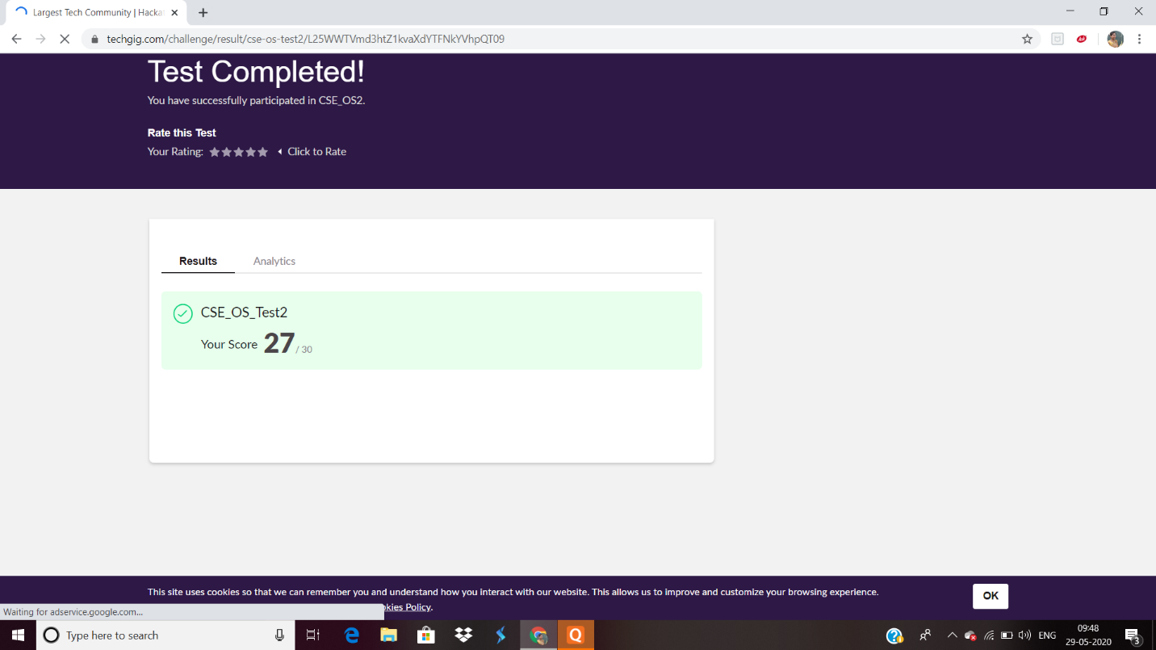

**Certification Course Details:**

**Name of the course**: Introduction to R

**Certificate Provider**: Great Learning

**Snapshot:**



**Online Coding Details:**

Problem 1:

**Write a java program to find size of the largest ‘+’ formed by all ones in binary matrix**

**Snapshot:**

