**DAILY ONLINE ACTIVITIES SUMMARY**

|  |  |  |  |  |  |  |  |  |
| --- | --- | --- | --- | --- | --- | --- | --- | --- |
| **Date:** | **31/05/2020** | | | | | **Name:** | **RACHANA B S** | |
| **Sem & Sec** | **4th Sem B Sec** | | | | | **USN:** | **4AL18CS065** | |
| **Online Test Summary** | | | | | | | | |
| **Subject** | | **Not conducted** | | | | | | |
| **Max. Marks** | | **-** | | **Score** | | | **-** | |
| **Certification Course Summary** | | | | | | | | |
| **Course** | **Introduction to R** | | | | | | | |
| **Certificate Provider** | | | **Great Learning Academy** | | **Duration** | | | **2.5 hrs** |
| **Coding Challenges** | | | | | | | | |
| **Problem Statement: Write a java program to calculate nPr** | | | | | | | | |
| **Status: executed** | | | | | | | | |
| **Uploaded the report in GitHub** | | | | | **yes** | | | |
| **If yes Repository name** | | | | | <https://github.com/bsrachana/lockdown_coding> | | | |
| **Uploaded the report in slack** | | | | | **yes** | | | |

Online Test Details: test was not conducted today.

Certification Course Details:

Introduction to R

Great Learning Academy

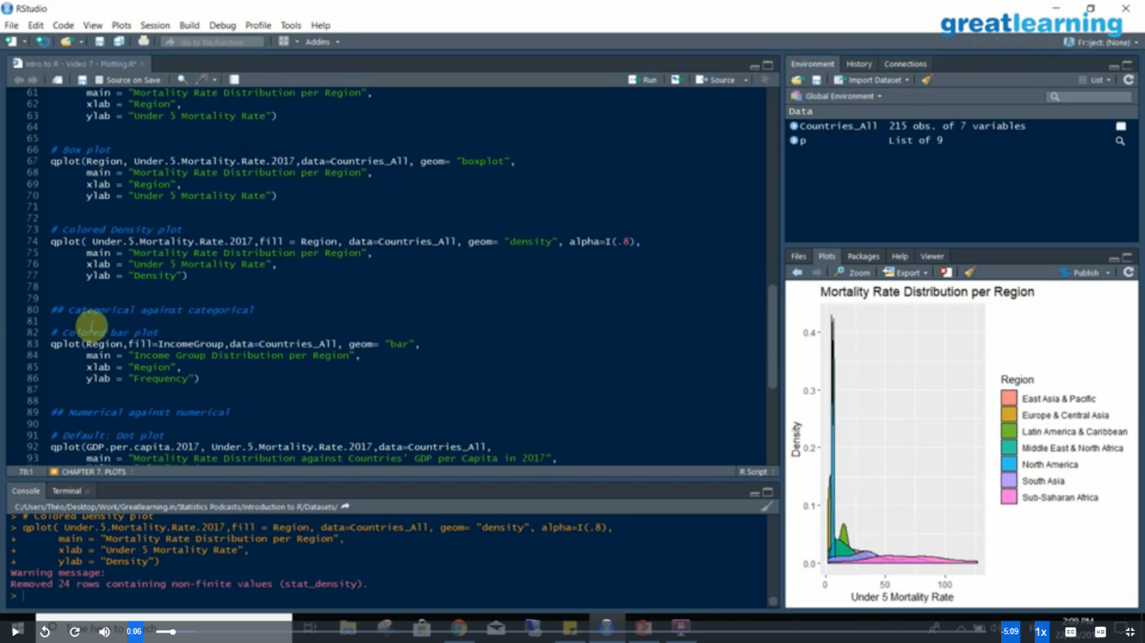

Coding Challenges Details:

Every day we are given with new question of coding related to the language of java and c. it seems interesting how we imbibe ourselves in depth to understand the logic, break it and then code for it.

Today’s question was : [Write a Java program to calculate nPr.](https://github.com/orgs/alvas-education-foundation/teams/2nd-year/discussions/89)

**nPr** represents n permutation r and value of nPr is **(n!) / (n-r)!.**

**Input:**  
The first line of the input contains **T** denoting the number of testcases. T testcases follow. First line of the test case will be the value of n and r respectively.

Output:  
For each test case, in a new line, output will be the value of nPr.

Constraints:  
**1 <= T <= 100  
1 <= n, r <= 20  
n >= r**

**Example:**  
Input:  
2  
2 1  
10 4  
Output:  
2  
5040

**Using the above given hint, I have created the code.**

