**DAILY ONLINE ACTIVITIES SUMMARY**

|  |  |  |  |  |  |  |  |  |
| --- | --- | --- | --- | --- | --- | --- | --- | --- |
| **Date:** | 02/06/2020 | | | | | **Name:** | RACHANA B S | |
| **Sem & Sec** | 4th SEM ‘B’ SEC | | | | | **USN:** | 4AL18CS065 | |
| **Online Test Summary** | | | | | | | | |
| **Subject** | | |  | | --- | | Complex Analysis, Probability and Statistical Methods(18MAT41) | | | | | | | |
| **Max. Marks** | | 30 | | **Score** | | | 29 | |
| **Certification Course Summary** | | | | | | | | |
| **Course** | Introduction to R | | | | | | | |
| **Certificate Provider** | | | Great Learning | | **Duration** | | | 2.5 Hours |
| **Coding Challenges** | | | | | | | | |
| **Problem Statement:**1.Write a C Program to find the leaders in the array.  2.To find the count of subarrays such that each subarray has exactly K distinct  elements. | | | | | | | | |
| **Status:** Completed | | | | | | | | |
| **Uploaded the report in Github** | | | | | YES | | | |
| **If yes Repository name** | | | | | https://github.com/bsrachana/lockdown-coding | | | |
| **Uploaded the report in slack** | | | | | YES | | | |

**Online Test Details:**

Today I attended internals of Complex Analysis, Probability and Statistical methods where the test was for 30 marks and of 2 rounds. 10 questions of 1 mark and 10 questions of 20 mark and the time limit was 40 mins. I scored 29/30

SNAPSHOT:

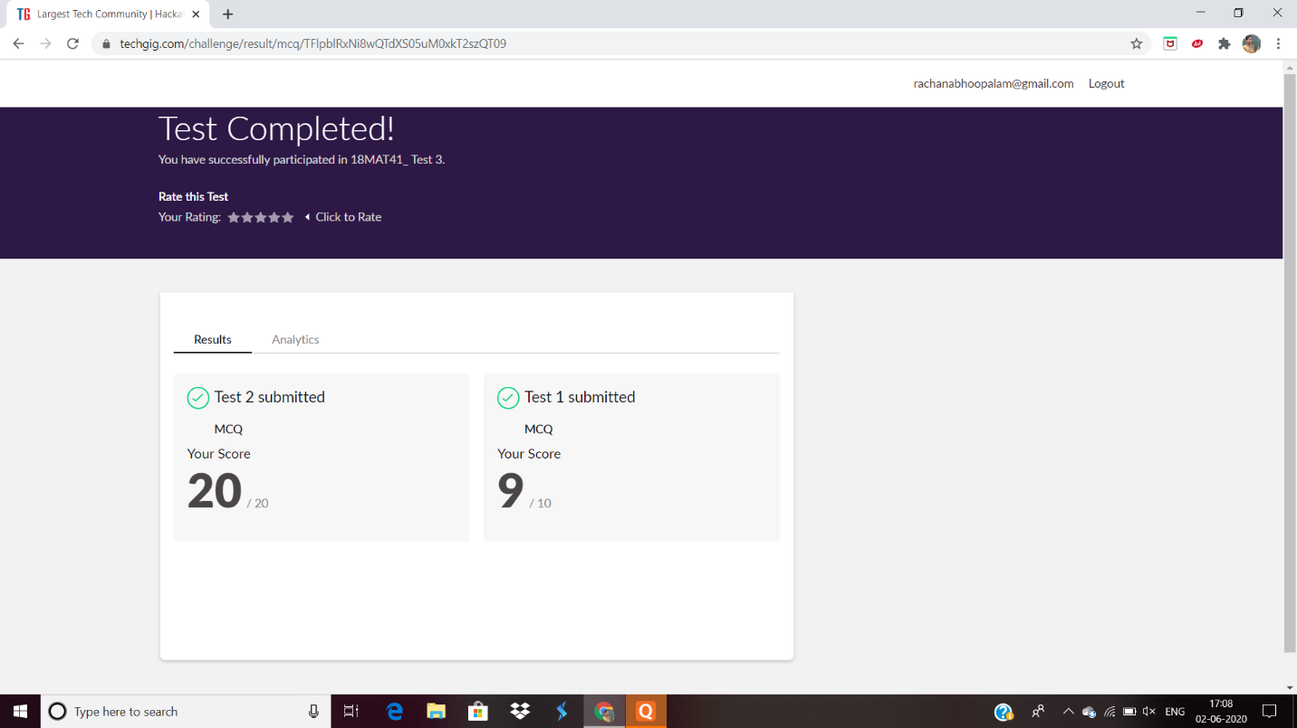

**Certification Course Details:**

**Name of the course**: Introduction to R

**Certificate Provider**: Great Learning Acamedy

I also completed RPA (Robotic Process Automation) course which was of 3 hours and I got the certified.

SNAPSHOT:

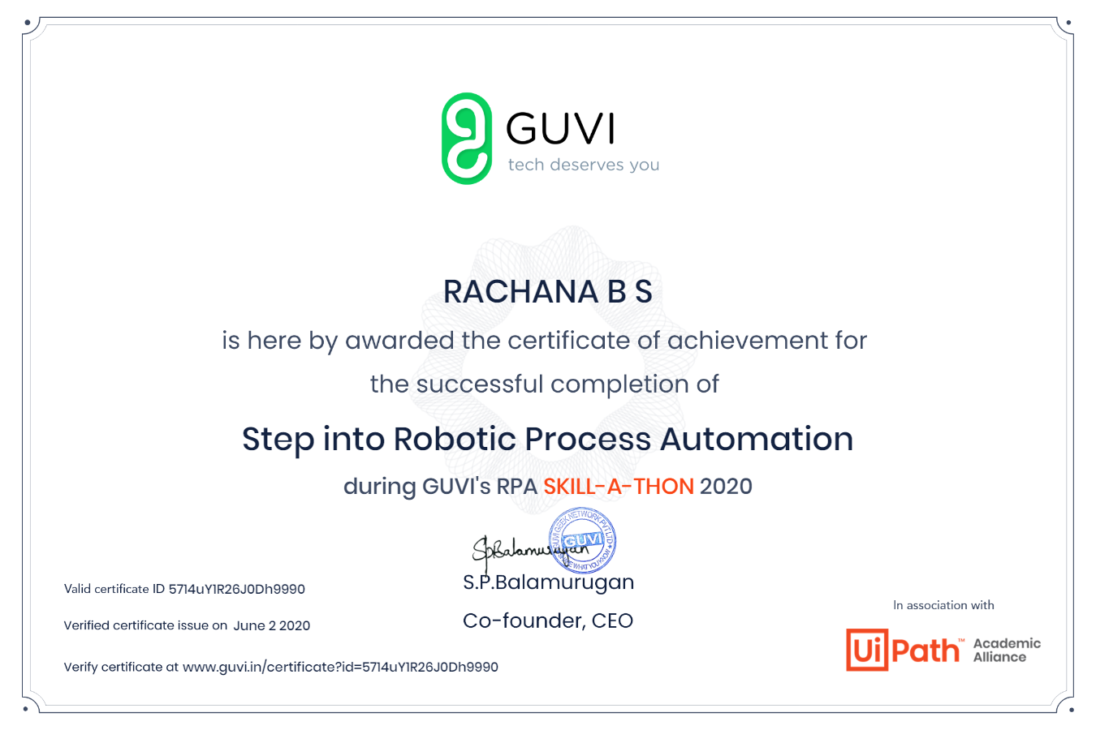

**Online Coding Details:**

Problem 1: Write a C Program to find the leaders in the array.

**Snapshot:**

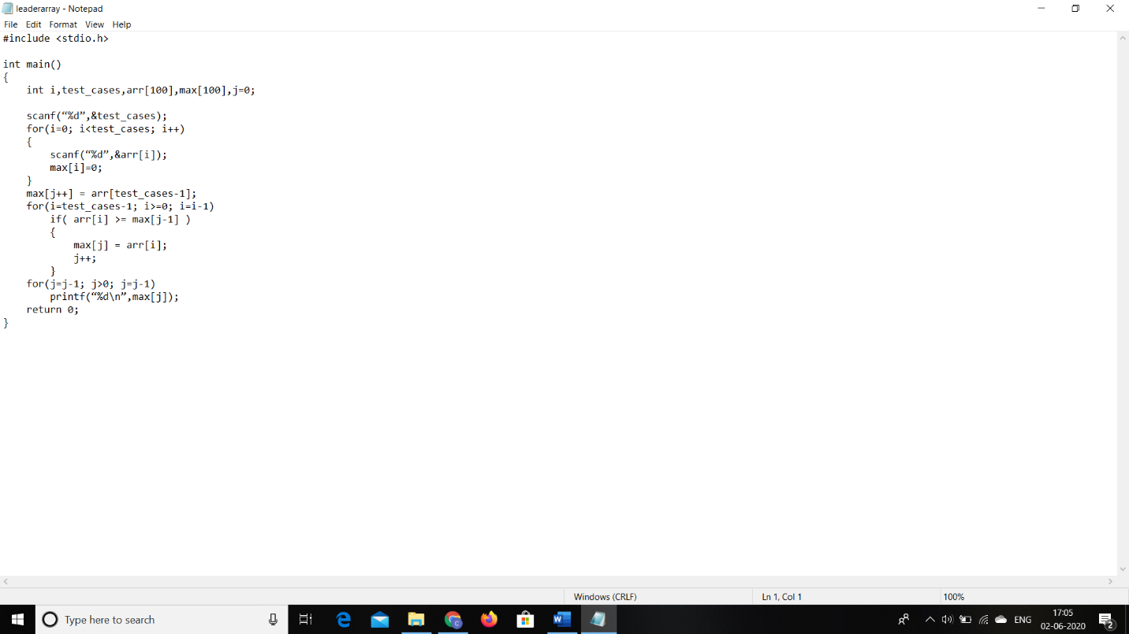

Problem 2: To find the count of subarrays such that each subarray has exactly K distinct elements.

**Snapshot:**

