**DAILY ONLINE ACTIVITIES SUMMARY**

|  |  |  |  |  |  |  |  |  |
| --- | --- | --- | --- | --- | --- | --- | --- | --- |
| **Date:** | 03/06/2020 | | | | | **Name:** | RACHANA B S | |
| **Sem & Sec** | 4th SEM ‘B’ SEC | | | | | **USN:** | 4AL18CS065 | |
| **Online Test Summary** | | | | | | | | |
| **Subject** | | Object Oriented Concepts(18CS45) | | | | | | |
| **Max. Marks** | | 30 | | **Score** | | | 14 | |
| **Certification Course Summary** | | | | | | | | |
| **Course** | Introduction to Google Cloud | | | | | | | |
| **Certificate Provider** | | | Udemy | | **Duration** | | | 2 weeks |
| **Coding Challenges** | | | | | | | | |
| **Problem Statement:** 1. Write a C Program to find inversion count of array.  2. Write a Java program to find Perfect Sum Problem. | | | | | | | | |
| **Status:** Completed | | | | | | | | |
| **Uploaded the report in Github** | | | | | YES | | | |
| **If yes Repository name** | | | | | https://github.com/bsrachana/lockdown-coding | | | |
| **Uploaded the report in slack** | | | | | YES | | | |

**Online Test Details:**

The online test was from module 2 and 3 which was about the Introduction to Java, Classes, Inheritance, Exception Handling. There were 30 questions and the duration was 45 minutes. The questions were optimal and were easy. The score that I got in the test is 14/30.

**Snapshot:**

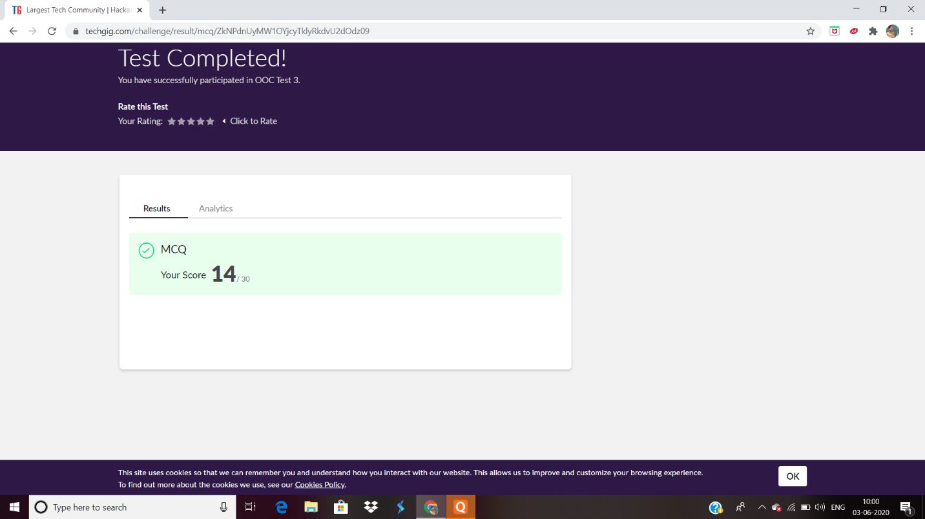

**Certification Course Details:**

**Name of the course**: Introduction to Google Cloud

**Certificate Provider**: Udemy

Today I learnt about the basic concepts of Google Cloud and Professional Cloud Architect (PCA). Under that how to design Solutions for Cloud/Hybrid Cloud environments.

**Snapshot:**

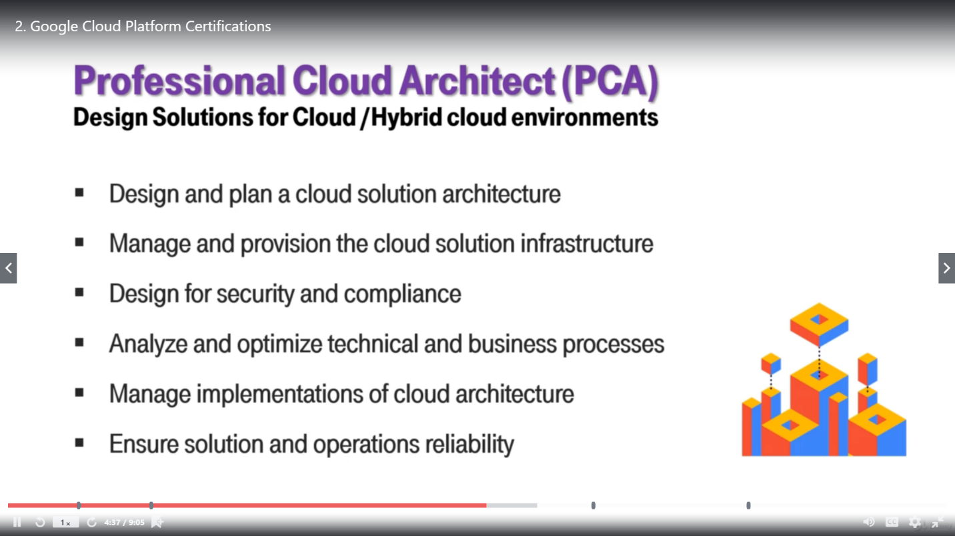

**Online Coding Details:**

Problem 1: Write a C Program to find inversion count of array.

**Snapshot:**

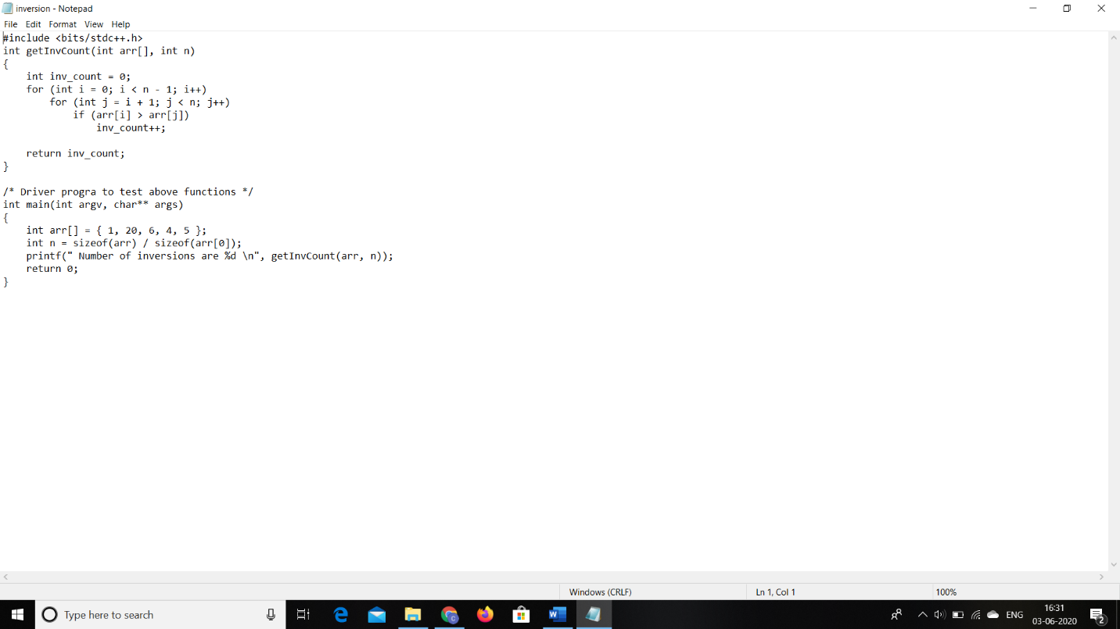

Problem 2: Write a Java program to find Perfect Sum Problem.

**Snapshot:**

