**DAILY ONLINE ACTIVITIES SUMMARY**

|  |  |  |  |  |  |  |  |  |
| --- | --- | --- | --- | --- | --- | --- | --- | --- |
| **Date:** | **04/07/2020** | | | | | **Name:** | **RACHANA B S** | |
| **Sem & Sec** | **4th Sem B Sec** | | | | | **USN:** | **4AL18CS065** | |
| **Online Test Summary** | | | | | | | | |
| **Subject** | | **Not conducted** | | | | | | |
| **Max. Marks** | | **-** | | **Score** | | | **-** | |
| **Certification Course Summary** | | | | | | | | |
| **Course** | **Virtual Internship on Data Science [Program Preview]** | | | | | | | |
| **Certificate Provider** | | | **Great Learning** | | **Duration** | | | **2 hours** |
| **Coding Challenges** | | | | | | | | |
| **Problem Statement: 1.** [Given an array of integer arr[] and an integer k, the task is to find the median of each window of size k starting from the left and moving towards the right by one position each time.](https://github.com/orgs/alvas-education-foundation/teams/2nd-year/discussions/145) | | | | | | | | |
| **Status: executed** | | | | | | | | |
| **Uploaded the report in GitHub** | | | | | **yes** | | | |
| **If yes Repository name** | | | | | <https://github.com/bsrachana/lockdown_coding> | | | |
| **Uploaded the report in slack** | | | | | **yes** | | | |

Online Test Details: test was not conducted today.

Certification Course Details:

In today’s session, I learnt about Plots.

SNAPSHOT:

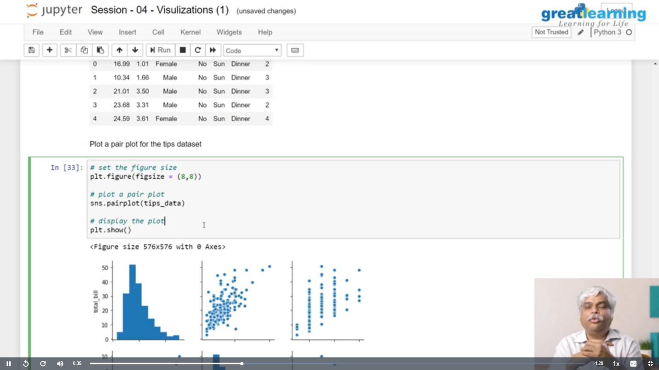

Coding Challenges Details:

Every day we are given with new question of coding related to the language of java and c. it seems interesting how we imbibe ourselves in depth to understand the logic, break it and then code for it.

Today’s question was:

1. [Given an array of integer arr[] and an integer k, the task is to find the median of each window of size k starting from the left and moving towards the right by one position each time.](https://github.com/orgs/alvas-education-foundation/teams/2nd-year/discussions/145)

Top of Form

Bottom of Form

|  |
| --- |
| Examples: Input: arr[] = {-1, 5, 13, 8, 2, 3, 3, 1}, k = 3 Output: 5 8 8 3 3 3 Input: arr[] = {-1, 5, 13, 8, 2, 3, 3, 1}, k = 4 Output: 6.5 6.5 5.5 3.0 2.5 |

SNAPSHOT:

