**DAILY ONLINE ACTIVITIES SUMMARY**

|  |  |  |  |  |  |  |  |  |
| --- | --- | --- | --- | --- | --- | --- | --- | --- |
| **Date:** | 04/06/2020 | | | | | **Name:** | RACHANA B S | |
| **Sem & Sec** | 4th SEM ‘B’ SEC | | | | | **USN:** | 4AL18CS065 | |
| **Online Test Summary** | | | | | | | | |
| **Subject** | | Microcontroller and Embedded Systems | | | | | | |
| **Max. Marks** | | 20 | | **Score** | | | 18 | |
| **Certification Course Summary** | | | | | | | | |
| **Course** | Introduction to Google Cloud | | | | | | | |
| **Certificate Provider** | | | Udemy | | **Duration** | | | 2 weeks |
| **Coding Challenges** | | | | | | | | |
| **Problem Statement:** Write a code segment in java to swap two numbers using call by object reference. | | | | | | | | |
| **Status:** Completed | | | | | | | | |
| **Uploaded the report in Github** | | | | | YES | | | |
| **If yes Repository name** | | | | | https://github.com/bsrachana/lockdown-coding | | | |
| **Uploaded the report in slack** | | | | | YES | | | |

**Online Test Details:**

The online test was from module 3. There were 20 questions and the duration was 30 minutes. The questions were optimal and were easy. The score that I got in the test is 18/20

**Snapshot:**

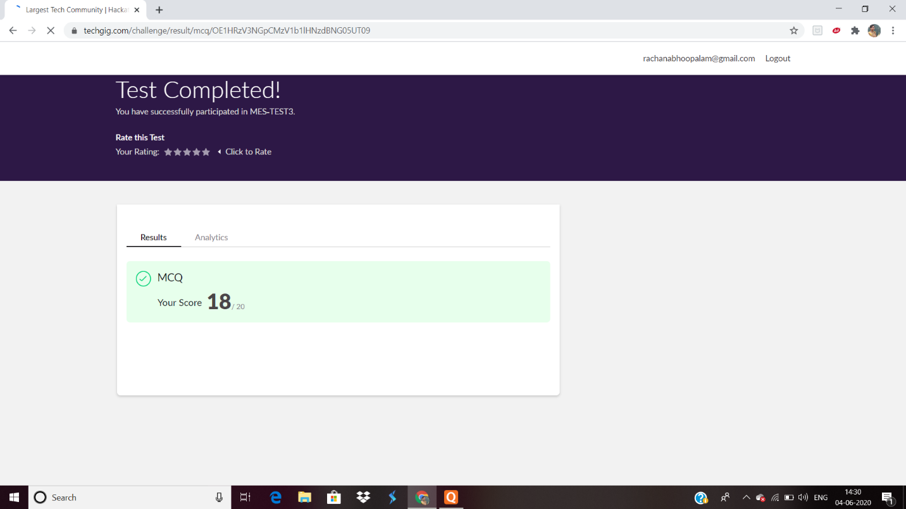

**Certification Course Details:**

**Name of the course**: Introduction to Google Cloud

**Certificate Provider**: Udemy

Today I learnt about the basic concepts of Google Cloud and a brief introduction about all the Google Cloud Certifications together.

**Snapshot:**

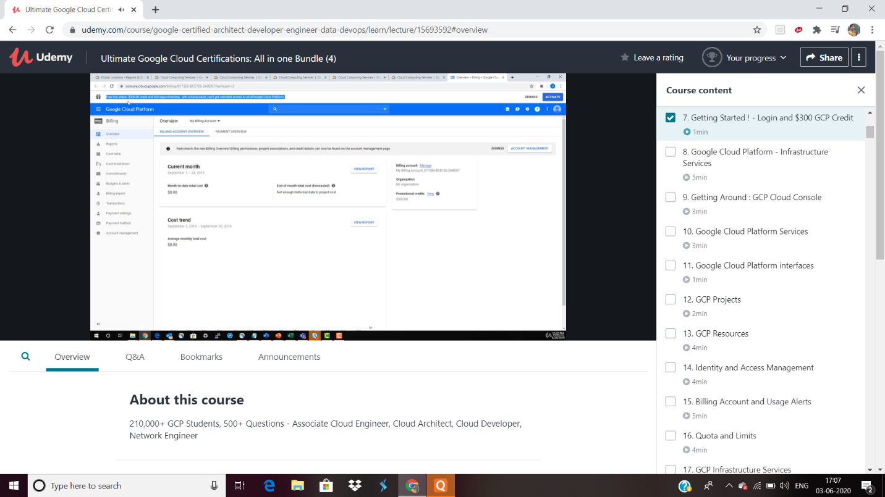

**Online Coding Details:**

Problem 1: Write a code segment in java to swap two numbers using call by object reference.

**Snapshot:**

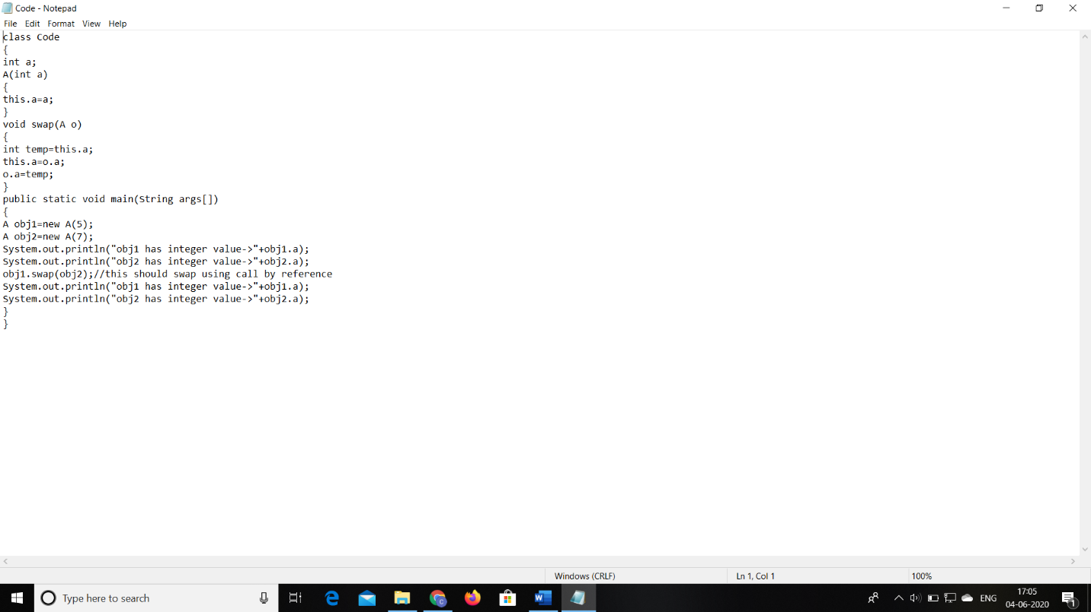

Problem 2:

Write a Java program to find Last Digit of a^b (a to the power b) for large numbers.

**Snapshot:**

