**DAILY ONLINE ACTIVITIES SUMMARY**

|  |  |  |  |  |  |  |  |  |
| --- | --- | --- | --- | --- | --- | --- | --- | --- |
| **Date:** | **05/06/2020** | | | | | **Name:** | **RACHANA B S** | |
| **Sem & Sec** | **4th Sem B Sec** | | | | | **USN:** | **4AL18CS065** | |
| **Online Test Summary** | | | | | | | | |
| **Subject** | | **Not conducted** | | | | | | |
| **Max. Marks** | | **-** | | **Score** | | | **-** | |
| **Certification Course Summary** | | | | | | | | |
| **Course** | **Introduction to Google Cloud** | | | | | | | |
| **Certificate Provider** | | | **Udemy** | | **Duration** | | | **2 weeks** |
| **Coding Challenges** | | | | | | | | |
| **Problem Statement:** write a java program to read three integer values from the keyboard and find the sum of the values. Declare a variable "sum" of type int and store the result in it. | | | | | | | | |
| **Status: executed** | | | | | | | | |
| **Uploaded the report in GitHub** | | | | | **yes** | | | |
| **If yes Repository name** | | | | | <https://github.com/bsrachana/lockdown_coding> | | | |
| **Uploaded the report in slack** | | | | | **yes** | | | |

Online Test Details: test was not conducted today.

Certification Course Details:

In today’s session, I learnt about GCP Projects in brief.

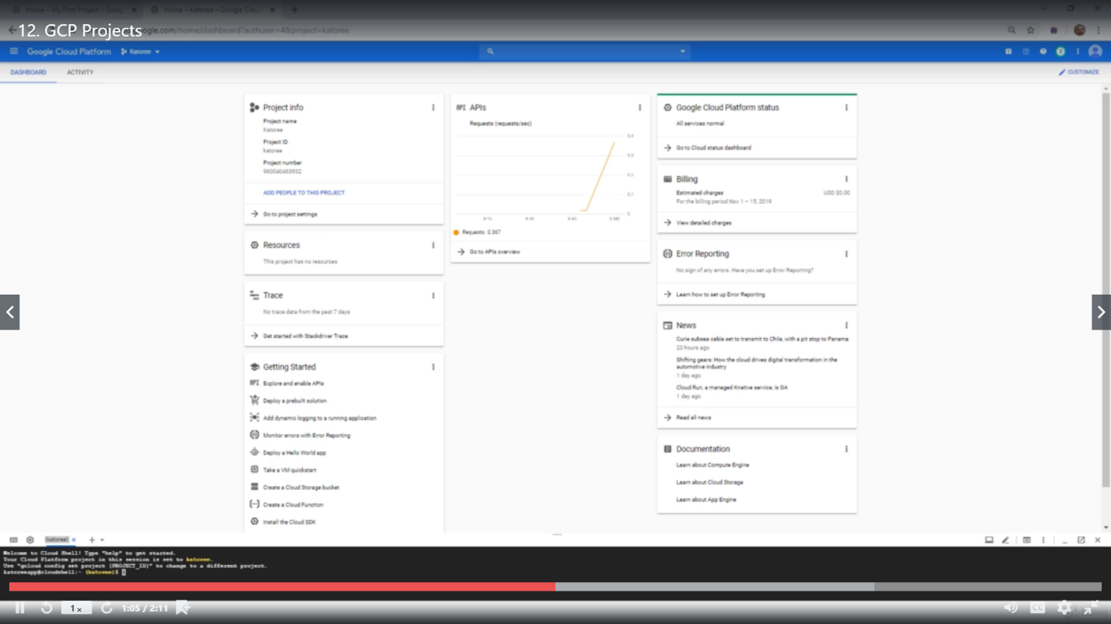

Coding Challenges Details:

Every day we are given with new question of coding related to the language of java and c. it seems interesting how we imbibe ourselves in depth to understand the logic, break it and then code for it.

Today’s question was:

1.Write a java program to read three integer values from the keyboard and find the sum of the values. Declare a variable "sum" of type int and store the result in it.

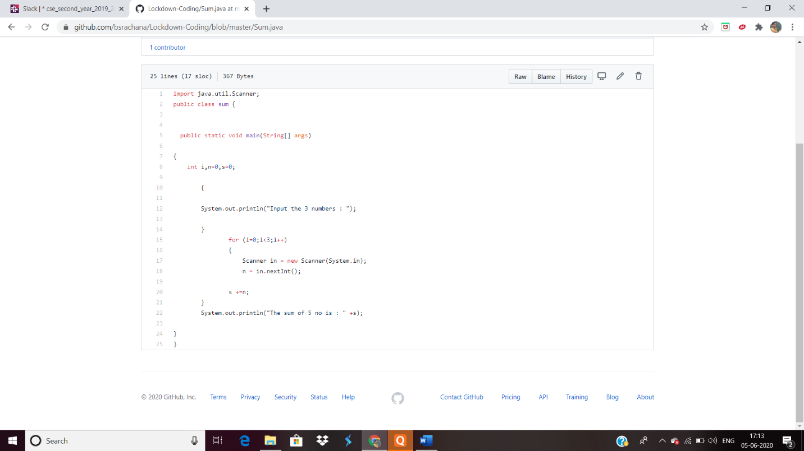

2. Given an array C of size N-1 and given that there are numbers from 1 to N with one element missing, the missing number is to be found.

**Input:**  
The first line of input contains an integer T denoting the number of test cases. For each test case first line contains N(size of array). The subsequent line contains N-1 array elements.

**Output:**  
Print the missing number in array.

**Constraints:**  
1 ≤ T ≤ 200  
1 ≤ N ≤ 107  
1 ≤ C[i] ≤ 107

Example:  
Input:  
1  
5  
1 2 3 5

Output:  
4

