**DAILY ONLINE ACTIVITIES SUMMARY**

|  |  |  |  |  |  |  |  |  |
| --- | --- | --- | --- | --- | --- | --- | --- | --- |
| **Date:** | 06/06/2020 | | | | | **Name:** | RACHANA B S | |
| **Sem & Sec** | 4th SEM ‘B’ SEC | | | | | **USN:** | 4AL18CS065 | |
| **Online Test Summary** | | | | | | | | |
| **Subject** | | Data Communication | | | | | | |
| **Max. Marks** | | 30 | | **Score** | | | 26 | |
| **Certification Course Summary** | | | | | | | | |
| **Course** | Introduction to Google Cloud | | | | | | | |
| **Certificate Provider** | | | Udemy | | **Duration** | | | 2 weeks |
| **Coding Challenges** | | | | | | | | |
| **Problem Statement:** Write a Java Program to find the duplicate characters in a string.  Write a Java Program to find the duplicate characters in a string.  Write a Java Program to find the duplicate characters in a string. | | | | | | | | |
| **Status:** Completed | | | | | | | | |
| **Uploaded the report in Github** | | | | | YES | | | |
| **If yes Repository name** | | | | | https://github.com/bsrachana/lockdown-coding | | | |
| **Uploaded the report in slack** | | | | | YES | | | |

**Online Test Details:**

The online test was from module 5. There were 30 questions and the duration of 45 minutes. The questions were optimal and were easy. The score that I got in the test is 26/30

**Snapshot:**

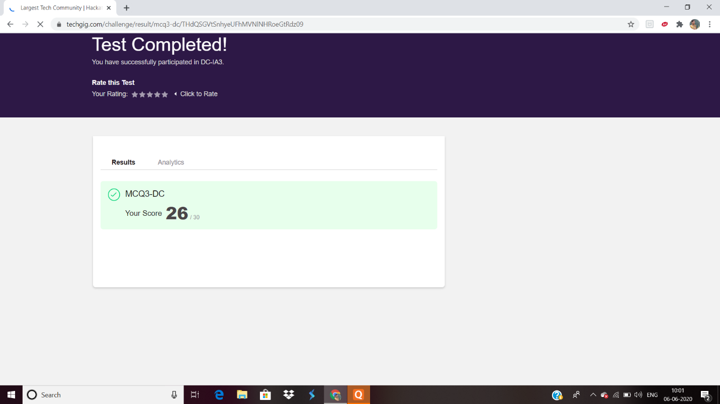

**Certification Course Details:**

**Name of the course**: Introduction to Google Cloud

**Certificate Provider**: Udemy

**Snapshot:**



**Online Coding Details:**

Problem 1: Write a Java Program to find the duplicate characters in a string.

**Snapshot:**

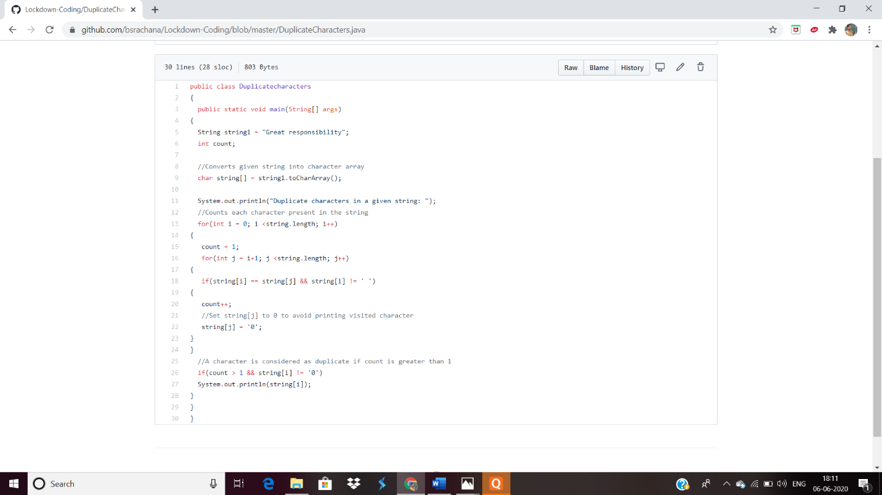

Problem 2:

[Write a program in C to rotate an array by N positions.](https://github.com/orgs/alvas-education-foundation/teams/2nd-year/discussions/103)

Top of Form

Bottom of Form

|  |
| --- |
| **Expected Output :** **The given array is :** 0 3 6 9 12 14 18 20 22 25 27 Enter the Position N from where you want to rotate: 4 From 4th position the values of the array are : 12 14 18 20 22 25 27 Before 4th position the values of the array are : 0 3 6 9 After rotating from 4th position the array is: 12 14 18 20 22 25 27 0 3 6 9 |

**Snapshot:**

