**DAILY ONLINE ACTIVITIES SUMMARY**

|  |  |  |  |  |  |  |  |  |
| --- | --- | --- | --- | --- | --- | --- | --- | --- |
| **Date:** | **07/07/2020** | | | | | **Name:** | **RACHANA B S** | |
| **Sem & Sec** | **4th Sem B Sec** | | | | | **USN:** | **4AL18CS065** | |
| **Online Test Summary** | | | | | | | | |
| **Subject** | | **Not conducted** | | | | | | |
| **Max. Marks** | | **-** | | **Score** | | | **-** | |
| **Certification Course Summary** | | | | | | | | |
| **Course** | **Virtual Internship on Data Science [Program Preview]** | | | | | | | |
| **Certificate Provider** | | | **Great Learning** | | **Duration** | | | **2 hours** |
| **Coding Challenges** | | | | | | | | |
| **Problem Statement: 1.** [Write a Java program to find the Nth natural number with exactly two bits set](https://github.com/orgs/alvas-education-foundation/teams/2nd-year/discussions/146) | | | | | | | | |
| **Status: executed** | | | | | | | | |
| **Uploaded the report in GitHub** | | | | | **yes** | | | |
| **If yes Repository name** | | | | | <https://github.com/bsrachana/lockdown_coding> | | | |
| **Uploaded the report in slack** | | | | | **yes** | | | |

Online Test Details: test was not conducted today.

Certification Course Details:

In today’s session, I learnt about Plots.

SNAPSHOT:

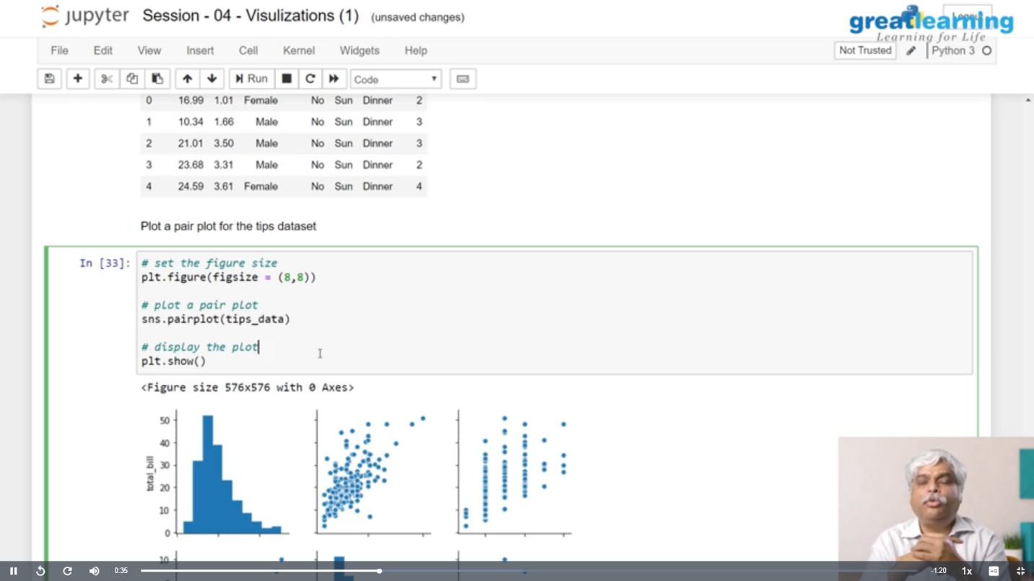

Coding Challenges Details:

Every day we are given with new question of coding related to the language of java and c. it seems interesting how we imbibe ourselves in depth to understand the logic, break it and then code for it.

Today’s question was:

1. [Write a Java program to find the Nth natural number with exactly two bits set](https://github.com/orgs/alvas-education-foundation/teams/2nd-year/discussions/146)

Top of Form

Bottom of Form

|  |
| --- |
| Given an integer N, the task is to find the Nth natural number with exactly two bits set.  Examples:  Input: N = 4 Output: 9  Input: N = 15 Output: 48  **Hint** **Explanation: of 1st example** Binary representation of numbers 1 -0001, 2- 0010, **3- 0011**, 4-0100, **5-0101**, **6-0110**, 7- 0111, 8-1000, **9 - 1001**, **10- 1010** etc. Here only for the bold numbers binary values contains exactly 2 bits 1's hence Numbers with exactly two bits set: 3, 5, 6, 9, 10, 12, … 4th number in this is 9.  **Therefore output is 9** |

SNAPSHOT:

