**DAILY ONLINE ACTIVITIES SUMMARY**

|  |  |  |  |  |  |  |  |  |
| --- | --- | --- | --- | --- | --- | --- | --- | --- |
| **Date:** | **07/06/2020** | | | | | **Name:** | **RACHANA B S** | |
| **Sem & Sec** | **4th Sem B Sec** | | | | | **USN:** | **4AL18CS065** | |
| **Online Test Summary** | | | | | | | | |
| **Subject** | | **Not conducted** | | | | | | |
| **Max. Marks** | | **-** | | **Score** | | | **-** | |
| **Certification Course Summary** | | | | | | | | |
| **Course** | **Introduction to Google Cloud** | | | | | | | |
| **Certificate Provider** | | | **Udemy** | | **Duration** | | | **2 weeks** |
| **Coding Challenges** | | | | | | | | |
| **Problem Statement:1.** Write a Java Program to find the second-highest number in an array. | | | | | | | | |
| **Status: executed** | | | | | | | | |
| **Uploaded the report in GitHub** | | | | | **yes** | | | |
| **If yes Repository name** | | | | | <https://github.com/bsrachana/lockdown_coding> | | | |
| **Uploaded the report in slack** | | | | | **yes** | | | |

Online Test Details: test was not conducted today.

Certification Course Details:

In today’s session, I learnt about Identity and Access Management, IAM Roles Hierarchy.

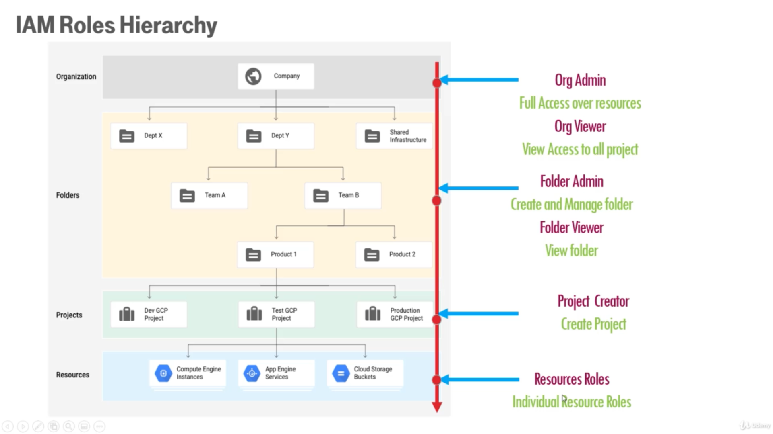

Coding Challenges Details:

Every day we are given with new question of coding related to the language of java and c. it seems interesting how we imbibe ourselves in depth to understand the logic, break it and then code for it.

Today’s question was:

1. Write a Java Program to find the second-highest number in an array.

Snapshot:

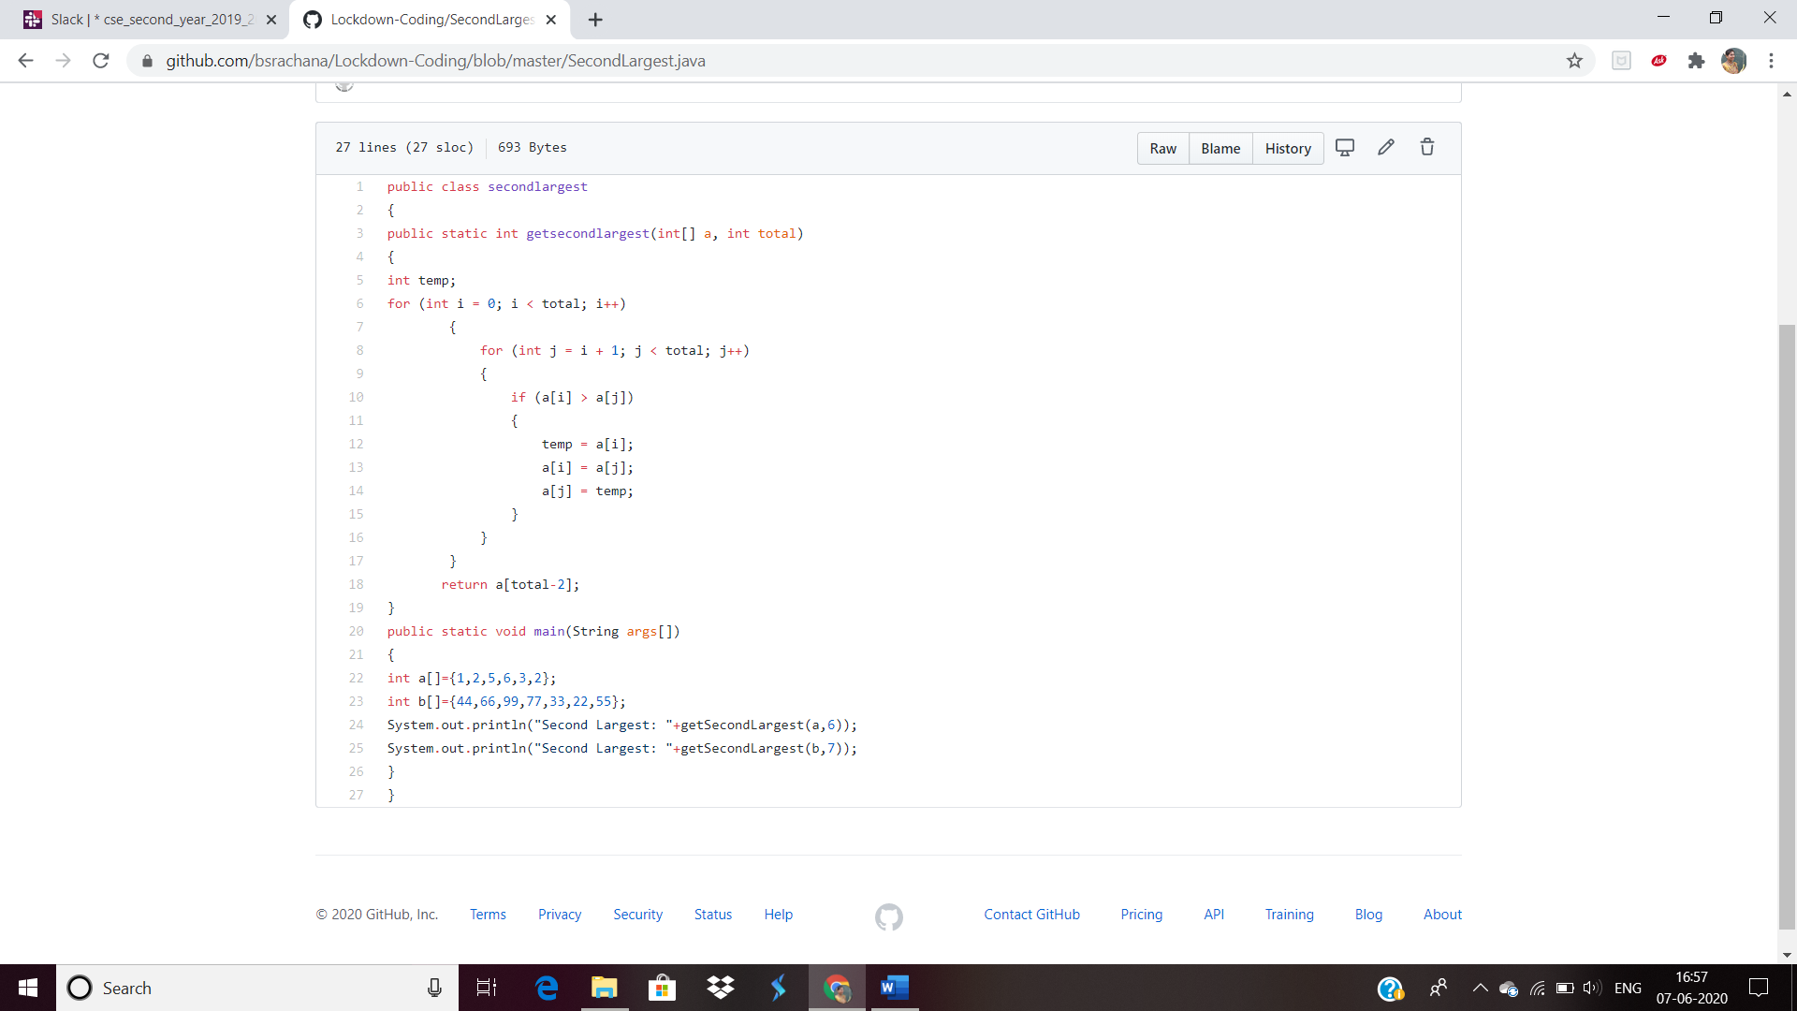

2. [Write a C++ Program to swap two numbers using friend as a bridge concept.](https://github.com/orgs/alvas-education-foundation/teams/2nd-year/discussions/106)

Top of Form

Bottom of Form

|  |
| --- |
| Note- Don't make use of temp variable while swapping. Program should use the concept of **friend function** ***Example***  **Input** a=10 b=20 **Output** a=20 b=10  Snapshot: |