**DAILY ONLINE ACTIVITIES SUMMARY**

|  |  |  |  |  |  |  |  |  |
| --- | --- | --- | --- | --- | --- | --- | --- | --- |
| **Date:** | **08/07/2020** | | | | | **Name:** | **RACHANA B S** | |
| **Sem & Sec** | **4th Sem B Sec** | | | | | **USN:** | **4AL18CS065** | |
| **Online Test Summary** | | | | | | | | |
| **Subject** | | **Not conducted** | | | | | | |
| **Max. Marks** | | **-** | | **Score** | | | **-** | |
| **Certification Course Summary** | | | | | | | | |
| **Course** | **Virtual Internship on Data Science [Program Preview]** | | | | | | | |
| **Certificate Provider** | | | **Great Learning** | | **Duration** | | | **2 hours** |
| **Coding Challenges** | | | | | | | | |
| **Problem Statement: 1.** [Write a java program to find whether the given strings are anagram](https://github.com/orgs/alvas-education-foundation/teams/2nd-year/discussions/147) | | | | | | | | |
| **Status: executed** | | | | | | | | |
| **Uploaded the report in GitHub** | | | | | **yes** | | | |
| **If yes Repository name** | | | | | <https://github.com/bsrachana/lockdown_coding> | | | |
| **Uploaded the report in slack** | | | | | **yes** | | | |

Online Test Details: test was not conducted today.

Certification Course Details:

In today’s session, I learnt about Plots.

SNAPSHOT:

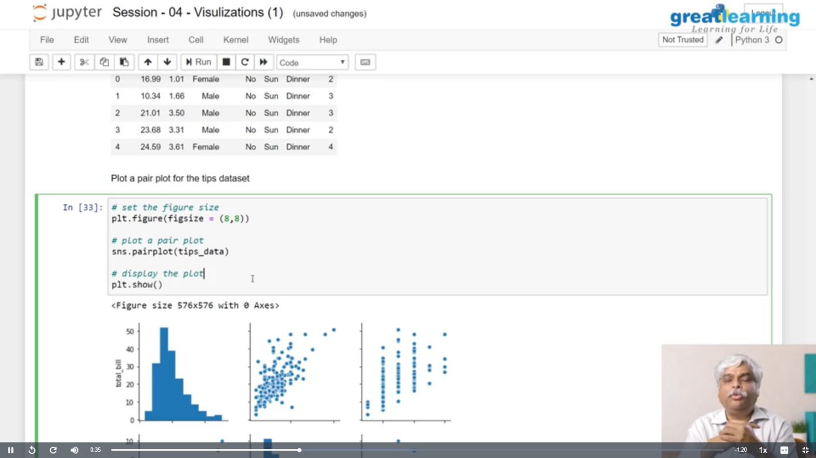

Coding Challenges Details:

Every day we are given with new question of coding related to the language of java and c. it seems interesting how we imbibe ourselves in depth to understand the logic, break it and then code for it.

Today’s question was:

1. [Write a java program to find whether the given strings are anagram](https://github.com/orgs/alvas-education-foundation/teams/2nd-year/discussions/147)

Top of Form

Bottom of Form

|  |
| --- |
| Given two strings a and b consisting of lowercase characters. The task is to check whether two given strings are anagram of each other or not. An anagram of a string is another string that contains same characters, only the order of characters can be different. For example, “act” and “tac” are anagram of each other.  **Example:** Input: alvasinsitute aalvsiittnsue allergy allergic  **Output:** YES NO  Explanation: Testcase 1: Both the string have same characters with same frequency. So, both are anagrams. Testcase 2: Characters in both the strings are not same, so they are not anagrams. |

SNAPSHOT:

