**DAILY ONLINE ACTIVITIES SUMMARY**

|  |  |  |  |  |  |  |  |  |
| --- | --- | --- | --- | --- | --- | --- | --- | --- |
| **Date:** | **07/06/2020** | | | | | **Name:** | **RACHANA B S** | |
| **Sem & Sec** | **4th Sem B Sec** | | | | | **USN:** | **4AL18CS065** | |
| **Online Test Summary** | | | | | | | | |
| **Subject** | | **Complex Analysis, Probability and Statistical Methods** | | | | | | |
| **Max. Marks** | | **30** | | **Score** | | | **20** | |
| **Certification Course Summary** | | | | | | | | |
| **Course** | **Introduction to Google Cloud** | | | | | | | |
| **Certificate Provider** | | | **Udemy** | | **Duration** | | | **2 weeks** |
| **Coding Challenges** | | | | | | | | |
| **Problem Statement:1.** [C Program to Generate All the Set Partitions of n Numbers Beginning from 1 and so on](https://github.com/orgs/alvas-education-foundation/teams/2nd-year/discussions/108) | | | | | | | | |
| **Status: executed** | | | | | | | | |
| **Uploaded the report in GitHub** | | | | | **yes** | | | |
| **If yes Repository name** | | | | | <https://github.com/bsrachana/lockdown_coding> | | | |
| **Uploaded the report in slack** | | | | | **yes** | | | |

Online Test Details:

Today I attended internals of Complex Analysis, Probability and Statistical methods where the test was for 30 marks. 15 questions of 2 mark of the time limit was 40 mins. I scored 20/30

SNAPSHOT:

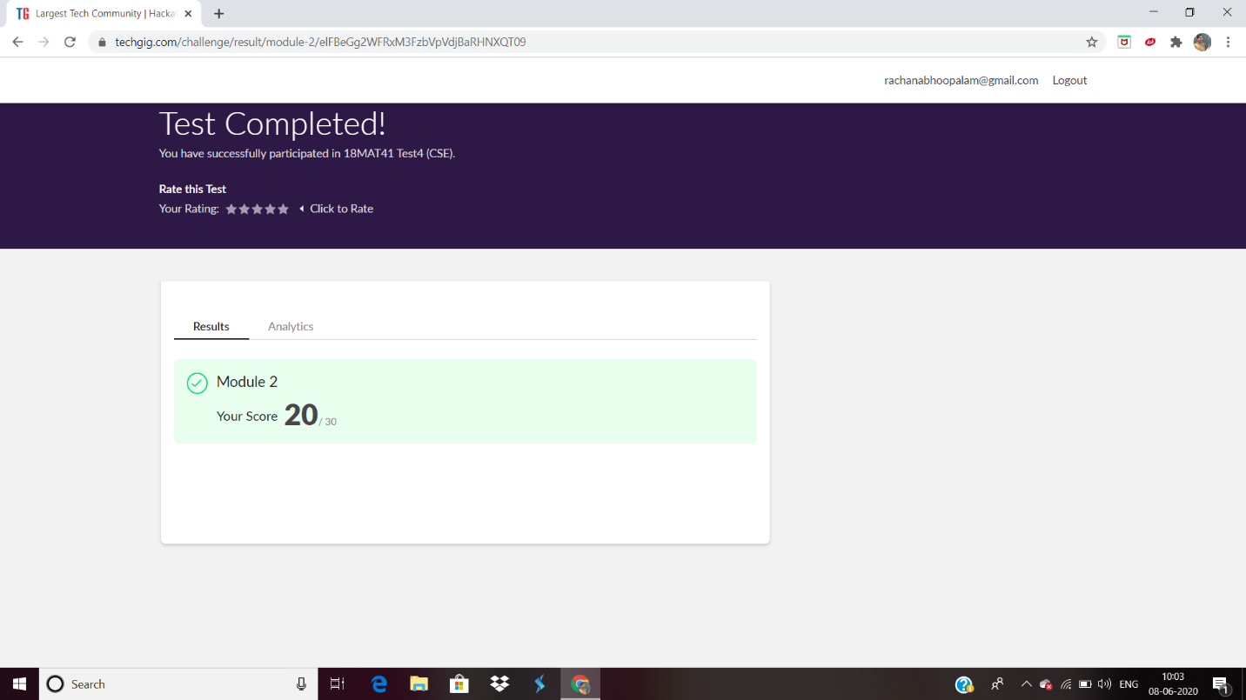

Certification Course Details:

In today’s session, I learnt about GCP Quotas in brief and also types of GCP quotas.

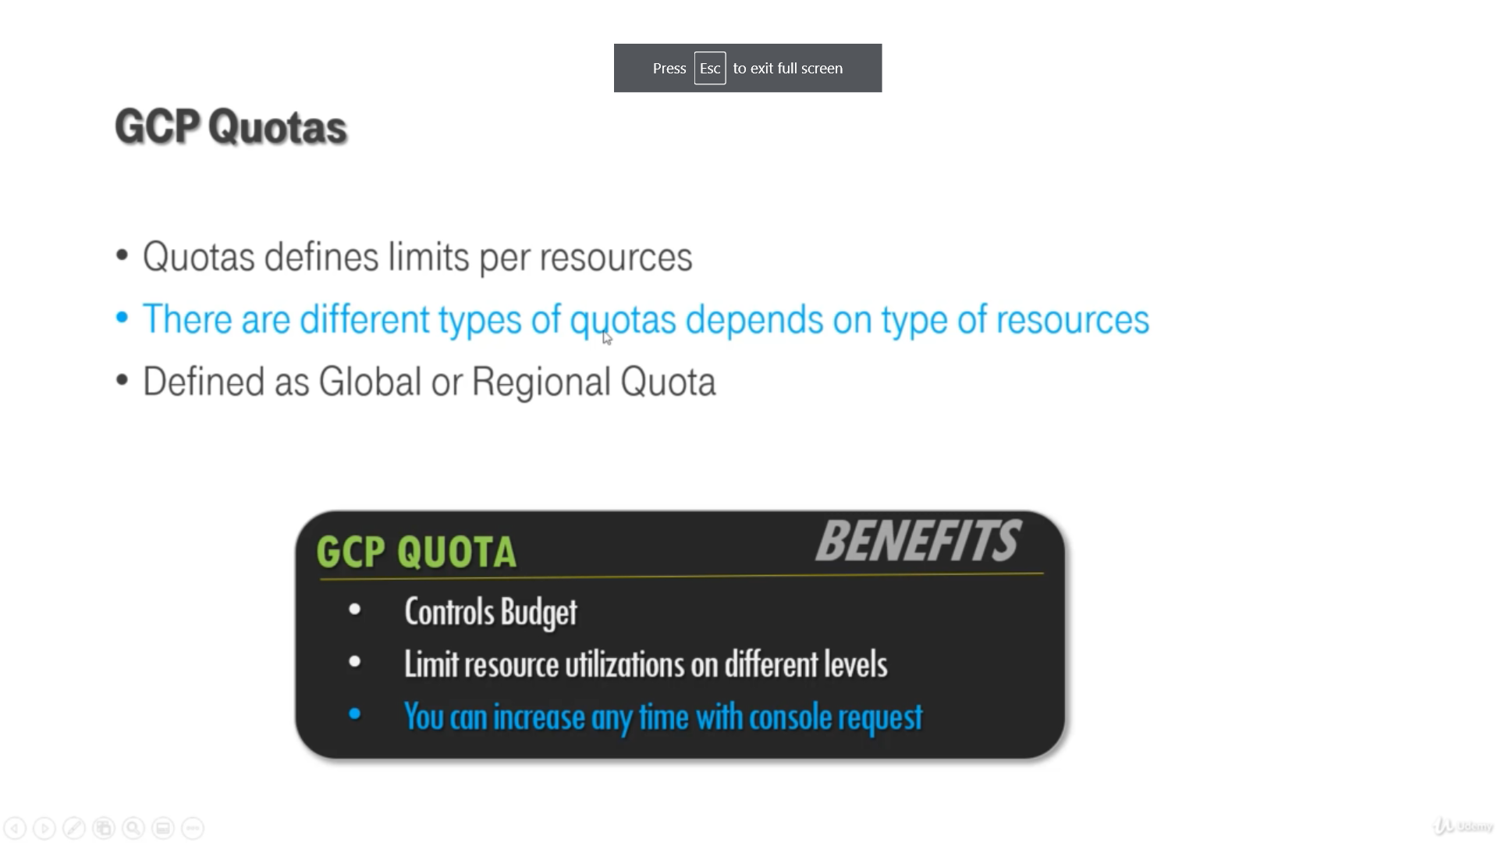

Coding Challenges Details:

Every day we are given with new question of coding related to the language of java and c. it seems interesting how we imbibe ourselves in depth to understand the logic, break it and then code for it.

Today’s question was:

1. [C Program to Generate All the Set Partitions of n Numbers Beginning from 1 and so on](https://github.com/orgs/alvas-education-foundation/teams/2nd-year/discussions/108)

This algorithm partitions an integer into numbers which sum up to form the original number. It generates partitions of a set of numbers for a given range.

**Sample Input**

Enter a number N to generate all set partition from 1 to N: 5  
Integer partition for 1 is:  
1

Integer partition for 2 is:  
2  
11

Integer partition for 3 is:  
3  
12  
111

Integer partition for 4 is:  
4  
13  
112  
1111  
22

Integer partition for 5 is:  
5  
14  
113  
1112  
11111  
122  
23

Snapshot:

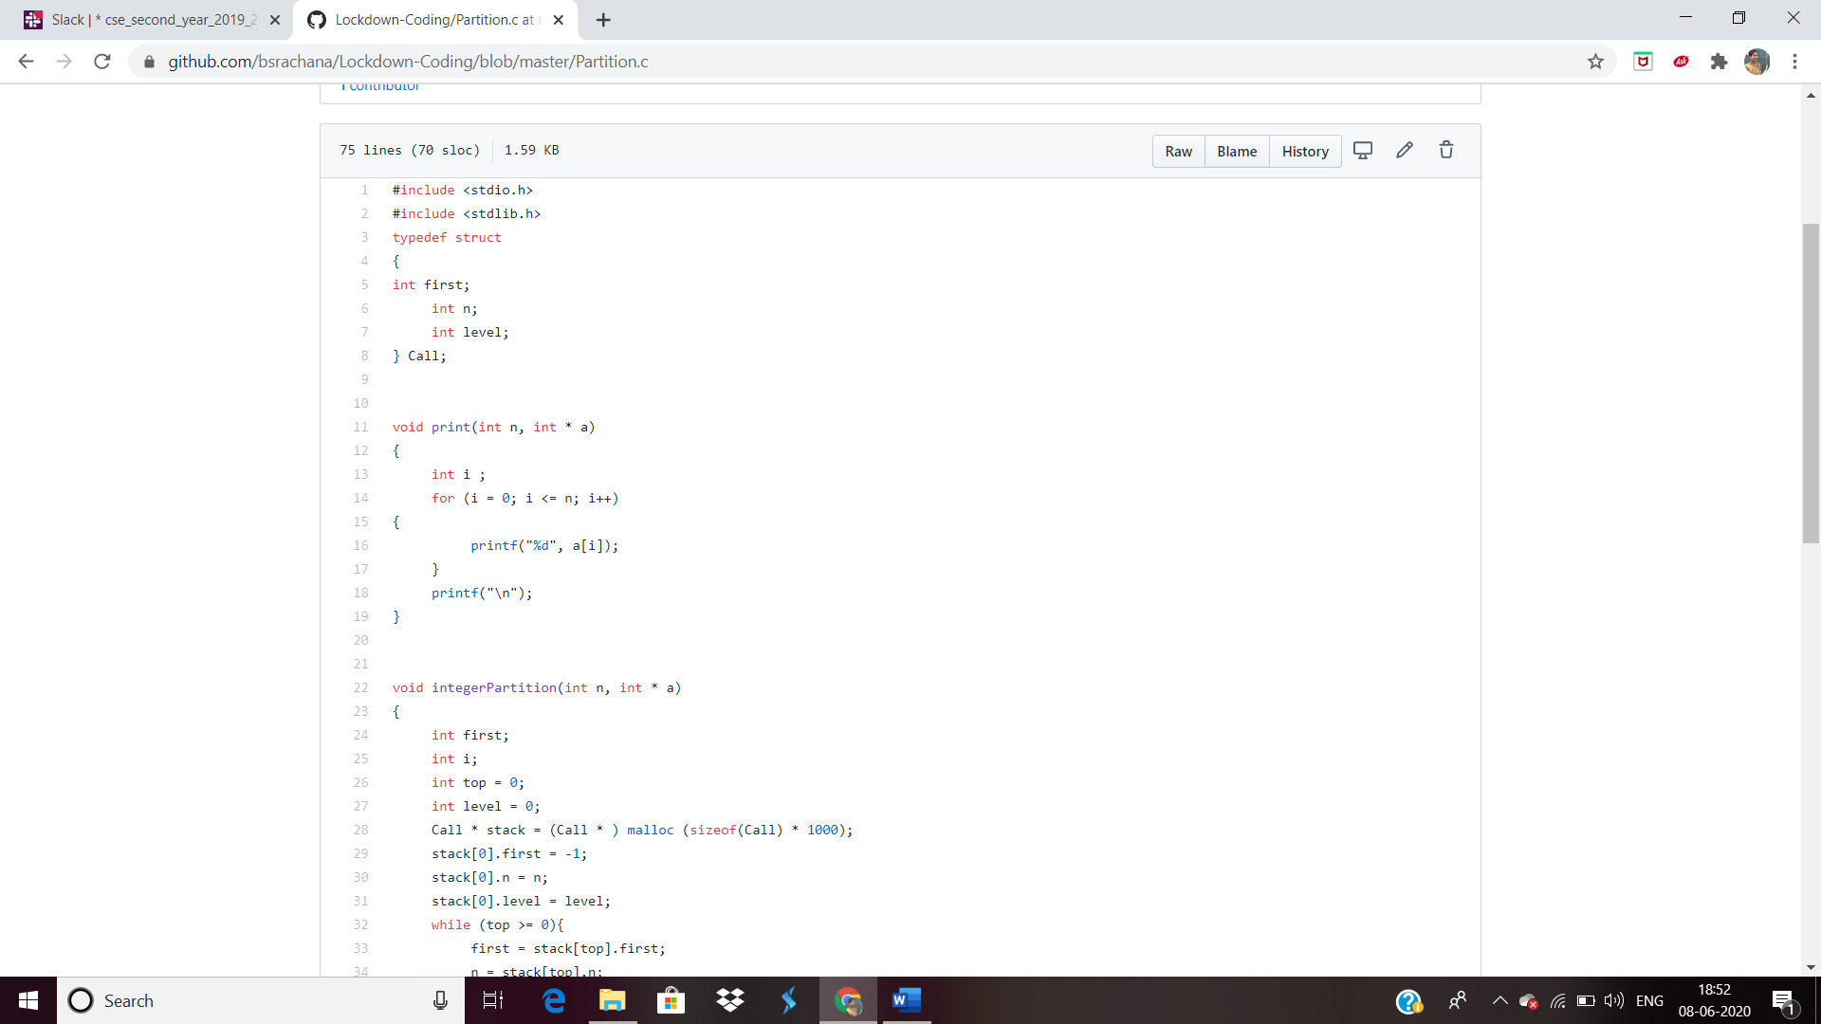

2. [Write a Java Program to check whether the given matrix is magic square or not](https://github.com/orgs/alvas-education-foundation/teams/2nd-year/discussions/107)

Top of Form

Bottom of Form

|  |
| --- |
| Given a matrix, check whether it’s Magic Square or not. A Magic Square is a n x n matrix of distinct element from 1 to n2 where sum of any row, column or diagonal is always equal to same number.  Examples:  Input : n = 3 2 7 6 9 5 1 4 3 8 Output : Magic matrix Explanation:In matrix sum of each row and each column and diagonals sum is same = 15.  Input : n = 3 1 2 2 2 2 1 2 1 2 Output : Not a Magic Matrix Explanation:In matrix sum of each row and each column and diagonals sum is not same. **Step to Follow**   1. Find sum of prime diagonal and secondary diagonal. 2. Calculate sum of each rows and columns. 3. If the prime diagonal and secondary diagonal sums is equal to every row’s sum and every column’s sum, then it is magic matrix. |
| Snapshot: |

Top of Form

Bottom of Form