**DAILY ONLINE ACTIVITIES SUMMARY**

|  |  |  |  |  |  |  |  |  |
| --- | --- | --- | --- | --- | --- | --- | --- | --- |
| **Date:** | **10/06/2020** | | | | | **Name:** | **RACHANA B S** | |
| **Sem & Sec** | **4th Sem B Sec** | | | | | **USN:** | **4AL18CS065** | |
| **Online Test Summary** | | | | | | | | |
| **Subject** | | **Object Oriented Concepts** | | | | | | |
| **Max. Marks** | | **30** | | **Score** | | | **18** | |
| **Certification Course Summary** | | | | | | | | |
| **Course** | **Introduction to Google Cloud** | | | | | | | |
| **Certificate Provider** | | | **Udemy** | | **Duration** | | | **2 weeks** |
| **Coding Challenges** | | | | | | | | |
| **Problem Statement:1.** [Write a java program to count all the triplets such that sum of two elements equals the third element.](https://github.com/orgs/alvas-education-foundation/teams/2nd-year/discussions/111)  2. [Write a C Program to print the sum of boundary elements of a matrix](https://github.com/orgs/alvas-education-foundation/teams/2nd-year/discussions/112) | | | | | | | | |
| **Status: executed** | | | | | | | | |
| **Uploaded the report in GitHub** | | | | | **yes** | | | |
| **If yes Repository name** | | | | | <https://github.com/bsrachana/lockdown_coding> | | | |
| **Uploaded the report in slack** | | | | | **yes** | | | |

Online Test Details:

Today I attended internals of Object Oriented Concepts where the test was for 30 marks. 15 questions of 2 mark of the time limit was 30 mins. I scored 18/30

SNAPSHOT:

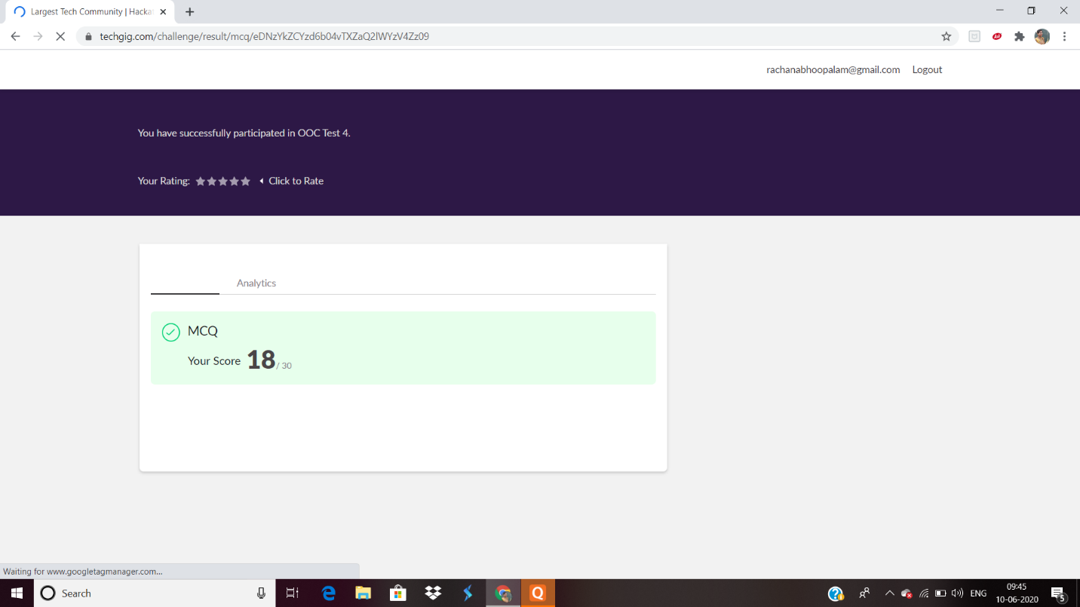

Certification Course Details:

In today’s session, I learnt about GCE and Computer Engine: its basic and types of Computer Engine

SNAPSHOT:

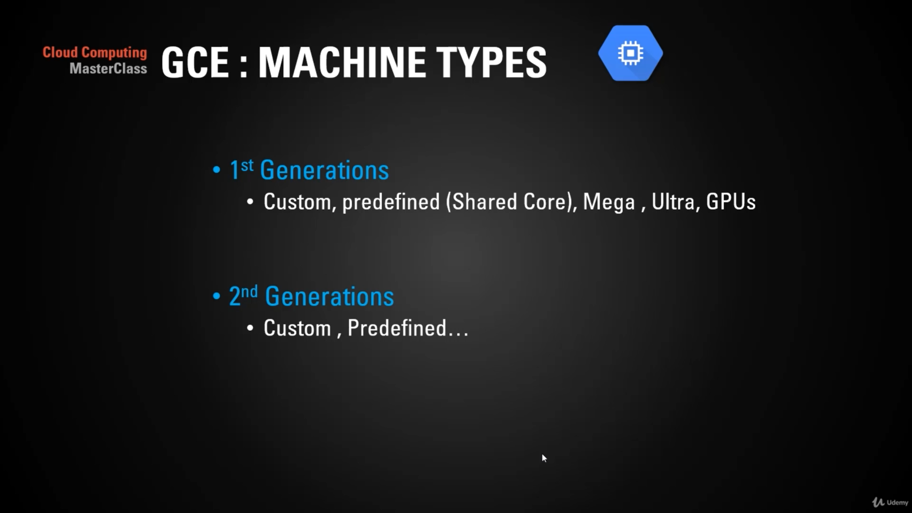

Coding Challenges Details:

Every day we are given with new question of coding related to the language of java and c. it seems interesting how we imbibe ourselves in depth to understand the logic, break it and then code for it.

Today’s question was:

1. [Write a java program to count all the triplets such that sum of two elements equals the third element.](https://github.com/orgs/alvas-education-foundation/teams/2nd-year/discussions/111)

Top of Form

Bottom of Form

|  |
| --- |
| Given an array of distinct integers. The task is to count all the triplets such that sum of two elements equals the third element.  Input: The first line of input contains an integer T denoting the number of test cases. Then T test cases follow. Each test case consists of two lines. First line of each test case contains an Integer N denoting size of array and the second line contains N space separated elements.  Output: For each test case, print the count of all triplets, in new line. If no such triplets can form, print "-1".  Constraints: 1 <= T <= 100 3 <= N <= 105 1 <= A[i] <= 106  **Example:** Input: 4 1 5 3 2  Output: 2  Explanation: There are 2 triplets: 1 + 2 = 3 and 3 +2 = 5  SNAPSHOT: |

|  |  |
| --- | --- |
| 2. [Write a C Program to print the sum of boundary elements of a matrix](https://github.com/orgs/alvas-education-foundation/teams/2nd-year/discussions/112)  Top of Form  Bottom of Form   |  | | --- | | Given a matrix, the task is to print the boundary elements of the matrix and display their sum. Sample Output 1: Enter M (Rows) and N (Columns): 3, 3 Enter the Elements: 1 2 3 4 5 6 7 8 9 OUTPUT: The Input Matrix is: 1 2 3 4 5 6 7 8 9 The Boundary Elements are: 1 2 3 4 6 7 8 9 The Sum of Boundary elements of the Matrix is: 40  Sample Output 2: Enter M (Rows) and N (Columns): 4, 5 Enter the Elements: 1 2 3 4 5 6 7 8 9 10 11 12 13 14 15 16 17 18 19 20 OUTPUT: The Input Matrix is: 1 2 3 4 5 6 7 8 9 10 11 12 13 14 15 16 17 18 19 20 The Boundary Elements are: 1 2 3 4 5 8 9 12 13 16 17 18 19 20 The Sum of Boundary elements of the Matrix is: 147 |   Snapshot: |

Top of Form

Bottom of Form