**DAILY ONLINE ACTIVITIES SUMMARY**

|  |  |  |  |  |  |  |  |  |
| --- | --- | --- | --- | --- | --- | --- | --- | --- |
| **Date:** | **11/07/2020** | | | | | **Name:** | **RACHANA B S** | |
| **Sem & Sec** | **4th Sem B Sec** | | | | | **USN:** | **4AL18CS065** | |
| **Online Test Summary** | | | | | | | | |
| **Subject** | | **Not conducted** | | | | | | |
| **Max. Marks** | | **-** | | **Score** | | | **-** | |
| **Certification Course Summary** | | | | | | | | |
| **Course** | **Introduction to Digital Marketing** | | | | | | | |
| **Certificate Provider** | | | **Great Learning** | | **Duration** | | | **2.5 hours** |
| **Coding Challenges** | | | | | | | | |
| **Problem Statement: 1**. [Write a Java program for Reversal algorithm for array rotation by 3](https://github.com/orgs/alvas-education-foundation/teams/2nd-year/discussions/148) | | | | | | | | |
| **Status: executed** | | | | | | | | |
| **Uploaded the report in GitHub** | | | | | **yes** | | | |
| **If yes Repository name** | | | | | <https://github.com/bsrachana/lockdown_coding> | | | |
| **Uploaded the report in slack** | | | | | **yes** | | | |

Online Test Details: test was not conducted today.

Certification Course Details:

In today’s session, I learnt about Introduction to Facebook Marketing.

SNAPSHOT:

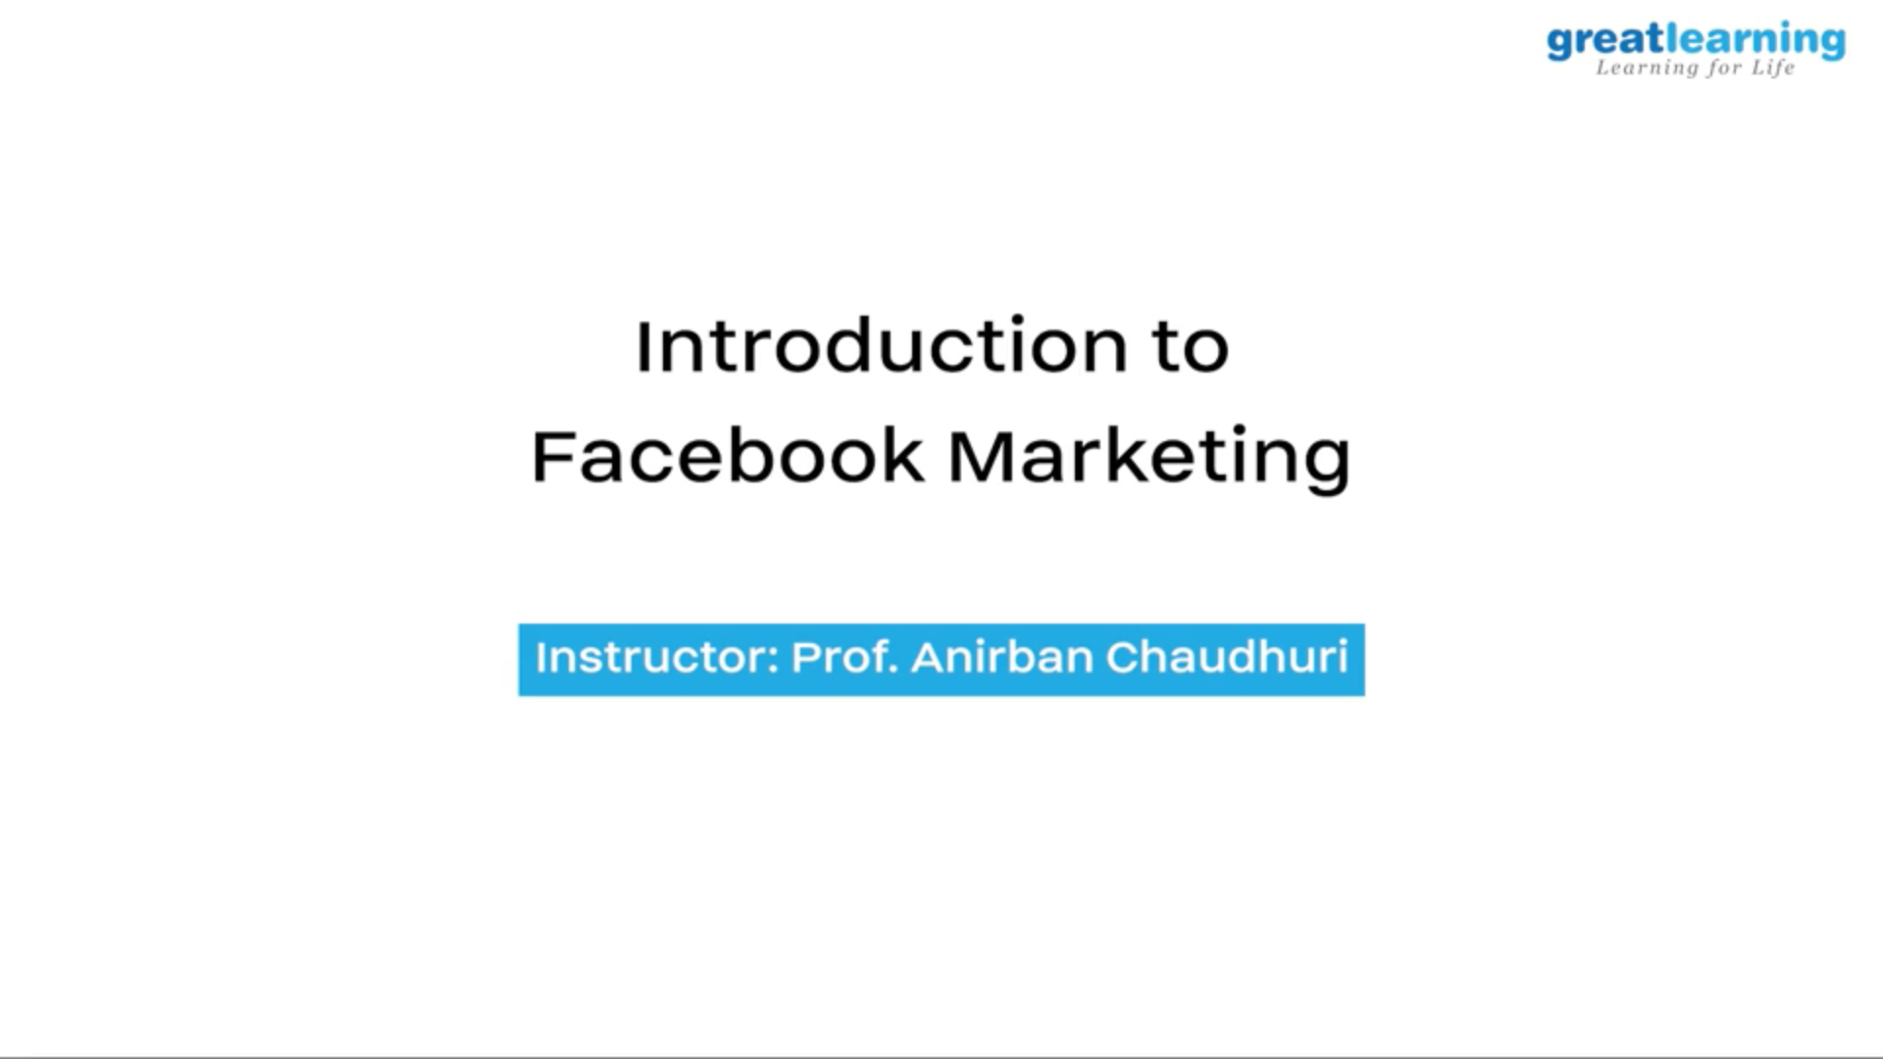

Coding Challenges Details:

Every day we are given with new question of coding related to the language of java and c. it seems interesting how we imbibe ourselves in depth to understand the logic, break it and then code for it.

Today’s question was:

1. [Write a Java program for Reversal algorithm for array rotation by 3](https://github.com/orgs/alvas-education-foundation/teams/2nd-year/discussions/148)

Top of Form

Bottom of Form

|  |
| --- |
| Given an array a[], array size n and d the number of index to be rotated task is to write a function rotate(arr[],d,n) that rotates arr[] of size n by d elements.  Example Input: n= 6 arr[]= {1,2,3,4,5,6} d=3 (specific) Output: arr[]= {4,5,6,1,2,3} |

SNAPSHOT:

