**DAILY ONLINE ACTIVITIES SUMMARY**

|  |  |  |  |  |  |  |  |  |
| --- | --- | --- | --- | --- | --- | --- | --- | --- |
| **Date:** | **12/06/2020** | | | | | **Name:** | **RACHANA B S** | |
| **Sem & Sec** | **4th Sem B Sec** | | | | | **USN:** | **4AL18CS065** | |
| **Online Test Summary** | | | | | | | | |
| **Subject** | | **Aadalitha Kannada** | | | | | | |
| **Max. Marks** | | **25** | | **Score** | | | **17** | |
| **Certification Course Summary** | | | | | | | | |
| **Course** | **Introduction to Google Cloud** | | | | | | | |
| **Certificate Provider** | | | **Udemy** | | **Duration** | | | **2 weeks** |
| **Coding Challenges** | | | | | | | | |
| **Problem Statement:1**. [Given two positive integer start and end. The task is to write a Python program to print all Prime numbers in an Interval.](https://github.com/orgs/alvas-education-foundation/teams/2nd-year/discussions/115) | | | | | | | | |
| **Status: executed** | | | | | | | | |
| **Uploaded the report in GitHub** | | | | | **yes** | | | |
| **If yes Repository name** | | | | | <https://github.com/bsrachana/lockdown_coding> | | | |
| **Uploaded the report in slack** | | | | | **yes** | | | |

Online Test Details:

Today I attended internals of Aadalitha Kannada where the test was for 25 marks. 25 questions of 1 mark of the time limit was 25 mins. I scored 17/25

SNAPSHOT:

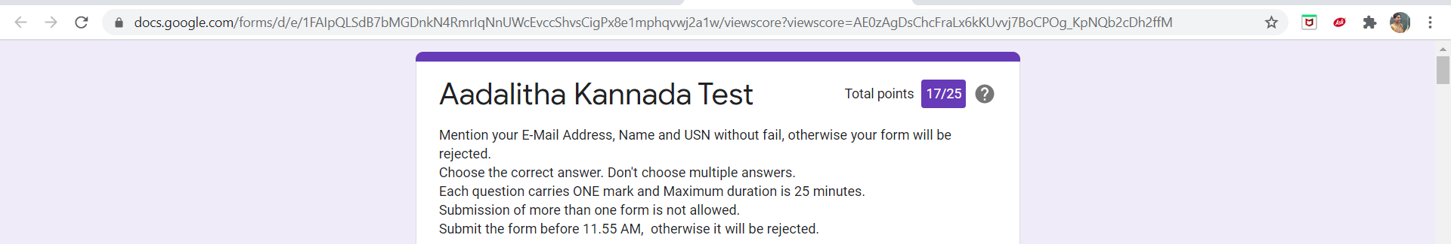

Certification Course Details:

In today’s session, I learnt about Kubernetes Engine.

SNAPSHOT:



Coding Challenges Details:

Every day we are given with new question of coding related to the language of java and c. it seems interesting how we imbibe ourselves in depth to understand the logic, break it and then code for it.

Today’s question was:

1. [Given two positive integer start and end. The task is to write a Python program to print all Prime numbers in an Interval.](https://github.com/orgs/alvas-education-foundation/teams/2nd-year/discussions/115)

Top of Form

Bottom of Form

|  |
| --- |
| Explanation : A prime number is a natural number greater than 1 that has no positive divisors other than 1 and itself. The first few prime numbers are {2, 3, 5, 7, 11, ….}. The idea to solve this problem is to iterate the val from start to end using a for loop and for every number, if it is greater than 1, check if it divides n. If we find any other number which divides, print that value |

SNAPSHOT:

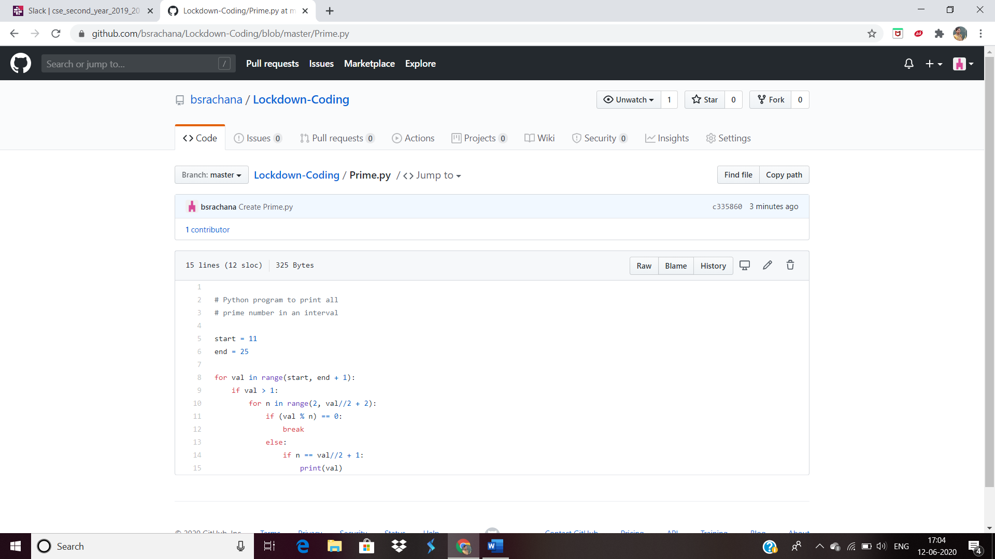

Top of Form

Bottom of Form