**DAILY ONLINE ACTIVITIES SUMMARY**

|  |  |  |  |  |  |  |  |  |
| --- | --- | --- | --- | --- | --- | --- | --- | --- |
| **Date:** | **13/07/2020** | | | | | **Name:** | **RACHANA B S** | |
| **Sem & Sec** | **4th Sem B Sec** | | | | | **USN:** | **4AL18CS065** | |
| **Online Test Summary** | | | | | | | | |
| **Subject** | | **Not conducted** | | | | | | |
| **Max. Marks** | | **-** | | **Score** | | | **-** | |
| **Certification Course Summary** | | | | | | | | |
| **Course** | **Introduction to Digital Marketing** | | | | | | | |
| **Certificate Provider** | | | **Great Learning** | | **Duration** | | | **2.5 hours** |
| **Coding Challenges** | | | | | | | | |
| **Problem Statement: 1**. Write a Java Program to find the duplicate characters in a string. | | | | | | | | |
| **Status: executed** | | | | | | | | |
| **Uploaded the report in GitHub** | | | | | **yes** | | | |
| **If yes Repository name** | | | | | <https://github.com/bsrachana/lockdown_coding> | | | |
| **Uploaded the report in slack** | | | | | **yes** | | | |

Online Test Details: test was not conducted today.

Certification Course Details:

In today’s session, I learnt about Ad set Set up Guide.

SNAPSHOT:

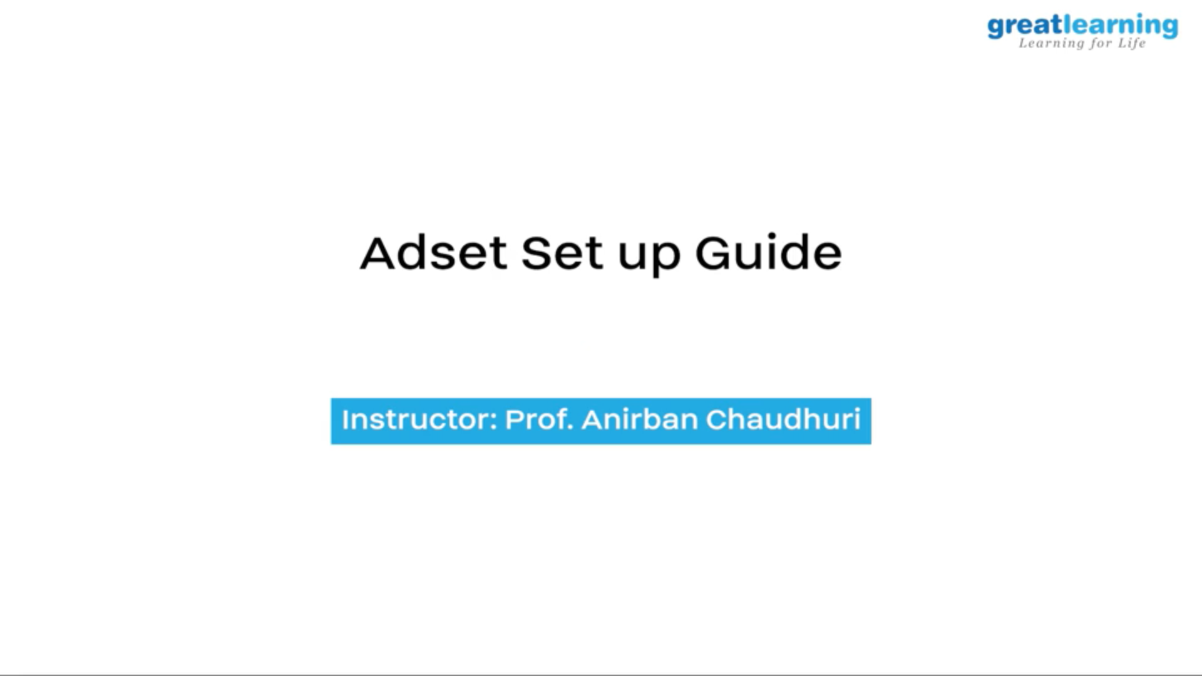

Coding Challenges Details:

Every day we are given with new question of coding related to the language of java and c. it seems interesting how we imbibe ourselves in depth to understand the logic, break it and then code for it.

Today’s question was:

1. Write a Java Program to find the duplicate characters in a string.

Top of Form

Bottom of Form

|  |
| --- |
|  |

SNAPSHOT:

