**DAILY ONLINE ACTIVITIES SUMMARY**

|  |  |  |  |  |  |  |  |  |
| --- | --- | --- | --- | --- | --- | --- | --- | --- |
| **Date:** | **13/06/2020** | | | | | **Name:** | **RACHANA B S** | |
| **Sem & Sec** | **4th Sem B Sec** | | | | | **USN:** | **4AL18CS065** | |
| **Online Test Summary** | | | | | | | | |
| **Subject** | | **Data Communication** | | | | | | |
| **Max. Marks** | | **30** | | **Score** | | | **29** | |
| **Certification Course Summary** | | | | | | | | |
| **Course** | **Introduction to Google Cloud** | | | | | | | |
| **Certificate Provider** | | | **Udemy** | | **Duration** | | | **2 weeks** |
| **Coding Challenges** | | | | | | | | |
| **Problem Statement:1**. [Write a C Program to calculate Electricity Bill](https://github.com/orgs/alvas-education-foundation/teams/2nd-year/discussions/116)  Top of Form  Bottom of Form   |  | | --- | | **Examples:**  Input: U = 250  Output: 3500  **Explanation:**  Charge for the first 100 units – 10100 = 1000Charge for the 100 to 200 units – 15100 = 1500 Charge for the 200 to 250 units – 20*50 = 1000 Total Electricity Bill = 1000 + 1500 + 1000 = 3500 | | | | | | | | | |
| **Status: executed** | | | | | | | | |
| **Uploaded the report in GitHub** | | | | | **yes** | | | |
| **If yes Repository name** | | | | | <https://github.com/bsrachana/lockdown_coding> | | | |
| **Uploaded the report in slack** | | | | | **yes** | | | |

Online Test Details:

Today I attended internals of Data Communication where the test was for 30 marks. 30 questions of 1 mark of the time limit was 30 mins. I scored 29/30

SNAPSHOT:

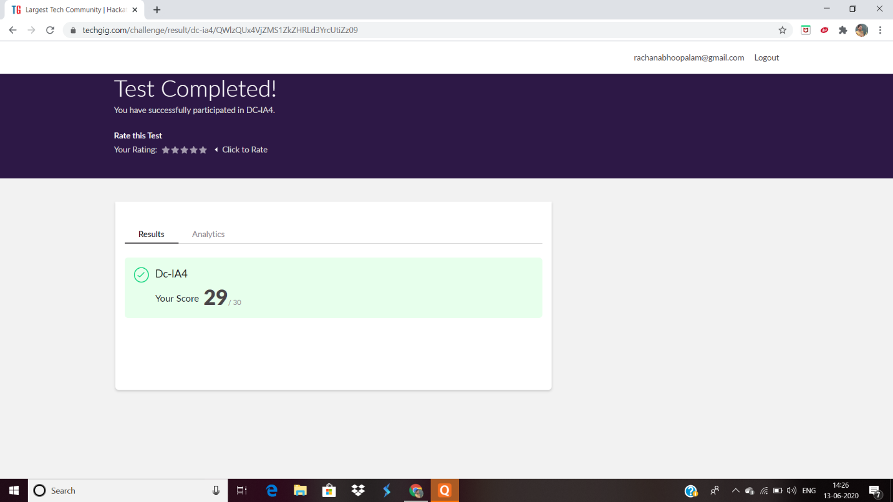

Certification Course Details:

In today’s session, I learnt about Cloud Run - Service.

SNAPSHOT:

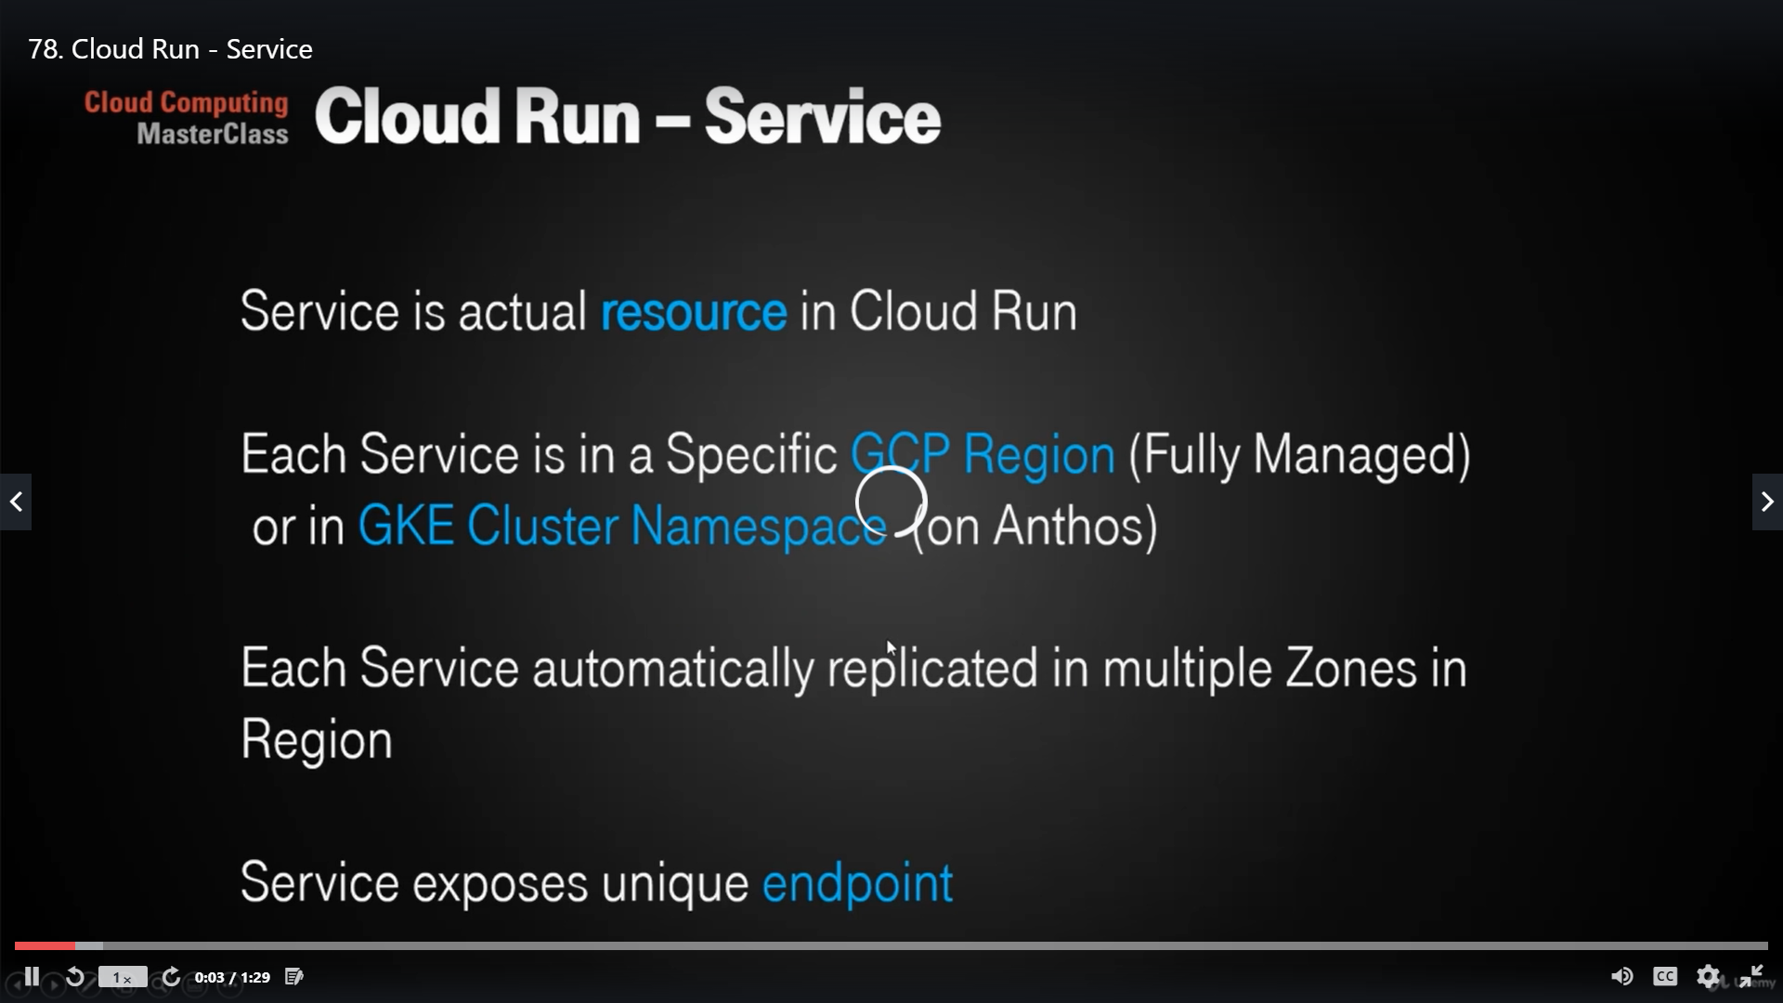

Coding Challenges Details:

Every day we are given with new question of coding related to the language of java and c. it seems interesting how we imbibe ourselves in depth to understand the logic, break it and then code for it.

Today’s question was:

1. [Write a C Program to calculate Electricity Bill](https://github.com/orgs/alvas-education-foundation/teams/2nd-year/discussions/116)

Top of Form

Bottom of Form

|  |
| --- |
| Given an integer U denoting the amount of KWh units of electricity consumed, the task is to calculate the electricity bill with the help of the below charges: • 1 to 100 units – Rs 10/- Per Unit • 100 to 200 units – Rs. 15/- Per Unit • 200 to 300 units – Rs. 20/- Per Unit • above 300 units – Rs. 25/- Per Unit  **Examples:**  Input: U = 250  Output: 3500  **Explanation:**  Charge for the first 100 units – 10100 = 1000Charge for the 100 to 200 units – 15100 = 1500 Charge for the 200 to 250 units – 20*50 = 1000 Total Electricity Bill = 1000 + 1500 + 1000 = 3500 |

Top of Form

Bottom of Form

|  |
| --- |
|  |

SNAPSHOT:

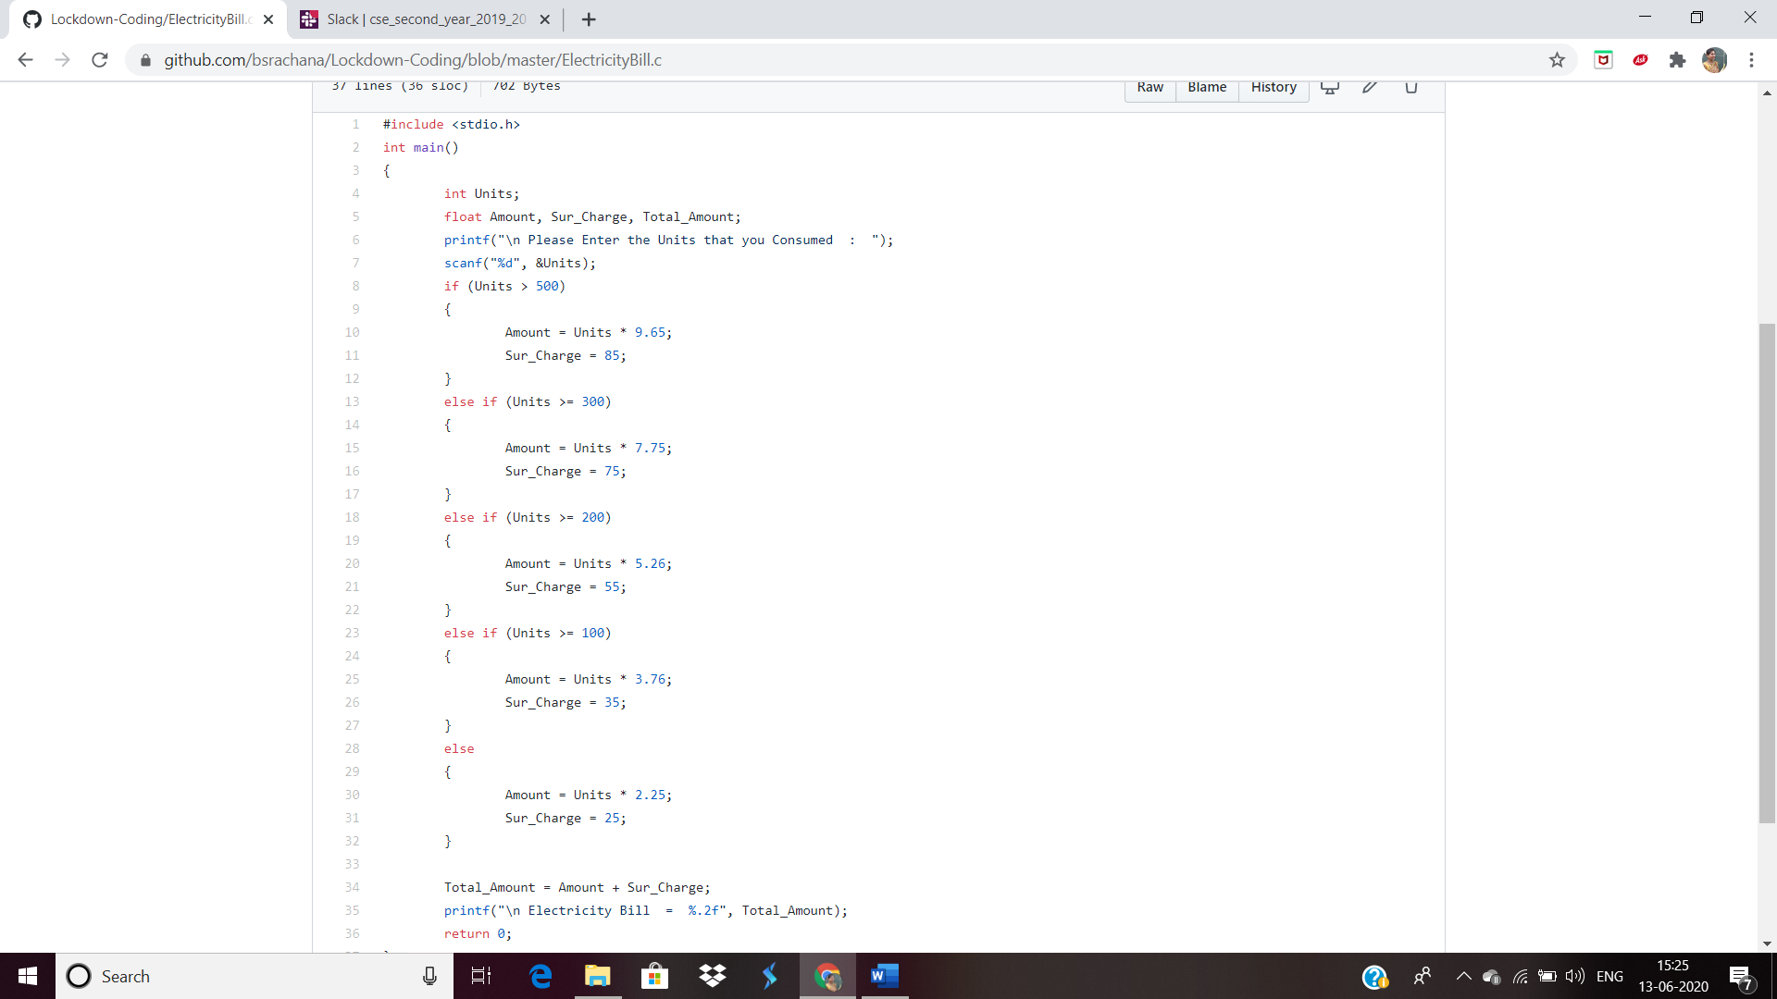

2. Write a Java Program to find the Non Repeating Sequence.

SNAPSHOT:  
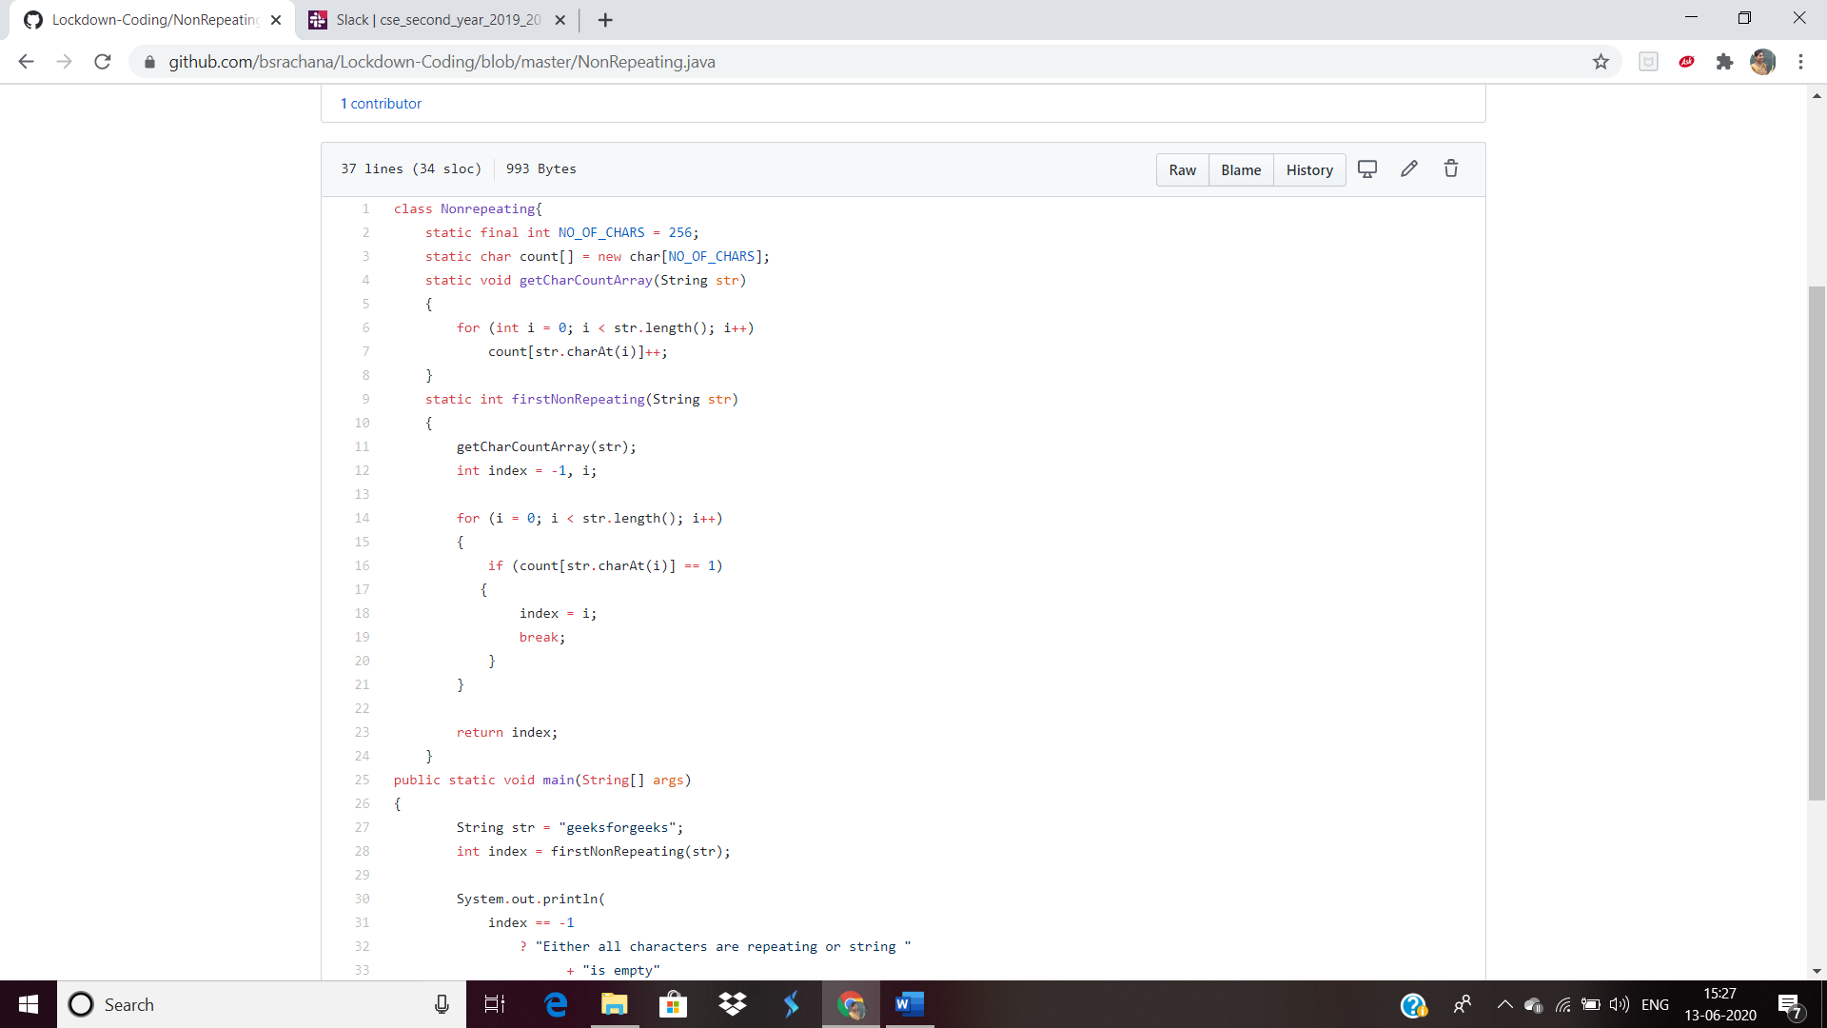

Top of Form

Bottom of Form