**DAILY ONLINE ACTIVITIES SUMMARY**

|  |  |  |  |  |  |  |  |  |
| --- | --- | --- | --- | --- | --- | --- | --- | --- |
| **Date:** | **14/07/2020** | | | | | **Name:** | **RACHANA B S** | |
| **Sem & Sec** | **4th Sem B Sec** | | | | | **USN:** | **4AL18CS065** | |
| **Online Test Summary** | | | | | | | | |
| **Subject** | | **Not conducted** | | | | | | |
| **Max. Marks** | | **-** | | **Score** | | | **-** | |
| **Certification Course Summary** | | | | | | | | |
| **Course** | **Introduction to Digital Marketing** | | | | | | | |
| **Certificate Provider** | | | **Great Learning** | | **Duration** | | | **2.5 hours** |
| **Coding Challenges** | | | | | | | | |
| **Problem Statement: 1**. [Write a java program to check for balanced parenthesis](https://github.com/orgs/alvas-education-foundation/teams/2nd-year/discussions/150) | | | | | | | | |
| **Status: executed** | | | | | | | | |
| **Uploaded the report in GitHub** | | | | | **yes** | | | |
| **If yes Repository name** | | | | | <https://github.com/bsrachana/lockdown_coding> | | | |
| **Uploaded the report in slack** | | | | | **yes** | | | |

Online Test Details: test was not conducted today.

Certification Course Details:

In today’s session, I learnt about Types of Ads.

SNAPSHOT:

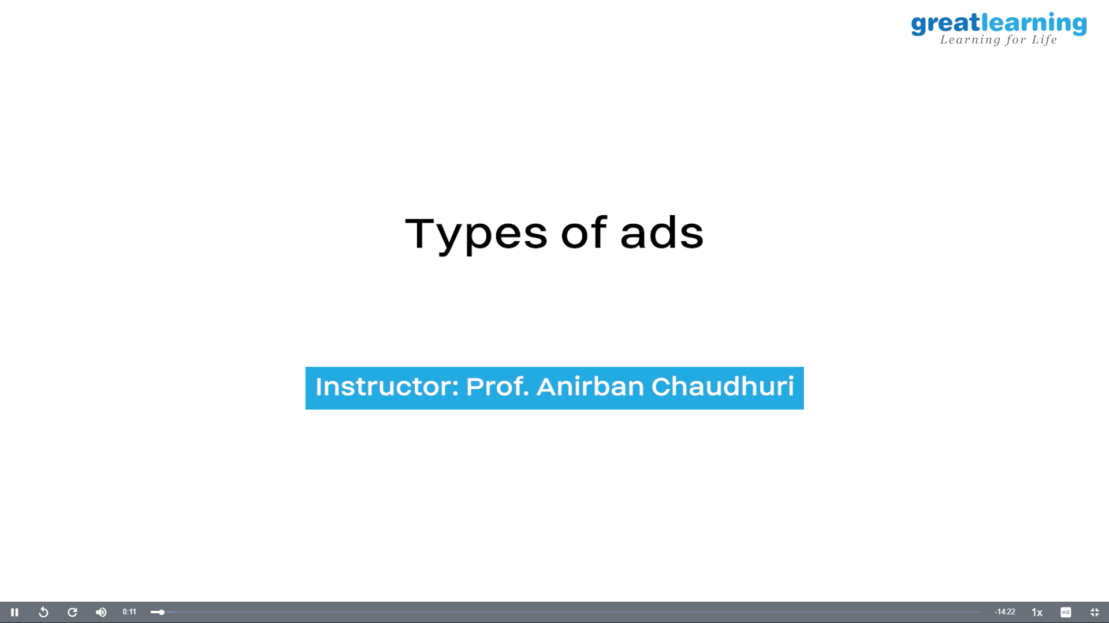

Coding Challenges Details:

Every day we are given with new question of coding related to the language of java and c. it seems interesting how we imbibe ourselves in depth to understand the logic, break it and then code for it.

Today’s question was:

1. [Write a java program to check for balanced parenthesis](https://github.com/orgs/alvas-education-foundation/teams/2nd-year/discussions/150)

Top of Form

Bottom of Form

|  |
| --- |
| Given an expression string exp. Examine whether the pairs and the orders of “{“,”}”,”(“,”)”,”[“,”]” are correct in exp. For example, the program should print 'balanced' for exp = “[()]{}{[()()](https://github.com/orgs/alvas-education-foundation/teams/2nd-year)}” and 'not balanced' for exp = “[(])”  Input: Input consists of a string of expression, in a separate line.  Output: Print 'balanced' without quotes if the pair of parenthesis is balanced else print 'not balanced' in a separate line.  Example: Input: {([])} () ([]  Output: balanced balanced not balanced |

vv

Top of Form

Bottom of Form

|  |
| --- |
|  |

SNAPSHOT:

