**DAILY ONLINE ACTIVITIES SUMMARY**

|  |  |  |  |  |  |  |  |  |
| --- | --- | --- | --- | --- | --- | --- | --- | --- |
| **Date:** | **14/06/2020** | | | | | **Name:** | **RACHANA B S** | |
| **Sem & Sec** | **4th Sem B Sec** | | | | | **USN:** | **4AL18CS065** | |
| **Online Test Summary** | | | | | | | | |
| **Subject** | | **Not conducted** | | | | | | |
| **Max. Marks** | | **-** | | **Score** | | | **-** | |
| **Certification Course Summary** | | | | | | | | |
| **Course** | **Introduction to Google Cloud** | | | | | | | |
| **Certificate Provider** | | | **Udemy** | | **Duration** | | | **2 weeks** |
| **Coding Challenges** | | | | | | | | |
| **Problem Statement:1.** [Write a C program to remove specific characters in the String](https://github.com/orgs/alvas-education-foundation/teams/2nd-year/discussions/117) | | | | | | | | |
| **Status: executed** | | | | | | | | |
| **Uploaded the report in GitHub** | | | | | **yes** | | | |
| **If yes Repository name** | | | | | <https://github.com/bsrachana/lockdown_coding> | | | |
| **Uploaded the report in slack** | | | | | **yes** | | | |

Online Test Details: test was not conducted today.

Certification Course Details:

In today’s session, I learnt about Stack driver Applications and Cloud monitoring, Logging, Trace, Debug, Error reporting.

SNAPSHOT:

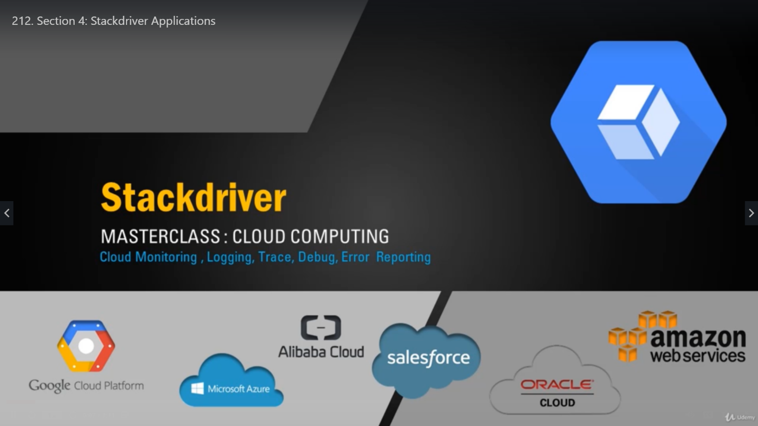

Coding Challenges Details:

Every day we are given with new question of coding related to the language of java and c. it seems interesting how we imbibe ourselves in depth to understand the logic, break it and then code for it.

Today’s question was:

1. [Write a C program to remove specific characters in the String](https://github.com/orgs/alvas-education-foundation/teams/2nd-year/discussions/117)

Top of Form

Bottom of Form

|  |
| --- |
| Example If the original string is "Welcome to AIET" and the user inputs string to remove "co" then the it should print "Welme to AIET" as output .  **Input** First line read a string Second line read key character to be removed.  **Output** String which doesn't contain key character |

Snapshot:

