**DAILY ONLINE ACTIVITIES SUMMARY**

|  |  |  |  |  |  |  |  |  |
| --- | --- | --- | --- | --- | --- | --- | --- | --- |
| **Date:** | **15/06/2020** | | | | | **Name:** | **RACHANA B S** | |
| **Sem & Sec** | **4th Sem B Sec** | | | | | **USN:** | **4AL18CS065** | |
| **Online Test Summary** | | | | | | | | |
| **Subject** | | **Not conducted** | | | | | | |
| **Max. Marks** | | **-** | | **Score** | | | **-** | |
| **Certification Course Summary** | | | | | | | | |
| **Course** | **Introduction to Google Cloud** | | | | | | | |
| **Certificate Provider** | | | **Udemy** | | **Duration** | | | **2 weeks** |
| **Coding Challenges** | | | | | | | | |
| **Problem Statement:1.** [Write a Java Program to find if string is K-Palindrome or not](https://github.com/orgs/alvas-education-foundation/teams/2nd-year/discussions/121)  **2.** [Write a C Program to perform the following operations on Triply Linked List (TLL)](https://github.com/orgs/alvas-education-foundation/teams/2nd-year/discussions/120)  **3.** [Write a C Program to implement the Binary Reversal.](https://github.com/orgs/alvas-education-foundation/teams/2nd-year/discussions/118) | | | | | | | | |
| **Status: executed** | | | | | | | | |
| **Uploaded the report in GitHub** | | | | | **yes** | | | |
| **If yes Repository name** | | | | | <https://github.com/bsrachana/lockdown_coding> | | | |
| **Uploaded the report in slack** | | | | | **yes** | | | |

Online Test Details: test was not conducted today.

Certification Course Details:

In today’s session, I learnt about Managing billing configuration.

SNAPSHOT:

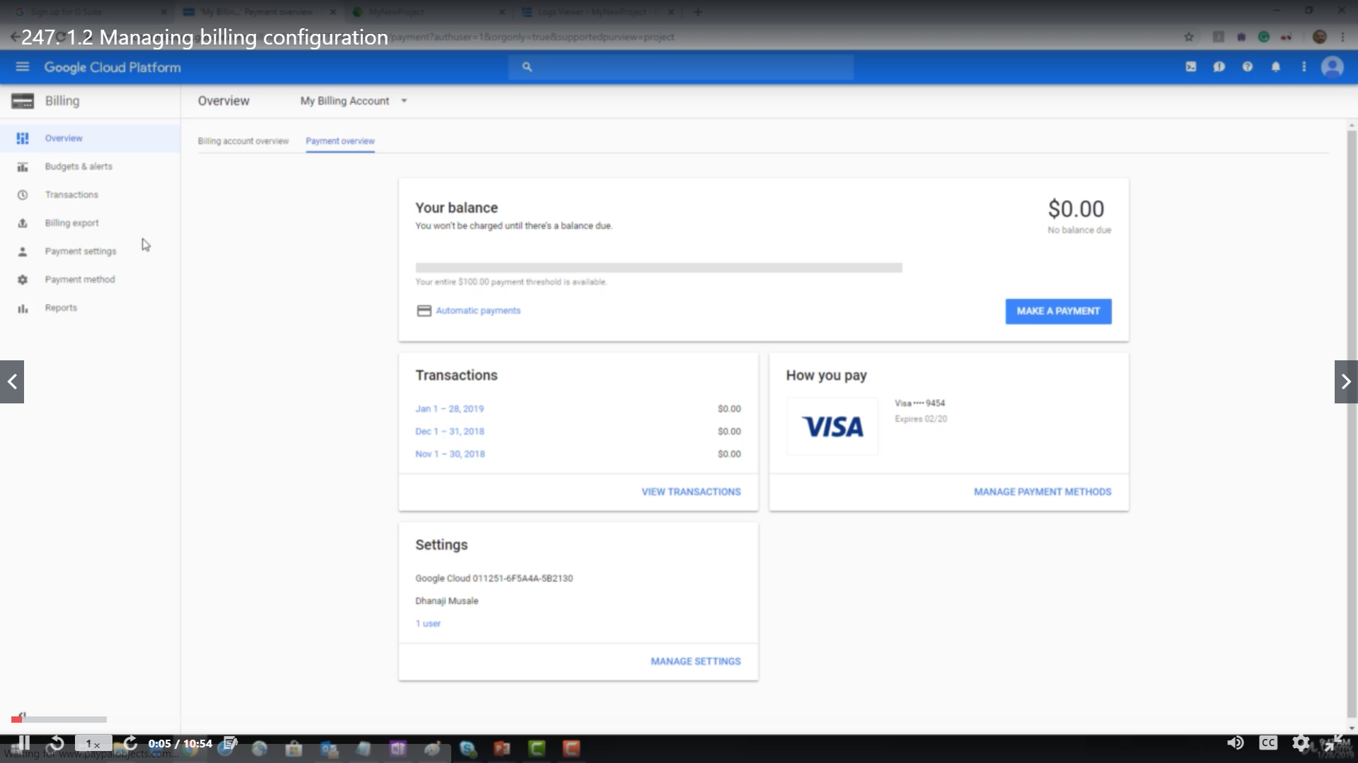

Coding Challenges Details:

Every day we are given with new question of coding related to the language of java and c. it seems interesting how we imbibe ourselves in depth to understand the logic, break it and then code for it.

Today’s question was:

1. [Write a Java Program to find if string is K-Palindrome or not](https://github.com/orgs/alvas-education-foundation/teams/2nd-year/discussions/121)

Top of Form

Bottom of Form

|  |
| --- |
| A string is k palindrome if it can be transformed into a palindrome on removing at most k characters from it. Your task is to complete the function is_k_palin which takes two arguments a string str and a number N . Your function should return true if the string is k palindrome else it should return false.  Input: The first line of input is an integer T denoting the number of test cases . Then T test cases follow . Each test case contains a string str and an integer N separated by space.  Output: The output will be 1 if the string is k palindrome else 0 .  **Example** Input : String - abcdecba, k = 1 Output : Yes String can become palindrome by remo- -ving 1 character i.e. either d or e)  Input : String - abcdeca, K = 2 Output : Yes Can become palindrome by removing 2 characters b and e.  Input : String - acdcb, K = 1 Output : No String can not become palindrome by removing only one character. |

Snapshot:

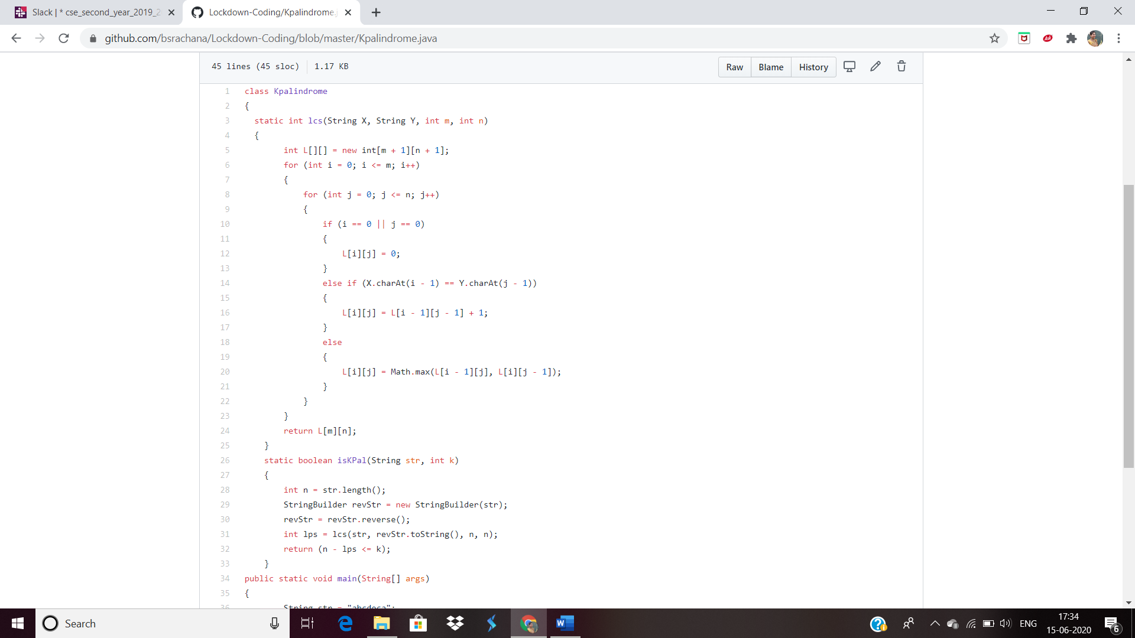

2. [Write a C Program to perform the following operations on Triply Linked List (TLL)](https://github.com/orgs/alvas-education-foundation/teams/2nd-year/discussions/120)

Top of Form

Bottom of Form

|  |  |
| --- | --- |
| Write a C Program to perform the following operations on Triply Linked List (TLL) (Note that line is begins from the number 1) (i) Insertion at Front of the TLL (ii) Insertion at End of the TLL (iii) Insertion at front of the specified line (iv) Insertion at the end of the specified line (v) Insertion at the specified position in the specified line (vi) Deletion from the Front of the TLL (vii) Deletion from the End of the TLL (viii) Deletion from the front of the specified line (ix) Deletion from the end of the specified line (x) Deletion from the specified position in the specified line. After each operation, you should display the TLL. For display and Delete operation, you should take care of underflow. No need to check for overflow during insertion, because it is dynamic.  SNAPSHOT:    3. [Write a C Program to implement the Binary Reversal.](https://github.com/orgs/alvas-education-foundation/teams/2nd-year/discussions/118)   |  | | --- | | Have the function BinaryReversal(str) take the str parameter being passed, which will be a positive integer, take its binary representation, reverse that string of bits, and then finally return the new reversed string in decimal form. For example: if str is 47 then the binary version of this integer is 101111 but we pad it to be 00101111 (Total number of bits must be multiples of 4). Your program should reverse this binary string which then becomes: 11110100 and then finally return the decimal version of this string, which is 244. Examples  Input: 213 Output: 171  Input: 4567 Output: 60296  SNAPSHOT: | |