**DAILY ONLINE ACTIVITIES SUMMARY**

|  |  |  |  |  |  |  |  |  |
| --- | --- | --- | --- | --- | --- | --- | --- | --- |
| **Date:** | **16/07/2020** | | | | | **Name:** | **RACHANA B S** | |
| **Sem & Sec** | **4th Sem B Sec** | | | | | **USN:** | **4AL18CS065** | |
| **Online Test Summary** | | | | | | | | |
| **Subject** | | **-------** | | | | | | |
| **Max. Marks** | | **-** | | **Score** | | | **-** | |
| **Certification Course Summary** | | | | | | | | |
| **Course** | **Introduction to Digital Marketing** | | | | | | | |
| **Certificate Provider** | | | **Great Learning** | | **Duration** | | | **2.5 hours** |
| **Coding Challenges** | | | | | | | | |
| **Problem Statement: -------** | | | | | | | | |
| **Status: -------** | | | | | | | | |
| **Uploaded the report in GitHub** | | | | | **------** | | | |
| **If yes Repository name** | | | | | <https://github.com/bsrachana/lockdown_coding> | | | |
| **Uploaded the report in slack** | | | | | **yes** | | | |

Online Test Details: Object Oriented Concepts.

Certification Course Details:

In today’s session, I learnt about Custom Audience.

SNAPSHOT:

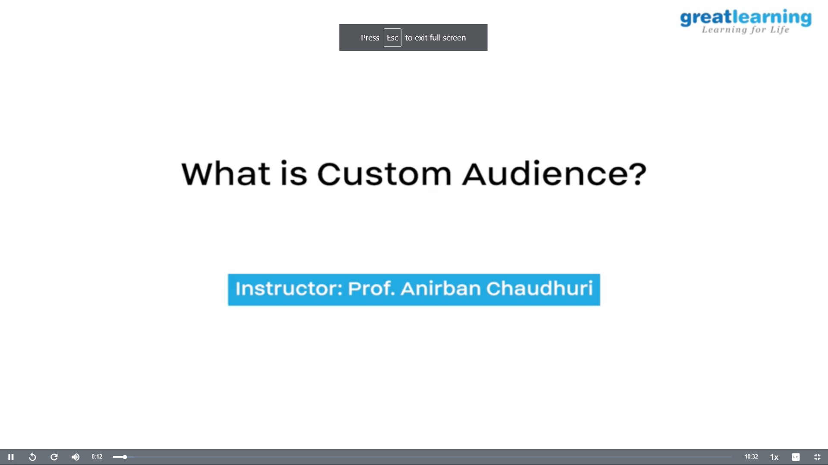

Coding Challenges Details:

No Coding Challenge Conducted today.