**DAILY ONLINE ACTIVITIES SUMMARY**

|  |  |  |  |  |  |  |  |  |
| --- | --- | --- | --- | --- | --- | --- | --- | --- |
| **Date:** | **16/06/2020** | | | | | **Name:** | **RACHANA B S** | |
| **Sem & Sec** | **4th Sem B Sec** | | | | | **USN:** | **4AL18CS065** | |
| **Online Test Summary** | | | | | | | | |
| **Subject** | | **Complex Analysis, Probability and Statistical Methods** | | | | | | |
| **Max. Marks** | | **30** | | **Score** | | | **22** | |
| **Certification Course Summary** | | | | | | | | |
| **Course** | **Introduction to Google Cloud** | | | | | | | |
| **Certificate Provider** | | | **Udemy** | | **Duration** | | | **2 weeks** |
| **Coding Challenges** | | | | | | | | |
| **Problem Statement: -** | | | | | | | | |
| **Status: -** | | | | | | | | |
| **Uploaded the report in GitHub** | | | | | **yes** | | | |
| **If yes Repository name** | | | | | <https://github.com/bsrachana/lockdown_coding> | | | |
| **Uploaded the report in slack** | | | | | **yes** | | | |

Online Test Details:

Today I attended internals of Complex Analysis, Probability and Statistical methods where the test was for 30 marks. 15 questions of 2 mark of the time limit was 40 mins. I scored 22/30

SNAPSHOT:

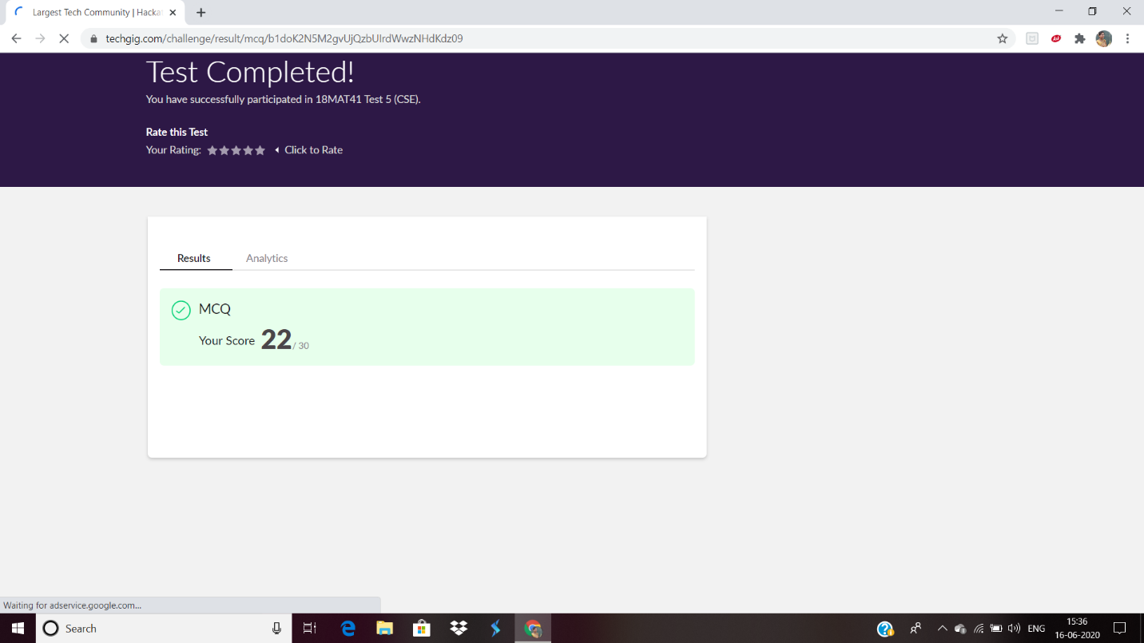

Certification Course Details:

In today’s session, I learnt about Designing performant apps- Platform Specific design.

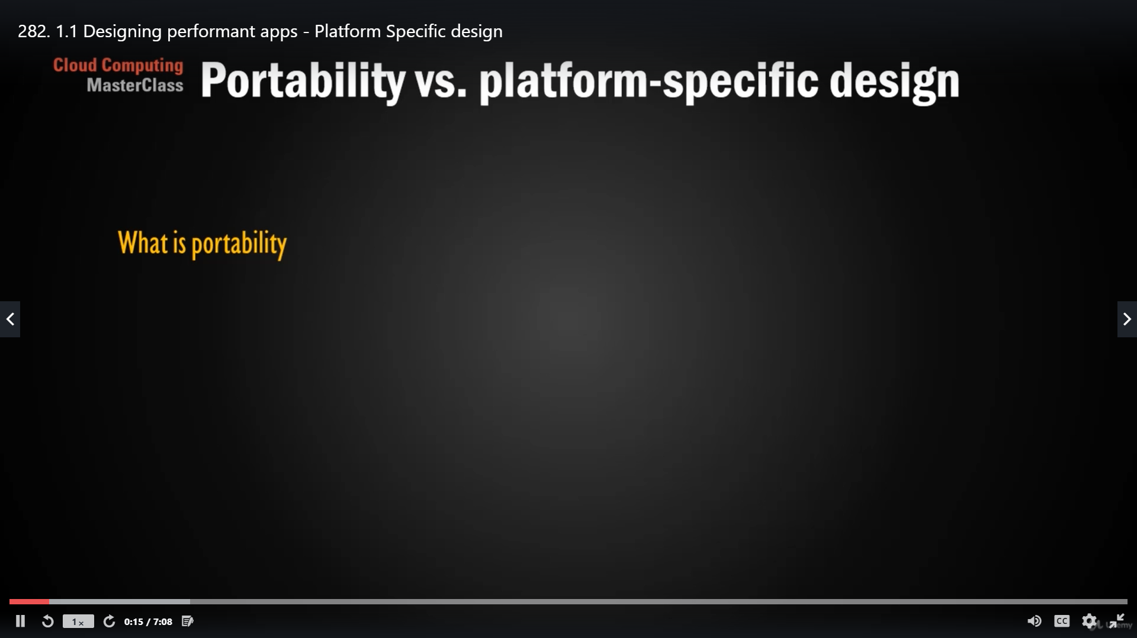

CODING CHALLENGE:

Not conducted.