**DAILY ONLINE ACTIVITIES SUMMARY**

|  |  |  |  |  |  |  |  |  |
| --- | --- | --- | --- | --- | --- | --- | --- | --- |
| **Date:** | **17/06/2020** | | | | | **Name:** | **RACHANA B S** | |
| **Sem & Sec** | **4th Sem B Sec** | | | | | **USN:** | **4AL18CS065** | |
| **Online Test Summary** | | | | | | | | |
| **Subject** | | **Not conducted** | | | | | | |
| **Max. Marks** | | **-** | | **Score** | | | **-** | |
| **Certification Course Summary** | | | | | | | | |
| **Course** | **Cloud Foundations** | | | | | | | |
| **Certificate Provider** | | | **Great Learning** | | **Duration** | | | **5 hours** |
| **Coding Challenges** | | | | | | | | |
| **Problem Statement:1.** Write a Python program to check whether a given a binary tree is valid binary search tree or not? (#71)  **2.** [Write a C Program to Count numbers that don’t contain 3](https://github.com/orgs/alvas-education-foundation/teams/2nd-year/discussions/123) | | | | | | | | |
| **Status: executed** | | | | | | | | |
| **Uploaded the report in GitHub** | | | | | **yes** | | | |
| **If yes Repository name** | | | | | <https://github.com/bsrachana/lockdown_coding> | | | |
| **Uploaded the report in slack** | | | | | **yes** | | | |

Online Test Details: test was not conducted today.

Certification Course Details:

In today’s session, I learnt about Introduction to Cloud Foundations.

SNAPSHOT:



Coding Challenges Details:

Every day we are given with new question of coding related to the language of java and c. it seems interesting how we imbibe ourselves in depth to understand the logic, break it and then code for it.

Today’s question was:

1. Write a Python program to check whether a given a binary tree is valid binary search tree or not? (#71)

Snapshot:

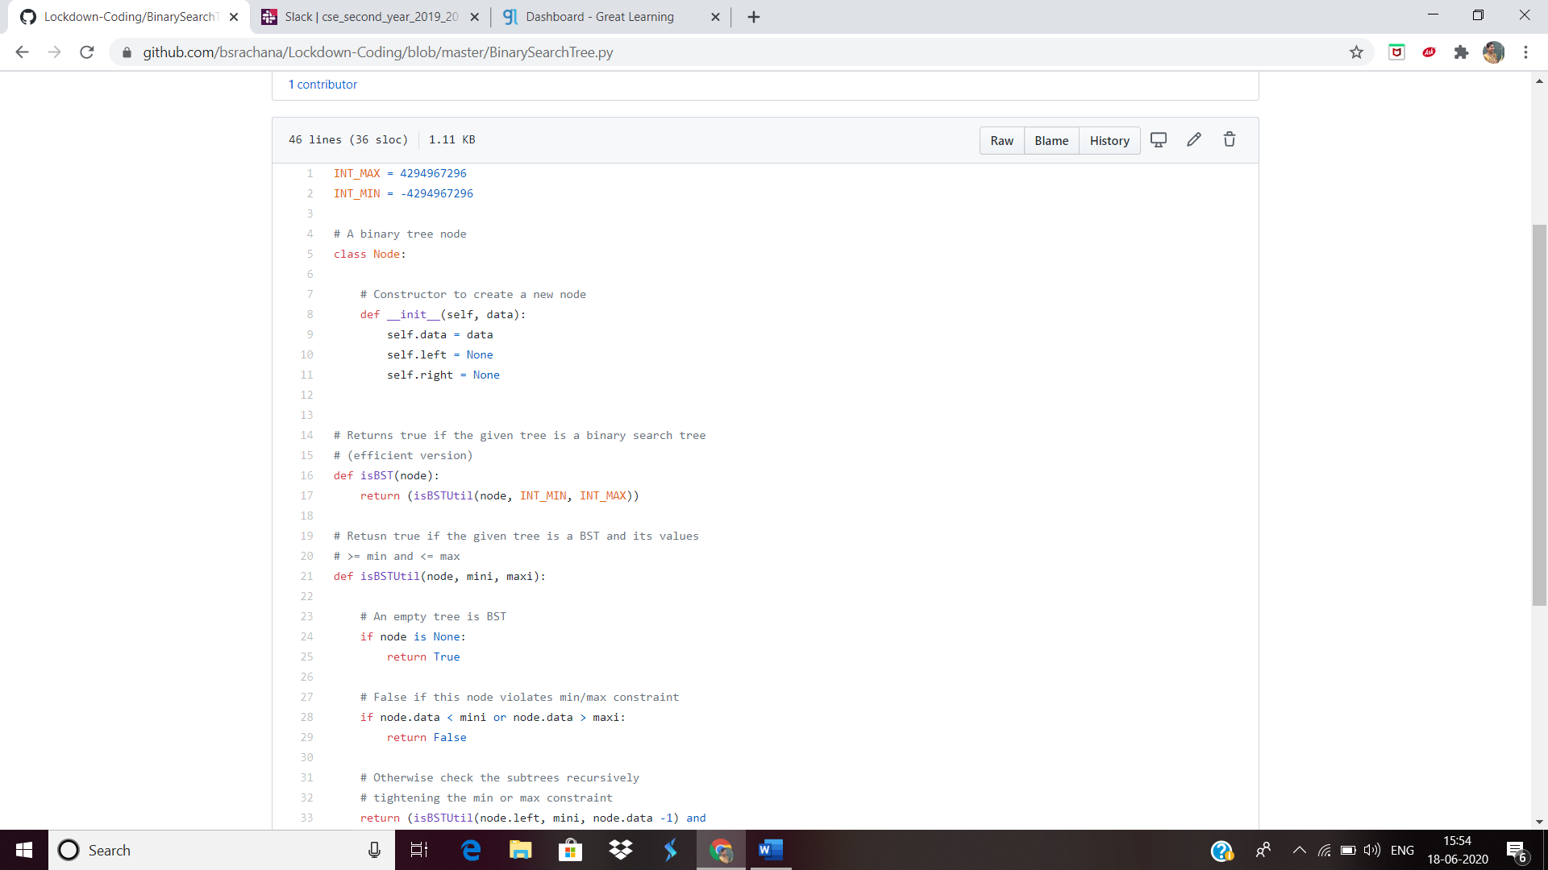

2. [Write a C Program to Count numbers that don’t contain 3](https://github.com/orgs/alvas-education-foundation/teams/2nd-year/discussions/123)

Top of Form

Bottom of Form

|  |
| --- |
| Given a number n, write a function that returns count of numbers from 1 to n that don’t contain digit 3 in their decimal representation. **Examples:** **Input:** n = 10 **Output:** 9 Here input is 10 means the numbers within 10 are 1,2,3,4,5,6,7,8,9,10 in this series 3 occurs only 1 times so answer is 9  **More examples** Input: n = 45 Output: 31 // Numbers 3, 13, 23, 30, 31, 32, 33, 34, // 35, 36, 37, 38, 39, 43 contain digit 3.  Input: n = 578 Output: 385 |

SNAPSHOT:

