**DAILY ONLINE ACTIVITIES SUMMARY**

|  |  |  |  |  |  |  |  |  |
| --- | --- | --- | --- | --- | --- | --- | --- | --- |
| **Date:** | **18/06/2020** | | | | | **Name:** | **RACHANA B S** | |
| **Sem & Sec** | **4th Sem B Sec** | | | | | **USN:** | **4AL18CS065** | |
| **Online Test Summary** | | | | | | | | |
| **Subject** | | **Not conducted** | | | | | | |
| **Max. Marks** | | **-** | | **Score** | | | **-** | |
| **Certification Course Summary** | | | | | | | | |
| **Course** | **Cloud Foundations** | | | | | | | |
| **Certificate Provider** | | | **Great Learning** | | **Duration** | | | **5 hours** |
| **Coding Challenges** | | | | | | | | |
| **Problem Statement:1.** [Write a C Program to generate first N Magic Numbers.](https://github.com/orgs/alvas-education-foundation/teams/2nd-year/discussions/125)  **2.** [Find the smallest positive integer value that cannot be represented as sum of any subset of a given array sorted in ascending order.](https://github.com/orgs/alvas-education-foundation/teams/2nd-year/discussions/124) | | | | | | | | |
| **Status: executed** | | | | | | | | |
| **Uploaded the report in GitHub** | | | | | **yes** | | | |
| **If yes Repository name** | | | | | <https://github.com/bsrachana/lockdown_coding> | | | |
| **Uploaded the report in slack** | | | | | **yes** | | | |

Online Test Details: test was not conducted today.

Certification Course Details:

In today’s session, I learnt about The Classical Enterprise, Why Cloud Computing? And A short history and evolution of Cloud.

SNAPSHOT:

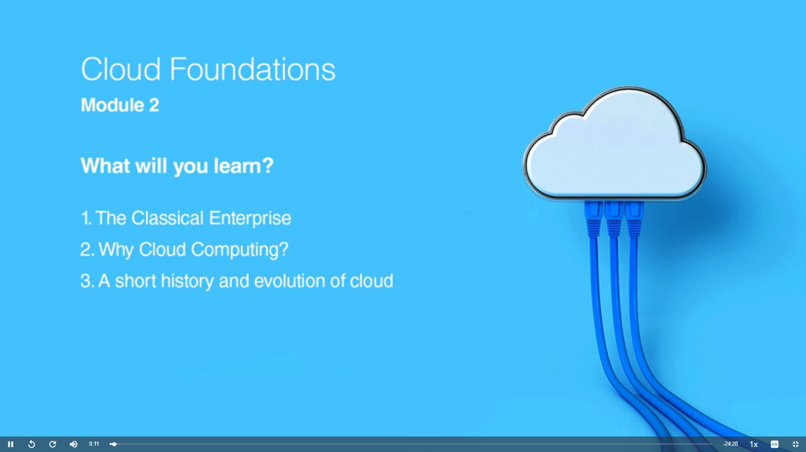

Coding Challenges Details:

Every day we are given with new question of coding related to the language of java and c. it seems interesting how we imbibe ourselves in depth to understand the logic, break it and then code for it.

Today’s question was:

1. [Write a C Program to generate first N Magic Numbers.](https://github.com/orgs/alvas-education-foundation/teams/2nd-year/discussions/125)

Top of Form

Bottom of Form

|  |
| --- |
| A magic number is defined as a number which can be expressed as a power of 5 or sum of unique powers of 5. First few magic numbers are 5, 25, 30(5 + 25), 125, 130(125 + 5), …. Input: n = 1 Output: 5  Input: n = 2 Output: 5 25  Input: n = 3 Output: 5 25 30  Input: n = 8 Output: 5 25 30 125 130 150 155 625  Hint: The magic numbers can be represented as 001, 010, 011, 100, 101, 110 etc, where 001 is 0pow(5,3) + 0pow(5,2) + 1*pow(5,1). So basically, we need to add powers of 5 for each bit set in given integer n. If n = 1; binary representation of 1 = 0001 Magic Number is: 0 * pow(5,4) + 0 * pow(5, 3) + 0 * pow(5, 2) + 1 * pow(5, 1) = 5  If n = 6; Binary representation of 6 is 0110 6th Magic Number is: 0 * pow(5, 4) + 1 * pow(5, 3) + 1 * pow(5, 2) + 0 * pow(5, 1) = 0 + 125 + 25 + 0 = 150  Logic:  Read n for(i = 0 to n) { Display ith magic number |

}

Snapshot:

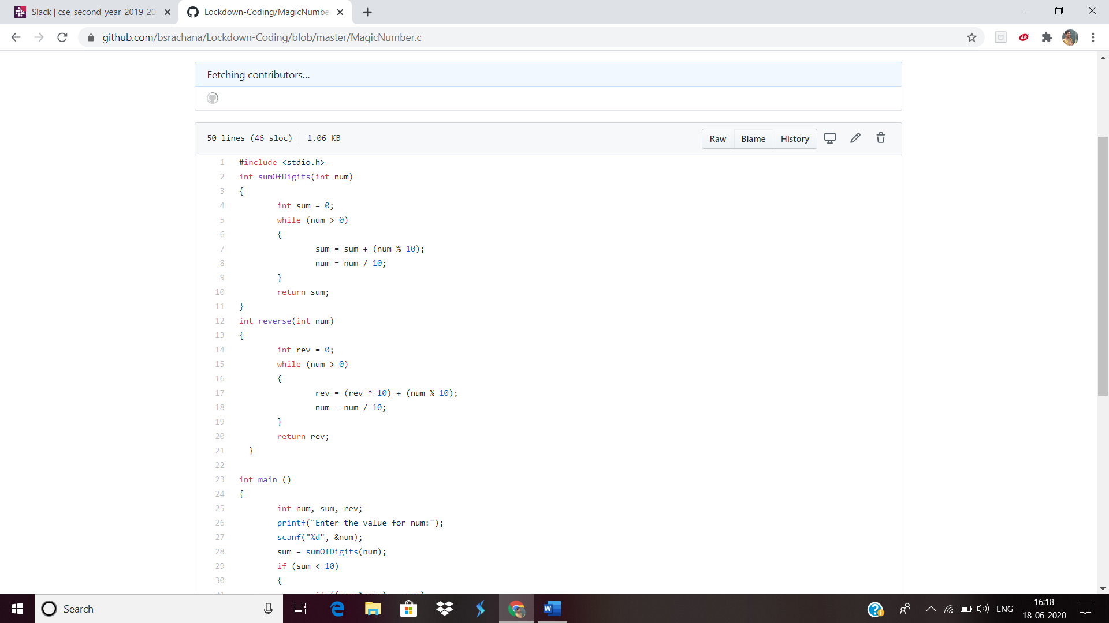

2. [Find the smallest positive integer value that cannot be represented as sum of any subset of a given array sorted in ascending order.](https://github.com/orgs/alvas-education-foundation/teams/2nd-year/discussions/124)

Top of Form

Bottom of Form

|  |
| --- |
| Given a sorted array (sorted in non-decreasing order) of positive numbers, find the smallest positive integer value that cannot be represented as sum of elements of any subset of given set Examples:  Input: arr[] = {1, 3, 6, 10, 11, 15}; Output: 2 There are no one or more elements to be added up to get sum = 2  Input: arr[] = {1, 1, 1, 1}; Output: 5 1 = 1, 1+1 = 2, 1+ 1 + 1 = 3, 1 + 1 + 1 + 1 = 4, There is no elements in the array to get sum 5  Input: arr[] = {1, 1, 3, 4}; Output: 10 1 = 1, 1 + 1 = 2, 3 = 3, 1 + 3 = 4, 1 + 4 = 5, 1 + 1 +4 = 6, 3 + 4 = 7........ To get sum 10, there is no elements in the array.  Input: arr[] = {1, 2, 5, 10, 20, 40} Output: 4 There are no elements to get sum = 4.  Input: arr[] = {1, 2, 3, 4, 5, 6} Output: 22 |

Top of Form

Bottom of Form

SNAPSHOT:

