**DAILY ONLINE ACTIVITIES SUMMARY**

|  |  |  |  |  |  |  |  |  |
| --- | --- | --- | --- | --- | --- | --- | --- | --- |
| **Date:** | **19/06/2020** | | | | | **Name:** | **RACHANA B S** | |
| **Sem & Sec** | **4th Sem B Sec** | | | | | **USN:** | **4AL18CS065** | |
| **Online Test Summary** | | | | | | | | |
| **Subject** | | **Microcontroller and Embedded Systems** | | | | | | |
| **Max. Marks** | | **20** | | **Score** | | | **18** | |
| **Certification Course Summary** | | | | | | | | |
| **Course** | **Cloud Foundations** | | | | | | | |
| **Certificate Provider** | | | **Great Learning** | | **Duration** | | | **5 hours** |
| **Coding Challenges** | | | | | | | | |
| **Problem Statement:1**. [Write a C Program to Count total set bits in all numbers from 1 to n](https://github.com/orgs/alvas-education-foundation/teams/2nd-year/discussions/129)  Top of Form  Bottom of Form   |  | | --- | | **Examples:**  Input: U = 250  Output: 3500  **Explanation:**  Charge for the first 100 units – 10100 = 1000Charge for the 100 to 200 units – 15100 = 1500 Charge for the 200 to 250 units – 20*50 = 1000 Total Electricity Bill = 1000 + 1500 + 1000 = 3500 | | | | | | | | | |
| **Status: executed** | | | | | | | | |
| **Uploaded the report in GitHub** | | | | | **yes** | | | |
| **If yes Repository name** | | | | | <https://github.com/bsrachana/lockdown_coding> | | | |
| **Uploaded the report in slack** | | | | | **yes** | | | |

Online Test Details:

Today I attended internals of Microcontroller and Embedded Systems where the test was for 20 marks. 20 questions of 1 mark of the time limit was 20 mins. I scored 18/20

SNAPSHOT:

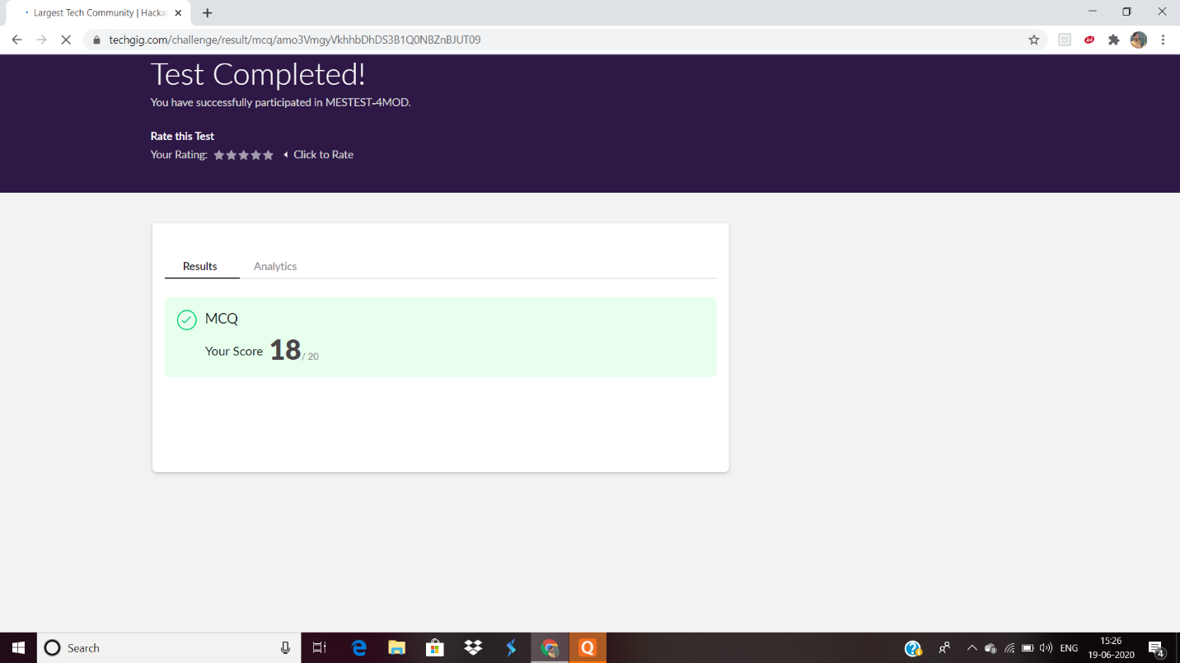

Certification Course Details:

In today’s session, I learnt about Introduction to Virtualization.

SNAPSHOT:



Coding Challenges Details:

Every day we are given with new question of coding related to the language of java and c. it seems interesting how we imbibe ourselves in depth to understand the logic, break it and then code for it.

Today’s question was:

1. [Write a C Program to Count total set bits in all numbers from 1 to n](https://github.com/orgs/alvas-education-foundation/teams/2nd-year/discussions/129)

Top of Form

Bottom of Form

|  |
| --- |
| Given a positive integer n, count the total number of set bits in binary representation of all numbers from 1 to n.  **Examples:** Input: n = 3 Output: 4 Input: n = 6 Output: 9  **Hint:** Read a positive integer (example: 3 indicates range), so u have to consider 1, 2, 3 as the input convert these numbers into binary and count the number of 1 in that (1- 0001, 2- 0010, 3- 0011) number of 1s from all 3 digit is 4 so the answer is 4 |

Top of Form

Bottom of Form

|  |
| --- |
|  |

SNAPSHOT:

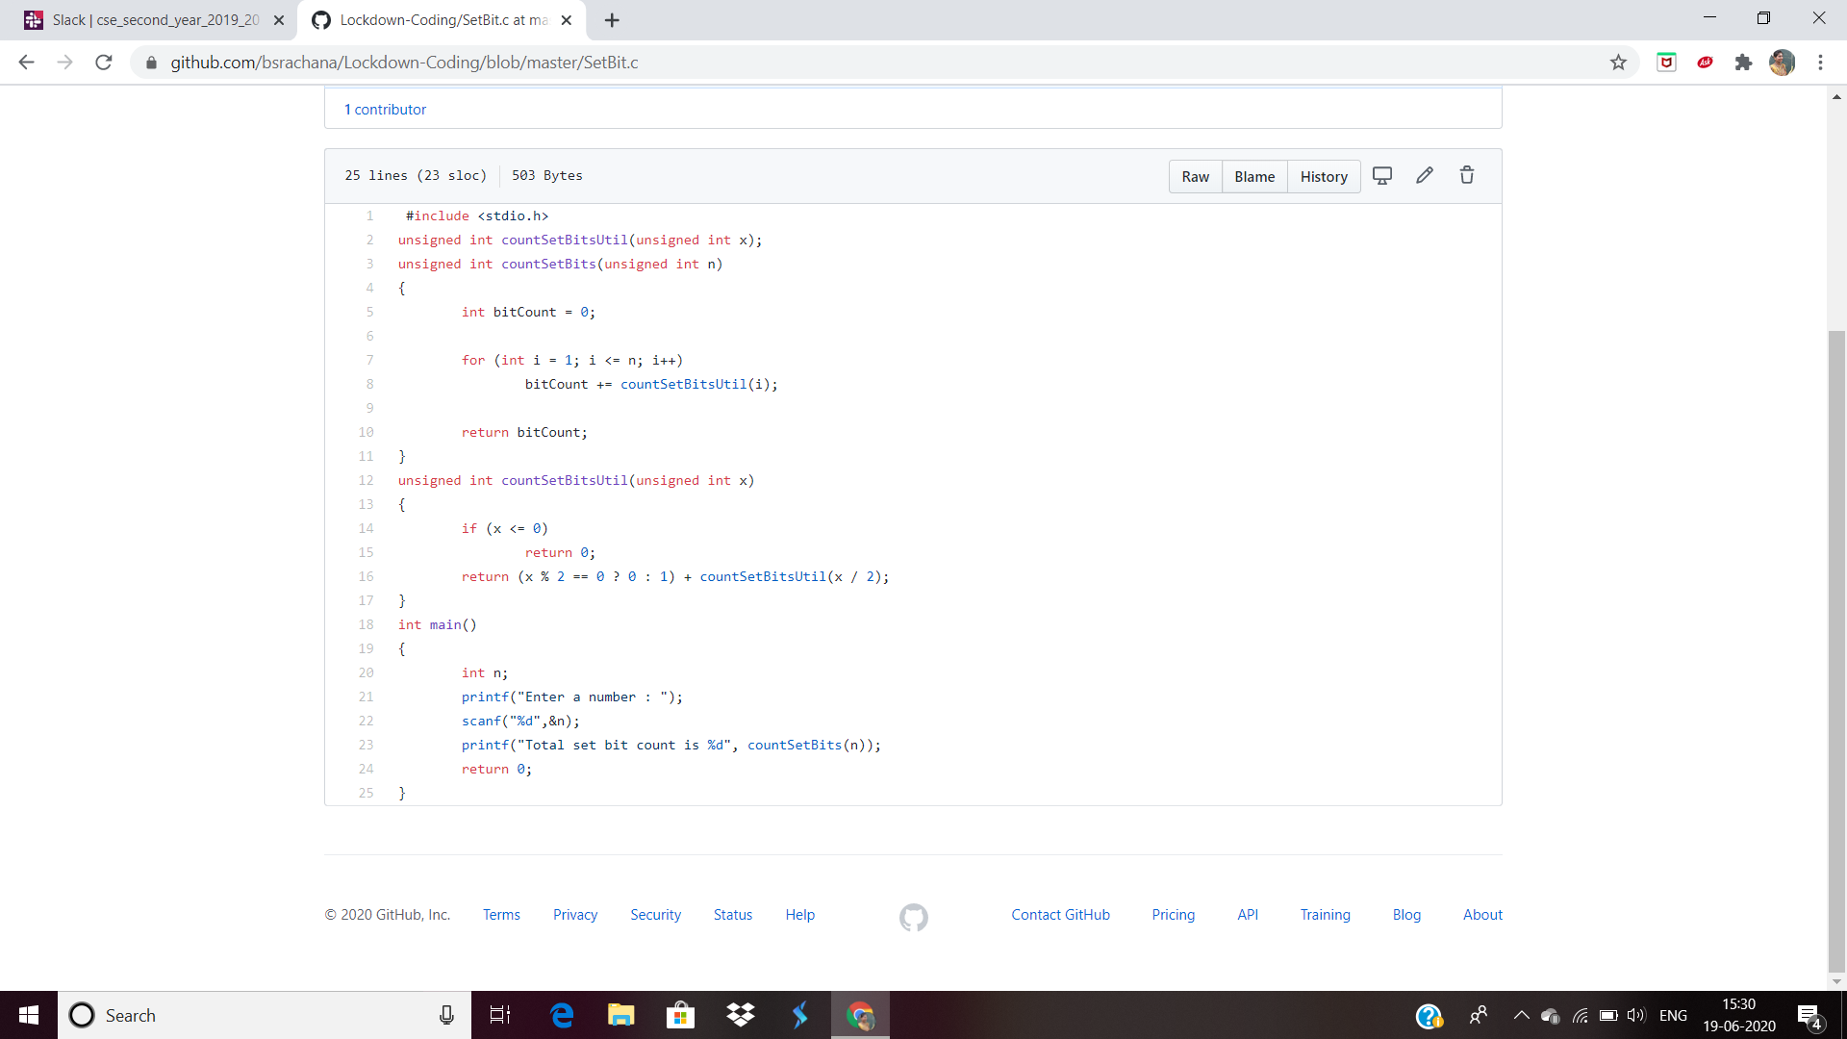

Top of Form

Bottom of Form