**DAILY ONLINE ACTIVITIES SUMMARY**

|  |  |  |  |  |  |  |  |  |
| --- | --- | --- | --- | --- | --- | --- | --- | --- |
| **Date:** | **20/06/2020** | | | | | **Name:** | **RACHANA B S** | |
| **Sem & Sec** | **4th Sem B Sec** | | | | | **USN:** | **4AL18CS065** | |
| **Online Test Summary** | | | | | | | | |
| **Subject** | | **Data Communication** | | | | | | |
| **Max. Marks** | | **30** | | **Score** | | | **25** | |
| **Certification Course Summary** | | | | | | | | |
| **Course** | **Cloud Foundations** | | | | | | | |
| **Certificate Provider** | | | **Great Learning** | | **Duration** | | | **5 hours** |
| **Coding Challenges** | | | | | | | | |
| **Problem Statement:1**. [Write a Java program to count number of bits to be flipped to convert A to B](https://github.com/orgs/alvas-education-foundation/teams/2nd-year/discussions/132)  2. [Program that compares counting words in files using an ArrayList and a Map](https://github.com/orgs/alvas-education-foundation/teams/2nd-year/discussions/131)  Bottom of Form  2.  Top of Form  Bottom of Form   |  | | --- | | **Examples:**  Input: U = 250  Output: 3500  **Explanation:**  Charge for the first 100 units – 10100 = 1000Charge for the 100 to 200 units – 15100 = 1500 Charge for the 200 to 250 units – 20*50 = 1000 Total Electricity Bill = 1000 + 1500 + 1000 = 3500 | | | | | | | | | |
| **Status: executed** | | | | | | | | |
| **Uploaded the report in GitHub** | | | | | **yes** | | | |
| **If yes Repository name** | | | | | <https://github.com/bsrachana/lockdown_coding> | | | |
| **Uploaded the report in slack** | | | | | **yes** | | | |

Online Test Details:

Today I attended internals of Data Communication where the test was for 30 marks. 30 questions of 1 mark of the time limit was 30 mins. I scored 25/30

SNAPSHOT:

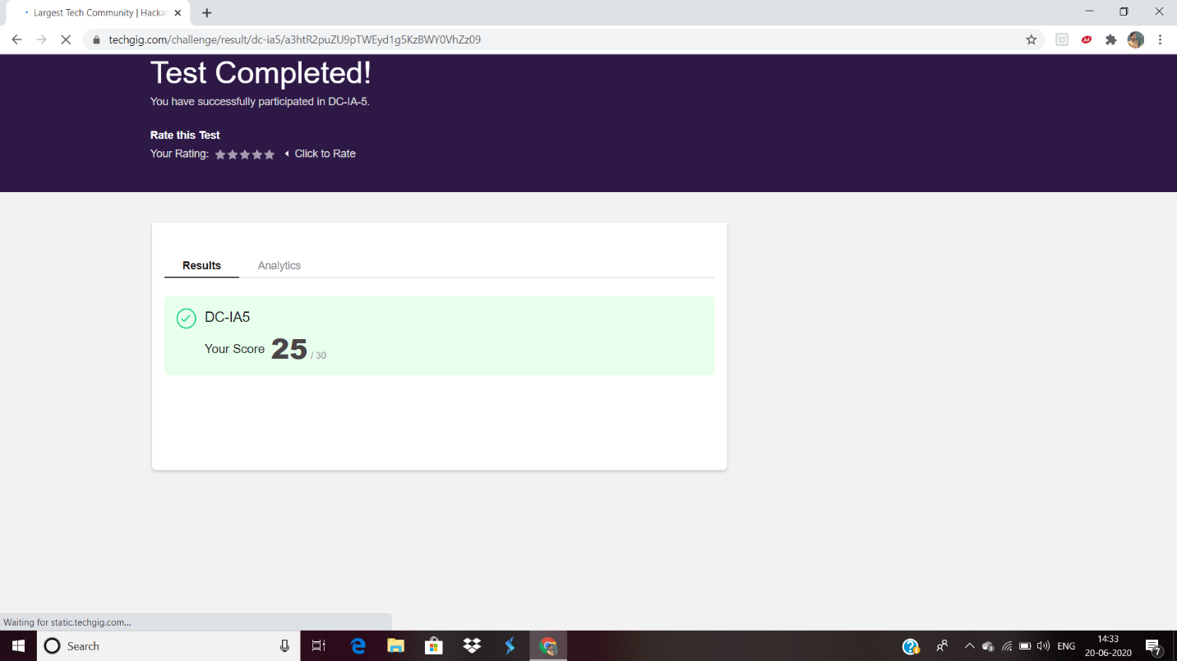

Certification Course Details:

Explanation about Cloud Foundations.

SNAPSHOT:

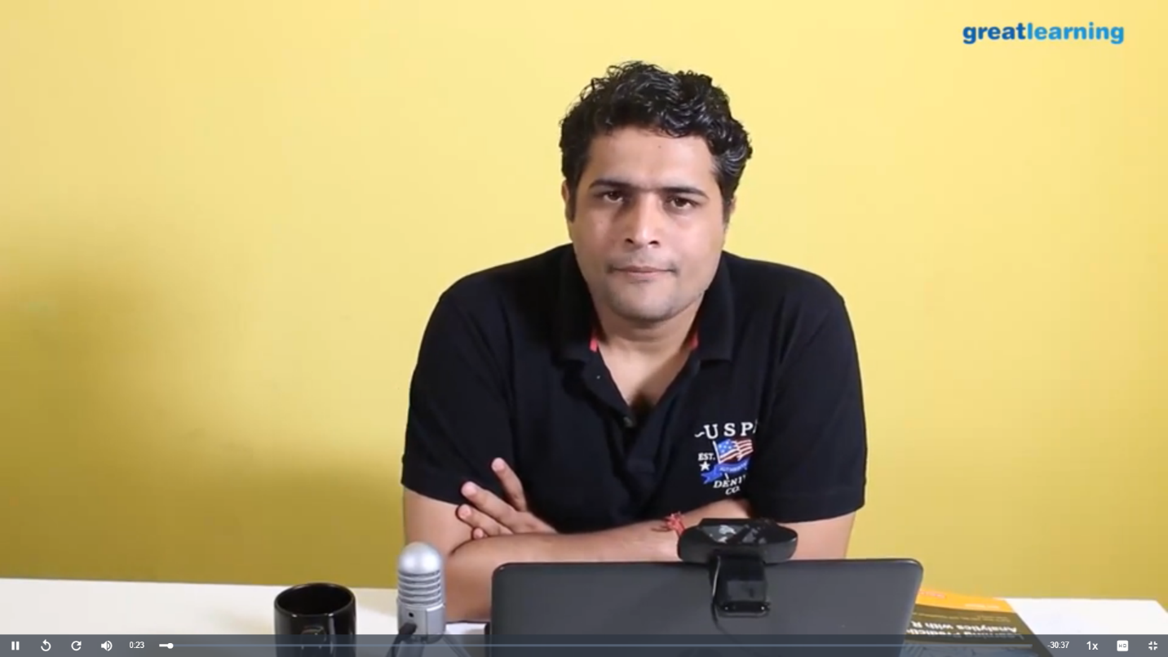

Coding Challenges Details:

Every day we are given with new question of coding related to the language of java and c. it seems interesting how we imbibe ourselves in depth to understand the logic, break it and then code for it.

Today’s question was:

1. [Write a Java program to count number of bits to be flipped to convert A to B](https://github.com/orgs/alvas-education-foundation/teams/2nd-year/discussions/132)

Top of Form

Bottom of Form

|  |
| --- |
| Given two numbers ‘a’ and b’. Write a program to count number of bits needed to be flipped to convert ‘a’ to ‘b’. **Example:**  Input: a = 10, b = 20 Output: 4 Binary representation of a is 000**0101**0 Binary representation of b is 00010100 We need to flip highlighted four bits in a to make it b.  Input: a = 7, b = 10 Output: 3 Binary representation of a is 0000**01**1**1** Binary representation of b is 00001010 We need to flip highlighted three bits in a to make it b.  **Hint**   1. Calculate XOR of A and B. a_xor_b = A ^ B 2. Count the set bits in the above calculated XOR result. countSetBits(a_xor_b) |

Top of Form

Bottom of Form

|  |
| --- |
|  |

SNAPSHOT:

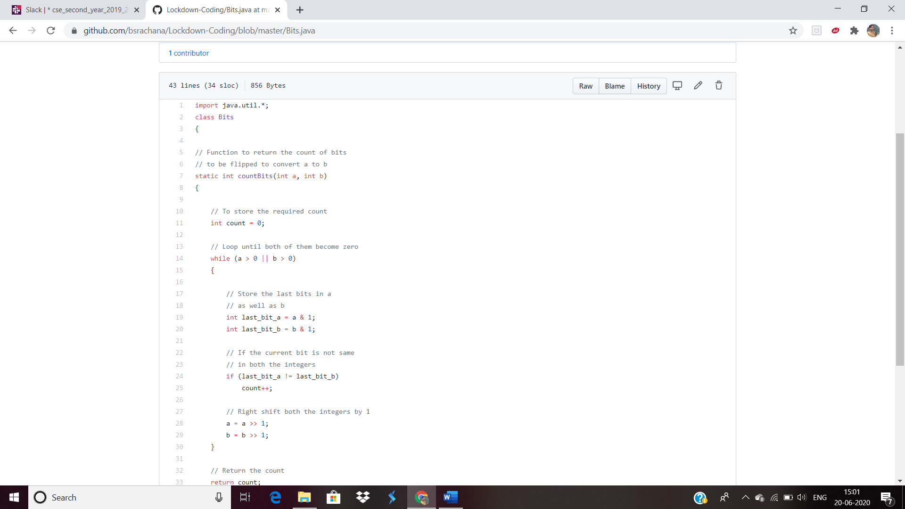

2. [Program that compares counting words in files using an ArrayList and a Map](https://github.com/orgs/alvas-education-foundation/teams/2nd-year/discussions/131)

Top of Form

Bottom of Form

|  |
| --- |
| Use java for coding |

SNAPSHOT:

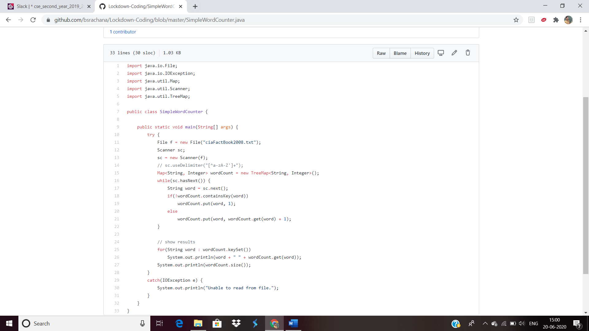

Top of Form

Bottom of Form