**DAILY ONLINE ACTIVITIES SUMMARY**

|  |  |  |  |  |  |  |  |  |
| --- | --- | --- | --- | --- | --- | --- | --- | --- |
| **Date:** | **21/06/2020** | | | | | **Name:** | **RACHANA B S** | |
| **Sem & Sec** | **4th Sem B Sec** | | | | | **USN:** | **4AL18CS065** | |
| **Online Test Summary** | | | | | | | | |
| **Subject** | | **Not conducted** | | | | | | |
| **Max. Marks** | | **-** | | **Score** | | | **-** | |
| **Certification Course Summary** | | | | | | | | |
| **Course** | **Cloud Foundations** | | | | | | | |
| **Certificate Provider** | | | **Great Learning** | | **Duration** | | | **5 hours** |
| **Coding Challenges** | | | | | | | | |
| **Problem Statement:1.** Write a C Program to rotate an array by K positions. | | | | | | | | |
| **Status: executed** | | | | | | | | |
| **Uploaded the report in GitHub** | | | | | **yes** | | | |
| **If yes Repository name** | | | | | <https://github.com/bsrachana/lockdown_coding> | | | |
| **Uploaded the report in slack** | | | | | **yes** | | | |

Online Test Details: test was not conducted today.

Certification Course Details:

In today’s session, I learnt about Price Economics and Decision Making, Heterogeneity, Fault Handling.

SNAPSHOT:

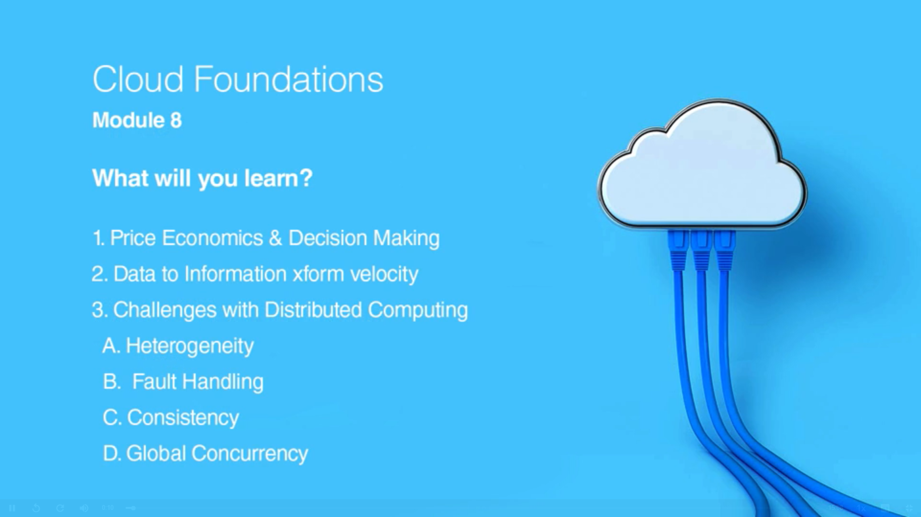

Coding Challenges Details:

Every day we are given with new question of coding related to the language of java and c. it seems interesting how we imbibe ourselves in depth to understand the logic, break it and then code for it.

Today’s question was:

1. [Write a C Program to rotate an array by K positions.](https://github.com/orgs/alvas-education-foundation/teams/2nd-year/discussions/130)

Top of Form

Bottom of Form

|  |
| --- |
| Circular array rotation means rotating the elements in the array where one rotation operation moves the last element of the array to the first position and shifts all remaining elements to the right.  For example, consider the following array = [4, 5, 6], • Initial array [4, 5, 6] • After one rotation [6, 4, 5] • After two rotations [5, 6, 4]  OUTPUT  Element at index 0: 5 Element at index 1: 6 Element at index 2: 4 |

SNAPSHOT:

