**DAILY ONLINE ACTIVITIES SUMMARY**

|  |  |  |  |  |  |  |  |  |
| --- | --- | --- | --- | --- | --- | --- | --- | --- |
| **Date:** | **22/06/2020** | | | | | **Name:** | **RACHANA B S** | |
| **Sem & Sec** | **4th Sem B Sec** | | | | | **USN:** | **4AL18CS065** | |
| **Online Test Summary** | | | | | | | | |
| **Subject** | | **Not conducted** | | | | | | |
| **Max. Marks** | | **-** | | **Score** | | | **-** | |
| **Certification Course Summary** | | | | | | | | |
| **Course** | **Cloud Foundations** | | | | | | | |
| **Certificate Provider** | | | **Great Learning** | | **Duration** | | | **5 hours** |
| **Coding Challenges** | | | | | | | | |
| **Problem Statement:1.** [Write a Java Program for Modular Exponentiation](https://github.com/orgs/alvas-education-foundation/teams/2nd-year/discussions/133) | | | | | | | | |
| **Status: executed** | | | | | | | | |
| **Uploaded the report in GitHub** | | | | | **yes** | | | |
| **If yes Repository name** | | | | | <https://github.com/bsrachana/lockdown_coding> | | | |
| **Uploaded the report in slack** | | | | | **yes** | | | |

Online Test Details: test was not conducted today.

Certification Course Details:

In today’s session, I learnt about Infrastructure automation, Abstraction, Provisioning, Allied Tech.

SNAPSHOT:

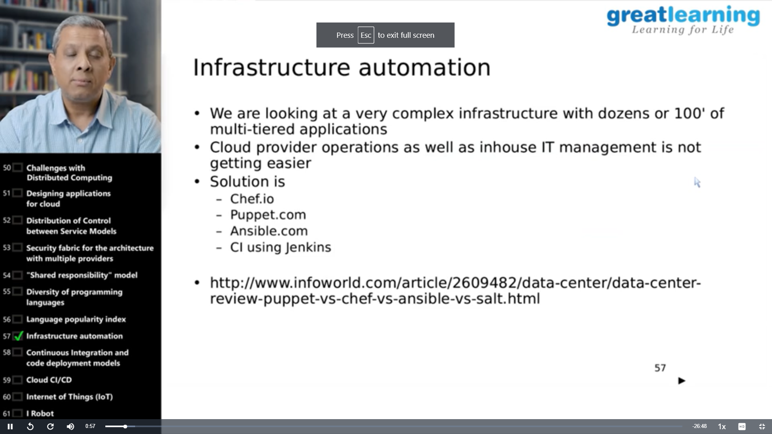

Coding Challenges Details:

Every day we are given with new question of coding related to the language of java and c. it seems interesting how we imbibe ourselves in depth to understand the logic, break it and then code for it.

Today’s question was:

1. [Write a Java Program for Modular Exponentiation](https://github.com/orgs/alvas-education-foundation/teams/2nd-year/discussions/133)

Top of Form

Bottom of Form

|  |
| --- |
| Given three numbers x, y and p, compute (xy) % p. Input: x = 2, y = 3, p = 5 Output: 3 Explanation: 2^3 % 5 = 8 % 5 = 3.  Input: x = 2, y = 5, p = 13 Output: 6 Explanation: 2^5 % 13 = 32 % 13 = 6. |

SNAPSHOT:

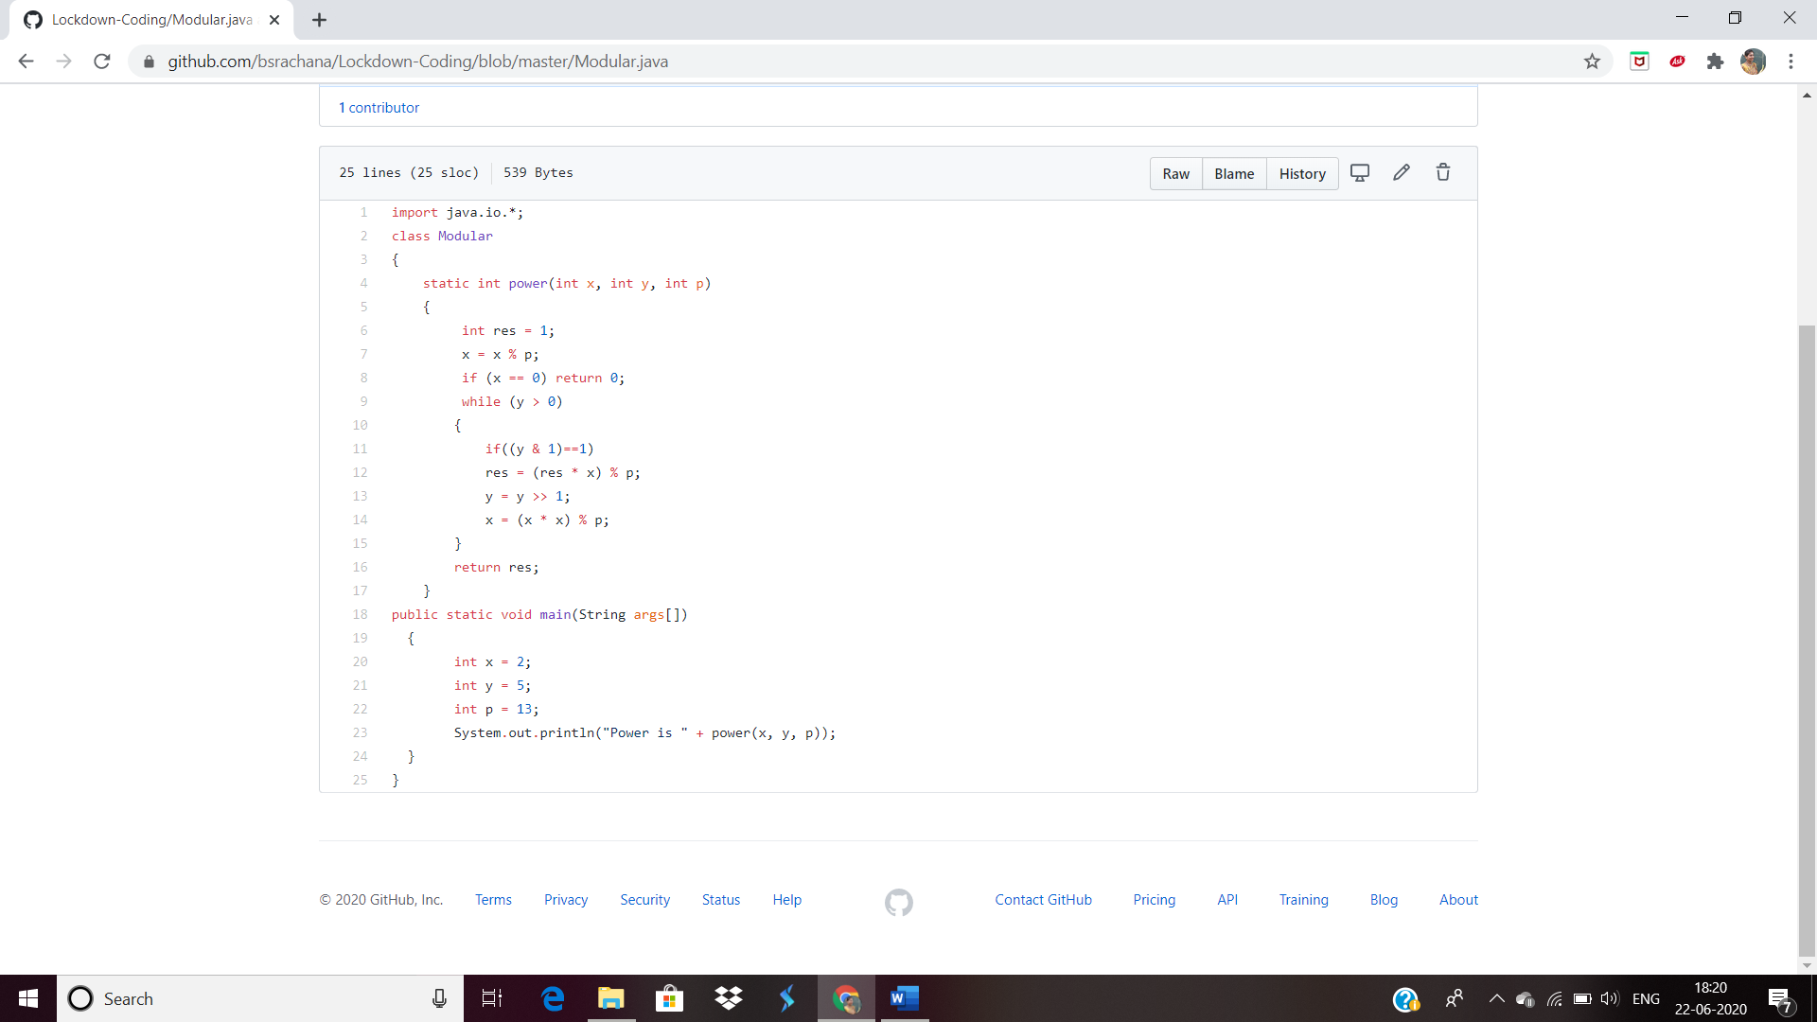

2. Write a Java program to find the Reversal.

SNAPSHOT:  
